**LIBRARY CAVENDISH UNIVERSITY ZAMBIA**

[Library Access - Cavendish University Zambia](https://www.google.com/url?sa=t&rct=j&q=&esrc=s&source=web&cd=1&cad=rja&uact=8&ved=2ahUKEwjgl9uXnNHoAhWxwsQBHSeAAWwQFjAAegQIAhAB&url=https%3A%2F%2Fwww.cavendishza.org%2Flibrary-access&usg=AOvVaw1DmjXxfTjVchcl5oisTvah)

[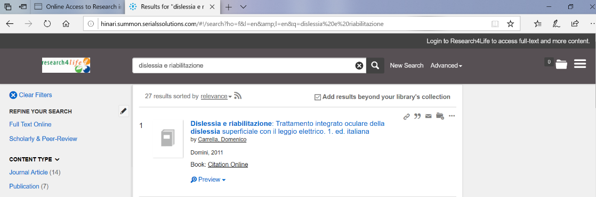](https://www.google.com/url?sa=t&rct=j&q=&esrc=s&source=web&cd=1&cad=rja&uact=8&ved=2ahUKEwjgl9uXnNHoAhWxwsQBHSeAAWwQFjAAegQIAhAB&url=https%3A%2F%2Fwww.cavendishza.org%2Flibrary-access&usg=AOvVaw1DmjXxfTjVchcl5oisTvah)