**WYOMING = 2**

**1** [**HINCKLEY LIBRARY**](http://www.nwc.cc.wy.us/library/) – (Powell, Wyoming, Usa)

<http://nwc.summon.serialssolutions.com/advanced#!/search?ho=f&l=en&q=(dislessia%20e%20riabilitazione)>

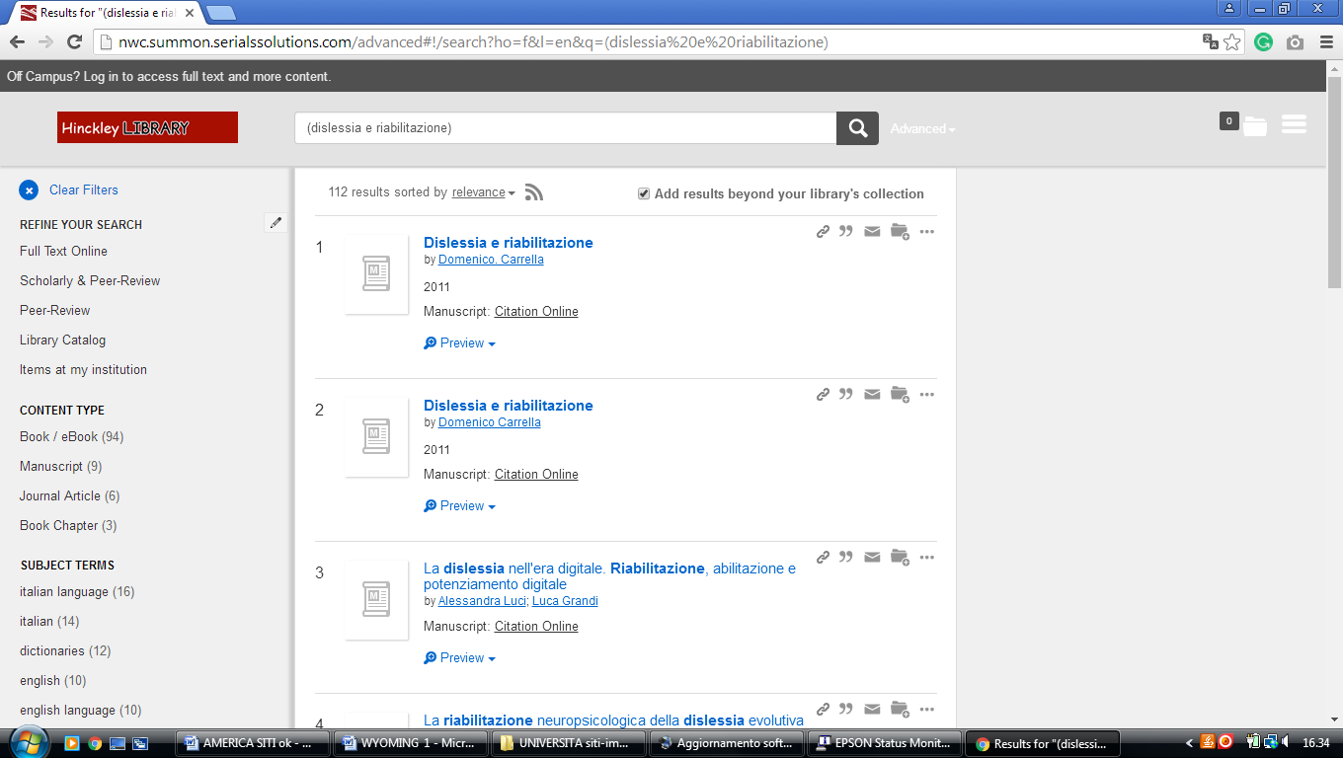

### 2 [LIBRARIES RESEARCH LAUNCHPAD @ UNIVERSITY OF WYOMING](http://www-lib.uwyo.edu/)

### (E. University Ave. Laramie WY, Usa)

<http://uwyo.summon.serialssolutions.com/search?fvf=ContentType%2CJournal+Article&fvf=ContentType%2CNewspaper+Article&fvf=ContentType%2CMagazine+Article&spellcheck=true&q=dislessia+e+riabilitazione#!/search?ho=f&l=en&q=dislessia%20e%20riabilitazione>

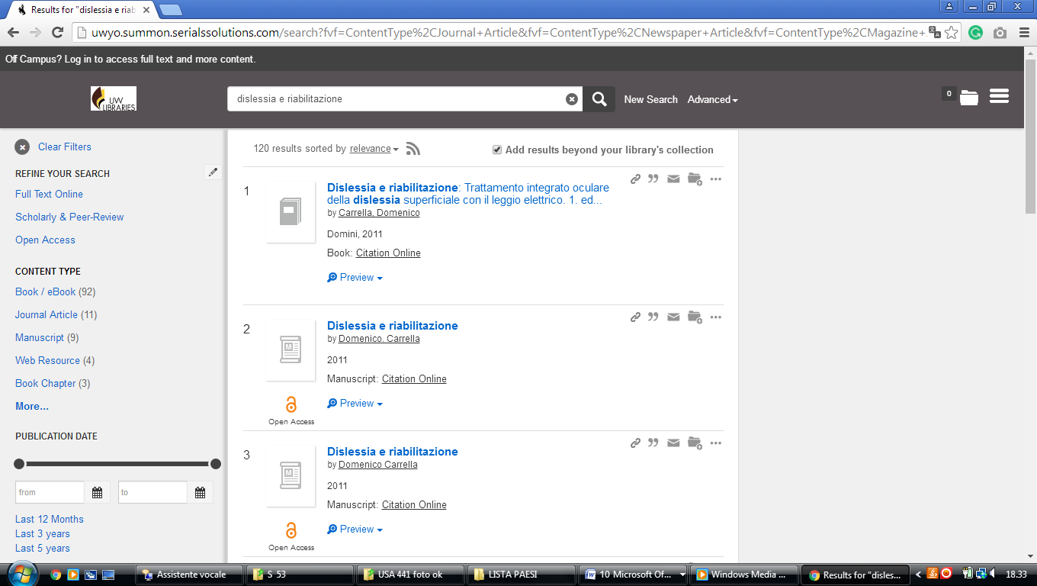

University of Wyoming Libraries AMERICA

uwyo.summon.serialssolutions.com/search?fvf=ContentType%2CJournal+Article&fvf=ContentType%2CNewspaper+Article&fvf=ContentType%2CMagazine+Article&spellcheck=true&q=dislessia+e+riabilitazione#!/search?ho=f&l=en&q=dislessia%20e%20riabilitazione

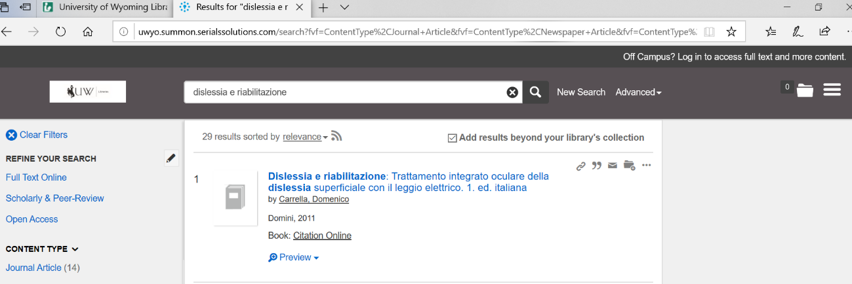

[**Casper College Library**](http://www.caspercollege.edu/library/)

Casper , Wyoming, United States

