**WASHINGTON = 16**

**1** [**RENTON TECHNICAL COLLEGE LIBRARY**](http://www.rtc.edu/library/) – (Renton, Washington, Usa)

<https://wactc-renton-primo.hosted.exlibrisgroup.com/primo-explore/search?institution=RENTON&vid=RENTON_V1&tab=default_tab&search_scope=EVERYTHING&mode=Basic&displayMode=full&bulkSize=10&highlight=true&dum=true&query=any,contains,dislessia%20e%20riabilitazione&displayField=all&pcAvailabiltyMode=true&sortby=rank&pcAvailability=true>

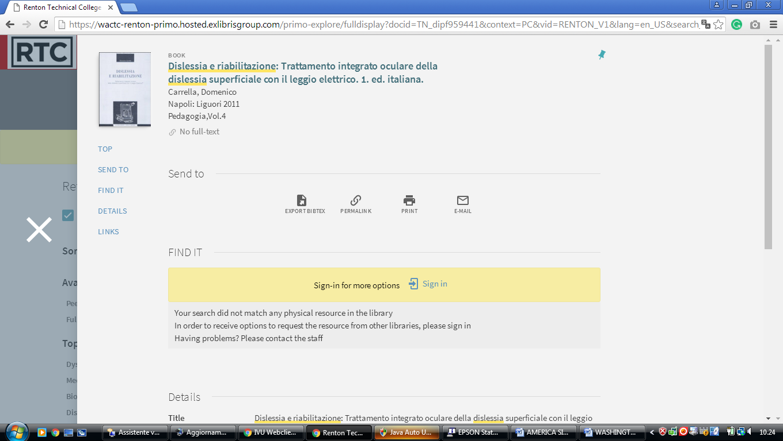

**2** [**CANNELL LIBRARY**](http://library.clark.edu/) – (Vancouver, Washington, Usa)

<http://alliance-primo.hosted.exlibrisgroup.com/primo_library/libweb/action/display.do;jsessionid=2EAB12FFE249077F99C49B3144D5A866?tabs=detailsTab&ct=display&fn=search&doc=TN_casalini_libriit02503952&indx=1&recIds=TN_casalini_libriit02503952&recIdxs=0&elementId=0&renderMode=poppedOut&displayMode=full&frbrVersion=&pcAvailabiltyMode=true&query=any%2Ccontains%2C+dislessia+e+riabilitazione&vl(3149435UI0)=any&dscnt=0&search_scope=clark_alma_summit_primo_central&scp.scps=scope%3A%28CC%29%2Cscope%3A%28P%29%2Cscope%3A%28E-CC%29%2Cscope%3A%28lg_all%29%2Cprimo_central_multiple_fe&vid=CC&onCampus=true&mode=Basic&highlight=true&bulkSize=20&institution=CC&queryTemp=+dislessia+e+riabilitazione&tab=default_tab&displayField=all&vl(freeText0)=%20dislessia%20e%20riabilitazione&group=GUEST&dstmp=1521754172575&gathStatIcon=true>

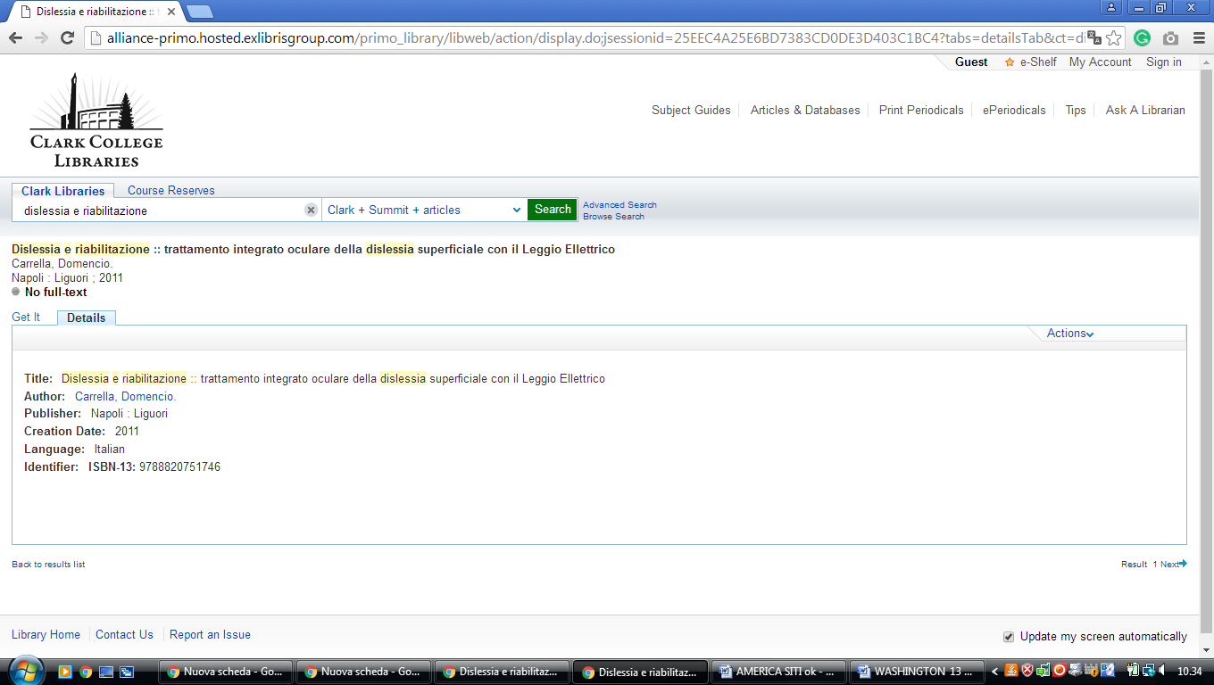

3 [**HIGHLINE LIBRARY**](http://flightline.highline.edu/library/) – (Des Moines, Washington, Usa)

<https://highline-primo.hosted.exlibrisgroup.com/primo-explore/search?queryTemp=dislessia%20e%20riabilitazione&institution=HIGHLINE&vid=HIGHLINE&tab=default_tab&group=GUEST&onCampus=true&displayMode=full&highlight=true&search_scope=EVERYTHING&query=any,contains,dislessia%20e%20riabilitazione&sortby=rank&pcAvailability=true>

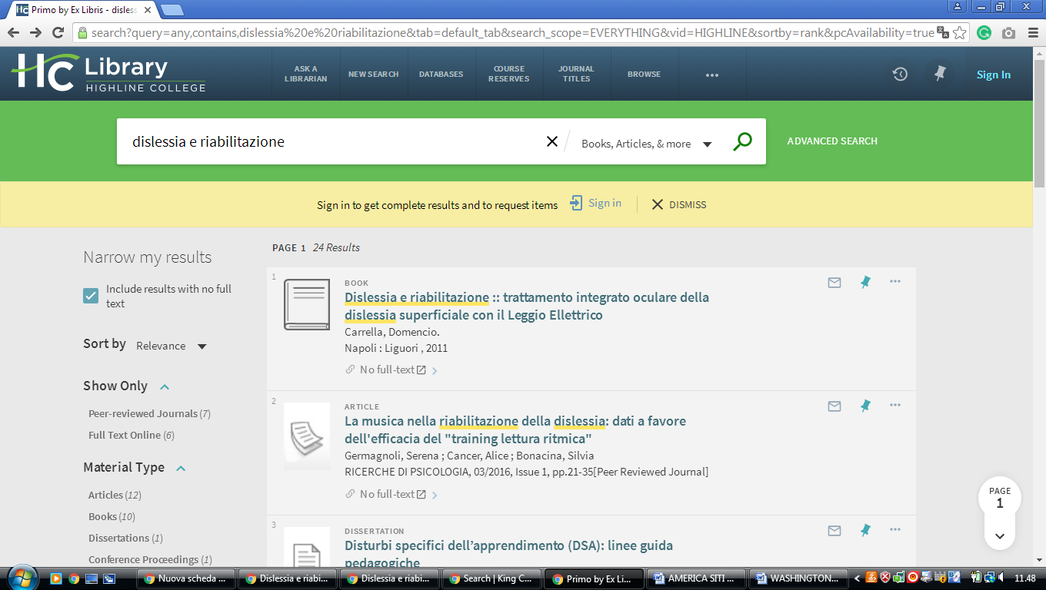

4 [**HOLMAN LIBRARY**](http://www.greenriver.edu/academics/library.htm) – (Auburn, Washington, Usa)

<https://wactc-greenriver-primo.hosted.exlibrisgroup.com/primo-explore/search?institution=GREENRIVER&vid=GREENRIVER_V1&tab=everything&search_scope=EVERYTHING&mode=Basic&displayMode=full&bulkSize=10&highlight=true&dum=true&query=any,contains,DISLESSIA%20E%20RIABILITAZIONE&displayField=all&pcAvailabiltyMode=true&sortby=rank&pcAvailability=true>

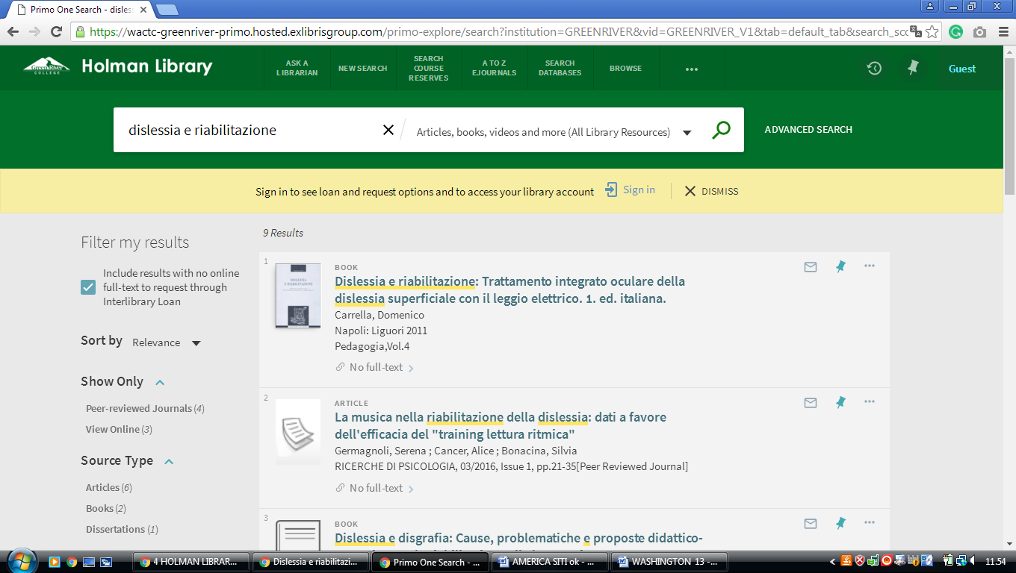

**5** [**WASHINGTON STATE UNIVERSITY**](http://www.wsulibs.wsu.edu/) **LIBRARIES**  **- (**Pullman, Washington, Usa)

<https://searchit.libraries.wsu.edu/primo-explore/search?institution=WSU&vid=WSU&mode=Basic&displayMode=full&bulkSize=10&highlight=true&dum=true&query=any,contains,%20dislessia%20e%20riabilitazione&query=&displayField=all&queryTemp=%20dislessia%20e%20riabilitazione&search_scope=WSU_everything>

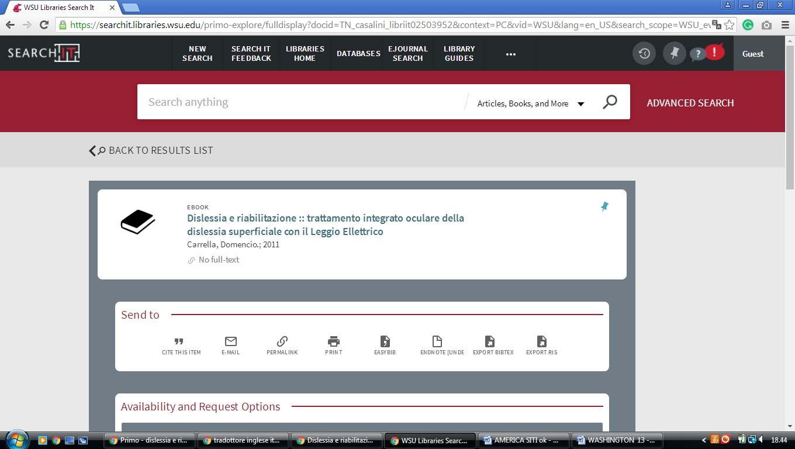

**6** [**WESTERN LIBRARIES**](http://www.library.wwu.edu/) - (Bellingham, Washington, Usa)

<http://onesearch.library.wwu.edu/primo_library/libweb/action/search.do?mode=Basic&vid=WWU&vl(freeText0)=dislessia%20e%20riabilitazione&fn=search&tab=everythingandmore&>

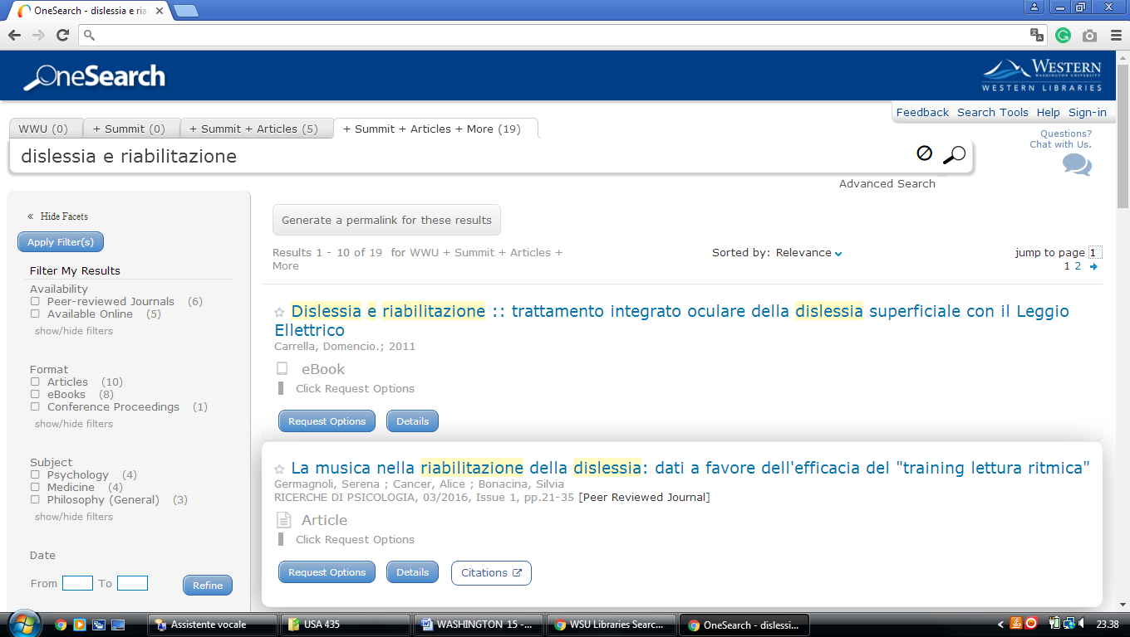

**7 SEATTLE UNIVERSITY LIBRARY – (**Seattle, Washington Usa)

<https://primo.seattleu.edu/primo_library/libweb/action/search.do?fn=search&ct=search&initialSearch=true&mode=Basic&tab=default_tab&indx=1&dum=true&srt=rank&vid=SEAU&frbg=&tb=t&vl%28freeText0%29=dislessia+e+riabilitazione&scp.scps=WorldCatLocal_SEAU>

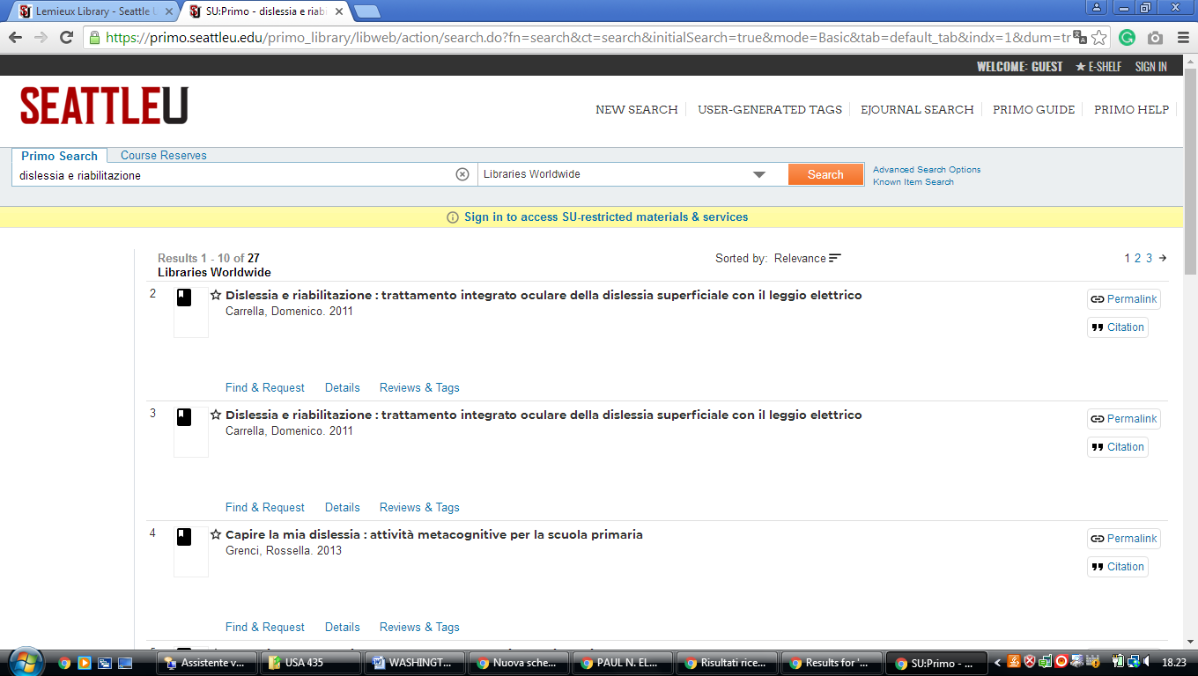

**8** [**PAUL N. ELBIN LIBRARY**](http://www.westliberty.edu/library/) – (West Liberty, West Virginia, Usa)

<https://wluelbinlibrary.on.worldcat.org/search?sortKey=LIBRARY&databaseList=638&queryString=kw%3Adislessia+e+riabilitazione+AND+x0%3Abook&changedFacet=author&scope=&format=all&database=all&author=Carrella%2C+Domenico&year=all&yearFrom=&yearTo=&language=all&topic=all>

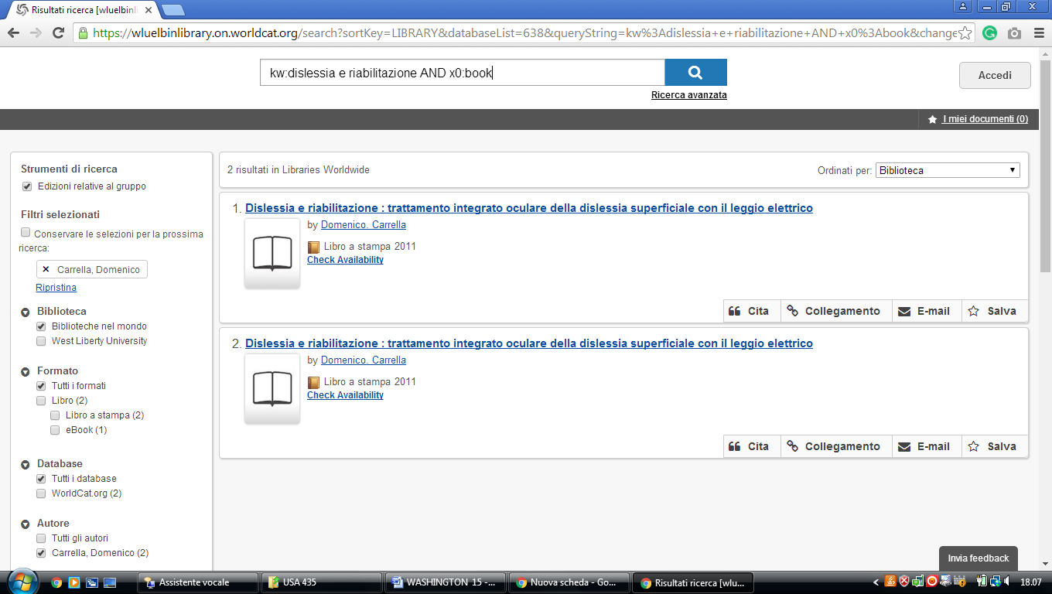

**9** [**WEST VIRGINIA UNIVERSITY LIBRARIES**](http://www.libraries.wvu.edu/) – (Morgantown, West Virginia, Usa)

<https://libwvu.on.worldcat.org/search?sortKey=BEST_MATCH&databaseList=&queryString=dislessia+e+riabilitazione&changedFacet=scope&clusterResults=on&scope=&scope=wz%3A1653>

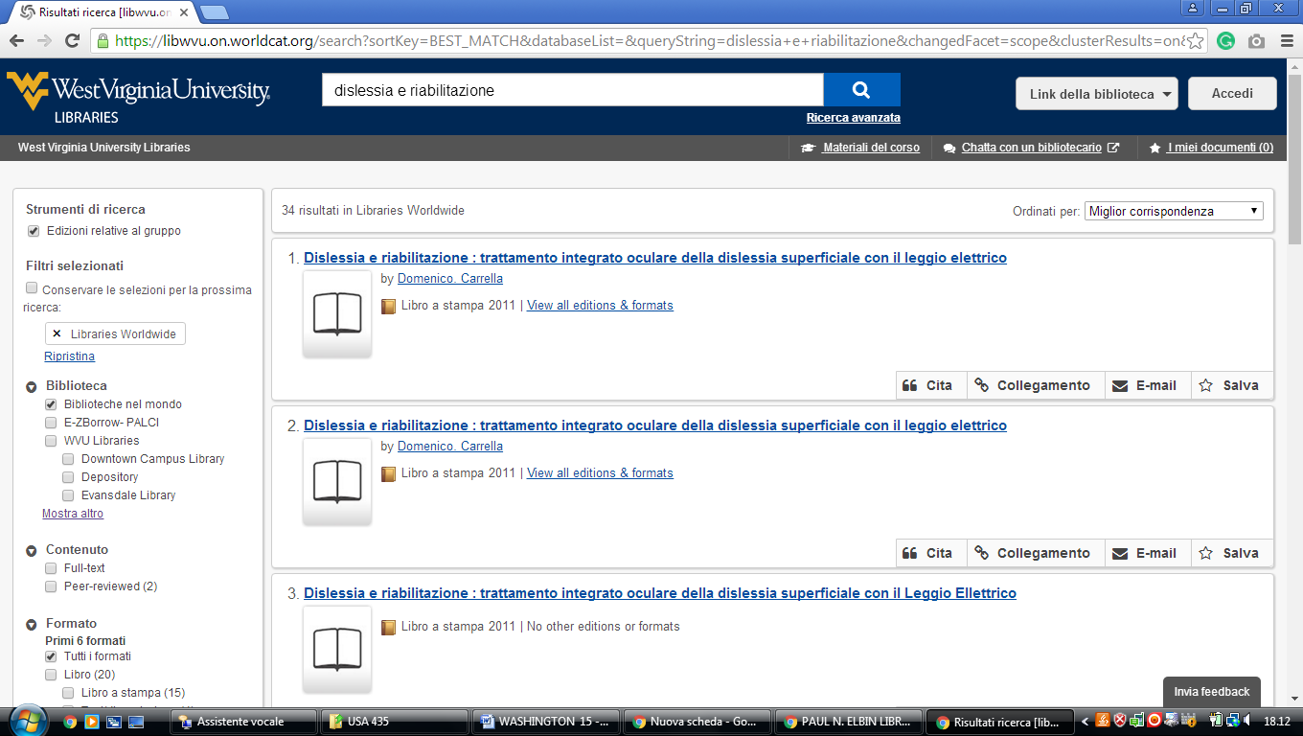

### 10 [MORTVEDT LIBRARY | PACIFIC LUTHERAN UNIVERSITY](https://www.google.it/url?sa=t&rct=j&q=&esrc=s&source=web&cd=3&cad=rja&uact=8&ved=0ahUKEwiJrPGZwe_UAhVDNxQKHcyoDPIQFghIMAI&url=https%3A%2F%2Fwww.plu.edu%2Flibrary%2F&usg=AFQjCNGHrAflgKZKCp_bBZ78CltKsSPzqg) – ([Parkland](https://en.wikipedia.org/wiki/Parkland,_Washington), WA,Usa)

<https://plu.worldcat.org/search?q=dislessia+e+riabilitazione&dblist=1708%2C1271%2C203%2C2237%2C2259%2C2260%2C2261%2C2268%2C2262%2C2263%2C2264%2C2267%2C2281%2C2328%2C3201%2C3284%2C2273%2C2276%2C2277%2C233%2C3369%2C245%2C251%2C2626%2C283%2C638&se=nodgr&sd=desc&fq=ap%3A%22carrella%2C+domenico%22&qt=facet_ap%3A>

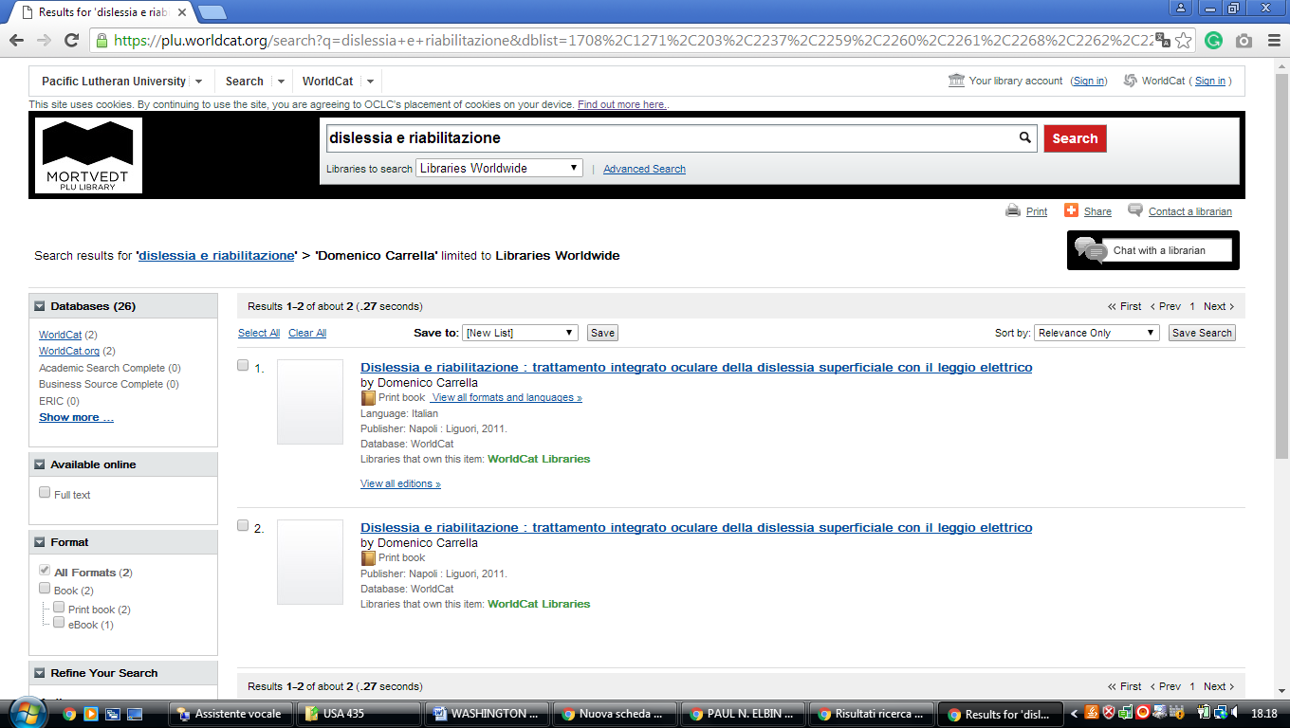

### 11 [UNIVERSITY LIBRARY | AMERICAN UNIVERSITY, WASHINGTON, D.C.](https://www.american.edu/library/)

### (Washington, Usa)

### (<https://american.summon.serialssolutions.com/search?s.q=dislessia+e+riabilitazione#!/search?ho=f&l=en&q=dislessia%20e%20riabilitazione>

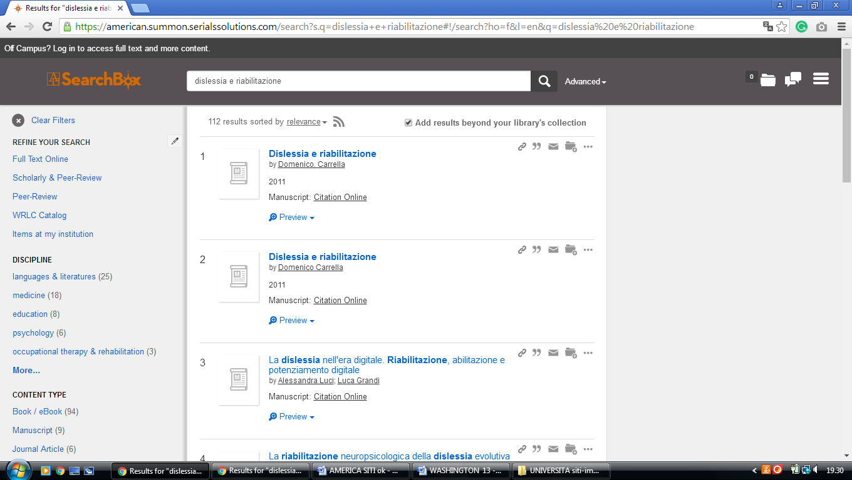

**12 GEORGETOWN UNIVERSITY, LIBRARY - (**Georgetown Washington, Usa)

<https://gt.summon.serialssolutions.com/?q=dislessia+e+riabilitazione#!/search?ho=f&l=en&q=dislessia%20e%20riabilitazione>

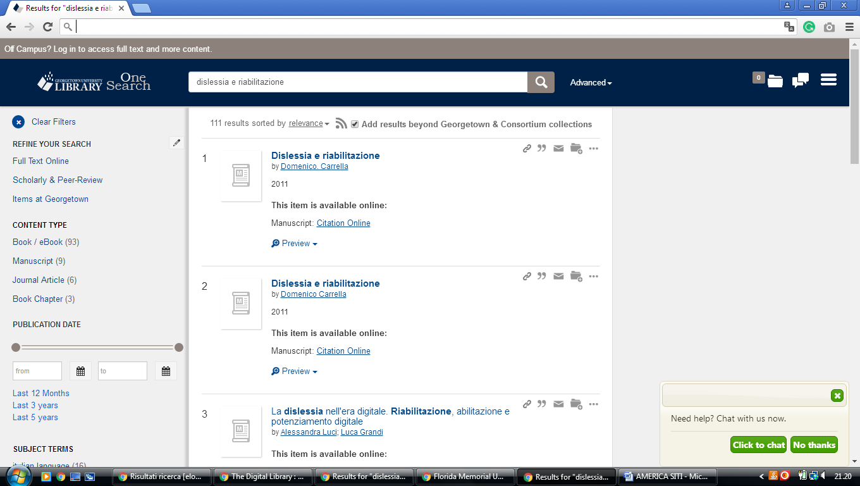

### 13 [THE CATHOLIC UNIVERSITY OF AMERICA UNIVERSITY LIBRARIES](http://libraries.cua.edu/) (Washington, USA)

<http://cua.summon.serialssolutions.com/search?keep_r=true&s.fvf%5B%5D=ContentType%2CJournal+Article&s.q=dislessia+e+riabilitazione&x=63&y=10#!/search?ho=f&l=en&q=dislessia%20e%20riabilitazione>

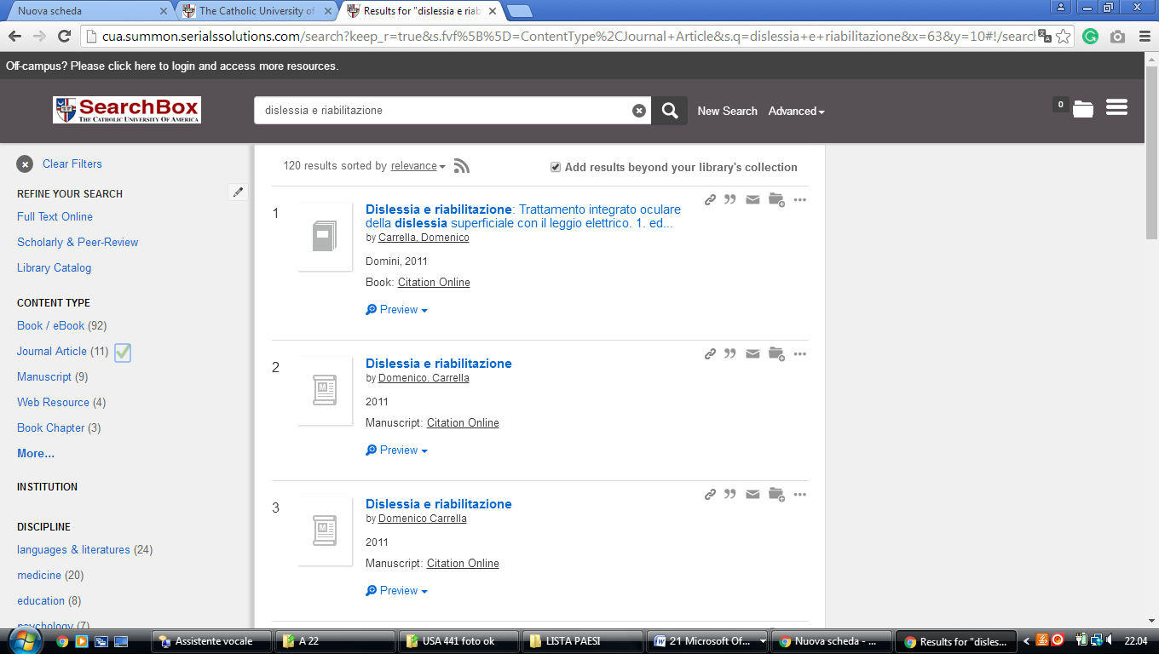

**14** [**UNIVERSITY OF WASHINGTON**](http://www.lib.washington.edu/) **- UNIVERSITY LIBRARIES – (**Washington, Usa)  [- sedi a: Seattle](https://it.wikipedia.org/wiki/Seattle), [Tacoma](https://it.wikipedia.org/wiki/Tacoma) e Bothell

<https://uwashington.on.worldcat.org/search?databaseList=&queryString=%20dislessia%20e%20riabilitazione>

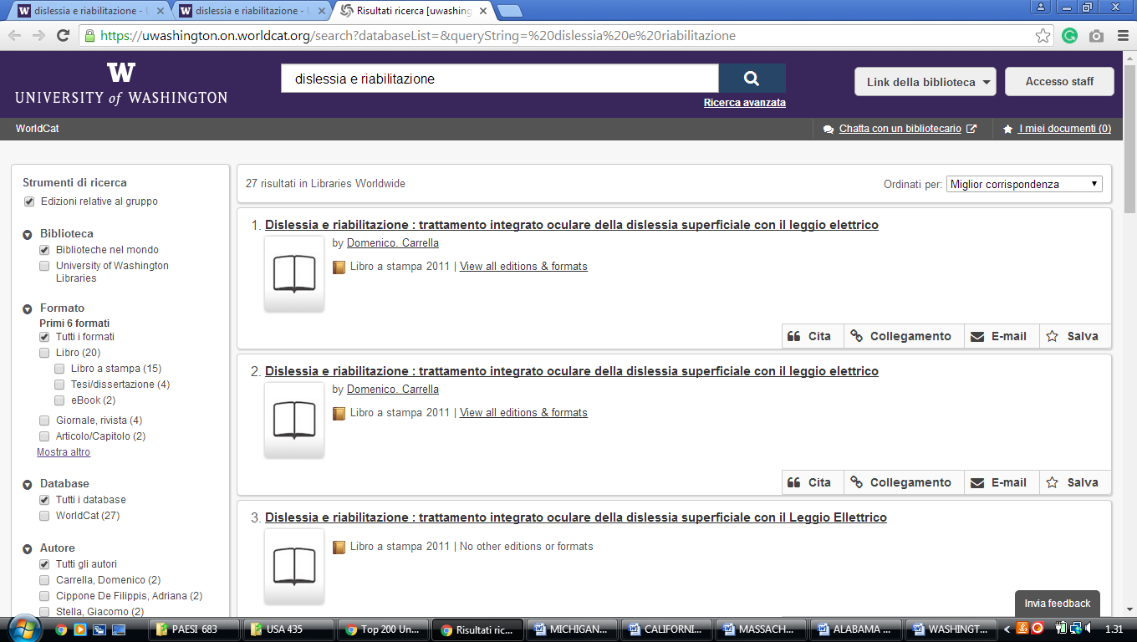

**15** [**THE CATHOLIC UNIVERSITY OF AMERICA UNIVERSITY LIBRARIES**](http://libraries.cua.edu/)

[http://cua.summon.serialssolutions.com/search?keep_r=true&s.fvf%5B%5D=ContentType%2CJournal+Article&s.q=dislessia+e+riabilitazione&x=41&y=15#!/search?ho=f&l=en&q=dislessia%20e%20riabilitazione](http://cua.summon.serialssolutions.com/search?keep_r=true&s.fvf%5B%5D=ContentType%2CJournal+Article&s.q=dislessia+e+riabilitazione&x=41&y=15%23!/search?ho=f&l=en&q=dislessia%20e%20riabilitazione)

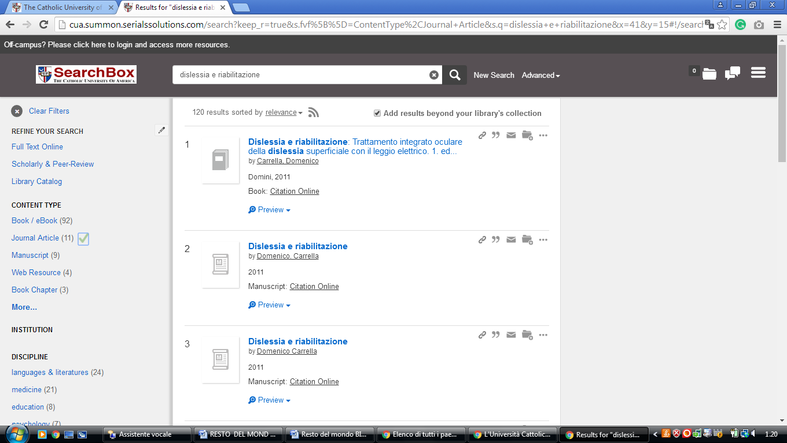

University Libraries - Catholic University of AMERICA

https://wrlc-cu.primo.exlibrisgroup.com/discovery/search?query=any,contains,dislessia%20e%20riabilitazione&tab=Everything&search_scope=WRLC_no_er_plus_CI&vid=01WRLC_CAA:01WRLC_CAA&lang=en&offset=0&pcAvailability=true

