**VIRGINIA 11**

**1** [**ALEXANDER MACK LIBRARY**](http://libguides.bridgewater.edu/home) - (Bridgewater, Virginia, Usa)

<https://bridgewatercollege.on.worldcat.org/search?sortKey=BEST_MATCH&databaseList=&queryString=dislessia+e+riabilitazione&changedFacet=scope&clusterResults=on&scope=&scope=wz%3A947>

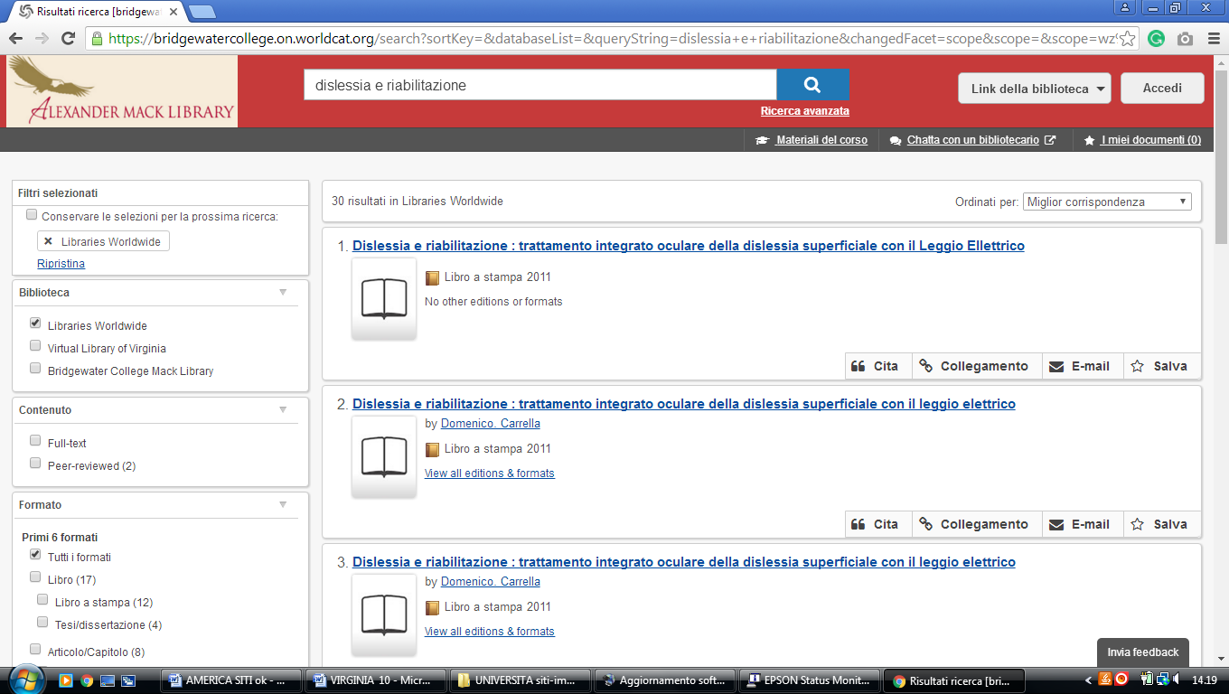

**2** [**AVERETT UNIVERSITY LIBRARY**](http://discover.averett.edu/library) – (Danville, Virginia, Usa)

<http://averett.on.worldcat.org/search?sortKey=RECENCY&databaseList=&queryString=dislessia+e+riabilitazione&changedFacet=scope&clusterResults=on&scope=&scope=wz%3A6679>

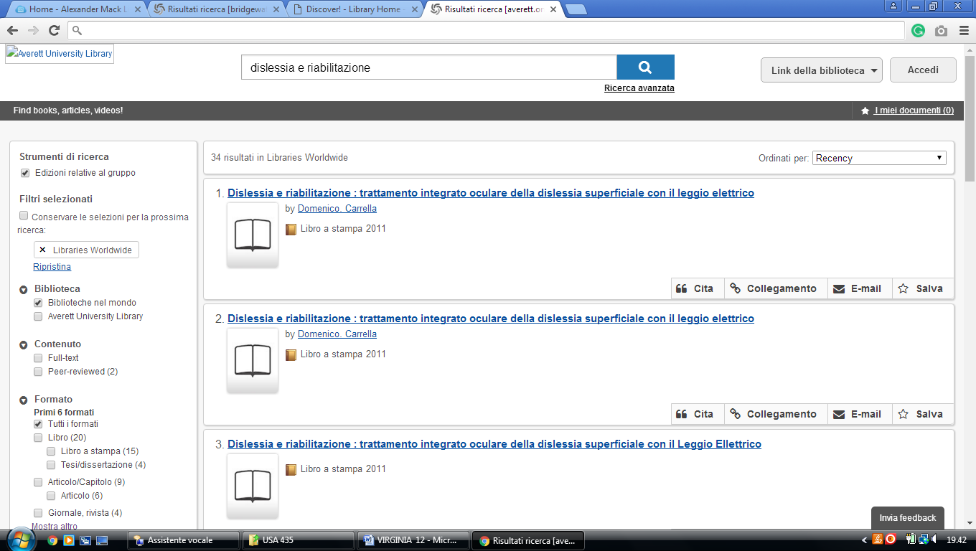

**3** [**BOATWRIGHT MEMORIAL LIBRARY**](http://library.richmond.edu/) – (Richmond, Virginia, Usa)

<https://richmond.summon.serialssolutions.com/search?s.q=#!/search?ho=f&l=it-IT&q=dislessia%20e%20riabilitazione>

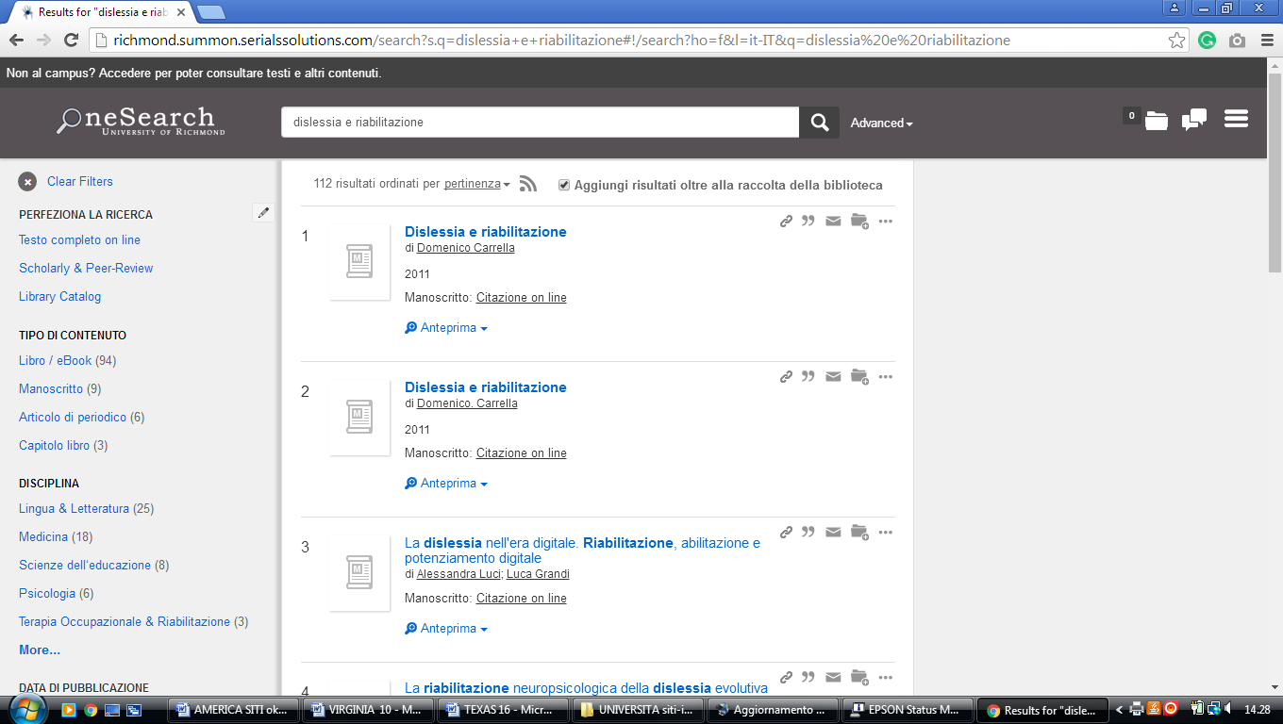

**4** [**EARL GREGG SWEM LIBRARY**](https://swem.wm.edu/) – (Williamsburg, Virginia, Usa)

<https://wm-primo.hosted.exlibrisgroup.com/primo_library/libweb/action/search.do?ct=facet&pcAvailabiltyMode=true&pcAvailClicked=true&vid=01COWM_WM&mode=Basic&tab=pci&fn=search&indx=1&dscnt=0&vl(freeText0)=dislessia%20e%20riabilitazione&dstmp=1521744849909>

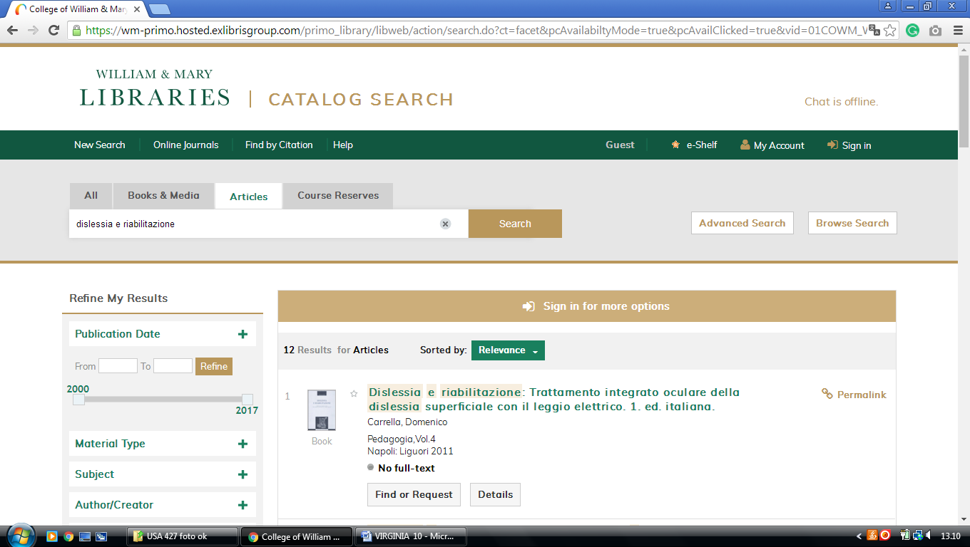

**5** [**GREENWOOD LIBRARY**](http://library.longwood.edu/) – (Farmville, Virginia, Usa)

<https://longwooduniversity.on.worldcat.org/search?sortKey=LIBRARY&databaseList=&queryString=dislessia+e+riabilitazione&changedFacet=author&clusterResults=on&scope=&format=&database=all&author=Carrella%2C+Domenico&year=all&yearFrom=&yearTo=&language=all&topic=all>

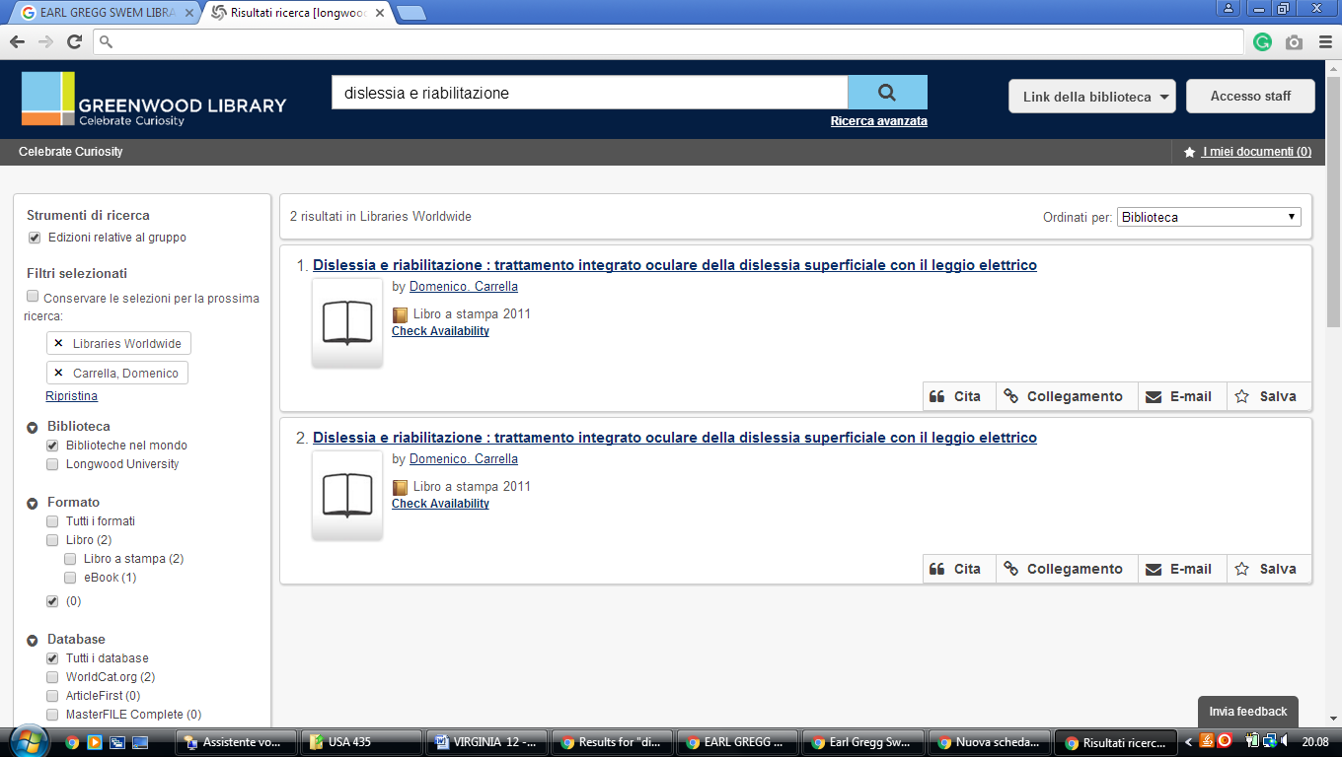

**6** [**HARVEY LIBRARY**](http://www.hamptonu.edu/universityservices/library/index.html) – (Hampton, Virginia, Usa)

<http://hamptonu.summon.serialssolutions.com/search?s.q=#!/search?ho=f&l=en&q=dislessia%20e%20riabilitazione>

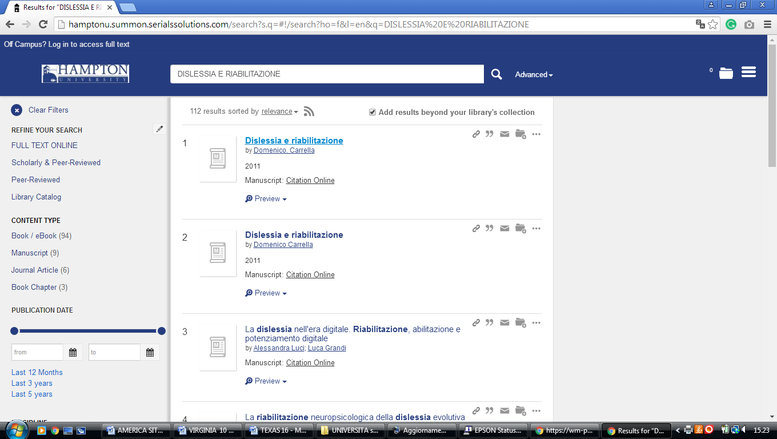

**7** [**HENRY CLAY HOFHEIMER II LIBRARY – (**](http://www.vwc.edu/library/) Norfolk, Virginia, Usa)

<https://vwu.on.worldcat.org/search?sortKey=LIBRARY&databaseList=&queryString=dislessia+e+riabilitazione&changedFacet=author&scope=&format=all&database=all&author=Carrella%2C+Domenico&year=all&yearFrom=&yearTo=&language=all&topic=all>

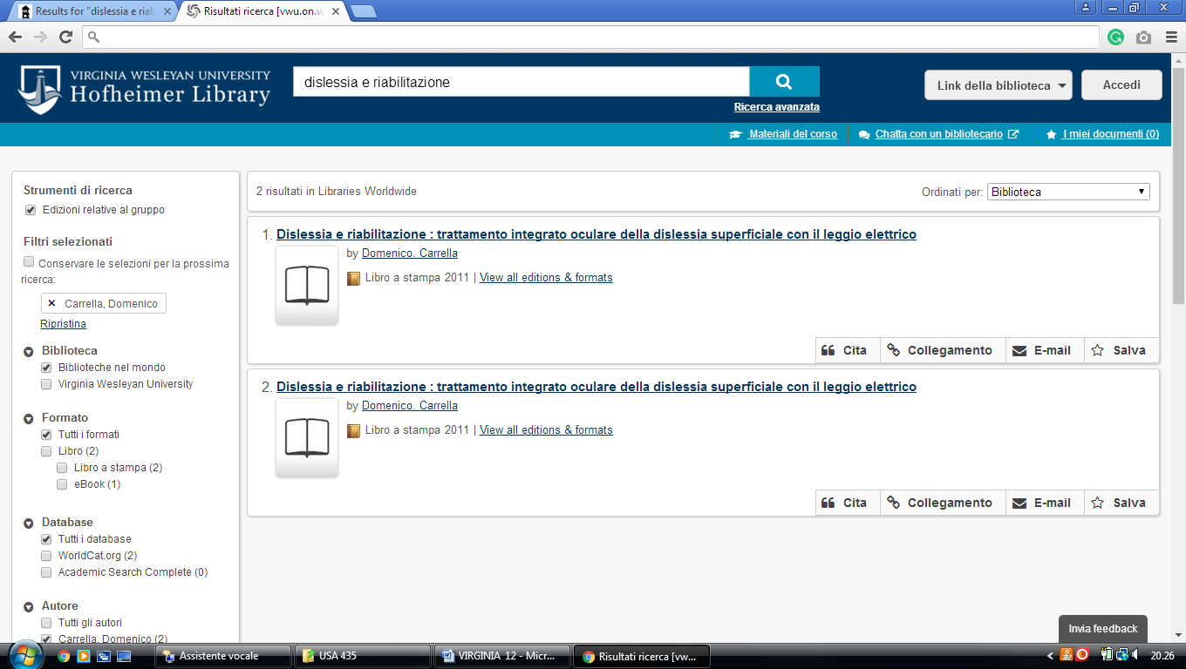

### 8 [UNIVERSITY LIBRARIES | VIRGINIA TECH](https://lib.vt.edu/) - (Virginia, Usa)

<https://vt.summon.serialssolutions.com/#!/search?ho=f&l=en&q=(dislessia%20e%20riabilitazione)>

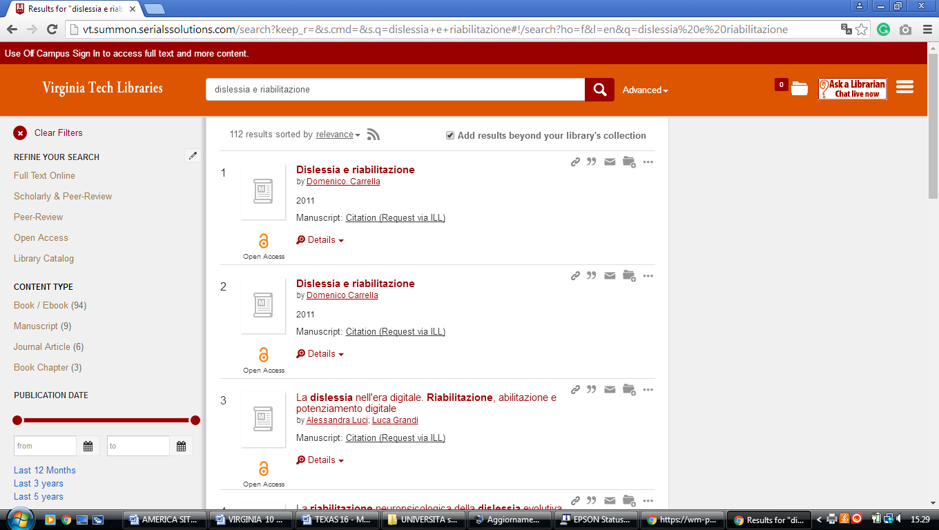

**9** [**WYNDHAM ROBERTSON LIBRARY**](http://www.hollins.edu/library/index.shtml) – (Roanoke, Virginia, Usa)

<https://hollins-primo.hosted.exlibrisgroup.com/primo-explore/search?institution=01HOLLINS&vid=01HOLLINS&mode=Basic&displayMode=full&bulkSize=10&highlight=true&dum=true&query=any,contains,%20dislessia%20e%20riabilitazione&query=&displayField=all&search_scope=default_scope&queryTemp=%20dislessia%20e%20riabilitazione&sortby=rank&lang=en_US&pcAvailability=true>

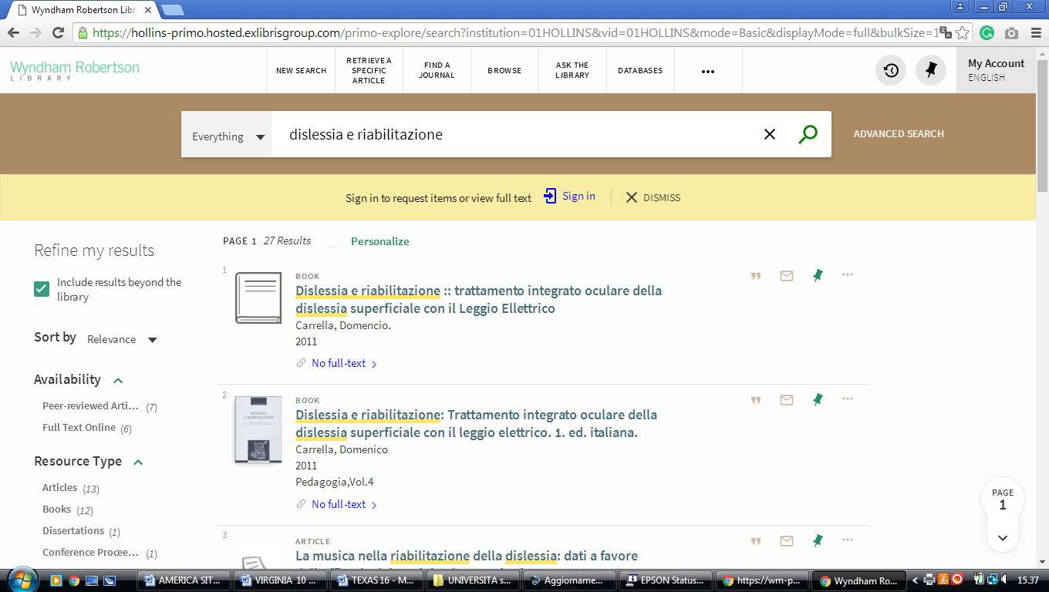

[**10 OATWRIGHT MEMORIAL LIBRARY - UNIVERSITY OF RICHMOND**](https://library.richmond.edu/) – (Virginia, Usa)

<https://richmond.summon.serialssolutions.com/search?s.q=dislessia+e+riabilitazione#!/search?ho=f&l=it-IT&q=dislessia%20e%20riabilitazione>

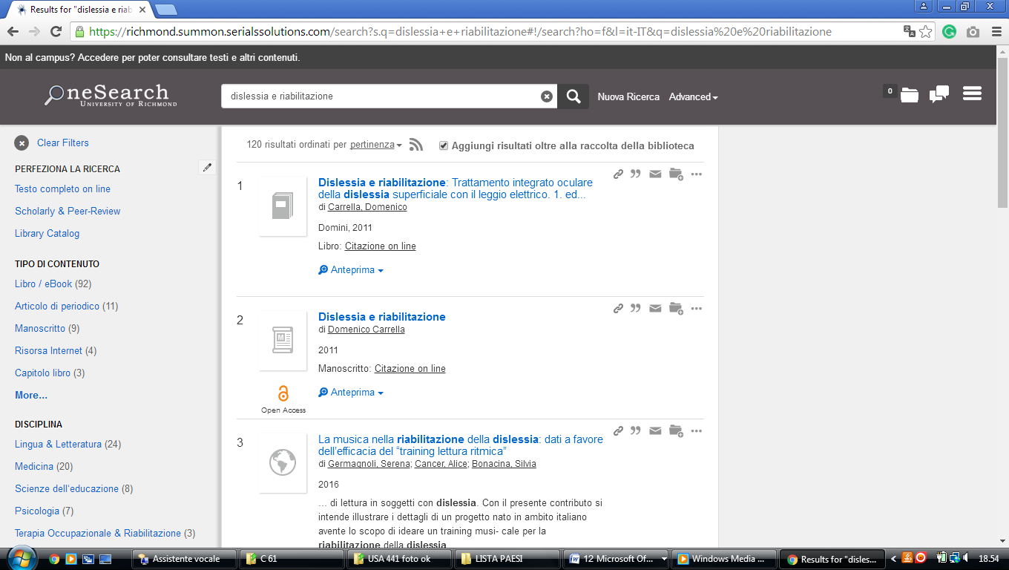

### 11 [WILLIAM & MARY LIBRARIES |](https://libraries.wm.edu/) - (Virginia, Usa)

<https://wm-primo.hosted.exlibrisgroup.com/primo_library/libweb/action/search.do?ct=facet&pcAvailabiltyMode=true&pcAvailClicked=true&pcAvailabiltyMode=false&query=any%2Ccontains%2Cdislessia%20e%20riabilitazione&fn=search&vl(516891084UI0)=any&indx=1&search_scope=EVERYTHING&dscnt=0&scp.scps=scope%3A(CWF_Print_WM)%2Cscope%3A(LAW)%2Cscope%3A(WM_Print_WM)%2Cscope%3A(01COWM_WM)%2Cscope%3A(01COWM_WM_CR)%2Cscope%3A(WM_Alma_WM)%2Cscope%3A(COWM_WM_E)%2Cprimo_central_multiple_fe&displayMode=full&mode=Basic&vid=01COWM_WM&institution=01COWM_WM&bulkSize=50&ct=search&highlight=true&tab=default_tab&displayField=all&vl(freeText0)=dislessia%20e%20riabilitazione&dum=true&dstmp=1520775572856&fromDL>

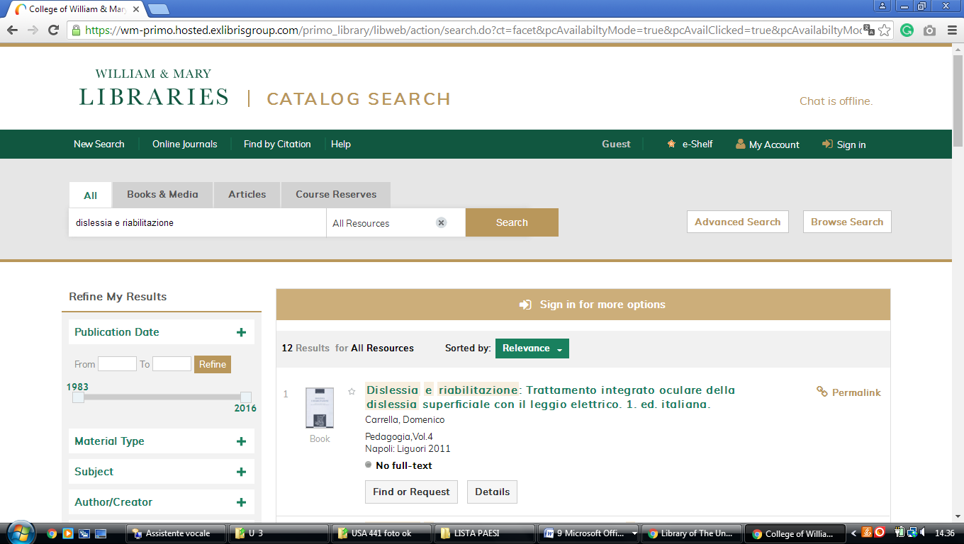

### [Jerry Falwell Library - Liberty University](https://www.liberty.edu/library/)

http://liberty.summon.serialssolutions.com/#!/search?ho=f&l=en&q=(dislessia%20e%20riabilitazione)

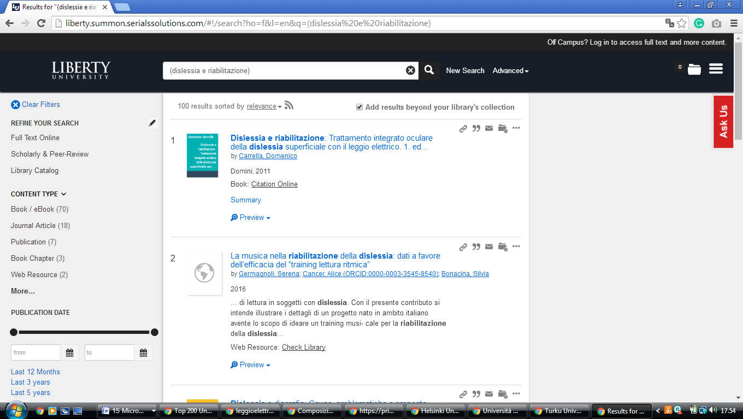

**WEST VIRGINIA UNIVERSITY (WV)**

[**Libraries at West Virginia University (WV)**](https://www.google.com/url?sa=t&rct=j&q=&esrc=s&source=web&cd=1&cad=rja&uact=8&ved=2ahUKEwiKyajfmKzoAhV3wMQBHZq8CdYQFjAAegQIFhAD&url=http%3A%2F%2Flibrary.wvu.edu%2F&usg=AOvVaw2QmOWkzyBD9itfRg1Bg1SK)

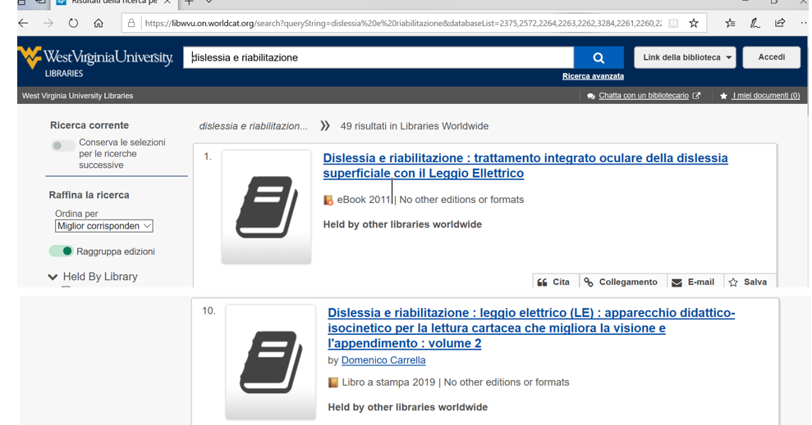 https://libwvu.on.worldcat.org/discovery