**VERMONT = 3**

**1 [DAVIS FAMILY LIBRARY](http://www.middlebury.edu/academics/lib" \t "_blank" \o "Davis Family Library) – (**Middlebury, Vermont, Usa)

[http://middlebury.summon.serialssolutions.com/search?s.q=dislessia+e+riabilitazione&spellcheck=true#!/search?ho=f&l=en&q=dislessia%20e%20riabilitazione](http://middlebury.summon.serialssolutions.com/search?s.q=dislessia+e+riabilitazione&spellcheck=true" \l "!/search?ho=f&l=en&q=dislessia%20e%20riabilitazione)

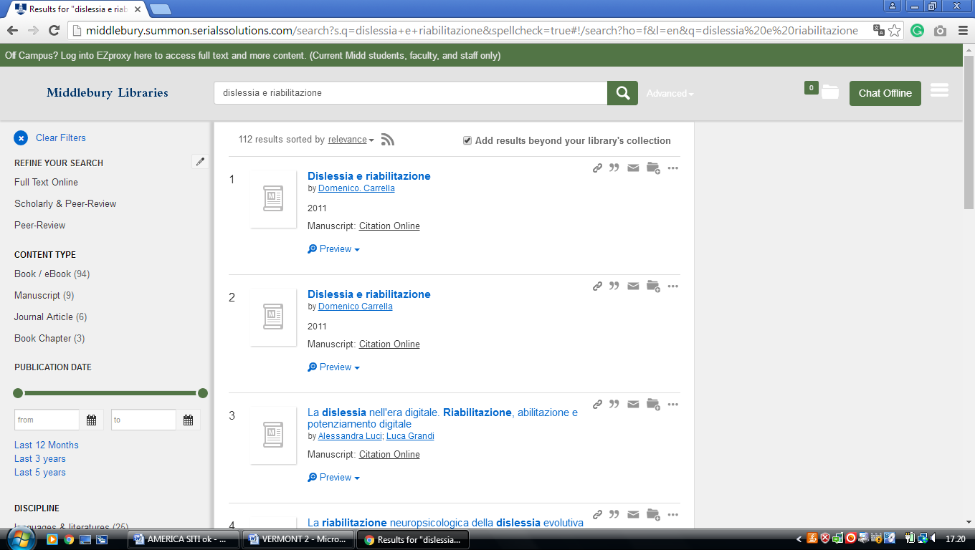

**2**  **[DAVIS FAMILY LIBRARY](http://www.middlebury.edu/academics/lib" \t "_blank" \o "Davis Family Library) – (**Middlebury, Vermont, Usa)

<https://middlebury.worldcat.org/search?q=kf%3Adislessia+e+riabilitazione&dblist=638&se=nodgr&sd=desc&fq=ap%3A%22carrella%2C+domenico%22&qt=facet_ap%3A>

**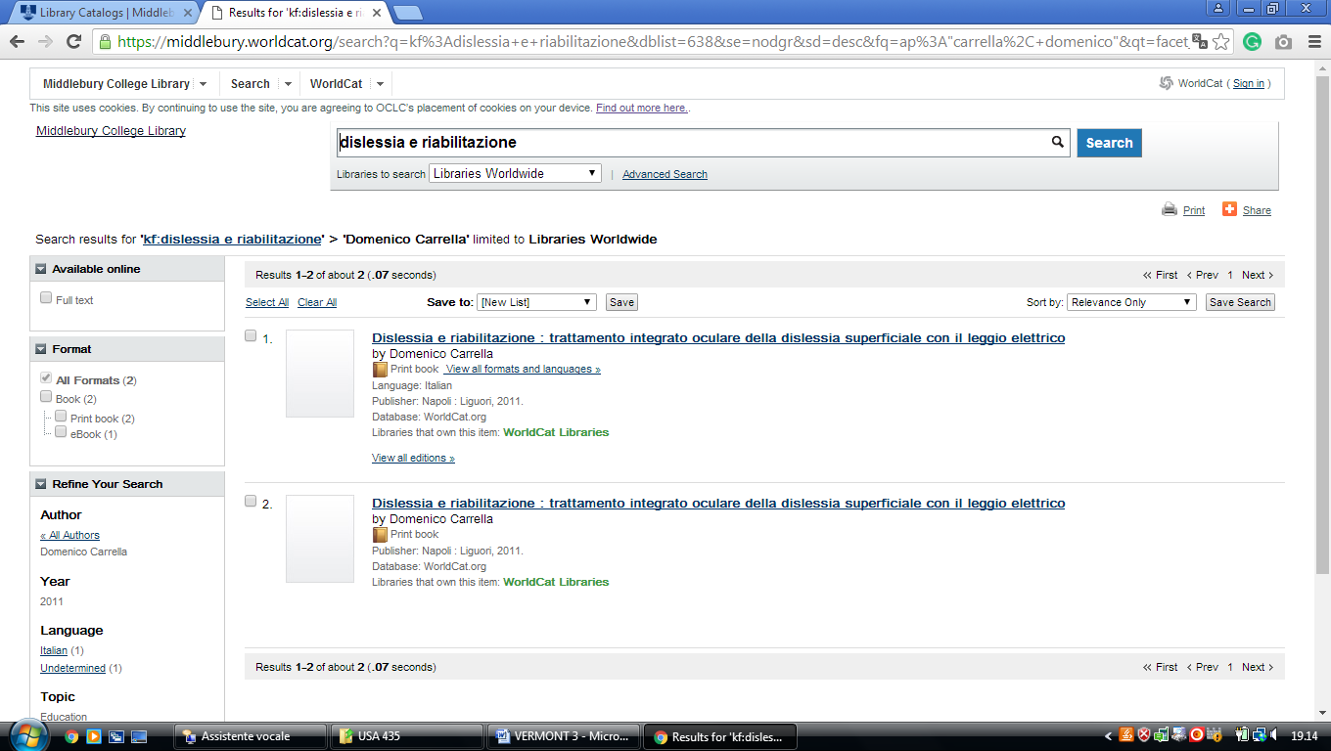**

**3 [KREITZBERG LIBRARY](http://www.norwich.edu/academics/library/" \t "_blank" \o "Kreitzberg Library)** – (Northfield, Vermont, Usa)

<https://norwich.on.worldcat.org/search?sortKey=LIBRARY&databaseList=&queryString=dislessia+e+riabilitazione&changedFacet=author&scope=&format=all&database=all&author=Carrella%2C+Domenico&year=all&yearFrom=&yearTo=&language=all&topic=all>

