**UTHA = 2**

### 1 STEWART LIBRARY - WEBER STATE UNIVERSITY - (Ogden, Utah, Usa)

[https://weber.summon.serialssolutions.com/#!/search?ho=f&l=en&q=dislessia%20e%20riabilitazione](https://weber.summon.serialssolutions.com/" \l "!/search?ho=f&l=en&q=dislessia%20e%20riabilitazione)

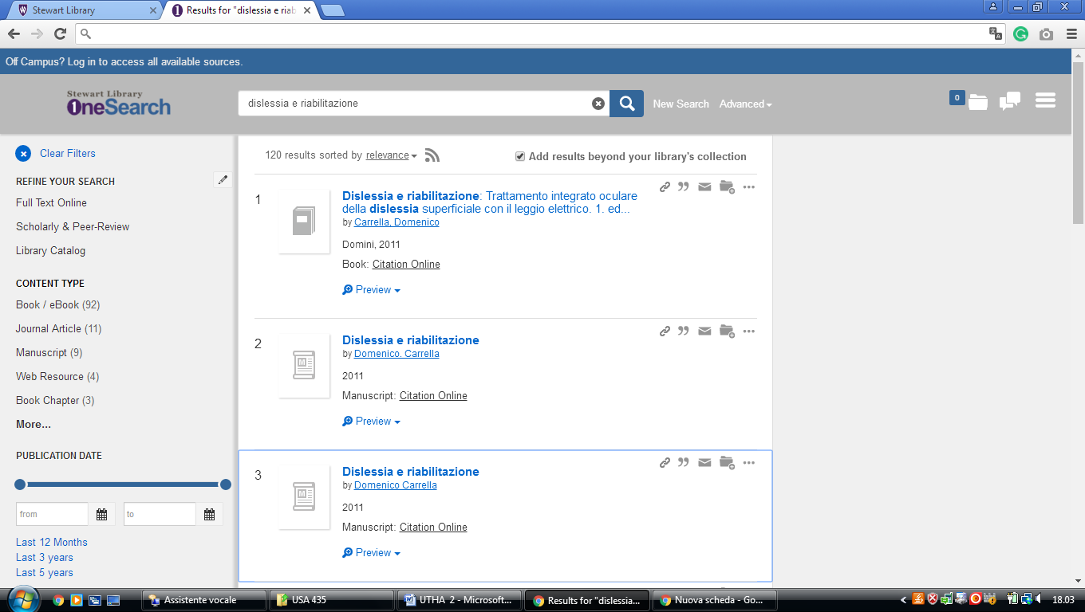

### 2 [HAROLD B. LEE LIBRARY](https://lib.byu.edu/) – ([Provo, Utah](https://en.wikipedia.org/wiki/Provo,_Utah" \o "Provo, Utah), Usa)

<https://search.lib.byu.edu/byu/search?type%5B%5D=book&type%5B%5D=ebook&q=dislessia+e+riabilitazione&expand=true>

