**TEXAS = 17**

**1** [**TEXAS MEDICAL CENTER LIBRARY**](http://www.library.tmc.edu/) – (Houston, Texas, Usa)

<http://tmclibrary.summon.serialssolutions.com/search?s.q=dislessia+e+riabilitazione#!/search?ho=f&l=it-IT&q=dislessia%20e%20riabilitazione>

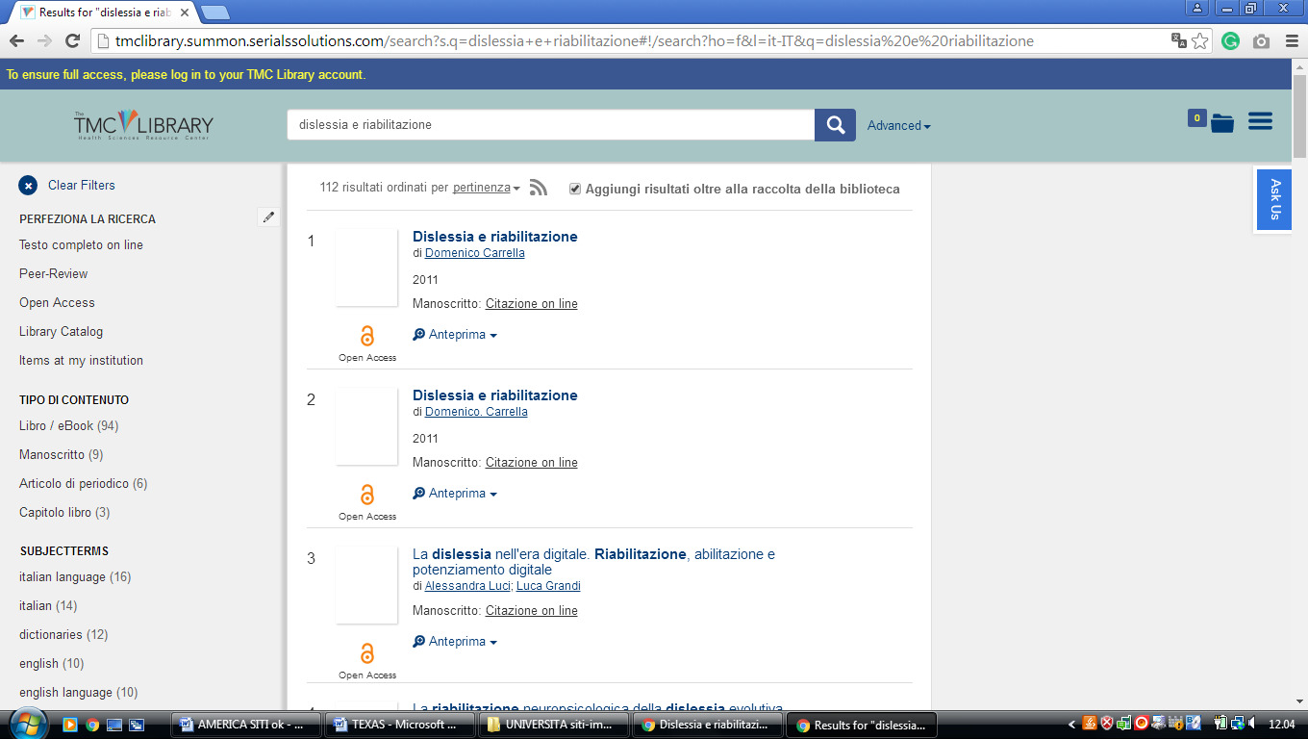

**2** [**A. FRANK SMITH JR. LIBRARY CENTER**](http://www.southwestern.edu/library/) – (Georgetown, Texas, Usa)

<https://southwestern.worldcat.org/search?q=kf%3Adislessia+e+riabilitazione&dblist=638&se=%24d&sd=desc&fq=ap%3A%22carrella%2C+domenico%22&qt=facet_ap%3A>

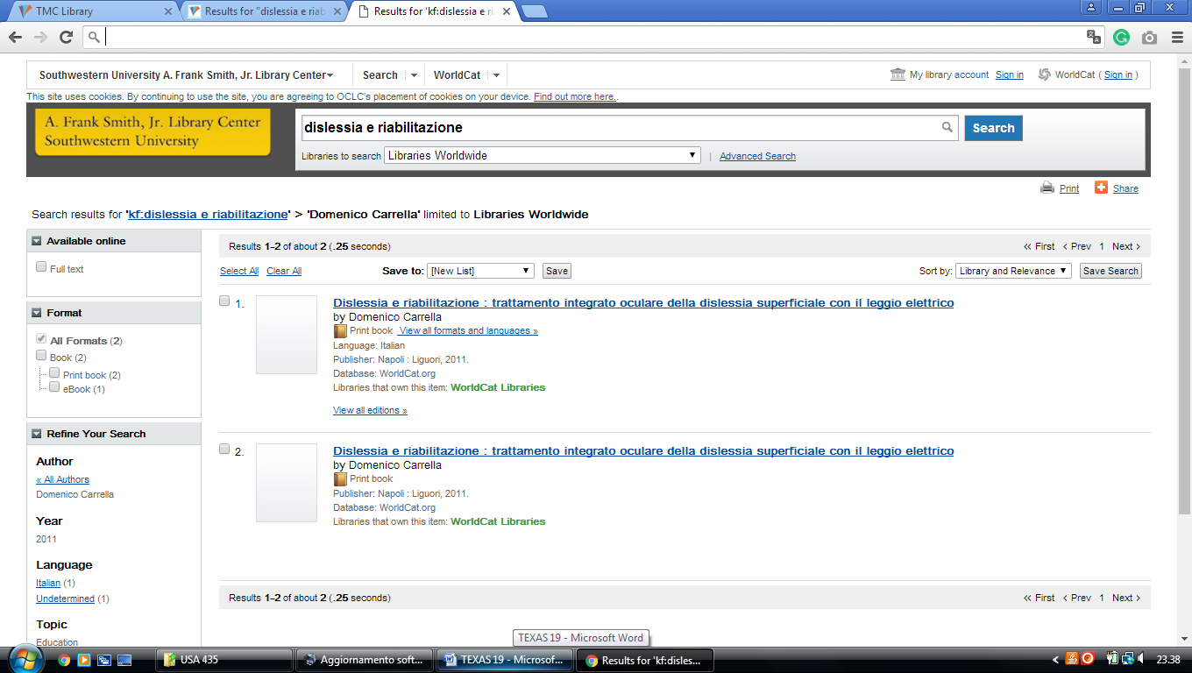

**3** [**BAYLOR UNIVERSITY LIBRARIES**](http://www.baylor.edu/lib/?_buref=661-48570) – (Waco,Texas, Usa)

<https://baylor.summon.serialssolutions.com/?#!/search?ho=f&fvf=ContentType,Newspaper%20Article,t&l=en&q=dislessia%20e%20riabilitazione>

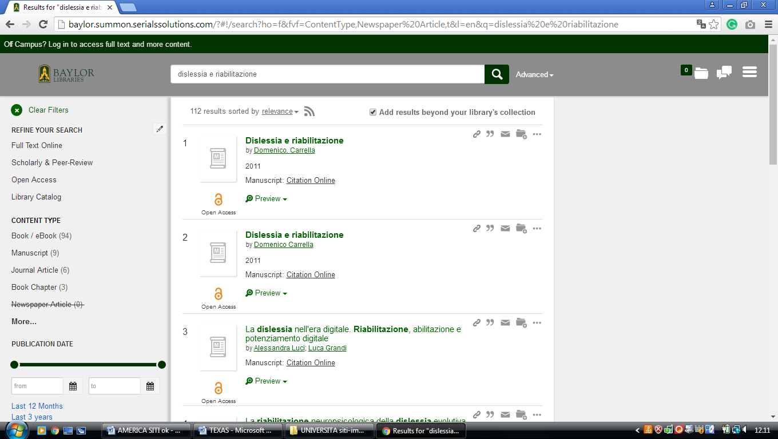

**4** [**DOHERTY LIBRARY**](http://www.stthom.edu/library_research/index.aqf) **– (**Houston, Texas, Usa)

<https://universityofstthomas.on.worldcat.org/search?sortKey=LIBRARY&databaseList=&queryString=dislessia+e+riabilitazione&changedFacet=author&clusterResults=off&scope=&format=all&database=all&author=Carrella%2C+Domenico&year=all&yearFrom=&yearTo=&language=all&topic=all>

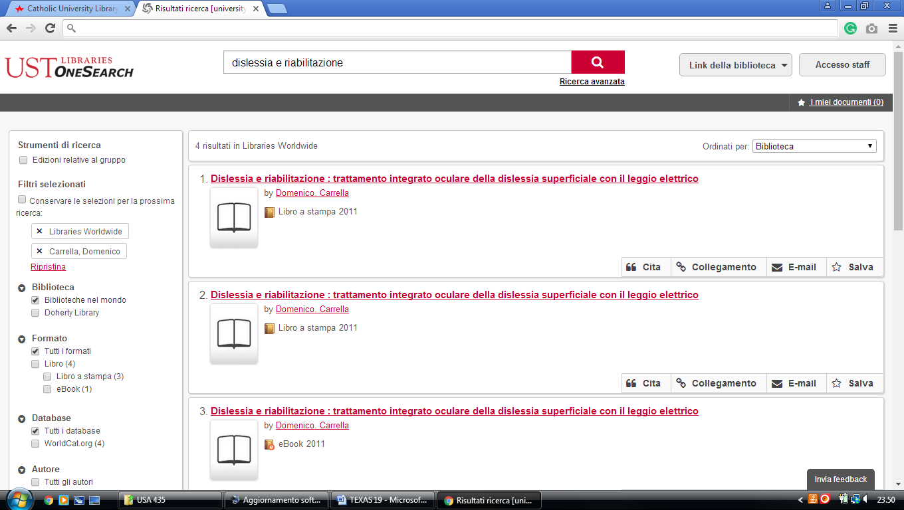

**5** [**DUNAGAN LIBRARY**](http://library.utpb.edu/) – (Odessa, Texas, Usa)

<http://utpb.summon.serialssolutions.com/?s.q=dislessia+e+riabilitazione&keep_r=true#!/search?ho=f&l=en&q=dislessia%20e%20riabilitazione>

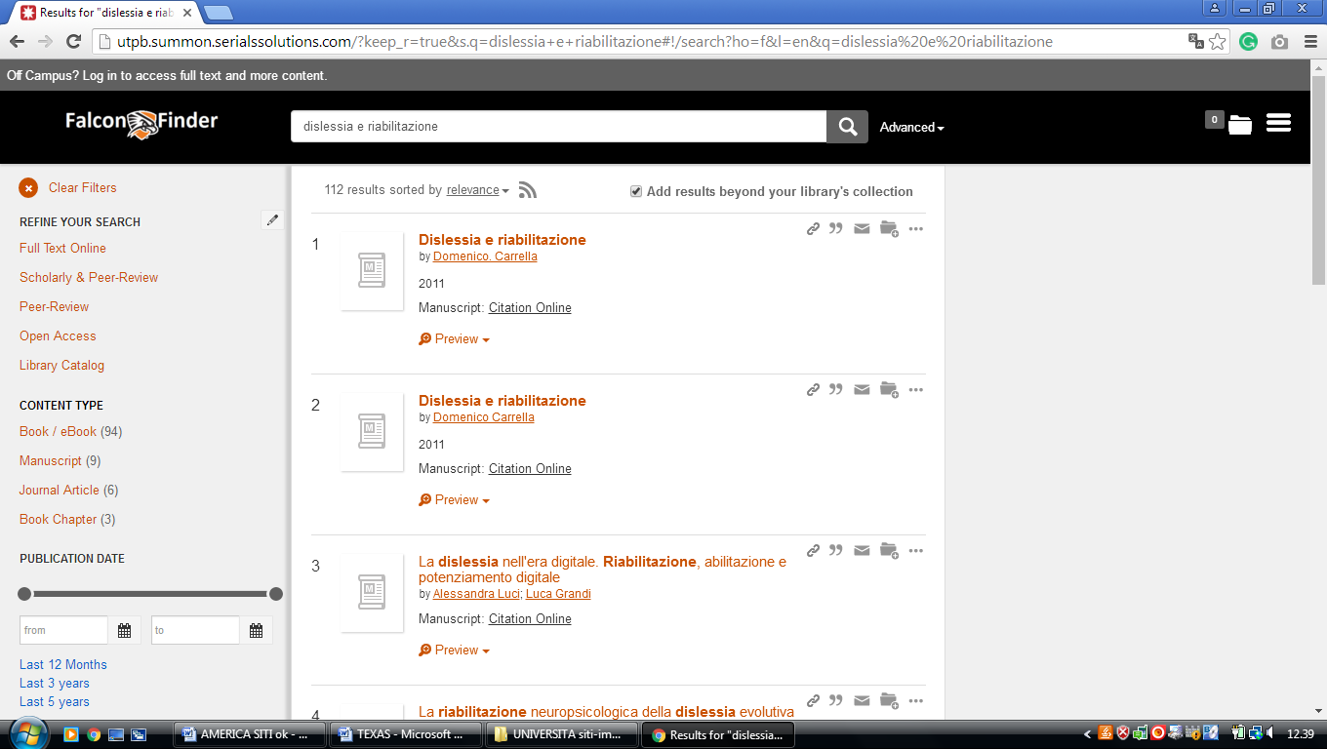

**6** [**KILLAM LIBRARY**](http://library.tamiu.edu/) – (Laredo, Texas, Usa)

<https://tamiu.on.worldcat.org/search?sortKey=LIBRARY&databaseList=2572%2C2264%2C2274%2C2263%2C2262%2C1271%2C2261%2C2260%2C2281%2C2328%2C1931%2C1875%2C2623%2C2237%2C2259%2C1697%2C2267%2C3201%2C2277%2C239%2C1708%2C638%2C1738%2C1847&queryString=dislessia+e+riabilitazione&changedFacet=author&scope=&format=all&database=all&author=Carrella%2C+Domenico&year=all&yearFrom=&yearTo=&language=all&topic=all>

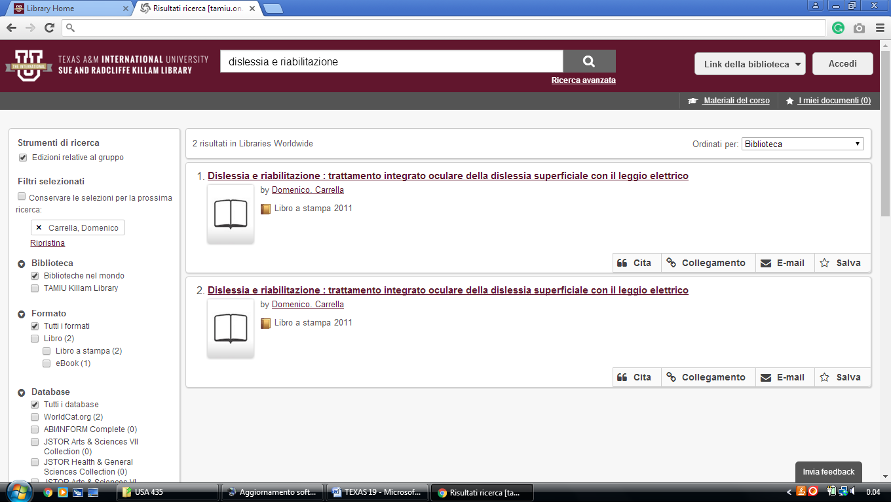

**7** [**MOODY MEDICAL LIBRARY**](http://ar.utmb.edu/ar/library/tabid/155/default.aspx) – (Galveston, Texas, Usa)

<https://utmblibrary.summon.serialssolutions.com/?q=dislessia+e+riabilitazione&myinst=UT+Medical+Branch+Library&fvf=ContentType%2CBook+Review%2Ct&fvf=ContentType%2CNewspaper+Article%2Ct&fvf=Language%2CEnglish&keep_r=true#!/search?ho=f&fvf=ContentType,Book%20Review,t%7CContentType,Newspaper%20Article,t%7CLanguage,English,f&l=en&q=dislessia%20e%20riabilitazione>

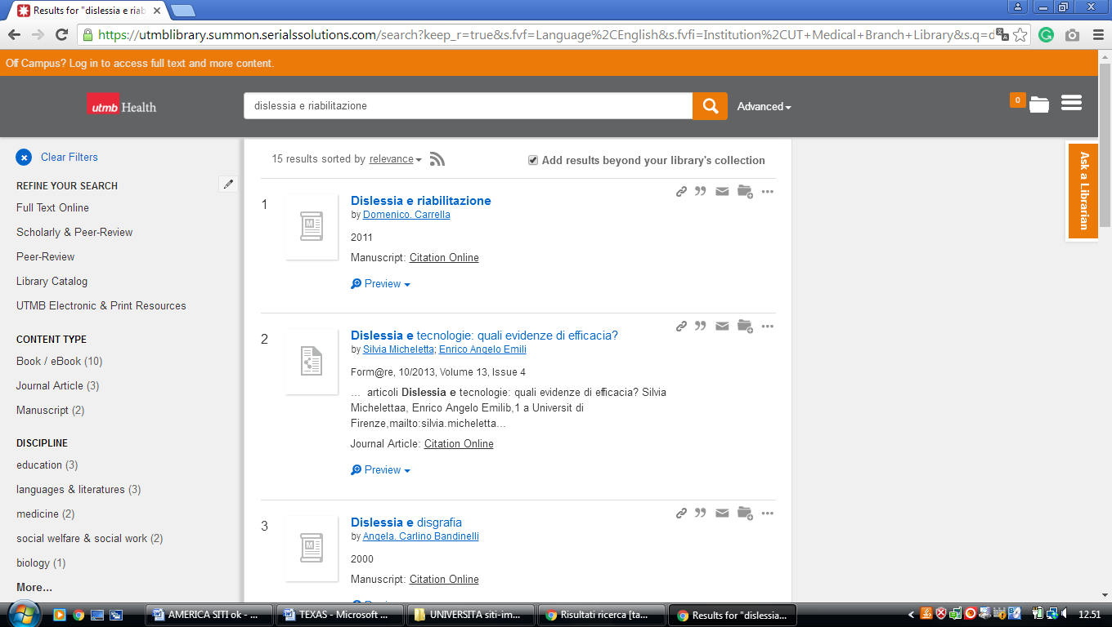

**8** [**PALO ALTO COLLEGE LIBRARY**](http://www.alamo.edu/pac/library/) – (San Antonio , Texas, Usa)

<https://paclibrary.on.worldcat.org/search?sortKey=LIBRARY&databaseList=&queryString=dislessia+e+riabilitazione&changedFacet=author&clusterResults=off&scope=&format=all&database=all&author=Carrella%2C+Domenico&year=all&yearFrom=&yearTo=&language=all&topic=all>

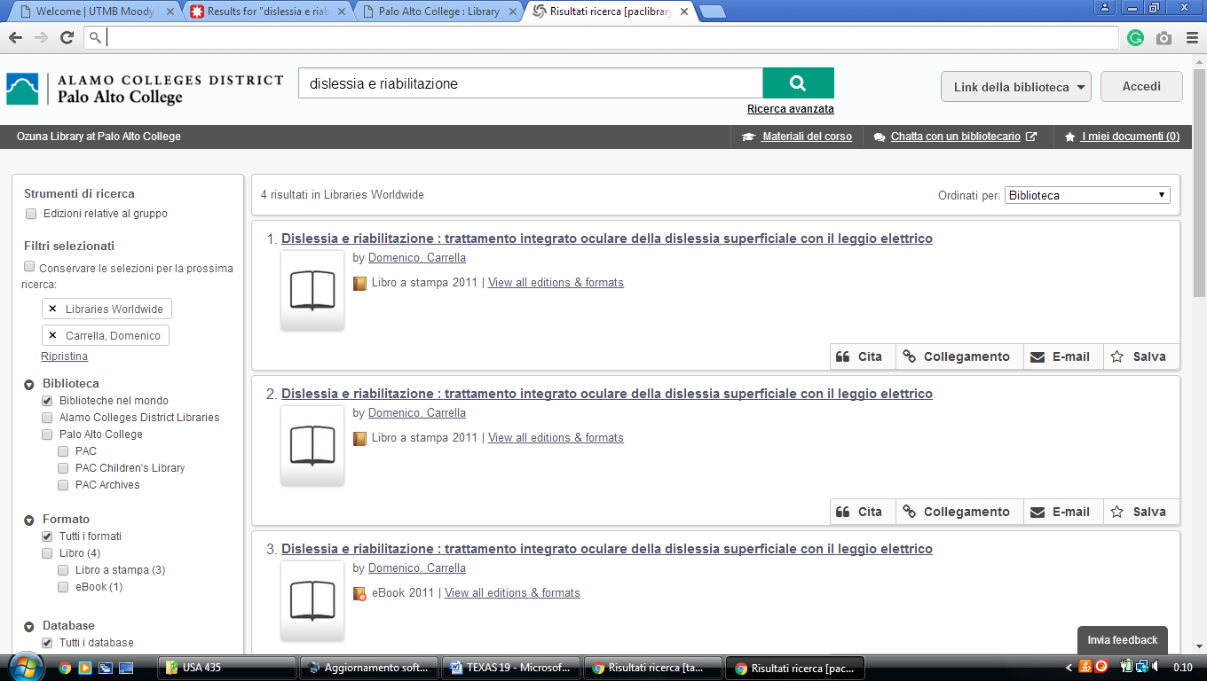

**9** [**RANDOLPH C. WATSON LIBRARY**](http://library.kilgore.edu/library/) - (Kilgore, Texas, Usa)

<https://kilgore.on.worldcat.org/search?sortKey=LIBRARY&databaseList=&queryString=dislessia+e+riabilitazione&changedFacet=author&scope=&format=all&database=all&author=Carrella%2C+Domenico&year=all&yearFrom=&yearTo=&language=all&topic=all>

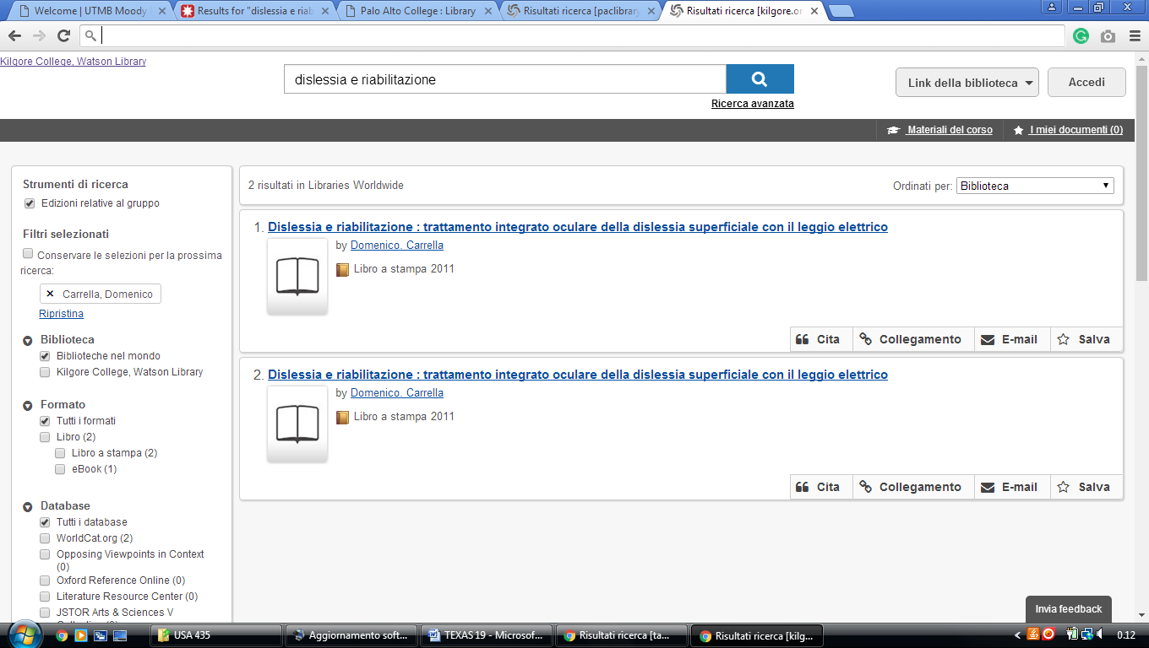

**10** [**ST. MARY'S UNIVERSITY LOUIS J.**](http://library.stmarytx.edu/) **BLUME LIBRARY – (**San Antonio Texas, Usa)

<http://eds.b.ebscohost.com/eds/resultsadvanced?vid=5&sid=e9414ffd-c71c-4676-a1a8-8fc1f72cb03a%40sessionmgr101&bquery=(dislessia+AND+e+AND+riabilitazione)&bdata=JnR5cGU9MSZzaXRlPWVkcy1saXZlJnNjb3BlPXNpdGU%3d>

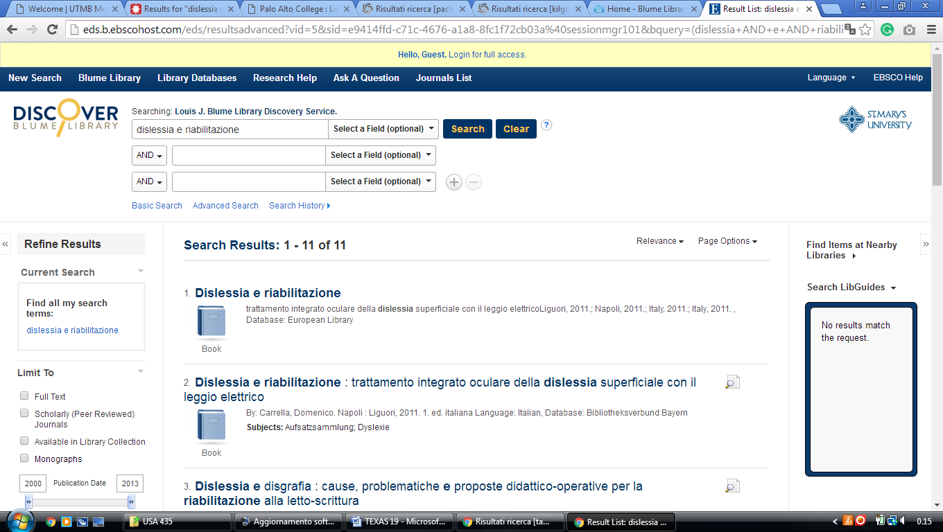

**11** [**UNIVERSITY OF TEXAS ARLINGTON**](http://www.uta.edu/library/) **LIBRARY - (**Arlington, Texas, Usa)

<http://uta.summon.serialssolutions.com/search?q=dislessia+e+riabilitazione#!/search?ho=f&l=en&q=dislessia%20e%20riabilitazione>

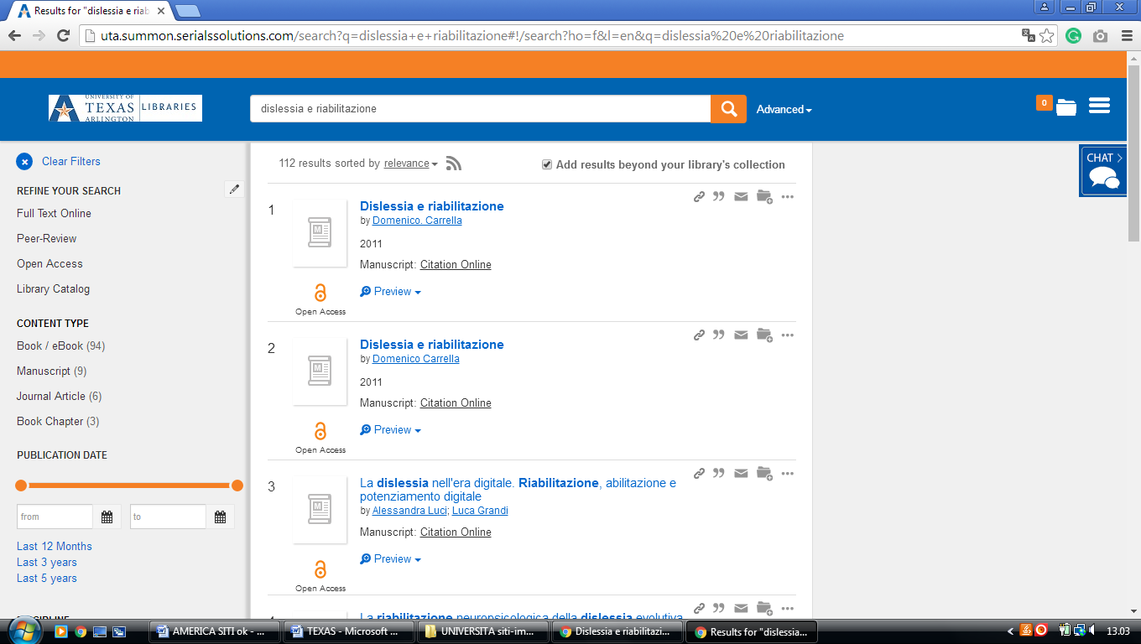

**12** [**UNIVERSITY OF TEXAS AT SAN ANTONIO**](http://lib.utsa.edu/) **LIBRARY – (**San Antonio Texas, Usa)

<https://utsa.summon.serialssolutions.com/?s.q=dislessia+e+riabilitazione&q=&s.fvf%5B%5D=ContentType%2CNewspaper+Article%2Ct&s.fvf%5B%5D=ContentType%2CBook+Review%2Ct#!/search?ho=f&fvf=ContentType,Newspaper%20Article,t%7CContentType,Book%20Review,t&l=en&q=dislessia%20e%20riabilitazione>

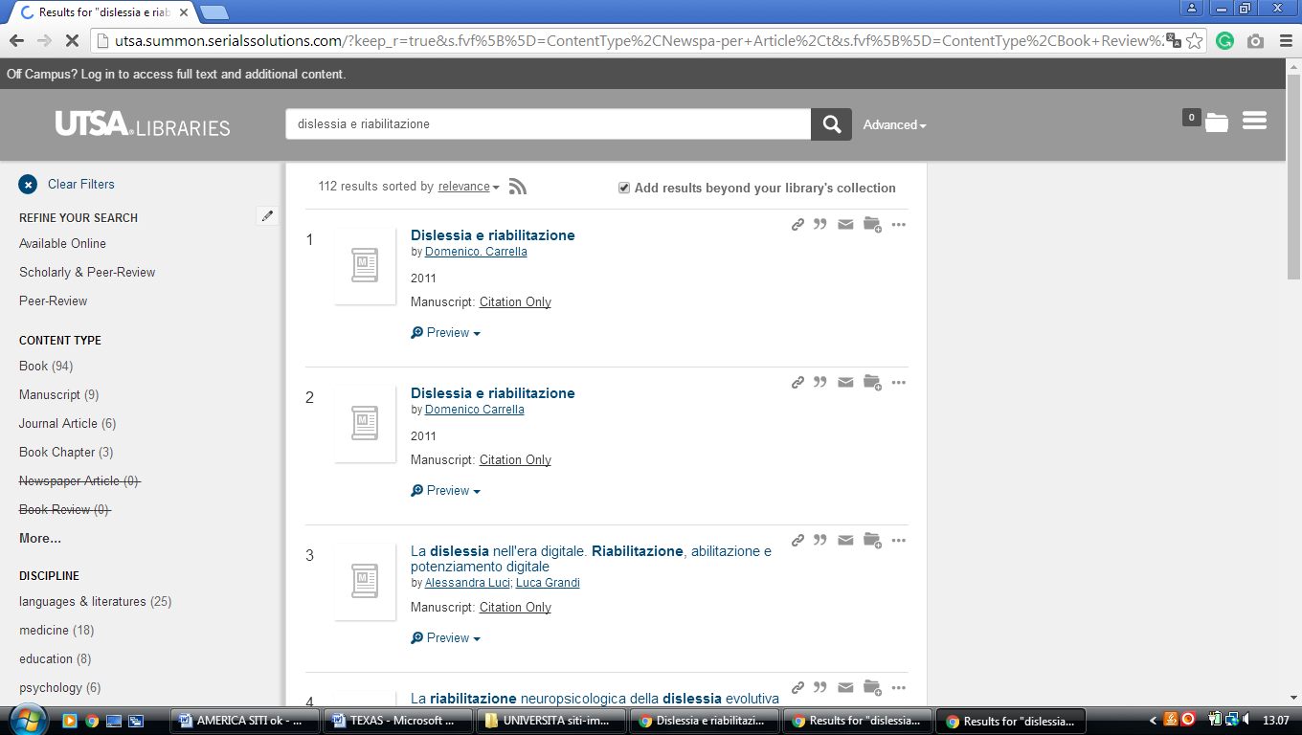

**13** [**UNIVERSITY OF TEXAS LIBRARIES**](http://www.lib.utexas.edu/) – (Austin, Texas, Usa)

<https://utexas.summon.serialssolutions.com/search?s.q=dislessia+e+riabilitazione#!/search?ho=f&l=en&q=dislessia%20e%20riabilitazione>

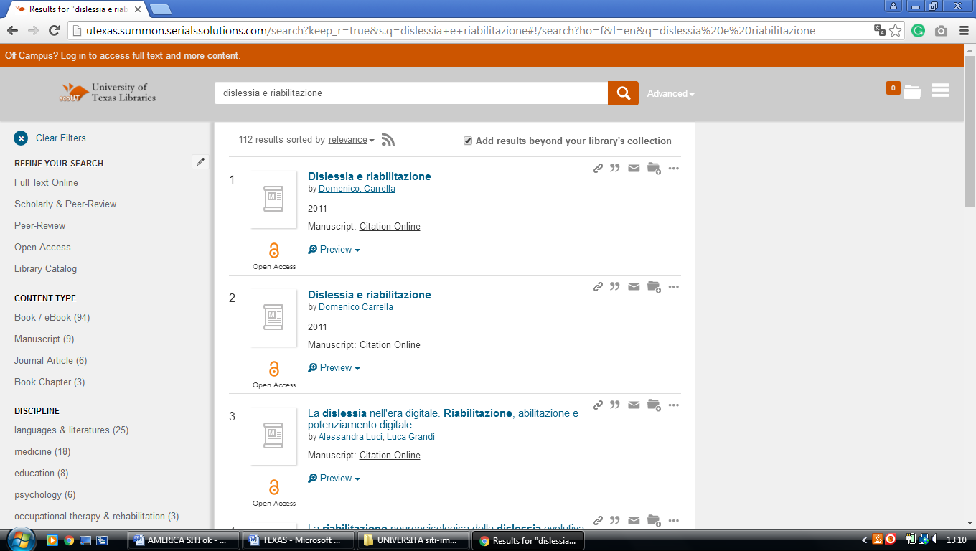

### 14 [WELCOME TO UTSA LIBRARIES | UTSA LIBRARIES](https://lib.utsa.edu/) – (Circle, San Antonio, TX, Usa)

<https://tamiu.on.worldcat.org/search?sortKey=LIBRARY&databaseList=2572%2C2264%2C2274%2C2263%2C2262%2C1271%2C2261%2C2260%2C2281%2C2328%2C1931%2C1875%2C2623%2C2237%2C2259%2C1697%2C2267%2C3201%2C2277%2C239%2C1708%2C638%2C1738%2C1847&queryString=dislessia+e+riabilitazione&changedFacet=author&scope=&format=all&database=all&author=Carrella%2C+Domenico&year=all&yearFrom=&yearTo=&language=all&topic=all>

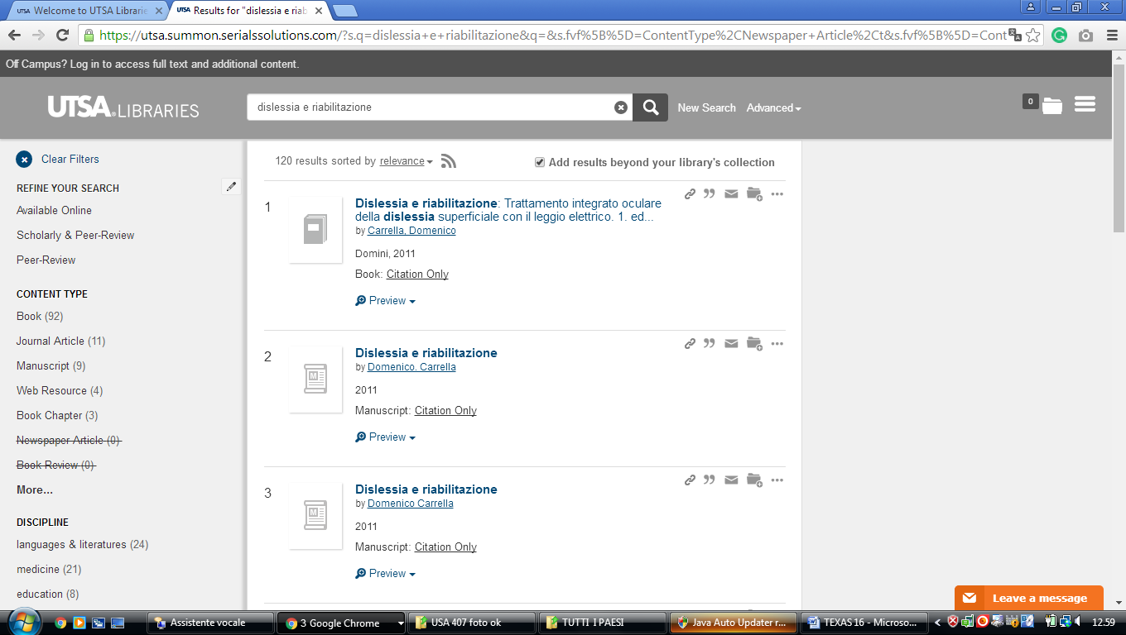

### [15 UNIVERSITY OF TEXAS LIBRARIES | THE UNIVERSITY OF TEXAS AT AUSTIN](https://lib.utexas.edu/) – (Usa)

<https://utexas.summon.serialssolutions.com/search?s.q=dislessia+e+riabilitazione#!/search?ho=f&l=en&q=dislessia%20e%20riabilitazione>

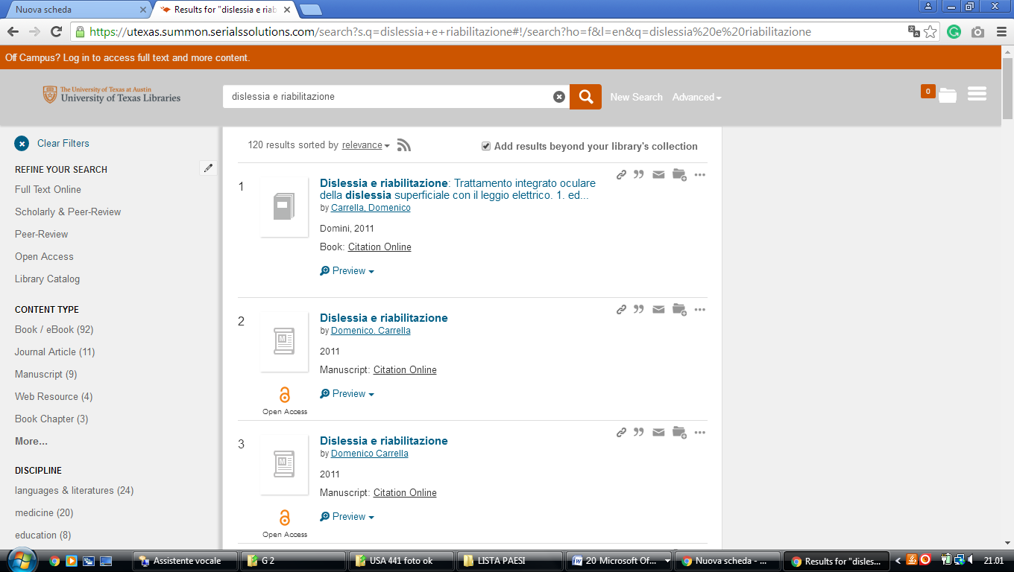

### 16 [UTA LIBRARIES - THE UNIVERSITY OF TEXAS AT ARLINGTON](http://library.uta.edu/) - (Usa)

<http://uta.summon.serialssolutions.com/search?q=dislessia+e+riabilitazione#!/search?ho=f&l=en&q=dislessia%20e%20riabilitazione>

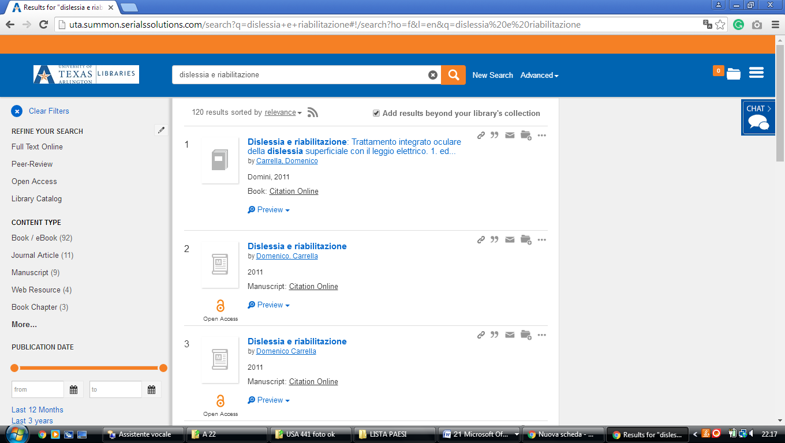

**17** [**ACE - ACADEMIC CENTER FOR ENRICHMENT**](http://library.seu.edu/seuace) **-** (Texas- Usa) <https://seu.on.worldcat.org/search?sortKey=LIBRARY&databaseList=&queryString=dislessia+e+riabilitazione&changedFacet=format&clusterResults=off&scope=&format=all&database=all&author=all&year=all&yearFrom=&yearTo=&language=all&topic=all>

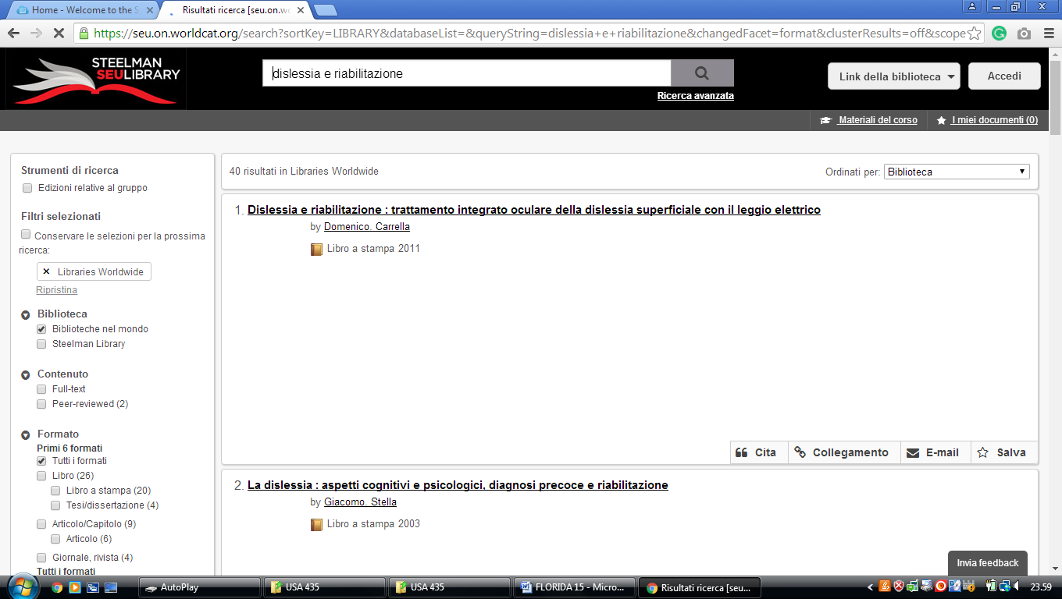

**10** [**FLORIDA STATE UNIVERSITY LIBRARIES**](http://www.lib.fsu.edu/) Tallahassee, Florida, USA