**TENNESSEE = 7**

**1** [**CARNEGIE-VINCENT LIBRARY**](http://library.lmunet.edu/) – (Harrogate, Tennessee, Usa)

<https://lmulibrary.on.worldcat.org/search?sortKey=LIBRARY&databaseList=&queryString=dislessia+e+riabilitazione&changedFacet=author&stickyFacetsChecked=on&scope=&format=all&database=all&author=Carrella%2C+Domenico&year=all&yearFrom=&yearTo=&language=all&topic=all>

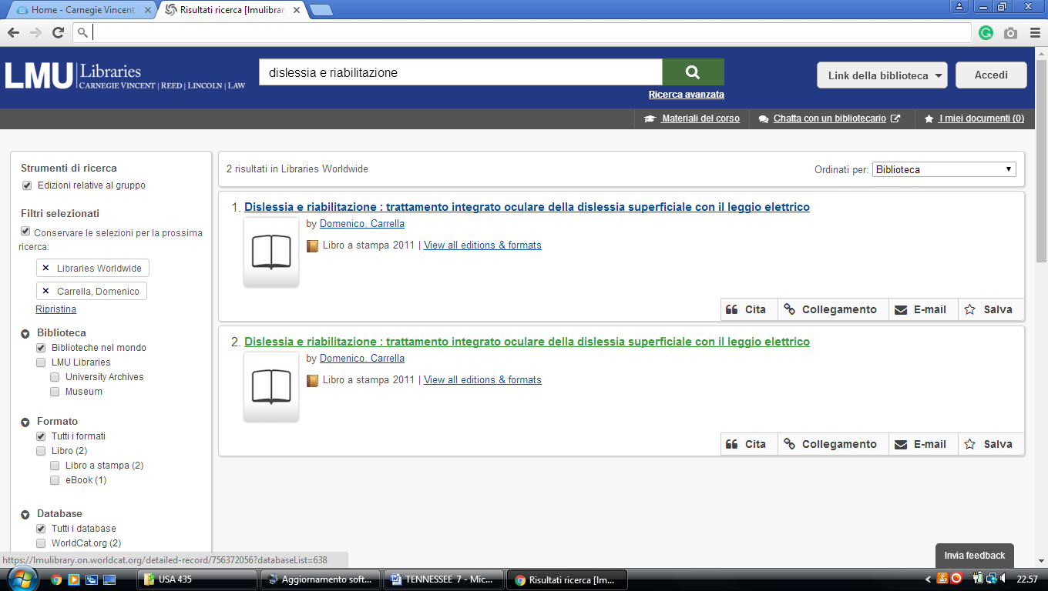

**2** [**CLEVELAND STATE COMMUNITY**](http://clevelandstatecc.libguides.com/home) **COLLEGE LIBRARY –** (Cleveland, TN, Usa)

<http://clevelandstatecc.worldcat.org/search?q=dislessia+e+riabilitazione&dblist=638&se=%24d&sd=desc&fq=ap%3A%22carrella%2C+domenico%22&qt=facet_ap%3A>

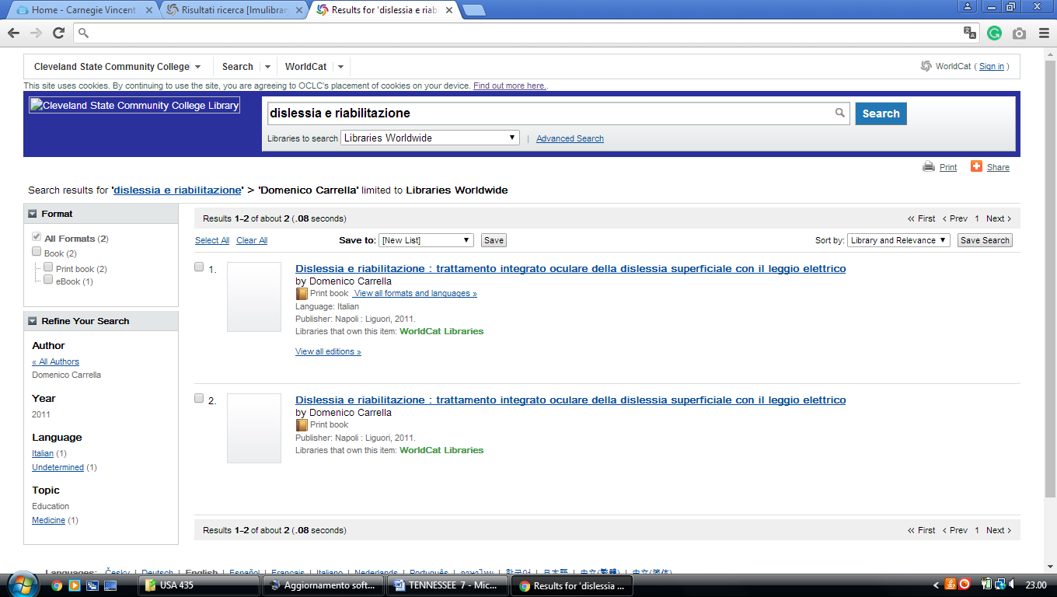

**3** [**EMMA WATERS SUMMAR LIBRARY**](http://www.uu.edu/library/) - (Jackson, Tennessee, Usa)

<http://uu.worldcat.org/search?q=dislessia+e+riabilitazione&dblist=638&se=%24d&sd=desc&fq=ap%3A%22carrella%2C+domenico%22&qt=facet_ap%3A>

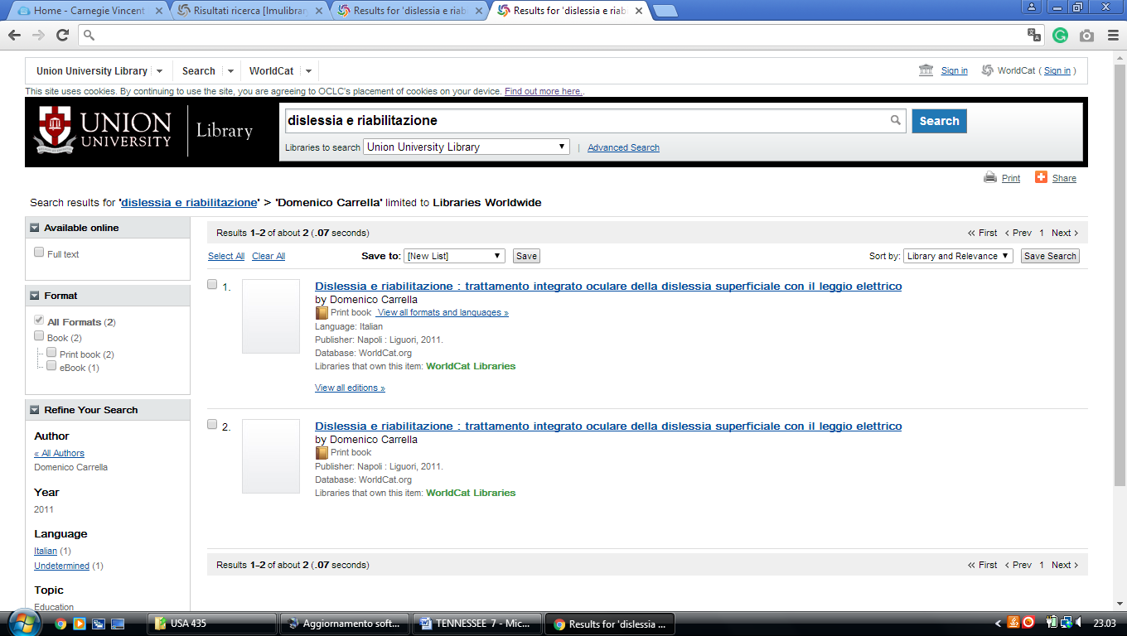

**4** [**JOHN E. MAYFIELD LIBRARY**](http://nscc.edu/academics/library/) – (Nashville, Tennessee, Usa)

<https://mayfieldlibrary.summon.serialssolutions.com/?#!/search?ho=f&l=en&q=dislessia%20e%20riabilitazione>

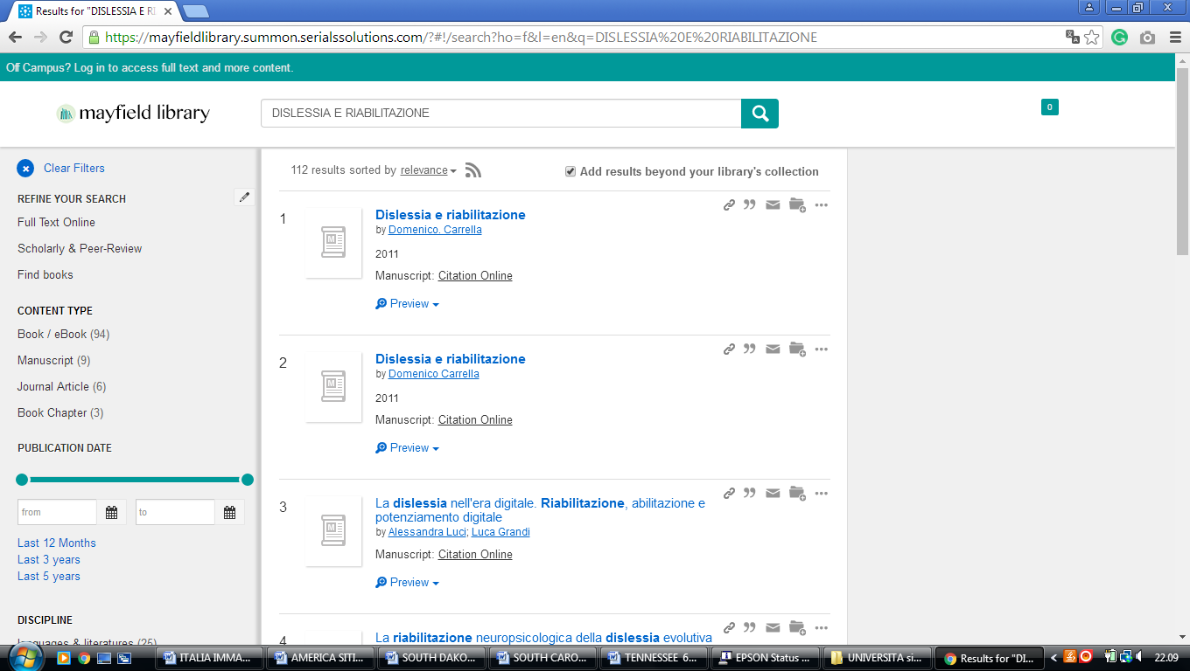

**5** [**PLOUGH LIBRARY**](http://www.cbu.edu/library/abouthome.html) – (Memphis, Tennessee, Usa)

<https://ploughlibrary.on.worldcat.org/search?sortKey=BEST_MATCH&databaseList=1080%2C1461%2C1082%2C197%2C2229%2C1732%2C897%2C1719%2C638%2C1912%2C3879%2C2264%2C2483%2C2482%2C1271%2C2261%2C283%2C2260%2C143%2C3548%2C2237%2C2259%2C203%2C2477%2C3004%2C1708%2C948&queryString=dislessia+e+riabilitazione&changedFacet=author&clusterResults=on&scope=&format=all&database=all&author=Carrella%2C+Domenico&year=all&yearFrom=&yearTo=&language=all&topic=all>

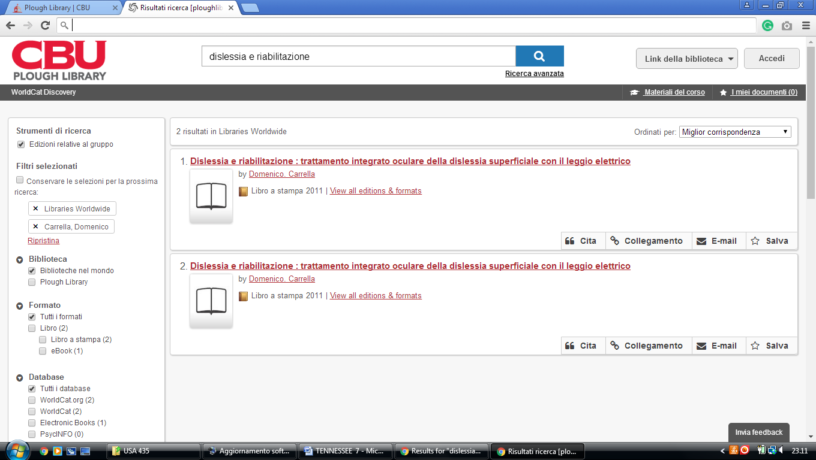

**6** [**UNIVERSITY OF MEMPHIS LIBRARIES**](http://www.memphis.edu/libraries/) - (Memphis, Tennessee, Usa)

<http://umemphis.worldcat.org/search?q=dislessia+e+riabilitazione&dblist=638&se=nodgr&sd=desc&fq=ap%3A%22carrella%2C+domenico%22&qt=facet_ap%3A>

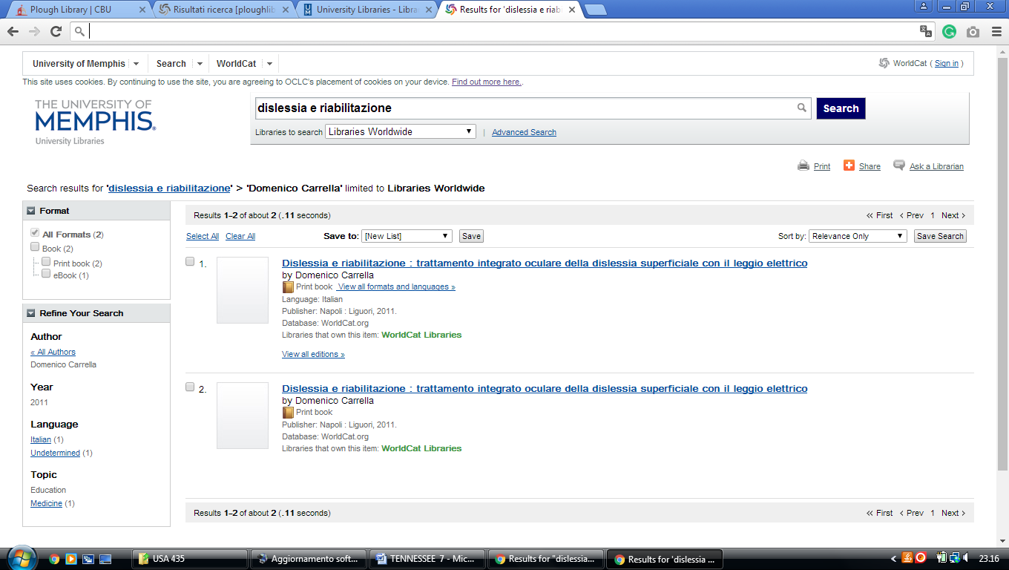

### [7 HOME - UNIVERSITY LIBRARIES: UNIVERSITY OF TENNESSEE – (Knoxville](https://www.lib.utk.edu/)

Tennessee, Usa)

<https://utk-almaprimo.hosted.exlibrisgroup.com/primo-explore/search?query=any,contains,dislessia%20e%20riabilitazione&tab=default_tab&search_scope=OneSearch&vid=01UTK&lang=en_US&offset=0&sortby=rank&pcAvailability=true>

