**SOUTH DAKOTA = 4**

**1** [**AUGUSTANA UNIVERSITY,**](http://library.augie.edu/) **MIKKELSEN LIBRARY – (**South Dakota, Usa)

<https://augustana.on.worldcat.org/search?sortKey=LIBRARY&databaseList=&queryString=dislessia+e+riabilitazione&changedFacet=author&scope=&format=all&database=all&author=Carrella%2C+Domenico&year=all&yearFrom=&yearTo=&language=all&topic=all>

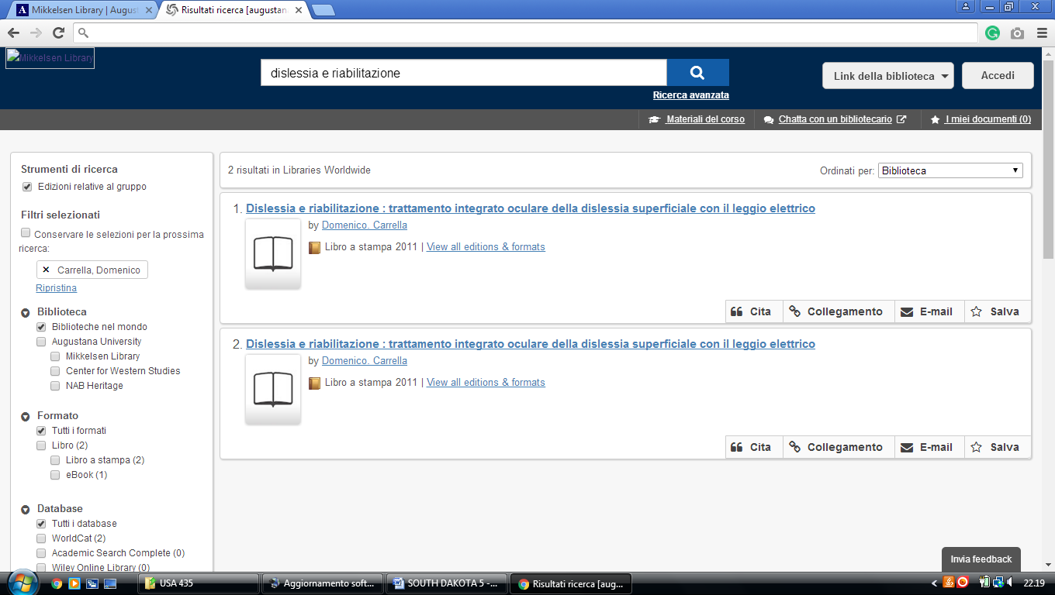

**2** [**DEVEREAUX LIBRARY**](http://library.sdsmt.edu/) – (Rapid City, South Dakota, Usa)

https://southdakotaschoolofminesandtechnology.on.worldcat.org/search?sortKey=LIBRARY&databaseList=&queryString=+dislessia+e+riabilitazione&changedFacet=author&scope=&format=all&database=all&author=Carrella%2C+Domenico&year=all&yearFrom=&yearTo=&language=all&topic=all

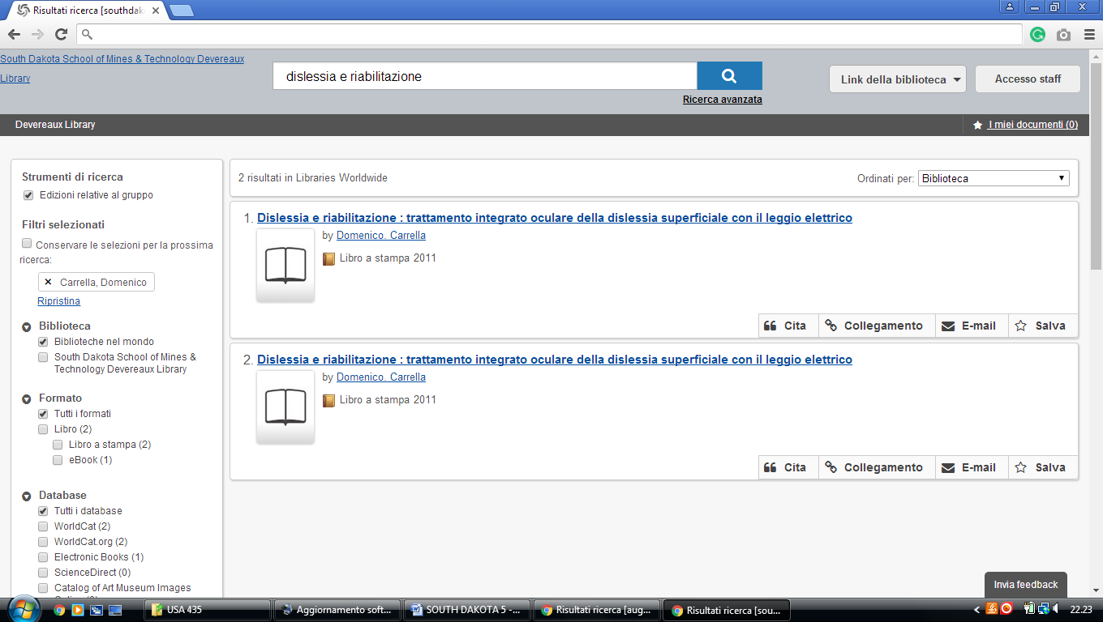

**3** [**UNIVERSITY OF SOUTH DAKOTA LIBRARY**](http://www.usd.edu/library/) – (Vermillion, South Dakota, Usa)

<http://usd.worldcat.org/search?q=kw%3Adislessia+e+riabilitazione&dblist=638&se=%24d&sd=desc&fq=ap%3A%22carrella%2C+domenico%22&qt=facet_ap%3A>

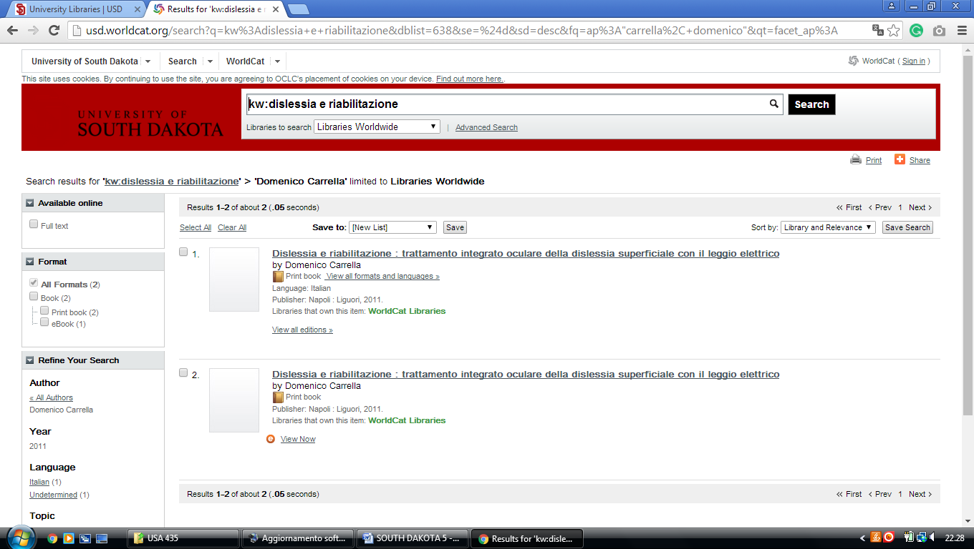

**4** [**BEULAH WILLIAMS LIBRARY**](http://www.northern.edu/library/pages/default.aspx) – (Aberdeen, South Dakota, Usa)

<http://usd.worldcat.org/search?q=kw%3Adislessia+e+riabilitazione&dblist=638&se=%24d&sd=desc&fq=ap%3A%22carrella%2C+domenico%22&qt=facet_ap%3A>

