**OREGON = 5**

### 1 [BARBER LIBRARY - CENTRAL OREGON COMMUNITY COLLEGE](https://www.cocc.edu/departments/library/) – ([Bend](https://en.wikipedia.org/wiki/Bend,_Oregon), [Oregon](https://en.wikipedia.org/wiki/Oregon), Usa)

<https://centraloregoncc.on.worldcat.org/search?sortKey=LIBRARY&databaseList=638&queryString=dislessia+e+riabilitazione&changedFacet=author&clusterResults=off&scope=&format=all&database=all&author=Carrella%2C+Domenico&year=all&yearFrom=&yearTo=&language=all&topic=all>

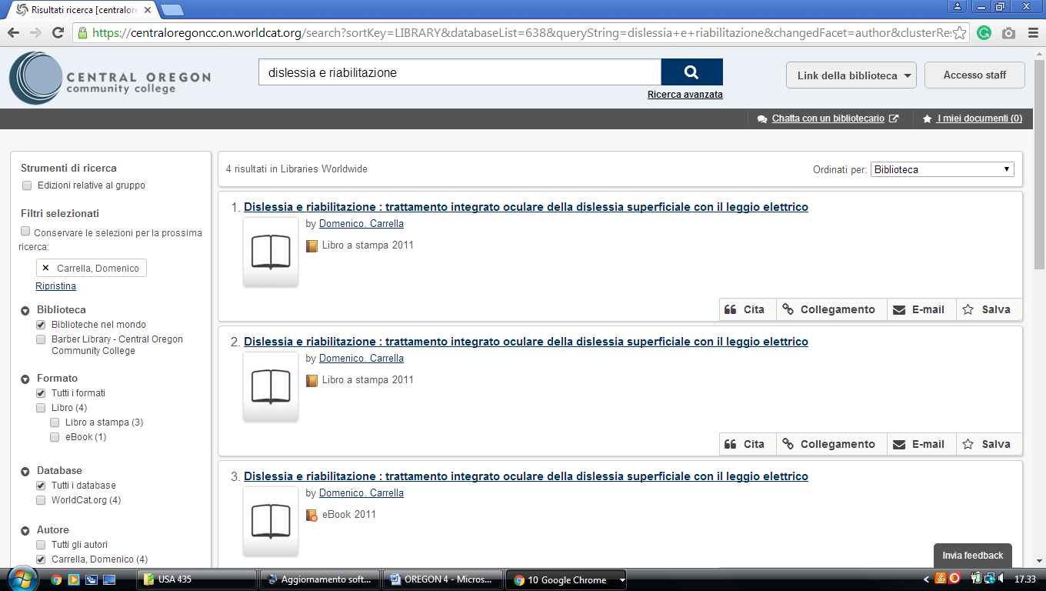

### 2 [LINFIELD LIBRARIES | LINFIELD COLLEGE](http://www.linfield.edu/linfield-libraries.html) – (McMinnville, Oregon, Usa)

<https://linfieldcollege.on.worldcat.org/search?sortKey=LIBRARY&databaseList=&queryString=dislessia+e+riabilitazione&changedFacet=author&scope=&format=all&database=all&author=Carrella%2C+Domenico&year=all&yearFrom=&yearTo=&language=all&topic=all>

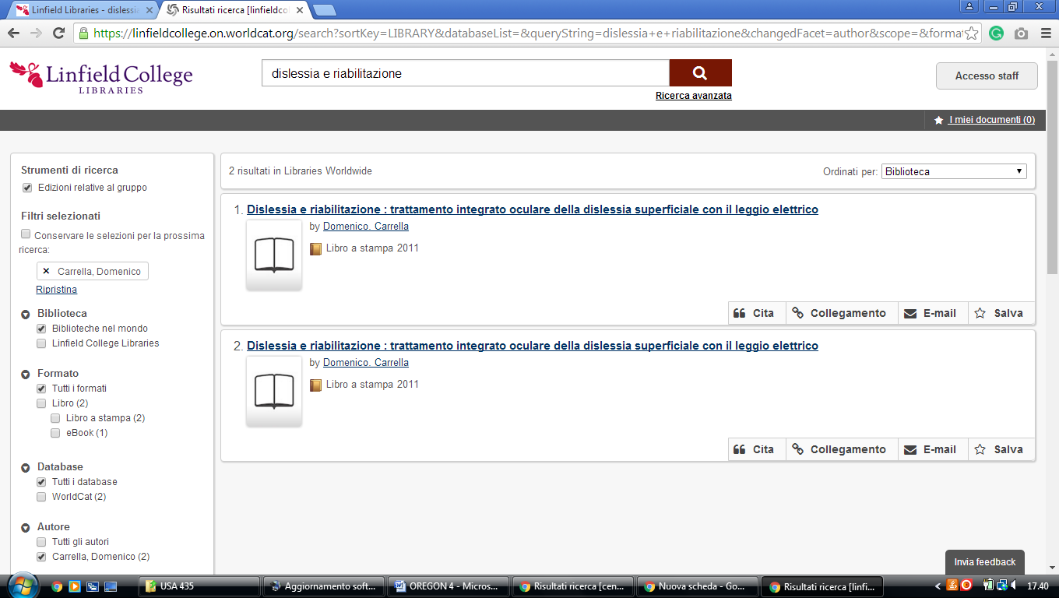

**3**  [**PIERCE LIBRARY, EASTERN OREGON UNIVERSITY**](http://library.eou.edu/)[– (La Grande](https://en.wikipedia.org/wiki/La_Grande,_Oregon), [Oregon](https://en.wikipedia.org/wiki/Oregon),

Usa)

<https://easternoregon.on.worldcat.org/search?databaseList=&queryString=dislessia+e+riabilitazion>

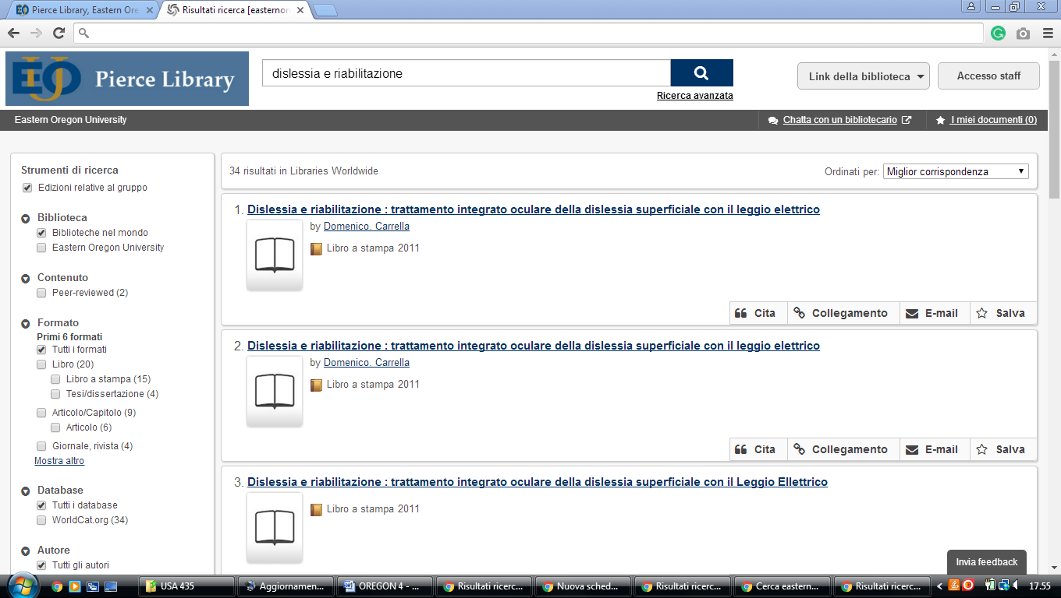

**4** [**UNIVERSITY OF OREGON LIBRARIES**](http://library.uoregon.edu/) **–** (Oregon, Usa)

<https://uolibraries.on.worldcat.org/search?sortKey=LIBRARY&databaseList=283&queryString=kw%3A%28DISLESSIA+E+RIABILITAZIONE%29&changedFacet=author&scope=&format=all&database=all&author=Carrella%2C+Domenico&year=all&yearFrom=&yearTo=&language=all&topic=all>

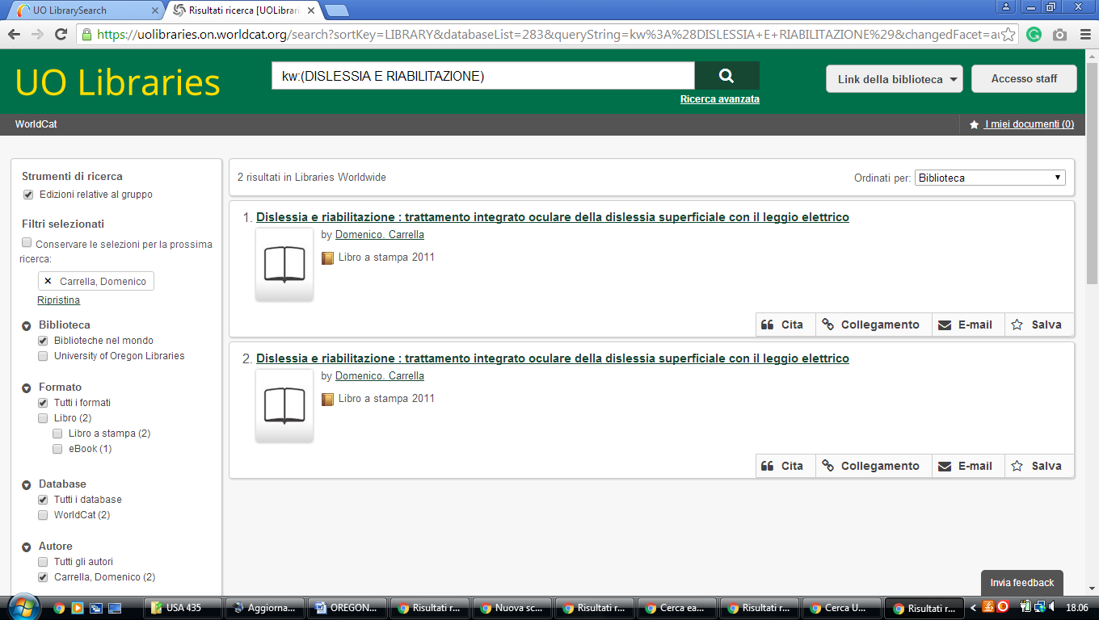

5 Hillsboro – Pacific University Libraries – (Oregon, Usa)

<https://pacificu.on.worldcat.org/search?qt=worldcat_org_all&queryString=dislessia+e+riabilitazione>

