**OKLAHOMA = 4**

**1** [**NORTHEASTERN STATE UNIVERSITY**](http://library.nsuok.edu/) **LIBRARIES – (**Tahlequah, Oklahoma, Usa)

<https://nsuok.on.worldcat.org/search?sortKey=LIBRARY&databaseList=&queryString=kw%3Adislessia+e+riabilitazione&changedFacet=author&clusterResults=off&scope=&format=all&database=all&author=Carrella%2C+Domenico&year=all&yearFrom=&yearTo=&language=all&topic=all>

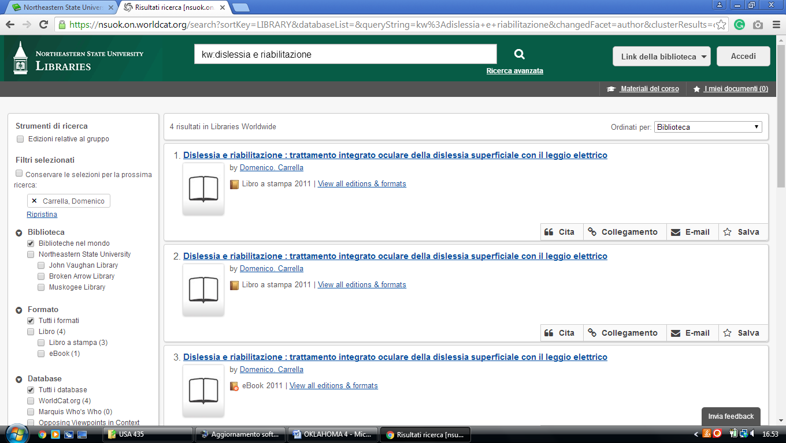

**2** [**SOUTHERN NAZARENE UNIVERSITY**](http://snu.edu/library) **LIBRARY – (**Bethany, Oklahoma, Usa)

<http://snu.summon.serialssolutions.com/?#!/search?ho=f&fvf=ContentType,Newspaper%20Article,t&l=en&q=dislessia%20e%20riabilitazione>

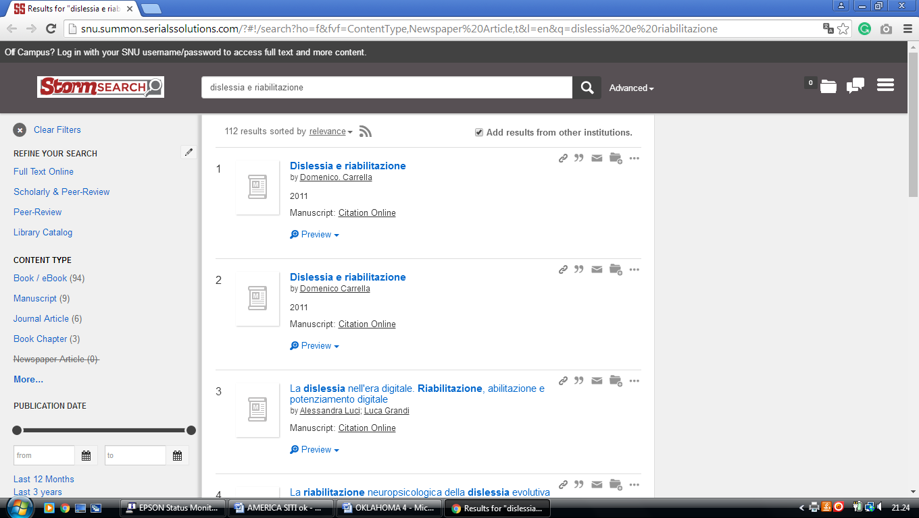

**3**  [**TULSA COMMUNITY COLLEGE LIBRARY**](http://library.tulsacc.edu/home) – (Tulsa, Oklahoma, Usa)

<https://tulsacommunitycollege-library.on.worldcat.org/search?sortKey=LIBRARY&databaseList=&queryString=dislessia+e+riabilitazione&changedFacet=author&clusterResults=off&scope=&format=all&database=all&author=Carrella%2C+Domenico&year=all&yearFrom=&yearTo=&language=all&topic=all>

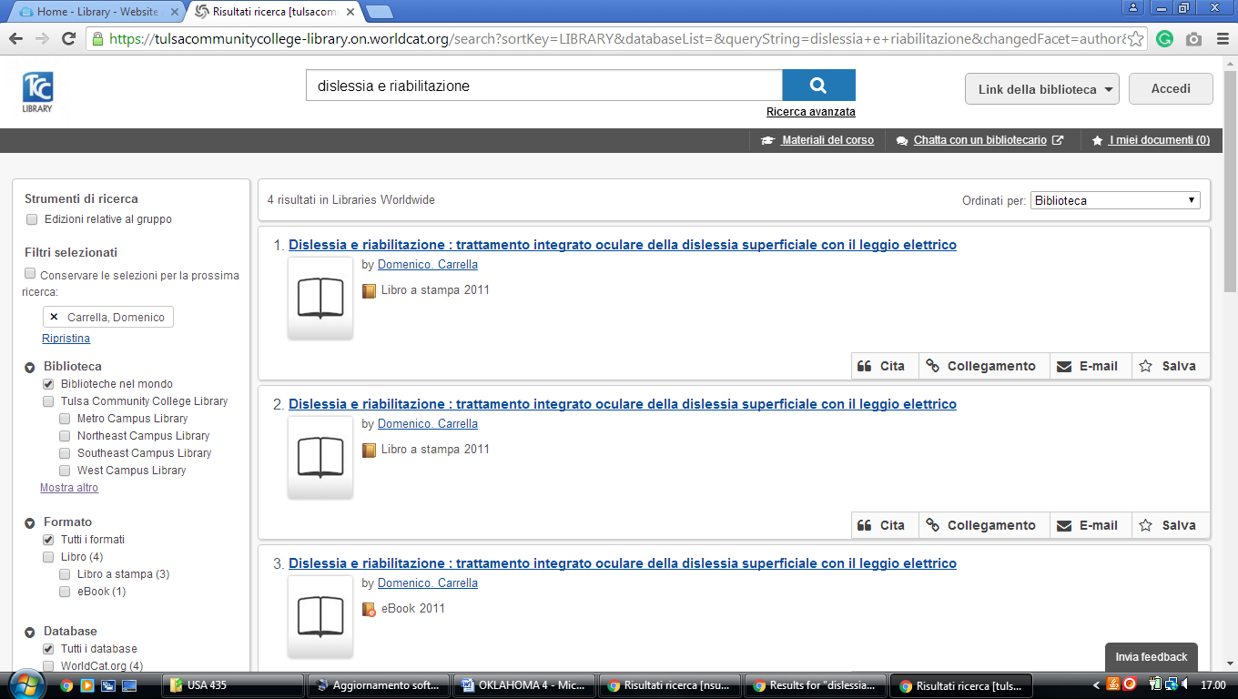

**4**  [**UNIVERSITY OF OKLAHOMA**](http://libraries.ou.edu/) **LIBRARIES – (**Norman, Oklahoma, Usa)

<http://ou.worldcat.org/search?q=dislessia+e+riabilitazione&dblist=1708%2C197%2C2229%2C2175%2C1978%2C638&se=%24d&sd=desc&fq=ap%3A%22carrella%2C+domenico%22&qt=facet_ap%3A>

