**NEW JERSEY = 4**

**1** [**CAMPBELL LIBRARY**](http://www.lib.rowan.edu/) – (Glassboro, New Jersey, Usa)

<https://rowan.summon.serialssolutions.com/search?s.q=dislessia+e+riabilitazione#!/search?ho=f&l=en&q=dislessia%20e%20riabilitazione>

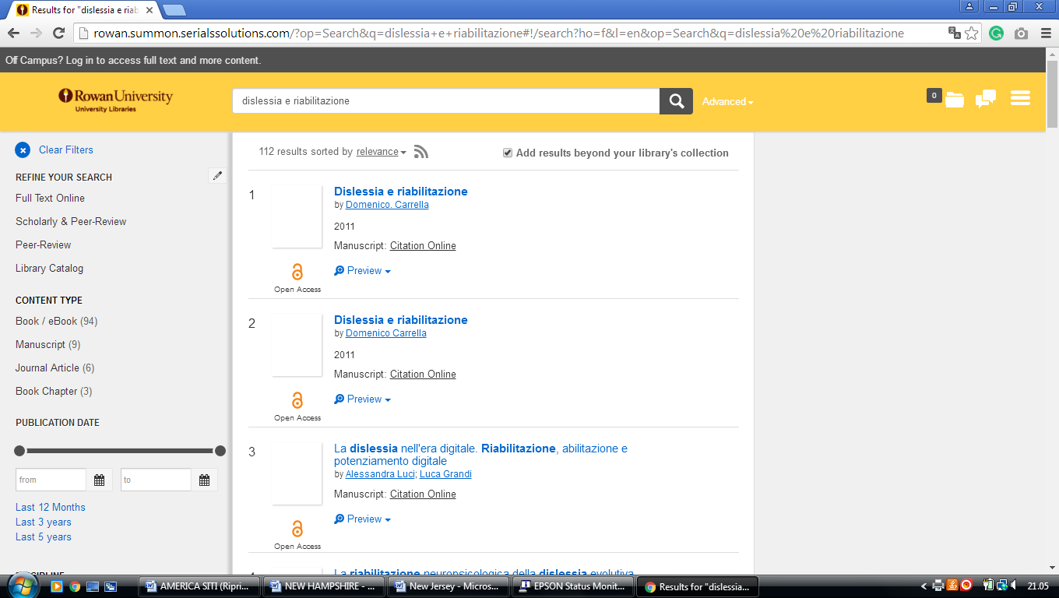

### 2 [SAMUEL C. WILLIAMS LIBRARY - STEVENS INSTITUTE OF TECHNOLOGY](https://library.stevens.edu/)

### (Hoboken, New Jersey, Usa)

### <https://stevens.on.worldcat.org/external-search?queryString=dislessia%20e%20riabilitazione&databaseList=2375,2570,173,251,1931,233,1875,1697,3313,217,638,3879,1271,2261,2260,285,143,3404,245,2237,2259,2897,203,2278,1708,3867&page=1&queryType=search&stickyFacetsChecked=false>

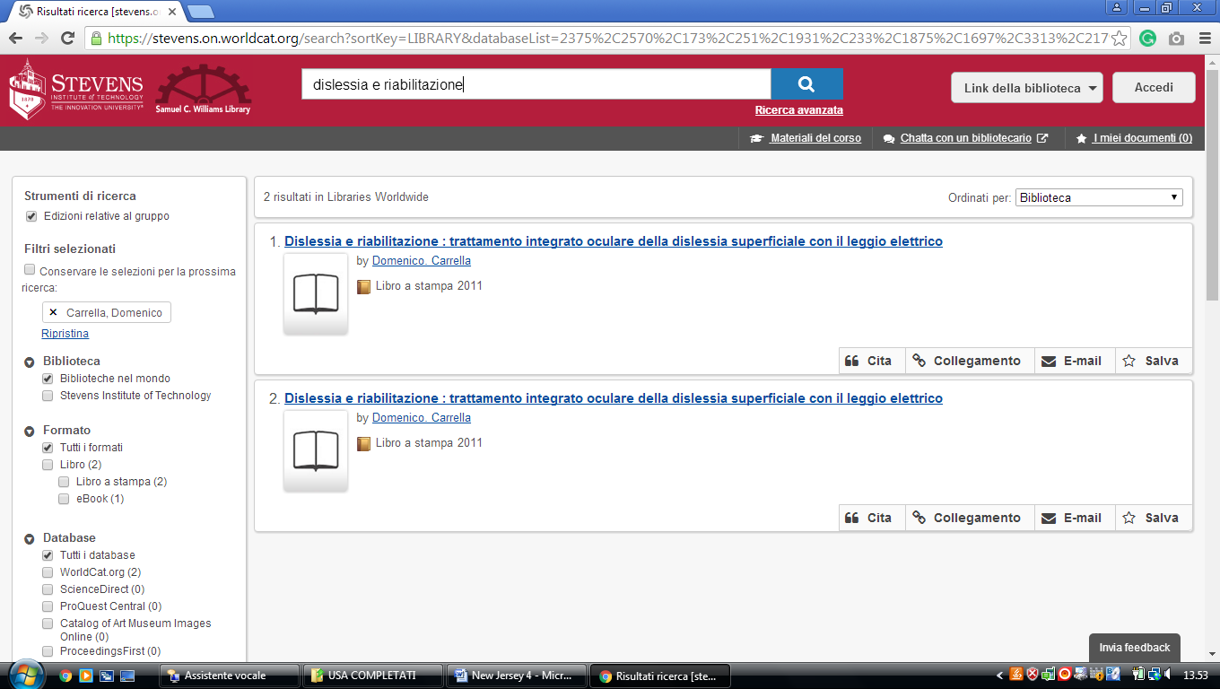

**3** [**SETON HALL UNIVERSITY LIBRARY**](http://www.shu.edu/academics/libraries/) – (South Orange, New Jersey, Usa)

<https://setonhall.on.worldcat.org/search?databaseList=283&queryString=dislessia+e+riabilitazione&clusterResults=false&scope>=

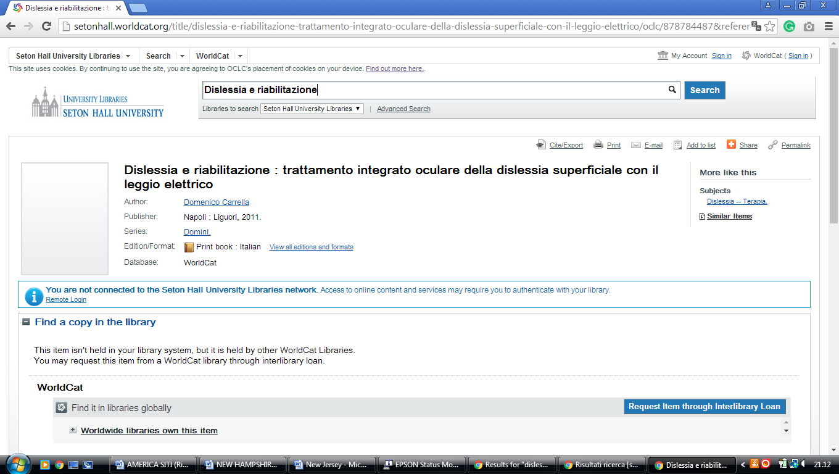

### 4 [PRINCETON UNIVERSITY LIBRARY: HOME PAGE](http://library.princeton.edu/) – (Princeton, New Jersey, Usa)

<http://princeton.summon.serialssolutions.com/search?s.q=dislessia+e+riabilitazione&s.fvf=IsScholarly,true&keep_r=true&s.dym=t&s.ho=t#!/search?ho=f&l=en&q=dislessia%20e%20riabilitazione&dym=t>

