**NEW YORK = 25**

**1** [**SYRACUSE UNIVERSITY LIBRARY**](http://library.syr.edu/)  - (Syracuse, New York, Usa)

<https://syracuse.summon.serialssolutions.com/search?q=dislessia+e+riabilitazione#!/search?ho=f&l=en&q=dislessia%20e%20riabilitazione>

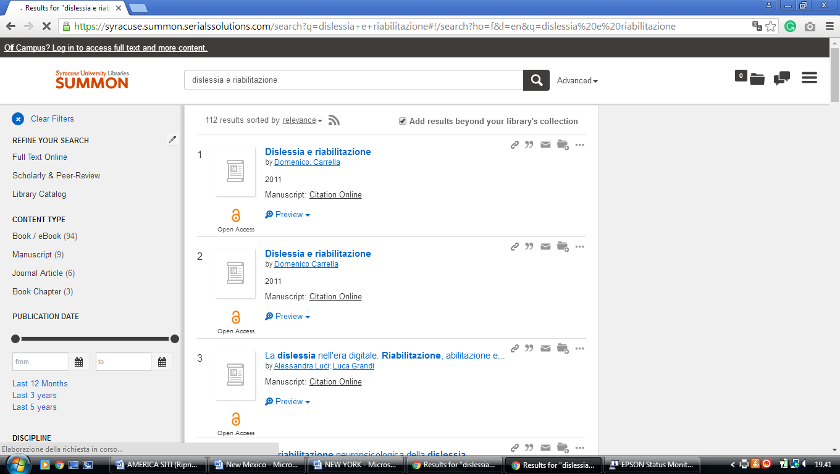

**2** [**TOURO COLLEGE LIBRARIES**](http://www.tourolib.org/) - (New York City, New York, Usa)

<http://touro.summon.serialssolutions.com/search?s.q=dislessia+e+riabilitazione#!/search?ho=f&l=en&q=dislessia%20e%20riabilitazione>

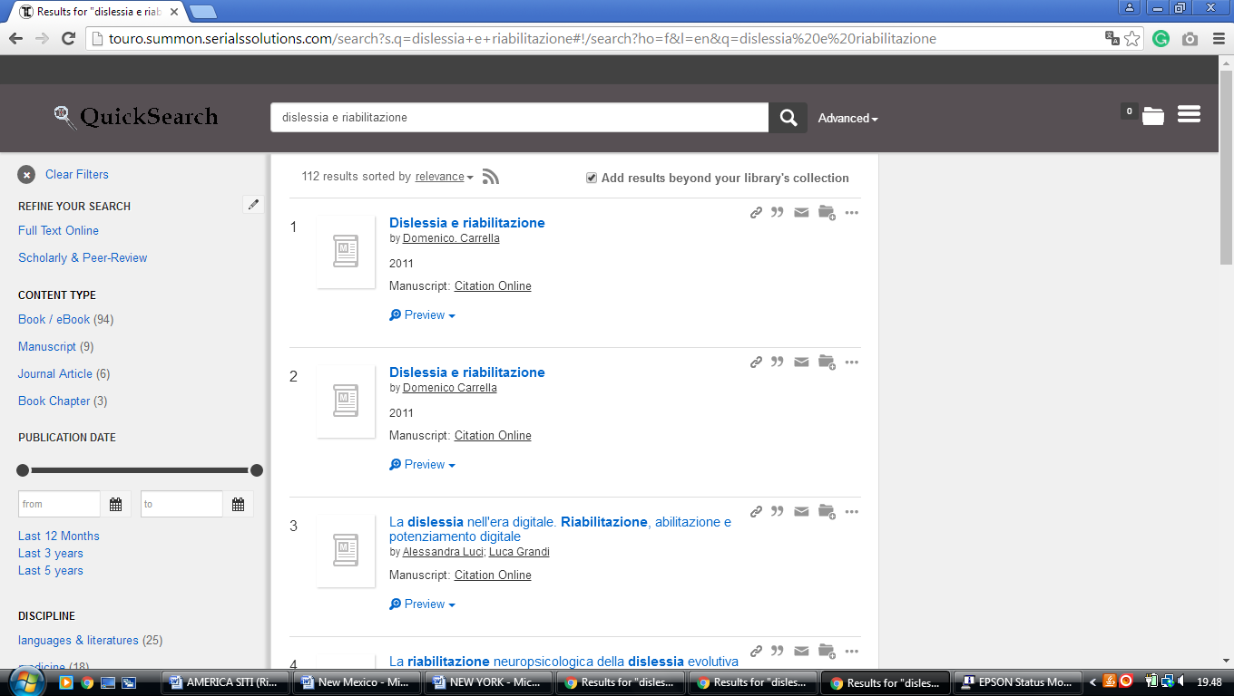

**3** [**ADELPHI UNIVERSITY LIBRARIES**](http://libraries.adelphi.edu/) – (Garden City, New York, Usa)

<http://adelphi.summon.serialssolutions.com/?fvf=ContentType%2CBook+Review%2Ct&q=dislessia+e+riabilitazione#!/search?ho=f&fvf=ContentType,Book%20Review,t&l=en&q=dislessia%20e%20riabilitazione>

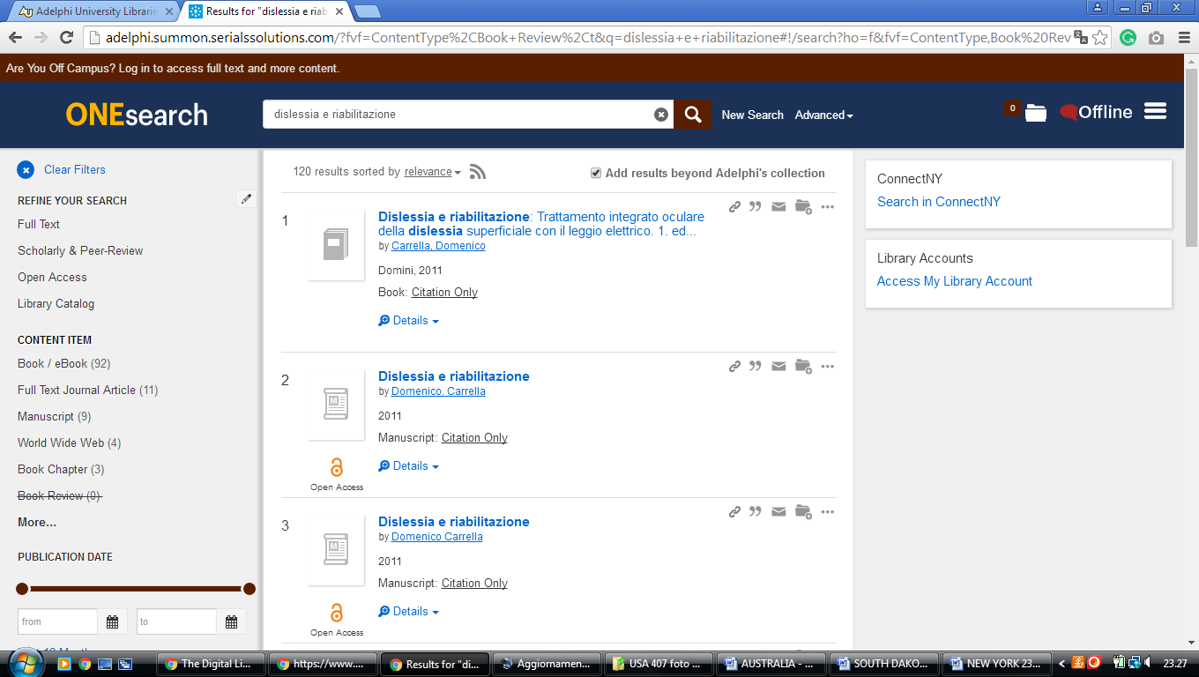

**4** [**ANDREW L. BOUWHUIS LIBRARY**](http://library.canisius.edu/) – (Buffalo, New York, Usa)

<http://canisius.summon.serialssolutions.com/?q=dislessia+e+riabilitazione#!/search?ho=f&l=en&q=dislessia%20e%20riabilitazione>

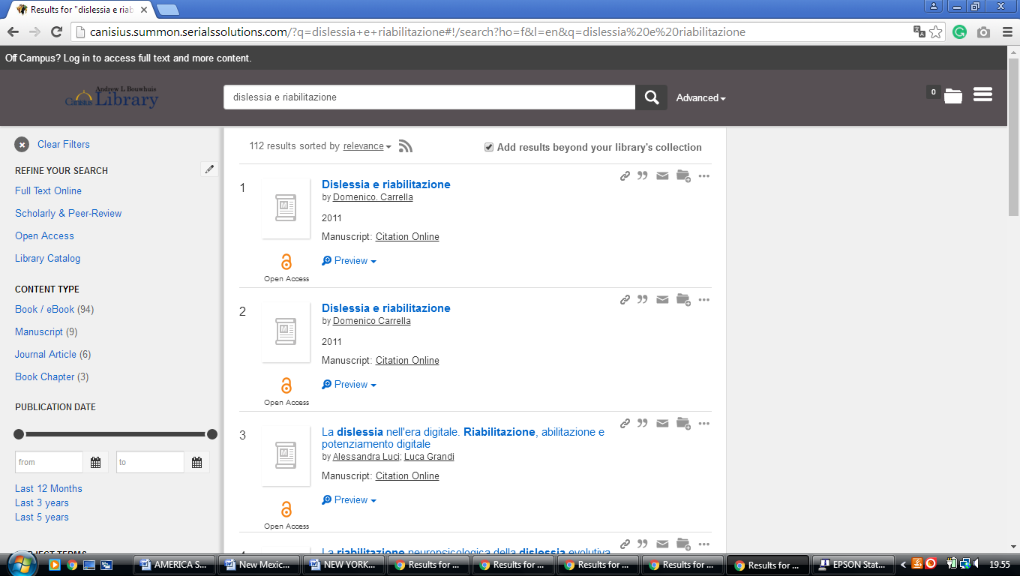

**5** [**BROOME COMMUNITY COLLEGE**](http://sunybroome.info/library/) **LIBRARY - (**Binghamton, New York, Usa)

<https://search.idsproject.org/index.php?query_value%5B0%5D=%22dislessia+e+riabilitazione&query_value%5B1%5D=&query_value%5B2%5D=per&query_operator%5B2%5D=not&search_scope=worldcat&search_form=advanced&sort_keys=Relevance&oclc_symbol=YSY&view=ids&auto_search_orig=Keyword%2B%2528all%2529%2B%2526quot%253Bdislessia%2Be%2Briabilitazione%2BNOT%2BMaterial%2Btype%2B%2528all%2529%2Bper.%2B%255BMy%2Blibrary%255D&auto_search=true>

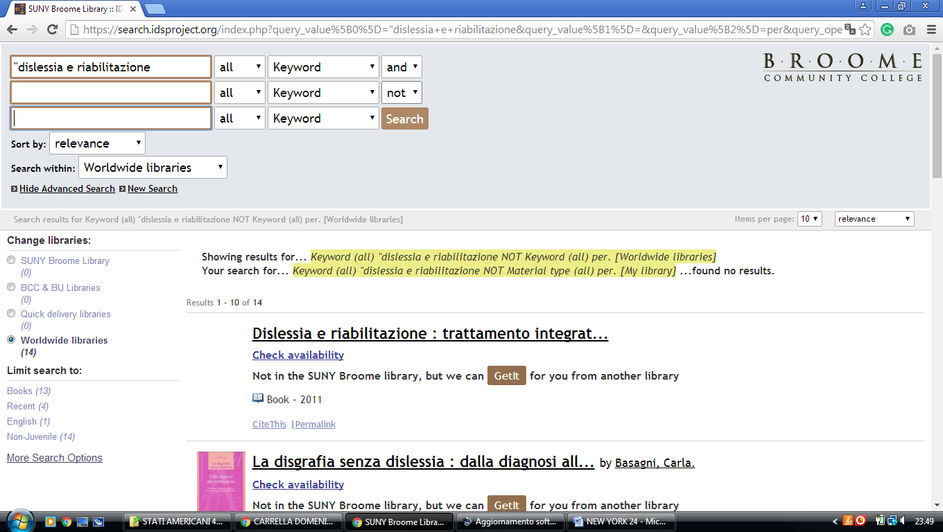

**6** [**CORNELL UNIVERSITY LIBRARY**](http://www.library.cornell.edu/) – (Ithaca, New York, Usa)

<http://cornell.worldcat.org/search?qt=wc_org_cornell&q=dislessia+e+riabilitazione&scope=0&oldscope=&wcsbtn2w=Search>

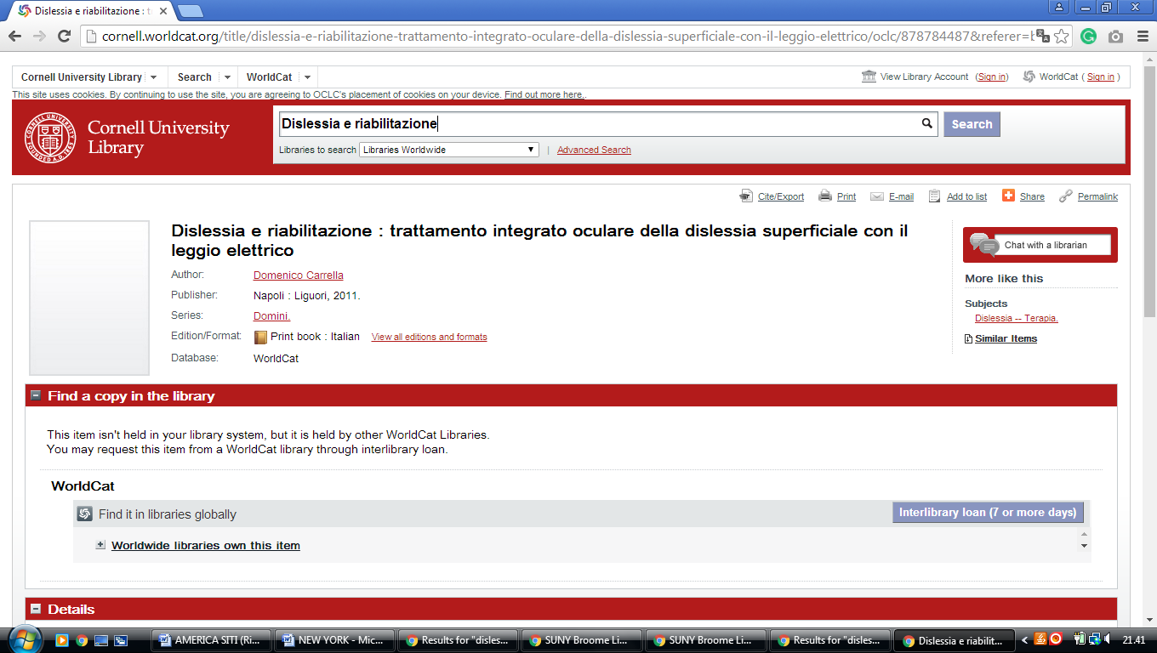

**7** [**DANIEL A. REED LIBRARY**](http://www.fredonia.edu/library/) – (Fredonia, New York, Usa)

<http://fredonia.summon.serialssolutions.com/search?s.q=dislessia+e+riabilitazione#!/search?ho=f&l=en&q=dislessia%20e%20riabilitazione>

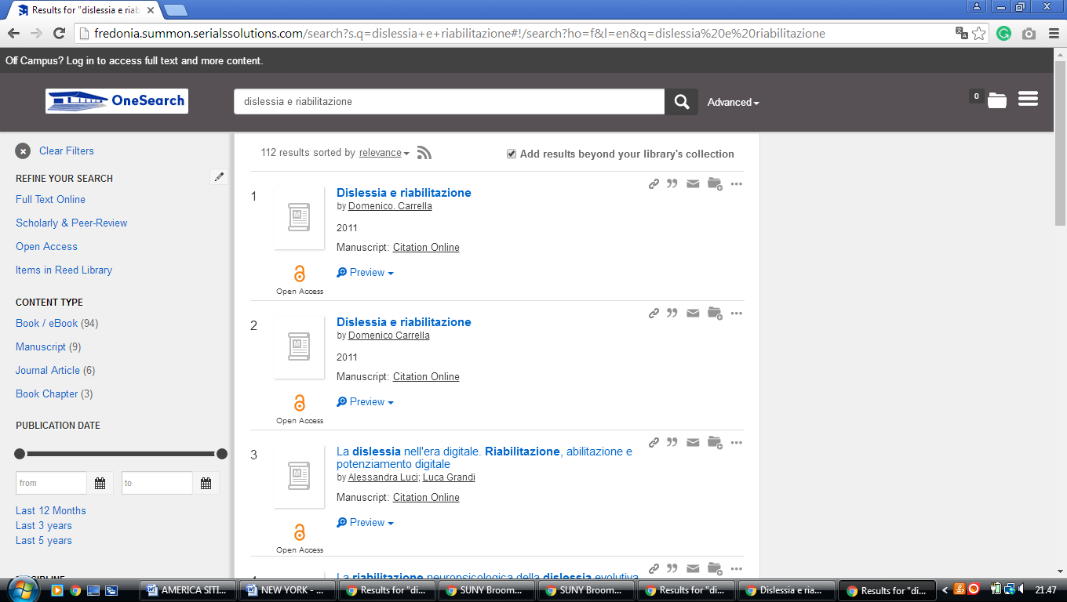

**8** [**DRAKE MEMORIAL LIBRARY**](http://www.brockport.edu/library/) – (Brockport, New York, Usa)

<https://brockport.summon.serialssolutions.com/?s.fvf=ContentType%2CNewspaper+Article%2Ct%7CContentType%2CBook+Review%2Ct%7CContentType%2CDissertation%2Ct&s.q=dislessia+e+riabilitazione#!/search?ho=f&fvf=ContentType,Newspaper%20Article,t%7CContentType,Book%20Review,t%7CContentType,Dissertation,t&l=en&q=dislessia%20e%20riabilitazione>

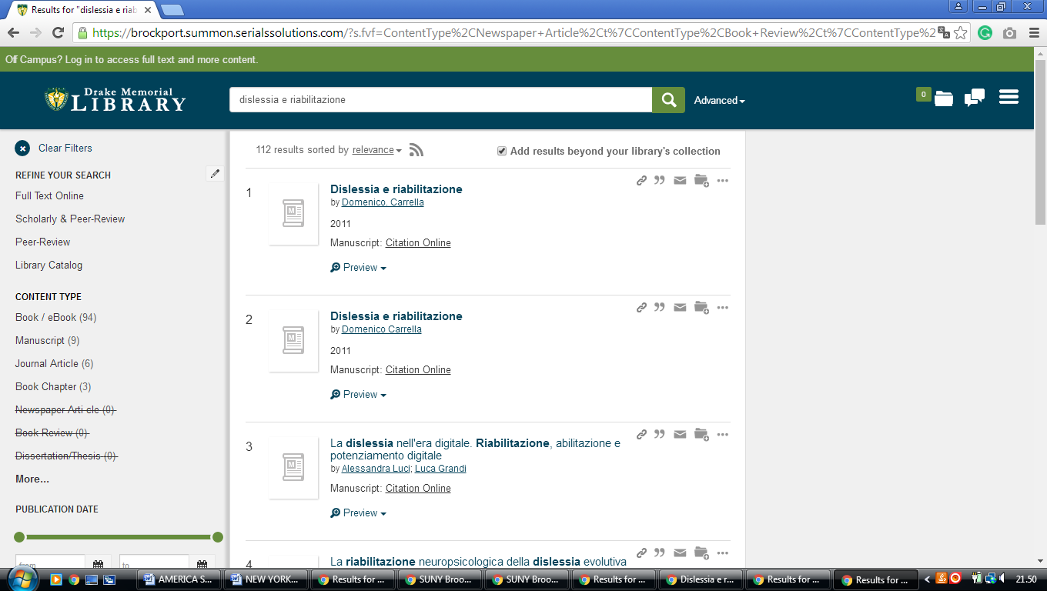

**9** [**E. H. BUTLER LIBRARY**](http://library.buffalostate.edu/) – (Buffalo, New York, Usa)

<https://buffalostate.summon.serialssolutions.com/search?s.q=dislessia+e+riabilitazione&spellcheck=true&keep_r=true#!/search?ho=f&l=en&q=dislessia%20e%20riabilitazione>

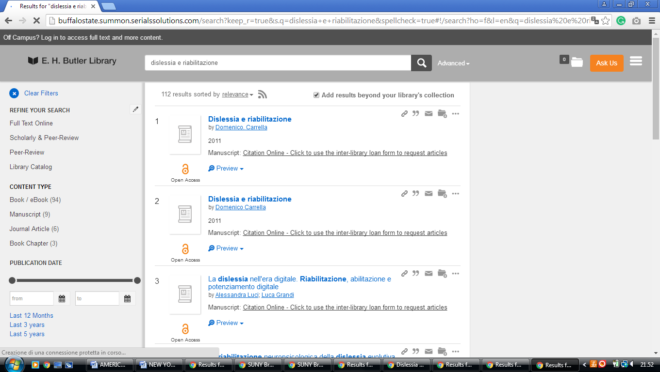

**10** [**ERIE COMMUNITY COLLEGE LIBRARY**](http://libguides.ecc.edu/home) – (Buffalo, New York, Usa)

<http://ecc.summon.serialssolutions.com/search?utf8=%E2%9C%93&s.q=dislessia+e+riabilitazione#!/search?ho=f&l=en&q=dislessia%20e%20riabilitazione>

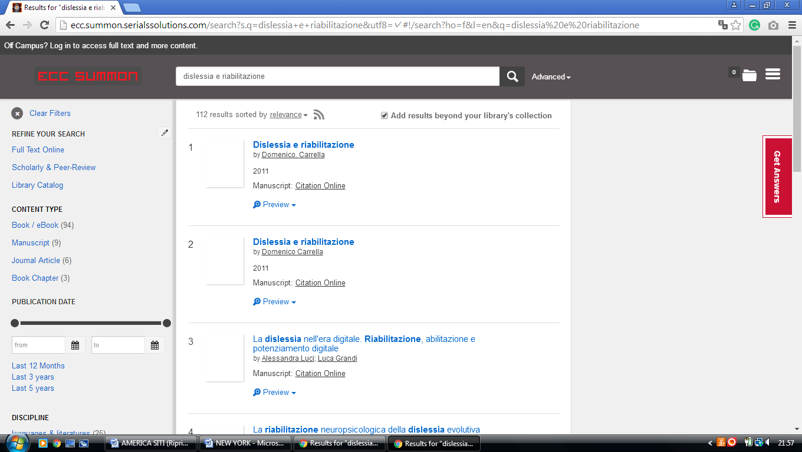

**11** [**HAMILTON COLLEGE LIBRARY**](http://www.hamilton.edu/library) – (Clinton, New York, Usa)

<https://hamilton.primo.exlibrisgroup.com/discovery/search?query=any,contains,dislessia%20e%20riabilitazione&tab=Everything&search_scope=MyInst_and_CI&vid=01HAMILTON_INST:01HAMILTON&lang=en&offset=0&sortby=rank&pcAvailability=true>

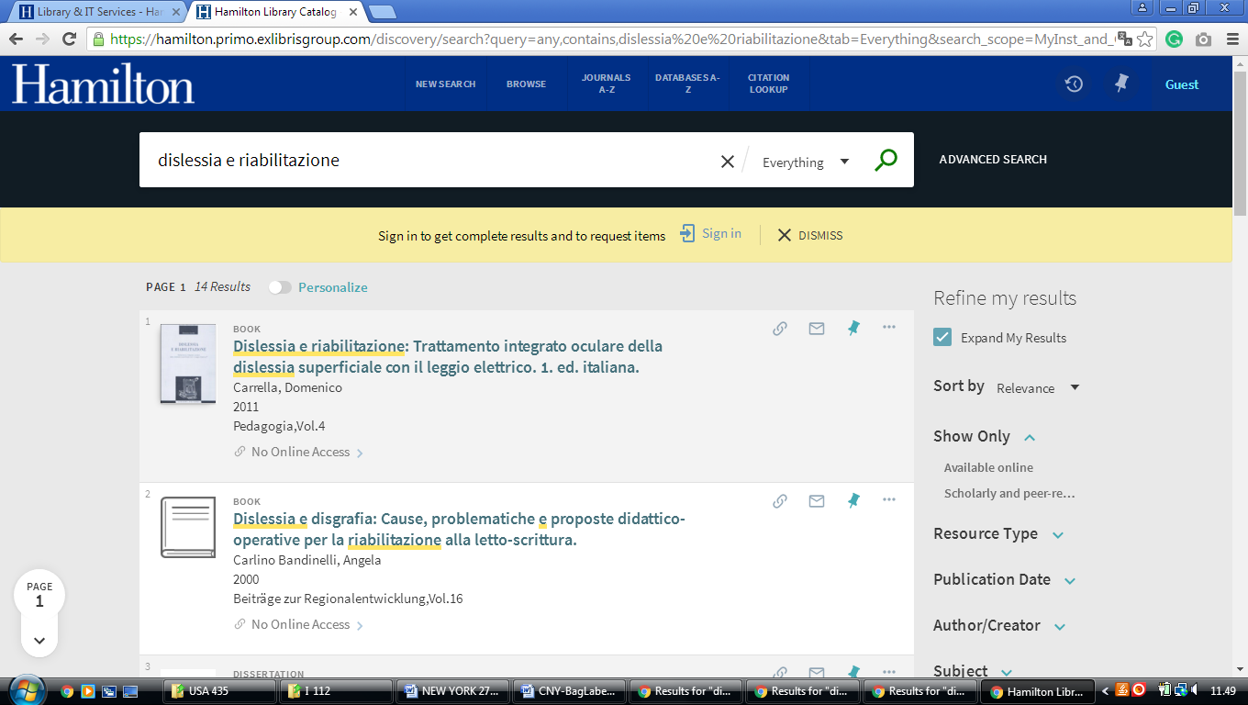

**12** [**IONA COLLEGE LIBRARIES**](http://www.iona.edu/library/) – (New Rochelle, New York, Usa)

<https://iona.on.worldcat.org/search?sortKey=LIBRARY&databaseList=&queryString=dislessia+e+riabilitazione&changedFacet=format&clusterResults=off&scope=&database=all&author=all&year=all&yearFrom=&yearTo=&language=all&topic=all>

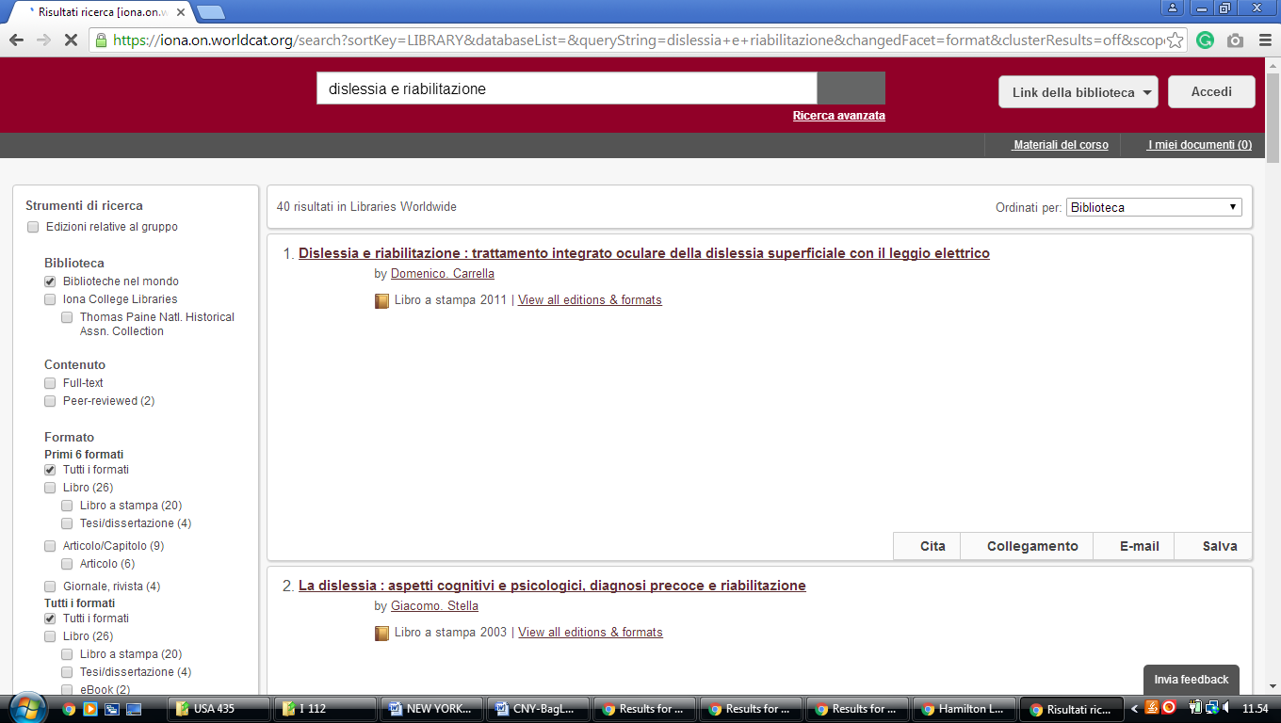

**13** [**JAMES A. CANNAVINO LIBRARY**](http://library.marist.edu/) – (Poughkeepsie, New York, Usa)

<http://marist.summon.serialssolutions.com/?q=dislessia+e+riabilitazione#!/search?ho=f&l=en&q=dislessia%20e%20riabilitazione>

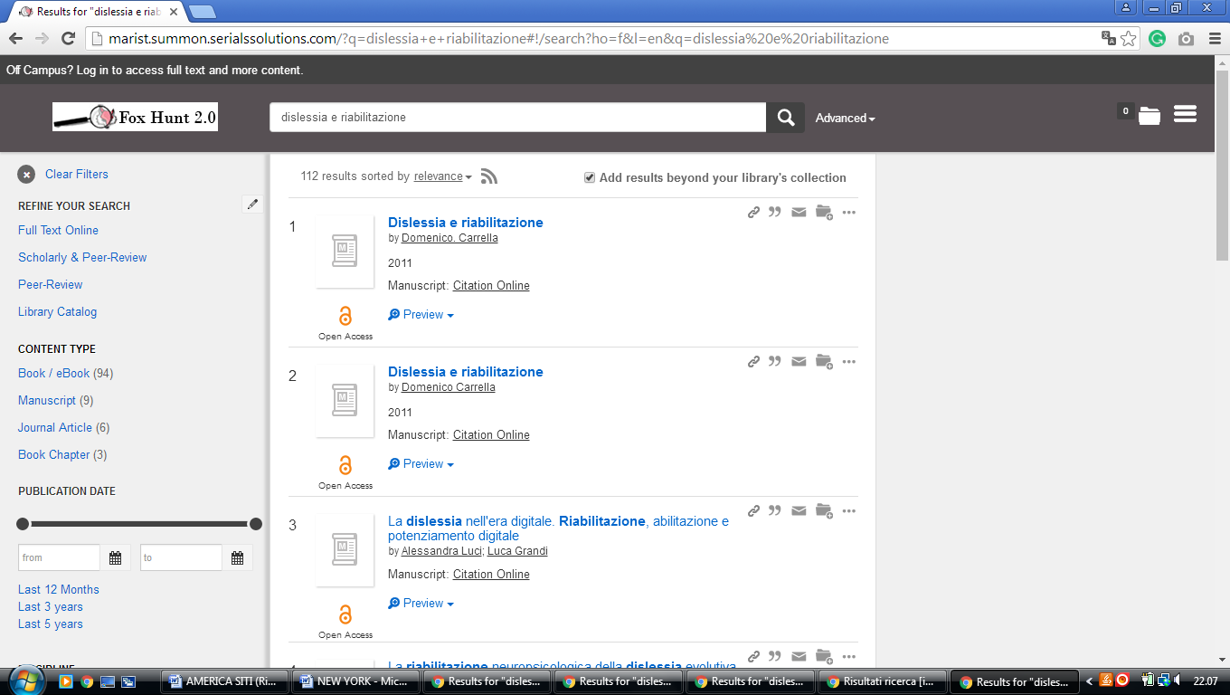

**14** [**NIAGARA UNIVERSITY LIBRARY**](http://library.niagara.edu/) – (Niagara Falls, New York, Usa)

<https://niagara.summon.serialssolutions.com/search?utf8=%E2%9C%93&s.q=dislessia+e+riabilitazione#!/search?ho=f&l=en&q=dislessia%20e%20riabilitazione>

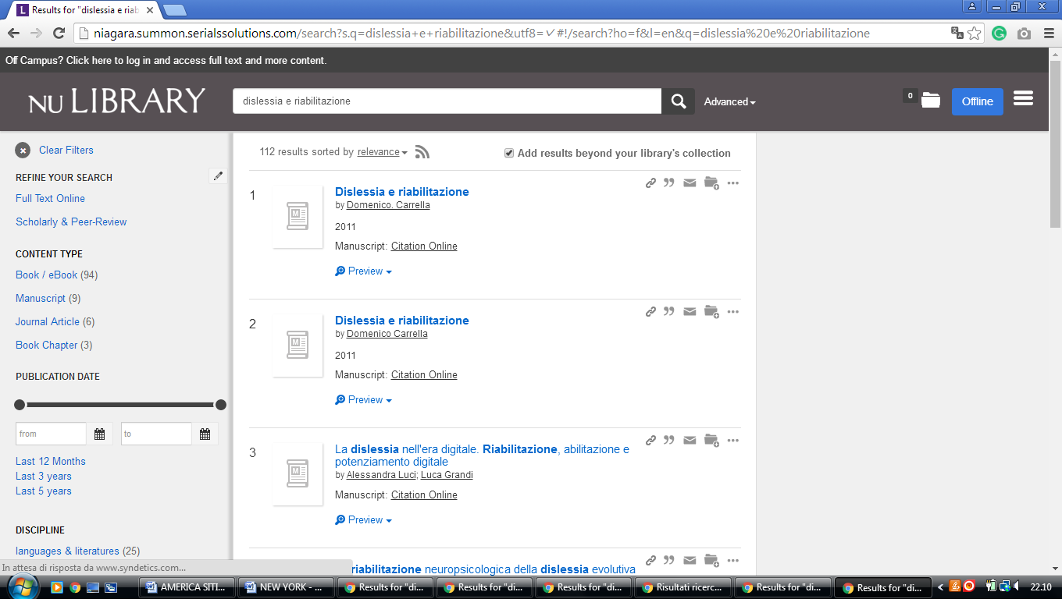

**15** [**SAGE LIBRARIES**](http://library.sage.edu/) – (Troy, New York, Usa)

<https://sage.summon.serialssolutions.com/search?q=dislessia+e+riabilitazione#!/search?ho=f&l=en&q=dislessia%20e%20riabilitazione>

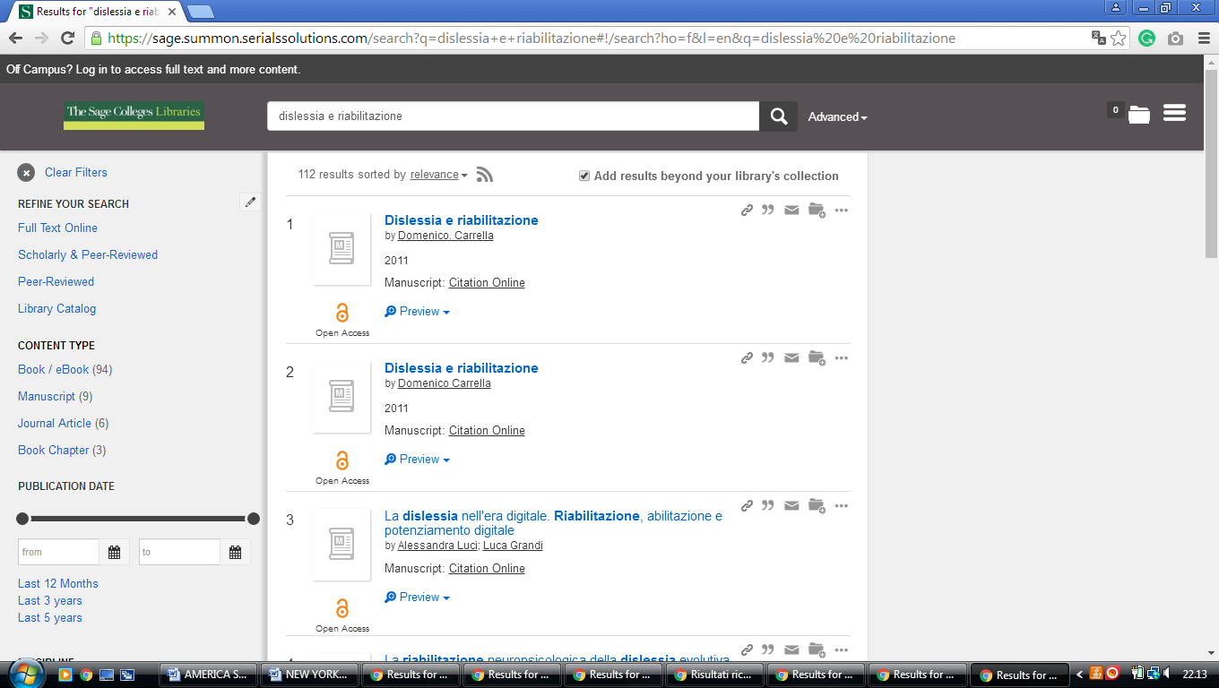

**16 SCHAFFER LIBRARY -** ([Schenectady](https://en.wikipedia.org/wiki/Schenectady,_New_York), [New York](https://en.wikipedia.org/wiki/New_York_(state)), Usa)

<https://union.summon.serialssolutions.com/?#!/search?ho=f&fvf=ContentType,Newspaper%20Article,t&l=en&q=dislessia%20e%20riabilitazione>

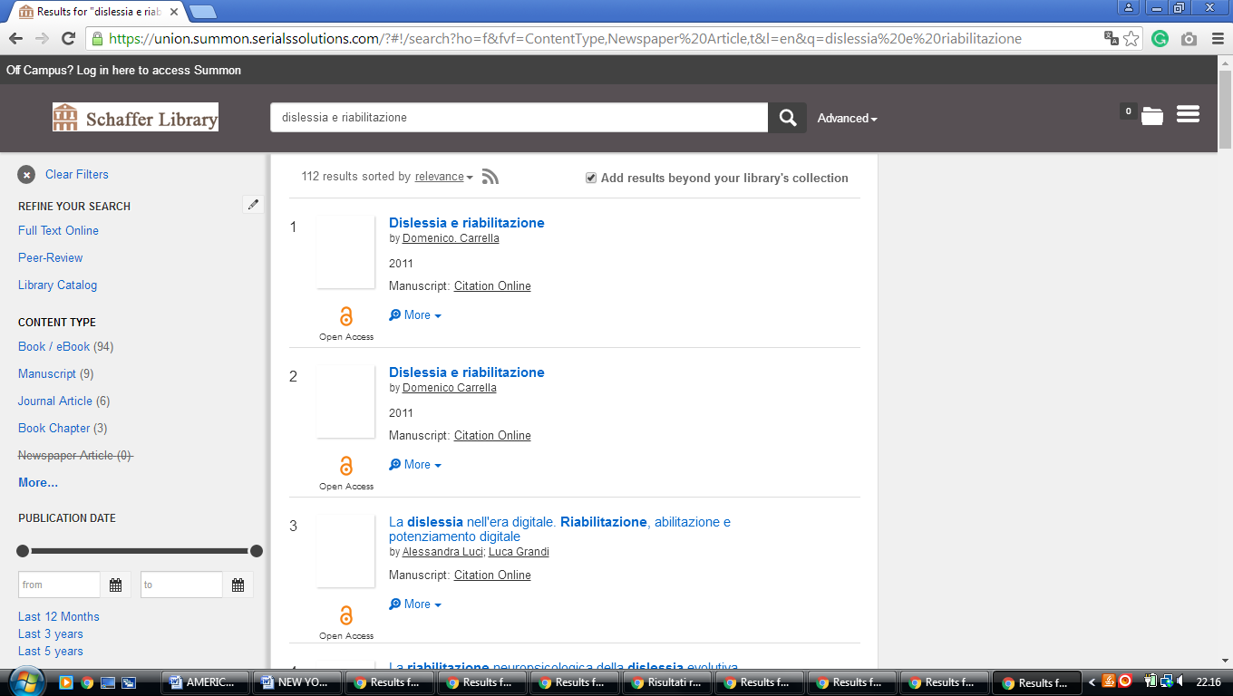

**17** [**STONY BROOK UNIVERSITY LIBRARIES**](http://www.library.stonybrook.edu/) – (Stony Brook, New York, Usa)

<http://eds.b.ebscohost.com/eds/results?vid=1&sid=cf0eb762-6fba-4d2e-96d3-78f289b72aa4%40sessionmgr103&bquery=(dislessia+AND+e+AND+riabilitazione)&bdata=JnR5cGU9MCZzaXRlPWVkcy1saXZlJnNjb3BlPXNpdGU%3d>

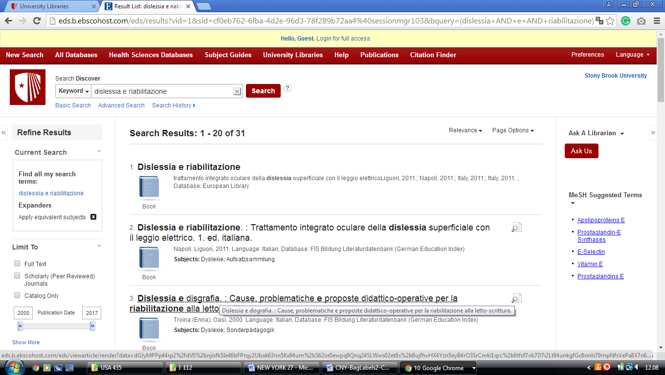

**18** [**UNIVERSITY OF ROCHESTER LIBRARIES**](http://www.library.rochester.edu/) – (Rochester, New York, Usa)

<http://rochester.summon.serialssolutions.com/search?s.q=dislessia+e+riabilitazione&submit=+&spellcheck=true&keep_r=true#!/search?ho=f&l=en&q=dislessia%20e%20riabilitazione>

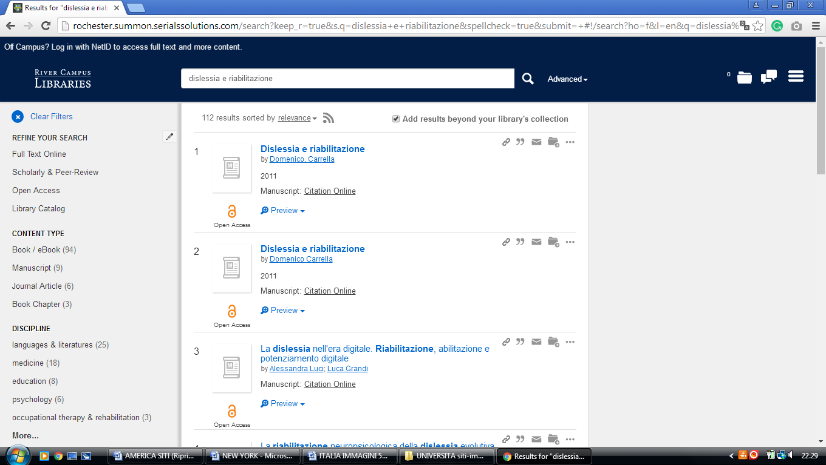

**19** [**WARREN HUNTING SMITH LIBRARY**](http://library.hws.edu/) **– (**Geneva, New York, Usa)

<https://hws.summon.serialssolutions.com/?q=dislessia+e+riabilitazione#!/search?ho=f&l=en&q=dislessia%20e%20riabilitazione>

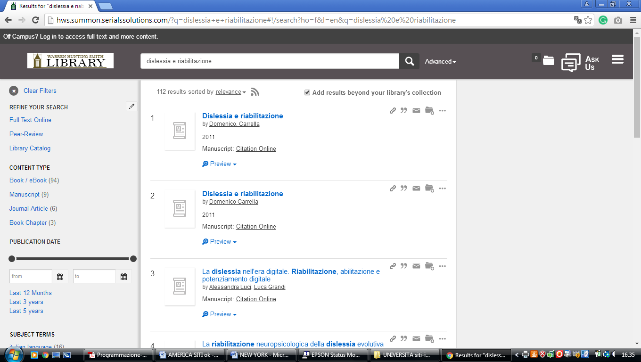

**20** [**DRAKE MEMORIAL LIBRARY**](http://www.brockport.edu/library/) – (Brockport, New York, Usa)

<https://brockport.summon.serialssolutions.com/?s.fvf=ContentType%2CNewspaper+Article%2Ct%7CContentType%2CBook+Review%2Ct%7CContentType%2CDissertation%2Ct&s.q=dislessia+e+riabilitazione#!/search?ho=f&fvf=ContentType,Newspaper%20Article,t%7CContentType,Book%20Review,t%7CContentType,Dissertation,t&l=en&q=dislessia%20e%20riabilitazione>

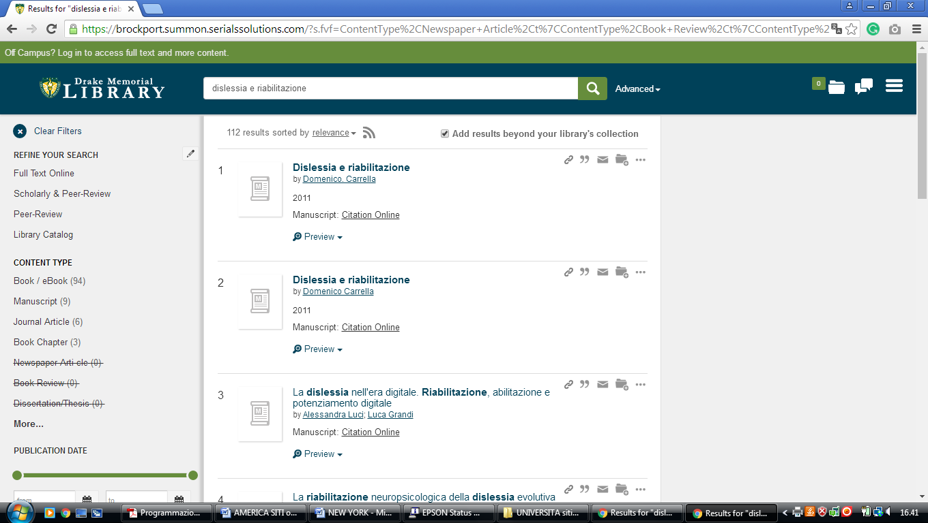

### 21 UNIVERSITY OF ROCHESTER LIBRARY – (Rochester, Ny, Usa)

<http://rochester.summon.serialssolutions.com/search?s.q=dislessia+e+riabilitazione&submit=+&spellcheck=true&keep_r=true#!/search?ho=f&l=en&q=dislessia%20e%20riabilitazione>

### 

**22**  **CLARKSON UNIVERSITY LIBRARY – (**[Potsdam, New York](https://en.wikipedia.org/wiki/Potsdam_(village),_New_York) Usa)

<https://clarksonuniversitylibrary.on.worldcat.org/search?queryString=dislessia%20e%20riabilitazione&databaseList=4058,2375,1461,3384,2271,3218,1953,1875,3313,1672,638,1736,1934,3879,2221,2264,2483,2263,2262,2261,2260,143,2237,2259,1542,2477,2476,3909,2277,3867,3967&page=1&queryType=search&stickyFacetsChecked=false>

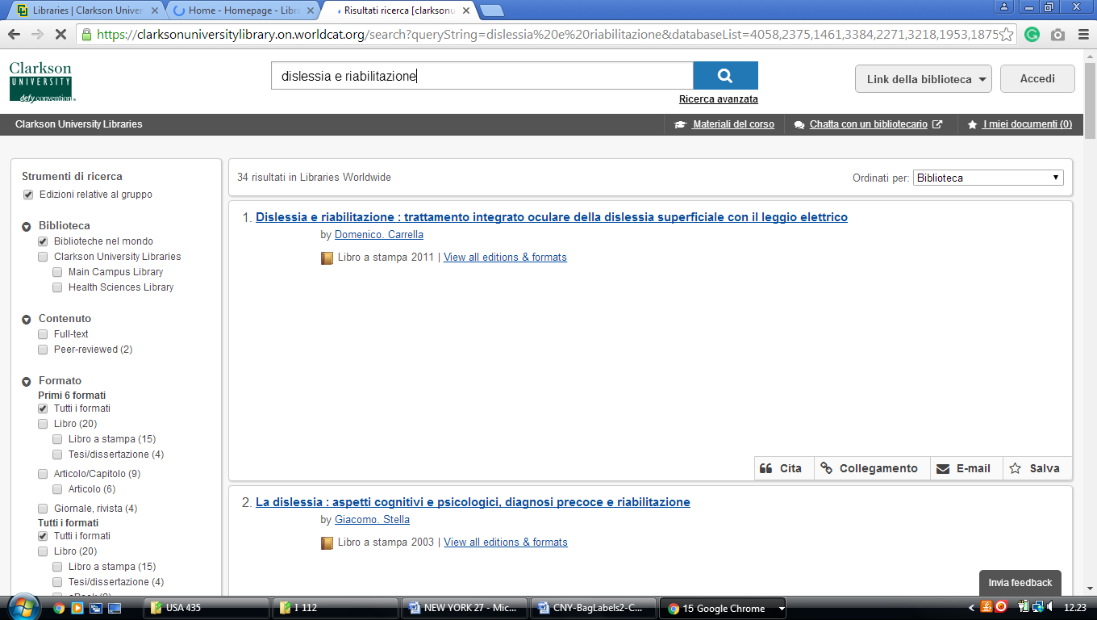

### 23 [THE HAROLD KOHN VISION SCIENCE LIBRARY - SUNY COLLEGE OF OPTOMETRY](https://www.sunyopt.edu/library) - (New York)

<http://eds.b.ebscohost.com/eds/resultsadvanced?vid=3&sid=39793f45-ba2c-4ea7-8cf2-7b608f7e77d3%40pdc-v-sessmgr01&bquery=(dislessia+AND+e+AND+riabilitazione)&bdata=JnR5cGU9MSZzaXRlPWVkcy1saXZl>

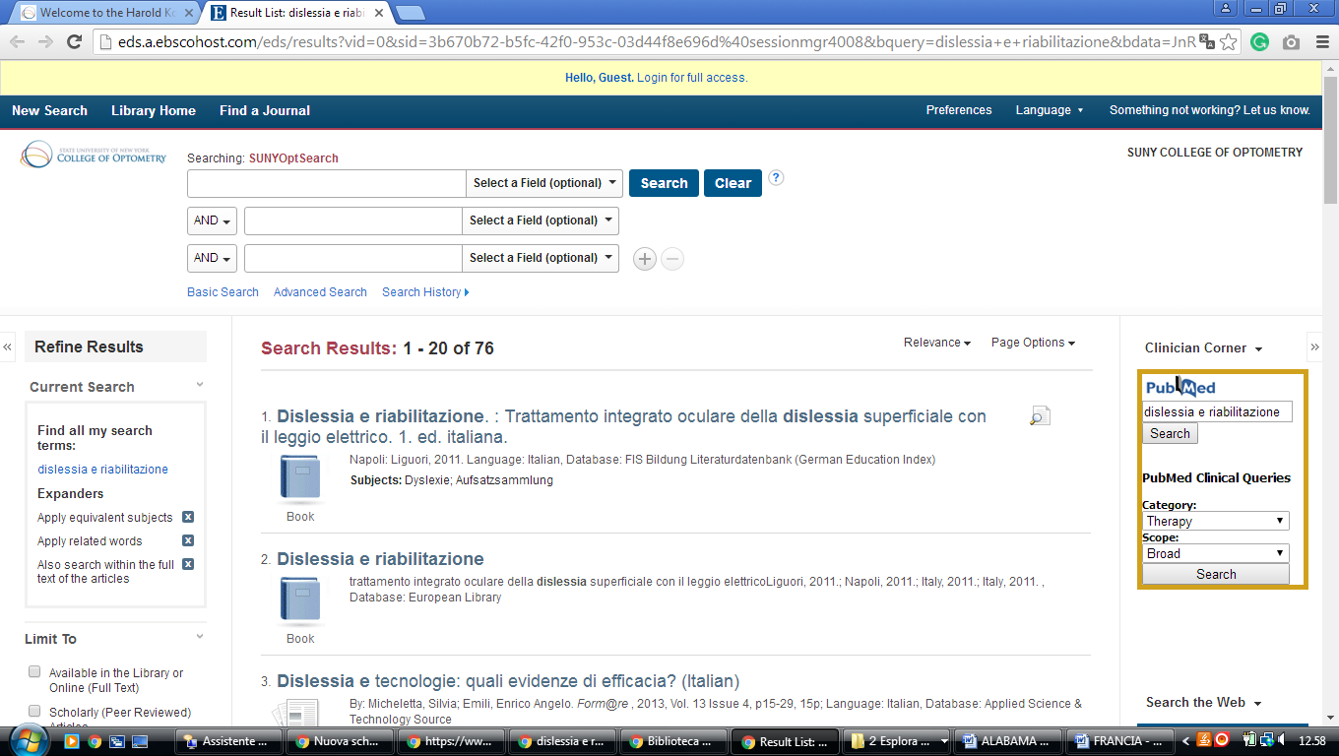

### 24 [LIBRARIES | ST. JOHN'S UNIVERSITY](https://www.stjohns.edu/libraries) - (New York, Usa)

<https://stjohnsuniversitylibraries.on.worldcat.org/search?sortKey=BEST_MATCH&databaseList=&queryString=dislessia+e+riabilitazione&changedFacet=scope&clusterResults=on&scope>=

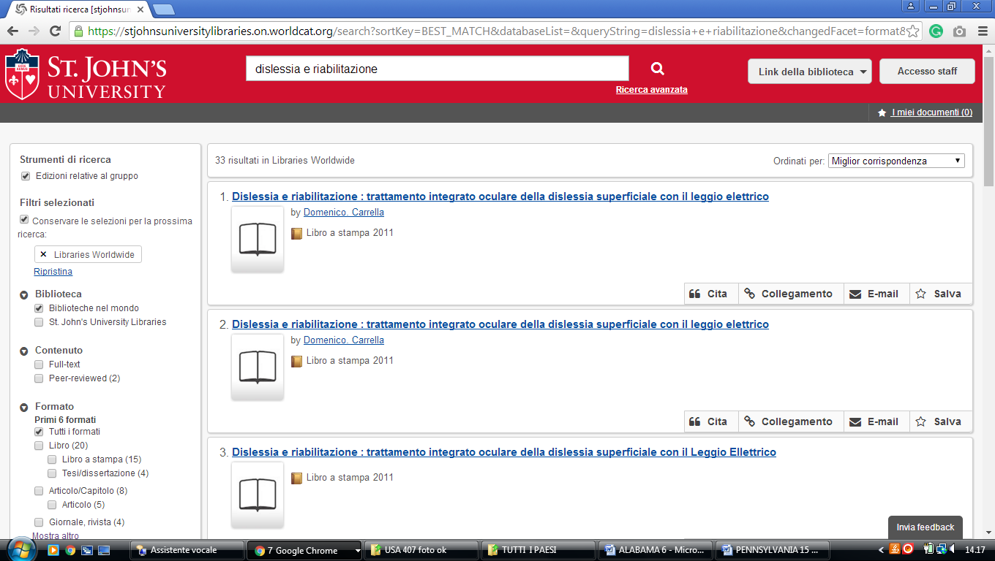

### 25 [UNIVERSITY AT BUFFALO LIBRARIES](https://library.buffalo.edu/) – (New York, Usa)

<https://buffalo.summon.serialssolutions.com/search?q=dislessia+e+riabilitazione&submit=%EE%A4%A4#!/search?ho=f&l=it-IT&q=dislessia%20e%20riabilitazione&submit=%EE%A4%A4>

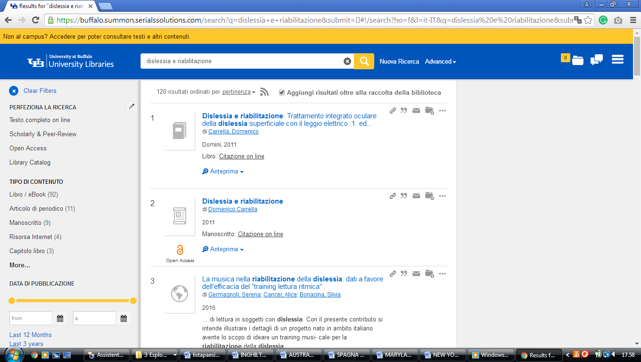

**Anne Ross Library and Learning Resource Center,** NEW YORK NY

[](https://www.umhs-sk.org/index.php)[**Anne Ross Library**](https://www.google.com/url?sa=t&rct=j&q=&esrc=s&source=web&cd=1&cad=rja&uact=8&ved=2ahUKEwjEps3ltbPoAhXRX8AKHVBwAqIQFjAAegQIAhAB&url=http%3A%2F%2Fumhs-library.com%2F&usg=AOvVaw0ssaQzUjjmSVR4jbWxbvWP)

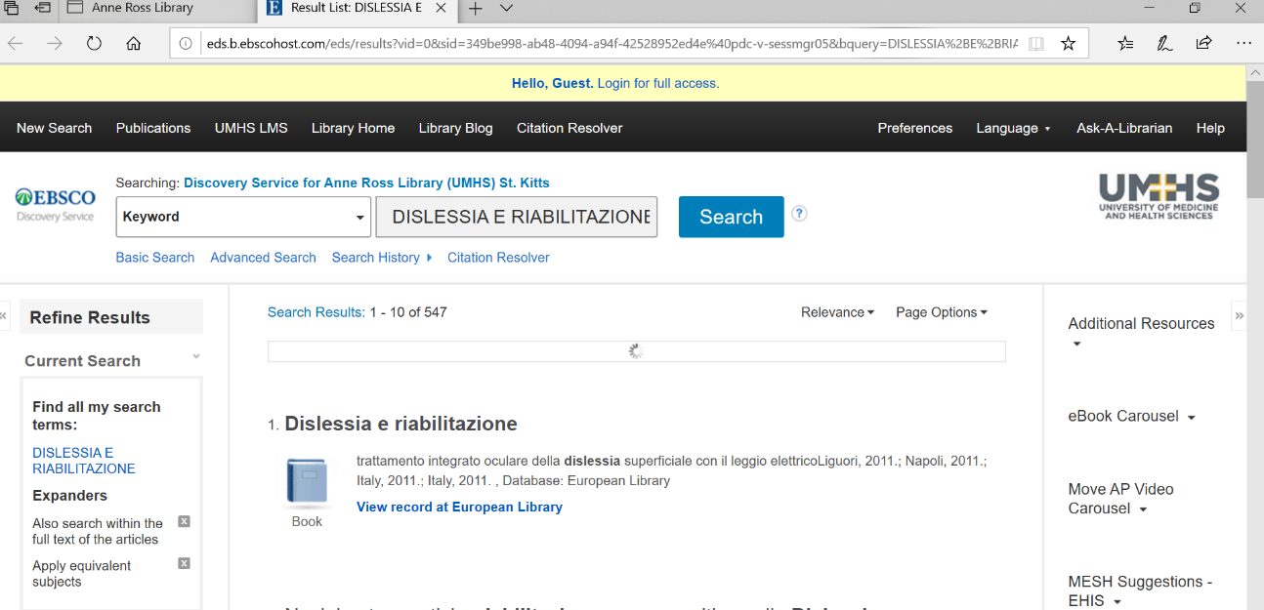

Stony Brook University Libraries

https://search.library.stonybrook.edu/discovery/search?vid=01SUNY_STB:01SUNY_STB&tab=Everything&qry=any&search_scope=MyInst_and_CI&mode=basic&displayMode=full&bulkSize=10&highlight=true&dum=true&query=any,contains,dislessia%20e%20riabilitazione&displayField=all&pcAvailabiltyMode=true&ebscohostsearchtext9=dislessia%20e%20riabilitazione&pcAvailability=true

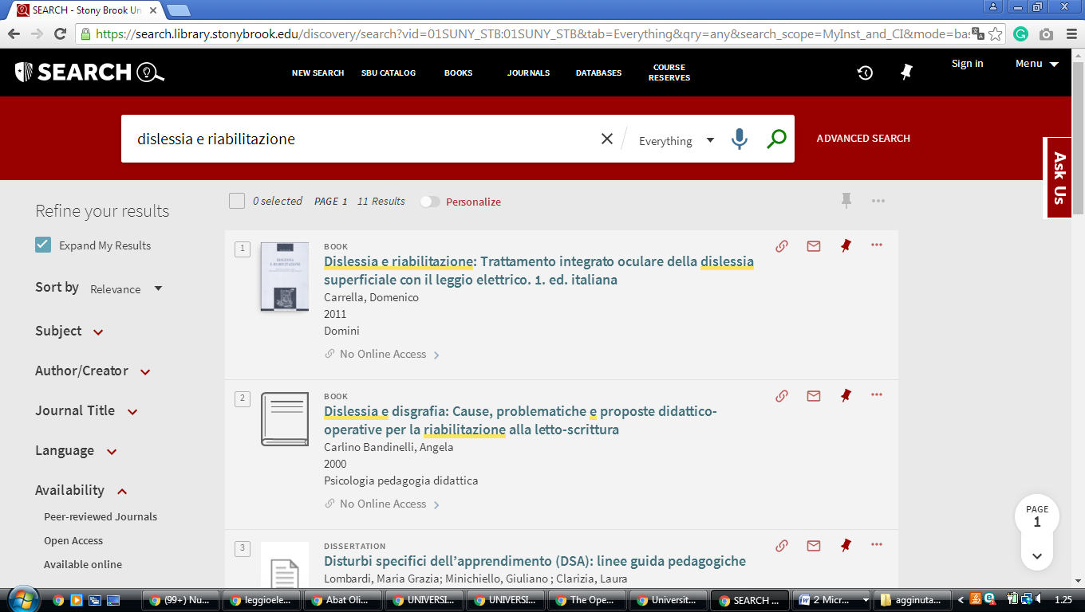

[**Clinton**](https://en.wikipedia.org/wiki/Clinton,_Oneida_County,_New_York)**, Hamilton College,** [**New York**](https://en.wikipedia.org/wiki/New_York_(state))

**Library & IT Services**

<https://hamilton.primo.exlibrisgroup.com/discovery/search?query=any,contains,dislessia%20e%20riabilitazione&tab=Everything&search_scope=MyInst_and_CI&vid=01HAMILTON_INST:01HAMILTON&lang=en&offset=0&pcAvailability=true>

