**NEW MEXICO = 3**

**1** [**UNM VALENCIA CAMPUS LIBRARY**](http://www.unm.edu/~unmvclib/) – (Tome, New Mexico, Usa)

<https://vclibrary.on.worldcat.org/search?sortKey=LIBRARY&databaseList=&queryString=dislessia+e+riabilitazione&changedFacet=format&clusterResults=off&scope=&database=all&author=all&year=all&yearFrom=&yearTo=&language=all&topic=all>

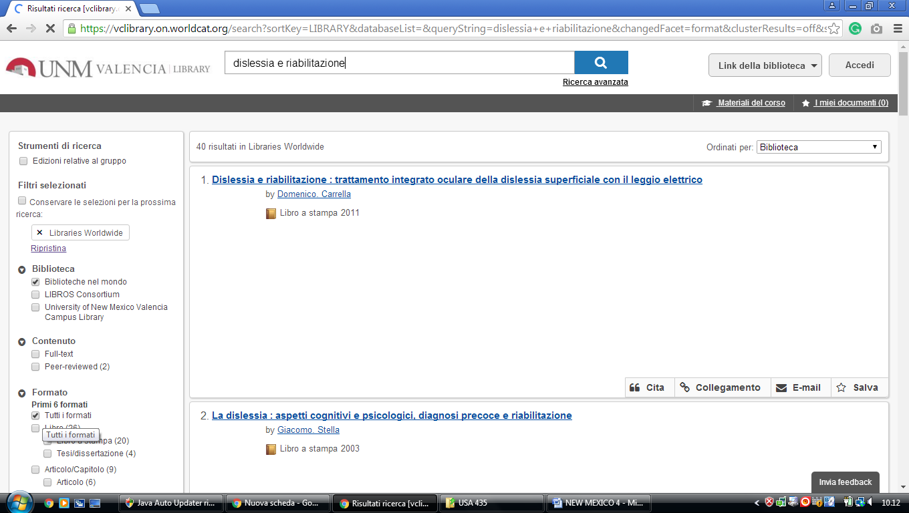

### 2 [LIBRARY > INSTITUTE OF AMERICAN INDIAN ARTS (IAIA)](https://iaia.edu/academics/library/) – (Santa Fe, Usa)

<https://iaialibrary.worldcat.org/search?q=dislessia+e+riabilitazione&qt=results_page&dblist=1708%2C1279%2C2259%2C2260%2C2262%2C2264%2C2267%2C1719%2C1728%2C638&scope=0&oldscope=2&fq>=

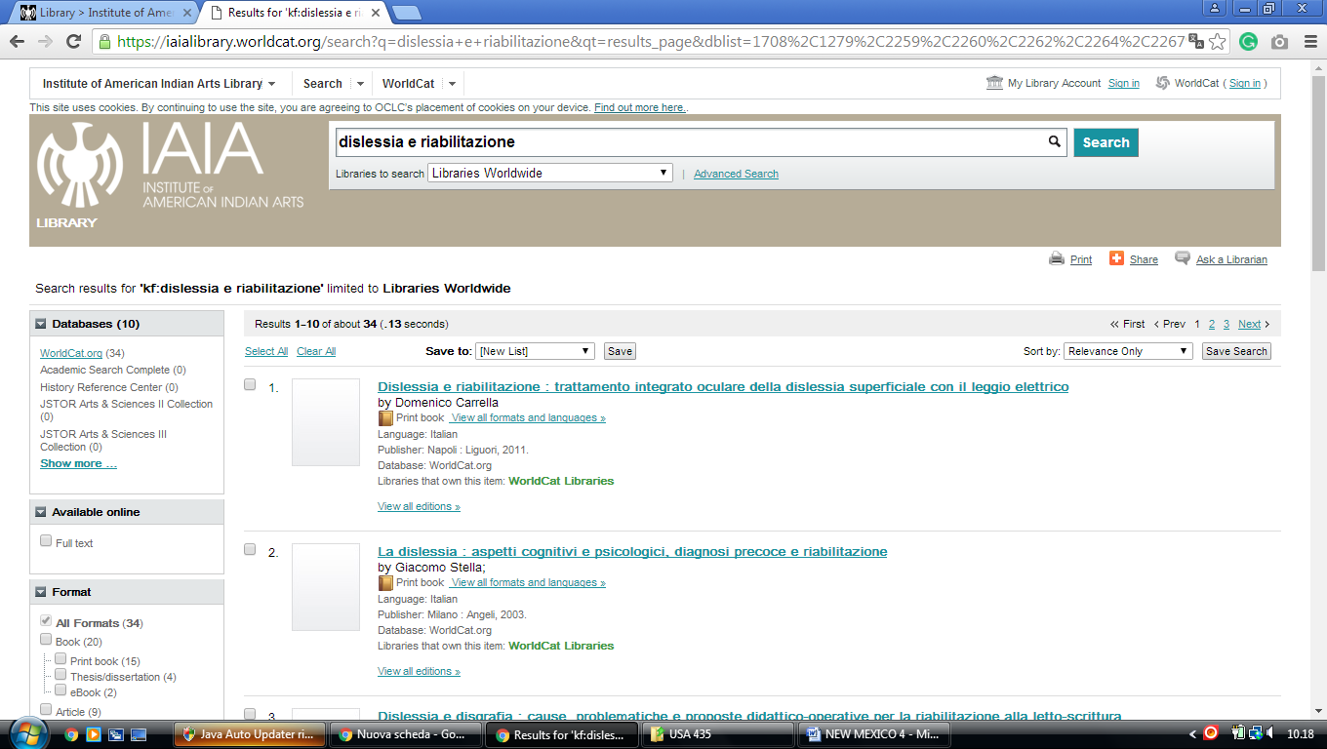

**3** [**SKEEN LIBRARY**](http://infohost.nmt.edu/~nmtlib/) – (Socorro, New Mexico, Usa)

<https://nmt.on.worldcat.org/search?sortKey=LIBRARY&databaseList=&queryString=dislessia+e+riabilitazione&changedFacet=format&clusterResults=off&scope=&database=all&author=all&year=all&yearFrom=&yearTo=&language=all&topic=all>

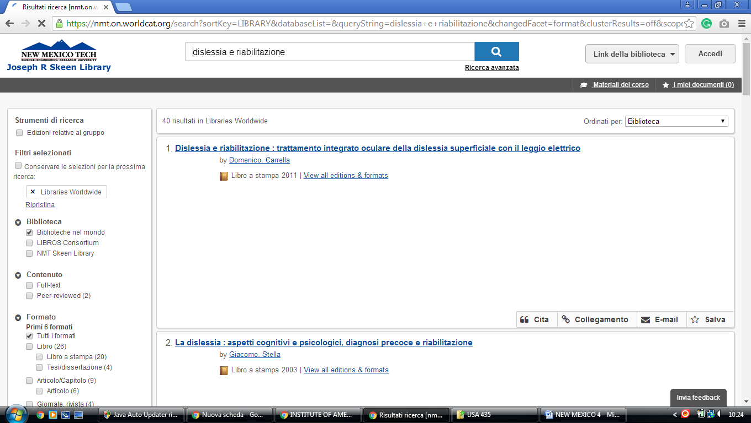

University of New Mexico library

https://unm.on.worldcat.org/search?queryString=kw:(DISLESSIA%20E%20RIABILITAZIONE)&databaseList=2264,2263,2262,1271,2261,2260,2281,143,2328,2007,2006,2237,2259,1697,3413,203,2268,2201,2267,1672,3036,3201,1708,638&page=1&queryType=search&origPageViewName=pages/advanced-search-page&scope=&stickyFacetsChecked=false&clusterResults=true

