**NEW HAMPSHIRE = 3**

**1** [**DARTMOUTH COLLEGE LIBRARY**](http://library.dartmouth.edu/) – (Hanover, New Hampshire, Usa)

[https://dartmouth.summon.serialssolutions.com/search?ho=t&fvf=ContentType%2CBook+%2F+eBook%2Cf%7CContentType%2CBook+Chapter%2Cf%7CContentType%2CNewspapers%2Ct%7CGenre%2Conline+databases%2Ct%7CGenre%2Cperiodicals%2Ct%7CGenre%2Cindexes%2Ct%7CGenre%2Celectronic+journals%2Ct%7CGenre%2Cabstracts%2Ct%7CGenre%2Cdatabases%2Ct&l=en&q=dislessia+e+riabilitazione&dart_q=dislessia+e+riabilitazione&search-type=all&op=Search#!/search?ho=f&fvf=ContentType,Newspapers,t%7CGenre,online%20databases,t%7CGenre,periodicals,t%7CGenre,indexes,t%7CGenre,electronic%20journals,t%7CGenre,abstracts,t%7CGenre,databases,t&l=en&q=dislessia%20e%20riabilitazione&dart_q=dislessia%20e%20riabilitazione&type=all&op=Search](https://dartmouth.summon.serialssolutions.com/search?ho=t&fvf=ContentType%2CBook+%2F+eBook%2Cf%7CContentType%2CBook+Chapter%2Cf%7CContentType%2CNewspapers%2Ct%7CGenre%2Conline+databases%2Ct%7CGenre%2Cperiodicals%2Ct%7CGenre%2Cindexes%2Ct%7CGenre%2Celectronic+journals%2Ct%7CGenre%2Cabstracts%2Ct%7CGenre%2Cdatabases%2Ct&l=en&q=dislessia+e+riabilitazione&dart_q=dislessia+e+riabilitazione&search-type=all&op=Search#!/search?ho=f&fvf=ContentType,Newspapers,t%7CGenre,online%20databases,t%7CGenre,periodicals,t%7CGenre,indexes,t%7CGenre,electronic%20journals,t%7CGenre,abstracts,t%7CGenre,databases,t&l=en&q=dislessia%20e%20riabilitazione&dart_q=dislessia%20e%20riabilitaz)

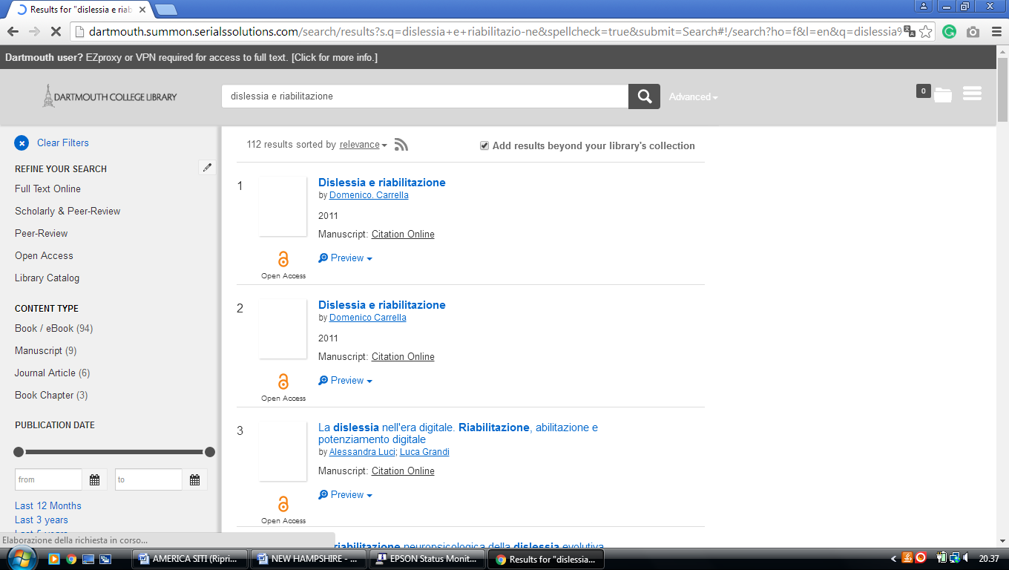

**2** [**LAMSON LIBRARY**](http://library.plymouth.edu/) – (Plymouth, New Hampshire, Usa)

<https://plymouth.on.worldcat.org/search?sortKey=RELEVANCE&databaseList=638&queryString=dislessia+e+riabilitazione&changedFacet=scope&clusterResults=on&scope=&scope=wz%3A109>

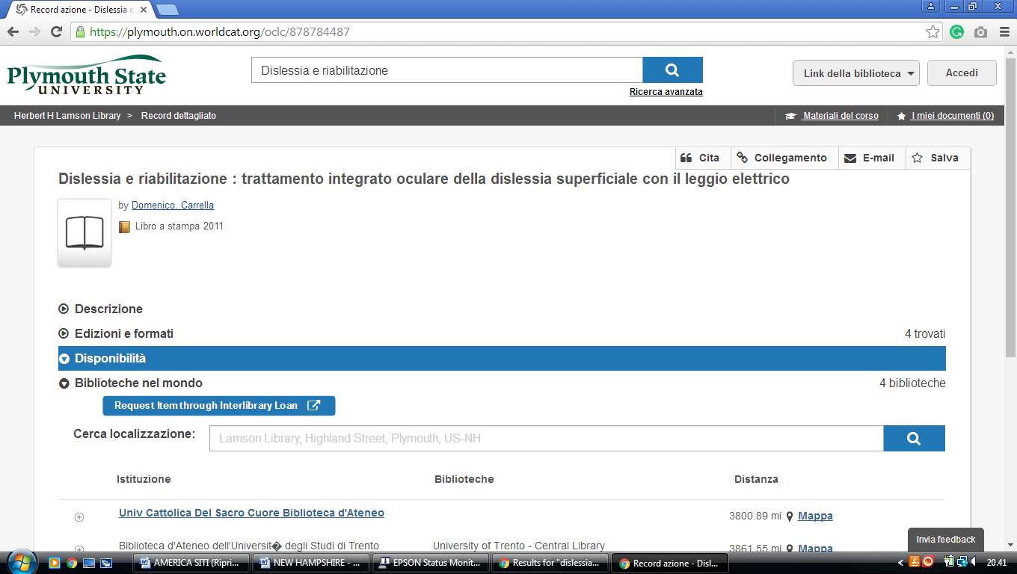

**3** [**MASON LIBRARY**](http://www.keene.edu/library/) – (Keene, New Hampshire, Usa)

<https://keenestatecollege.on.worldcat.org/search?sortKey=LIBRARY&databaseList=&queryString=dislessia+e+riabilitazione&changedFacet=scope&clusterResults=off&scope=&format=all&database=all&author=all&year=all&yearFrom=&yearTo=&language=all&topic=all>

