**NEVADA = 2**

**1** [**UNIVERSITY OF NEVADA - RENO**](http://knowledgecenter.unr.edu/) **LIBRARY** – (Nevada, Usa)

<https://unr.summon.serialssolutions.com/#!/search?ho=f&l=en&q=DISLESSIA%20E%20RIABILITAZIONE>

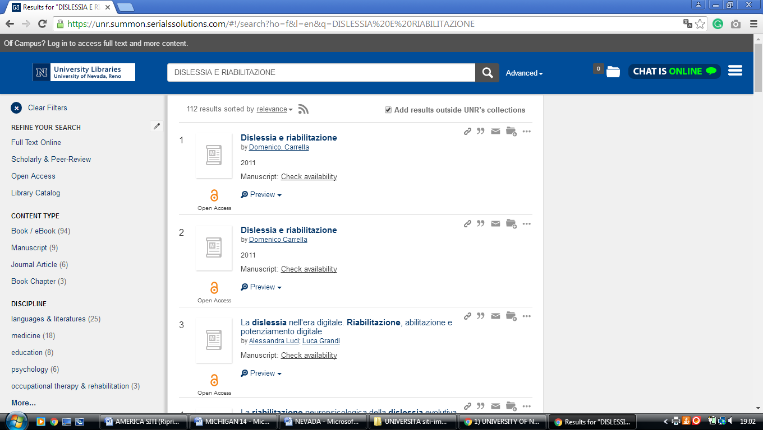

**2** [**WNC LIBRARY & MEDIA SERVICES**](http://library.wnc.edu/) – (Carson City, Nevada, Usa)

<http://wnc.summon.serialssolutions.com/?#!/search?ho=f&l=en&q=dislessia%20e%20riabilitazione>

