**MONTANA = 3**

**1** [**MONTANA STATE UNIVERSITY**](http://www.msubillings.edu/library/) **BILLINGS LIBRARY – (**Billings, Montana, Usa)

<https://msub-primo.hosted.exlibrisgroup.com/primo_library/libweb/action/search.do?ct=facet&pcAvailabiltyMode=true&pcAvailClicked=true&vid=01TRAILS_MSU_BILLINGS&fn=search&indx=1&dscnt=0&vl(freeText0)=dislessia%20e%20riabilitazione&dstmp=1521589849053>

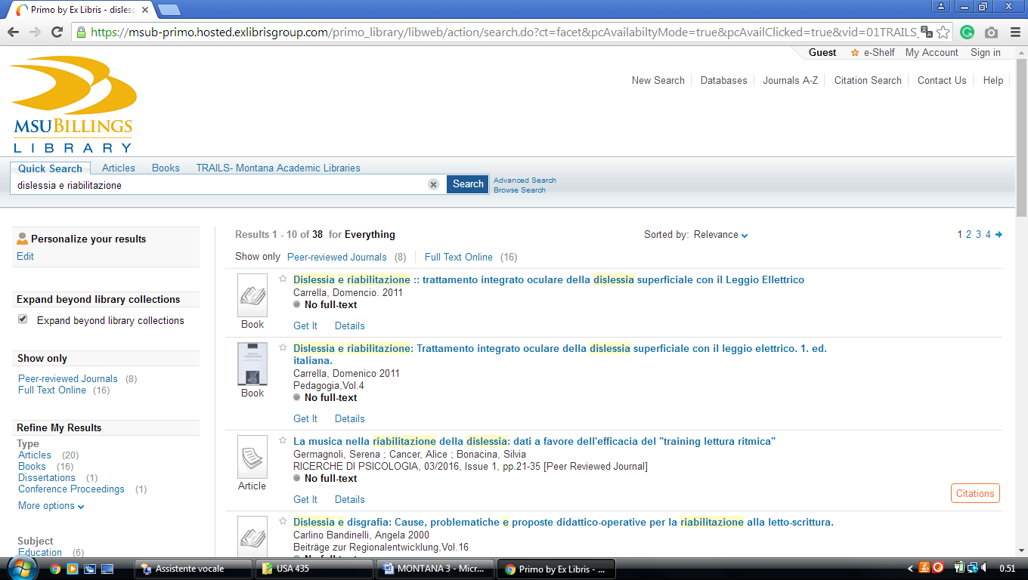

**2** [**MONTANA TECH LIBRARY**](http://www.mtech.edu/library/) – (Butte, Montana, Usa)

<https://mtech-primo.hosted.exlibrisgroup.com/primo-explore/search?institution=01TRAILS_UM_MTECH&vid=01TRAILS_UM_MTECH&tab=default_tab&search_scope=ALL-01TRAILS_UM_MTECH&query=any,contains,%20dislessia%20e%20riabilitazione&queryTemp=%20dislessia%20e%20riabilitazione&sortby=rank&lang=en_US&pcAvailability=true>

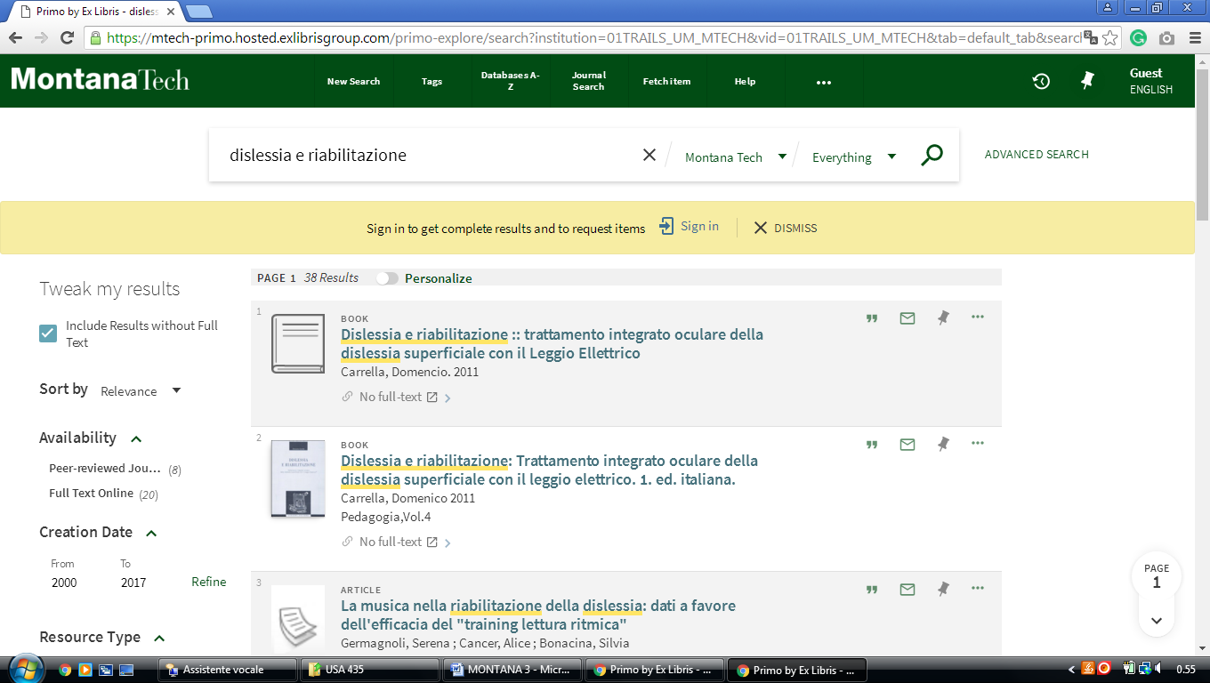

**3** [**NORTHERN VANDE BOGART LIBRARY**](http://www.msun.edu/infotech/library/) – (Havre, Montana, Usa)

<https://msun-primo.hosted.exlibrisgroup.com/primo-explore/search?institution=01TRAILS_MSU_NORTH&vid=01TRAILS_MSU_NORTH&tab=default_tab&query=any,contains,%20dislessia%20e%20riabilitazione&queryTemp=%20dislessia%20e%20riabilitazione&sortby=rank&lang=en_US>

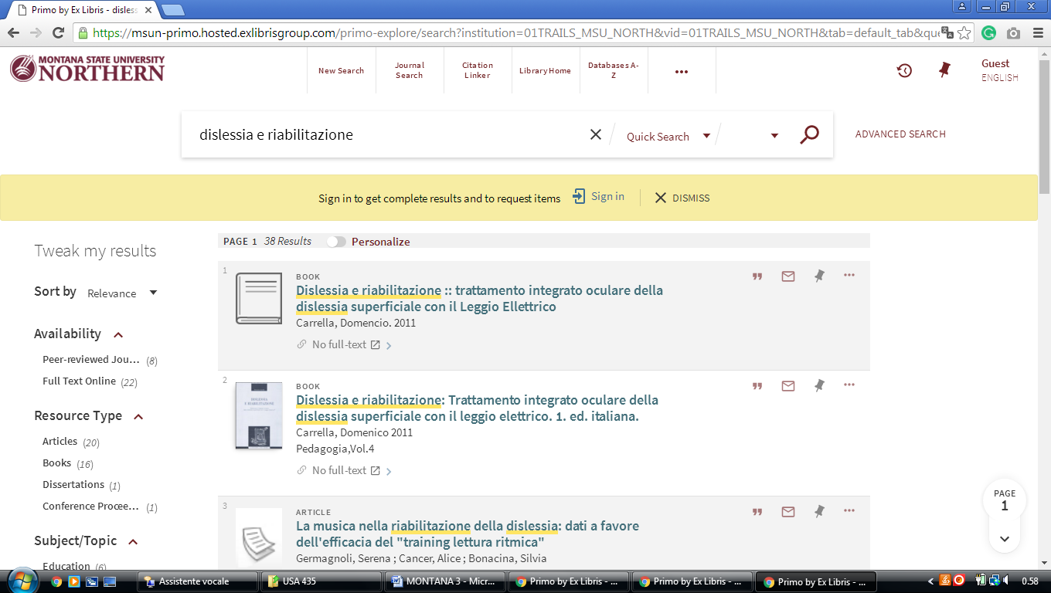

[University Of Providence, Library | Great Falls,](https://www.uprovidence.edu/academics/library/)

https://omni-primo.hosted.exlibrisgroup.com/primo-explore/search?vid=01TRAILS_UGF&search_scope=EVERYTHING&tab=everything&query=any,contains,dislessia%20e%20riabilitazione&pcAvailability=true&lang=en_US

