**MISSUORI = 9**

**1** [**PICKLER MEMORIAL LIBRARY**](http://library.truman.edu/) – (Kirksville, Missouri, Usa)

<http://truman.summon.serialssolutions.com/search?s.q=dislessia+e+riabilitazione&s.fvf%5B%5D=ContentType%2CBook+Review%2Ct&spellcheck=true#!/search?ho=f&fvf=ContentType,Book%20Review,t&l=en&q=dislessia%20e%20riabilitazione>

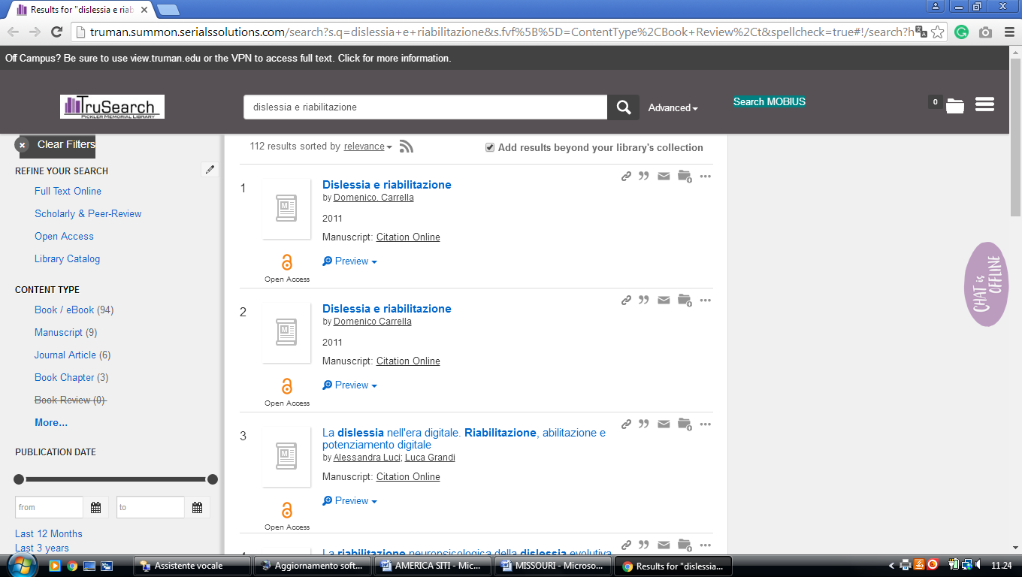

**2** [**CURTIS LAWS WILSON LIBRARY**](http://library.mst.edu/) – (Rolla, Missouri, USA)

<http://mst.summon.serialssolutions.com/search?s.fvf%5B%5D=ContentType%2CNewspaper+Article%2Ct&keep_r=true&s.q=dislessia+e+riabilitazione#!/search?ho=f&fvf=ContentType,Newspaper%20Article,t&l=en&q=dislessia%20e%20riabilitazione>

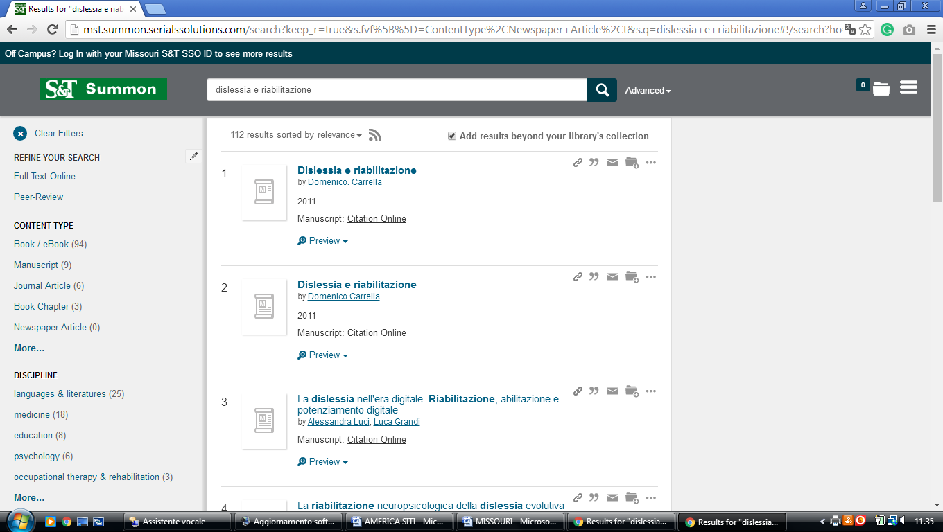

### 3 [LINDENWOOD LIBRARY | LINDENWOOD UNIVERSITY](http://library.lindenwood.edu/) - (St. Charles, Missouri, Usa)

<http://lindenwood.summon.serialssolutions.com/?#!/search?ho=f&l=en&q=dislessia%20e%20riabilitazione>

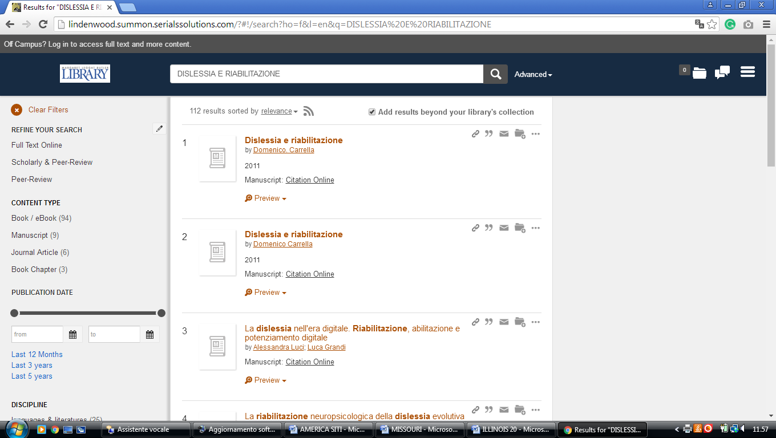

**4 [MIDWESTERN BAPTIST THEOLOGICAL](http://www.mbts.edu/current_students/library/" \t "_blank" \o "Midwestern Baptist Theological Seminary Library) SEMINARY LIBRARY - (**KC, MISSUORI, Usa)

<http://eds.a.ebscohost.com/eds/results?vid=3&sid=63b5e13c-8563-4d8e-8ffb-c002c1e31a28%40sessionmgr4009&bquery=(dislessia+AND+e+AND+riabilitazione)&bdata=JkF1dGhUeXBlPWlwLHVybCxjcGlkJmN1c3RpZD1zODM4NTA4MCZ0eXBlPTAmc2l0ZT1lZHMtbGl2ZQ%3d%3d>

**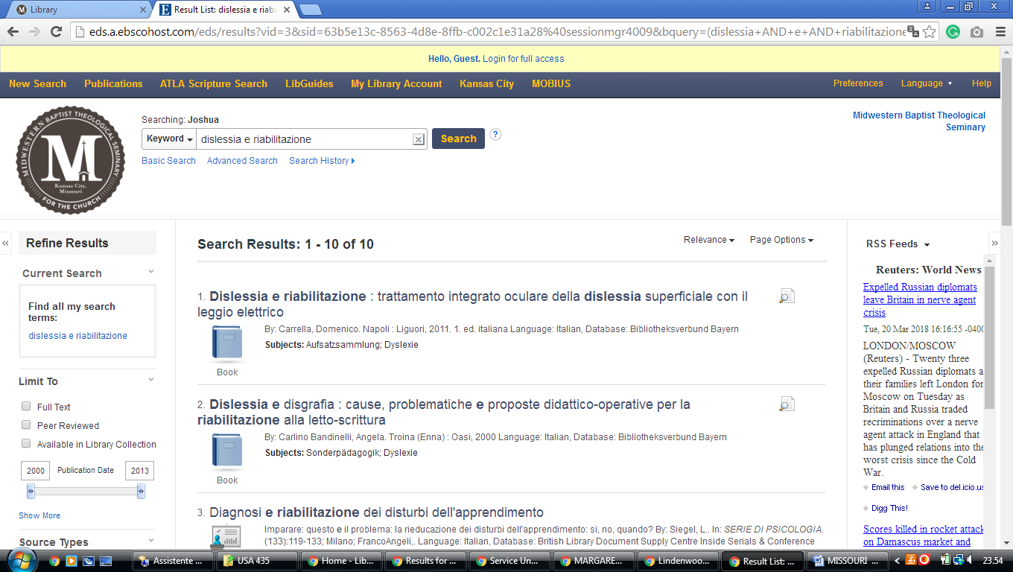**

### 5 [LIBRARY HOURS - JAMES C. KIRKPATRICK LIBRARY - UNIVERSITY OF CENTRAL ...](https://library.ucmo.edu/hours)(Warrensburg, Missouri, Usa)

<http://ucmo.summon.serialssolutions.com/search?q=dislessia%20e%20riabilitazione&s.q=dislessia+e%20riabilitazione#!/search?ho=f&l=en&q=dislessia%20e%20riabilitazione>

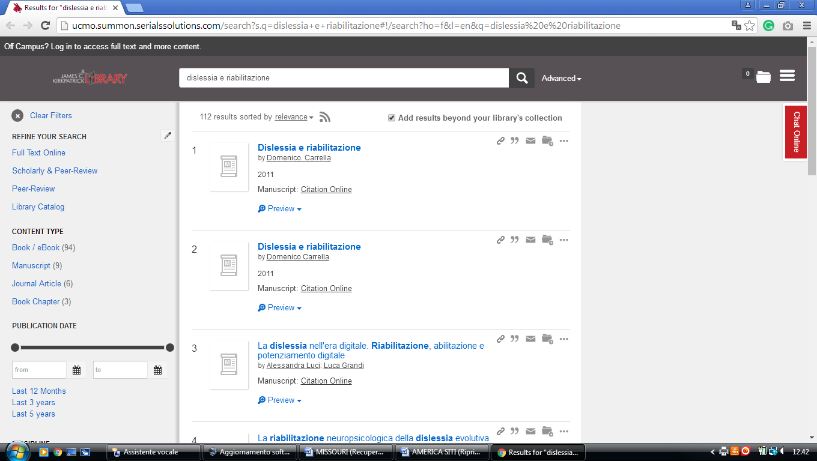

### 6 [MILLER NICHOLS LIBRARY - UMKC LIBRARIES - UNIVERSITY OF MISSOURI ...](https://library.umkc.edu/mnl)- (Missouri, Usa)

<https://umkc.summon.serialssolutions.com/?q=dislessia+e+riabilitazione&op=Submit&form_build_id=form-ACsBFfOMjmQnk52adMvsUkRfW1J8hZXOXkC8ABAAxB0&form_id=get_home_search_form#!/search?ho=f&l=it-IT&q=dislessia%20e%20riabilitazione&op=Submit&form_build_id=form-ACsBFfOMjmQnk52adMvsUkRfW1J8hZXOXkC8ABAAxB0&form_id=get_home_search_form>

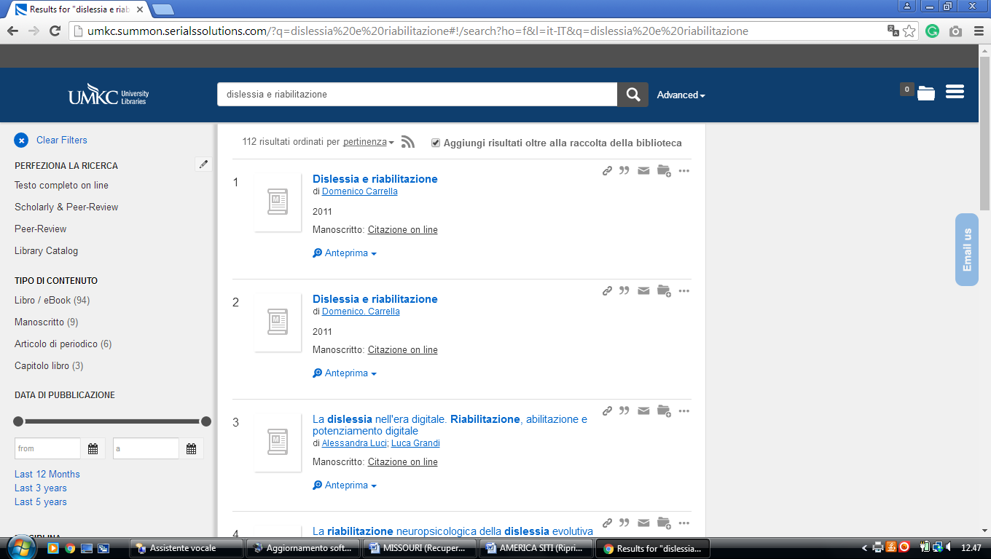

# 7 [UNIVERSITY OF MISSOURI-KANSAS CITY](http://library.umkc.edu/) LEON E. BLOCH LAW LIBRARY

<https://umkc.summon.serialssolutions.com/?q=dislessia%20e%20riabilitazione&fvf=Discipline,law,f#!/search?ho=f&l=it-IT&q=dislessia%20e%20riabilitazione>

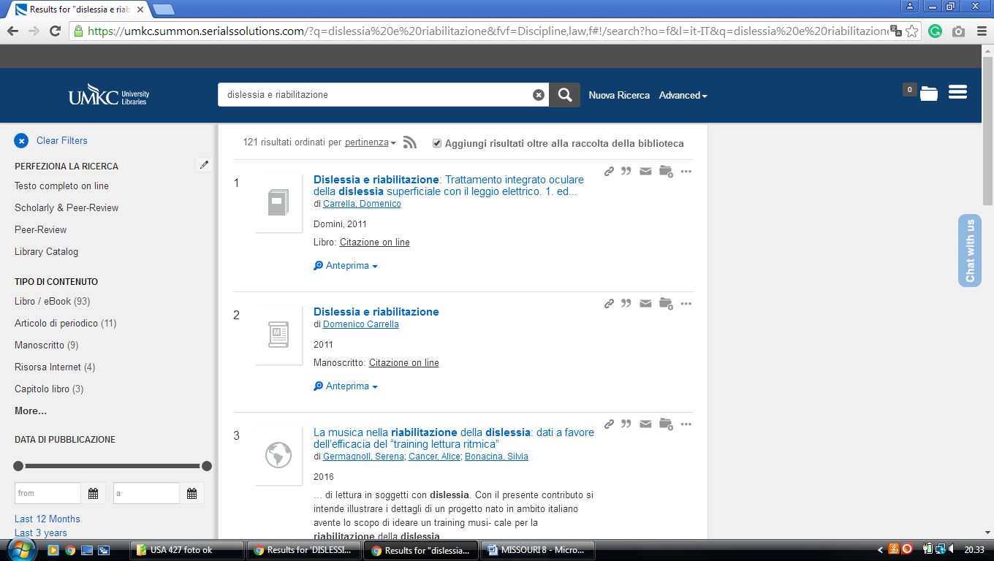

**8** [**UNIVERSITY OF MISSOURI - ST. LOUIS**](http://www.umsl.edu/library/)**, LIBRARY** – (Missouri, Usa)

<http://umsl.summon.serialssolutions.com/?q=dislessia+e+riabilitazione#!/search?ho=f&l=en&q=dislessia%20e%20riabilitazione>

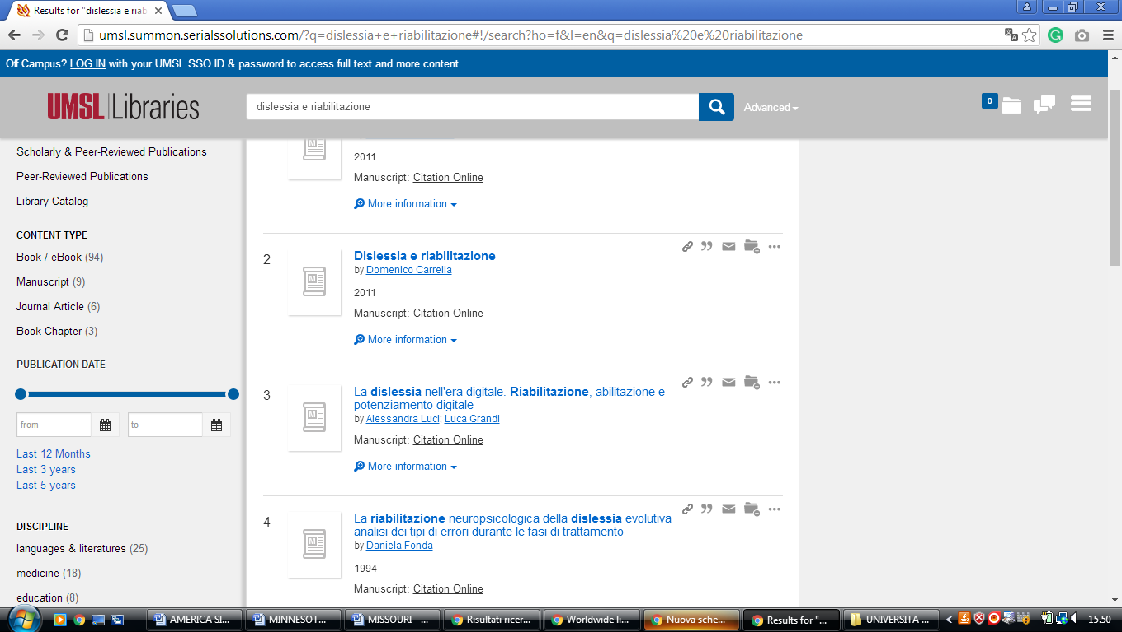

### 9 [MILLER NICHOLS LIBRARY | UNIVERSITY LIBRARIES](https://library.umkc.edu/mnl) - (St. Kansas City, Mo, Usa)

<https://umkc.summon.serialssolutions.com/?q=dislessia+e+riabilitazione&op=Submit&form_build_id=form-Bex82iE2i661sd24zLN5t0yQ764RDC-pmzn8BS3oFoQ&form_id=get_home_search_form#!/search?ho=f&l=it-IT&q=dislessia%20e%20riabilitazione&op=Submit&form_build_id=form-Bex82iE2i661sd24zLN5t0yQ764RDC-pmzn8BS3oFoQ&form_id=get_home_search_form>

