**MISSISIPI = 2**

**1** [**UNIVERSITY OF SOUTHERN MISSISSIPPI**](http://www.lib.usm.edu/) **LIBRARIES - (**Attiesburg Usa)

<http://primo-pmtna01.hosted.exlibrisgroup.com/primo_library/libweb/action/search.do?ct=facet&pcAvailabiltyMode=true&pcAvailClicked=true&set=all&query=any%2Ccontains%2Cdislessia%20e%20riabilitazione&vl(11963621UI0)=any&fn=search&indx=1&searchfield=dislessia%20e%20riabilitazione&search_scope=BLENDED&dscnt=0&scp.scps=scope%3A(USM_III)%2Cscope%3A(USM_IR)%2Cscope%3A(USM_P)%2Cscope%3A(USM_POH)%2Cprimo_central_multiple_fe&vid=USM&institution=01USM&bulkSize=10&ct=search&highlight=true&tab=default_tab&dym=true&displayField=title&vl(freeText0)=dislessia%20e%20riabilitazione&dstmp=1521583366236&fromDL>

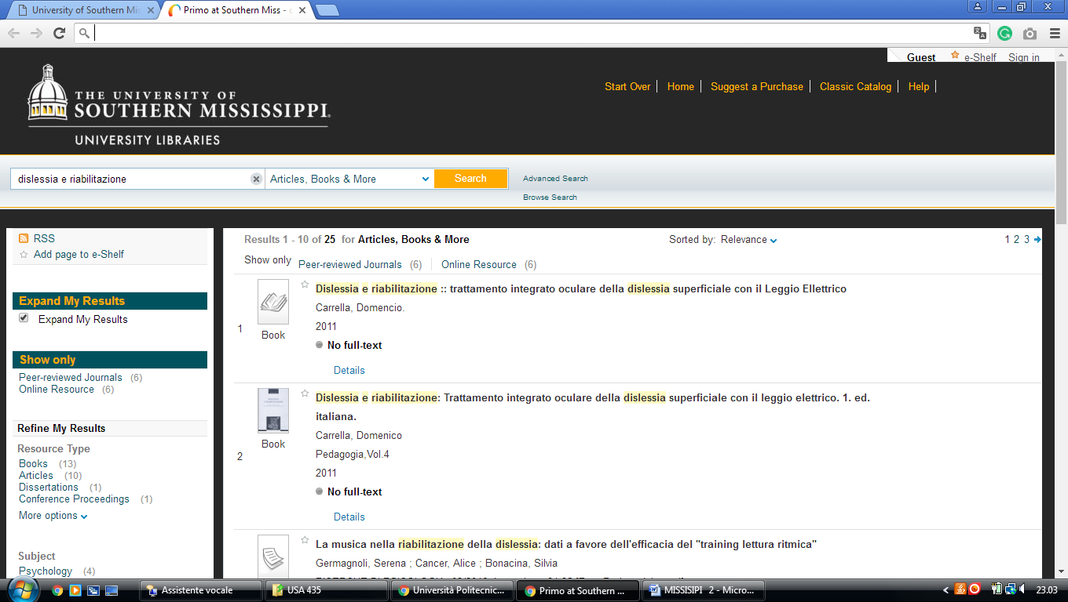

### 2 [THE UNIVERSITY OF MISSISSIPPI LIBRARIES | THE UNIVERSITY OF MISSISSIPPI ..](https://libraries.olemiss.edu/) ([Oxford](https://it.wikipedia.org/wiki/Oxford_(Mississippi)), [Mississippi](https://it.wikipedia.org/wiki/Mississippi), Usa)

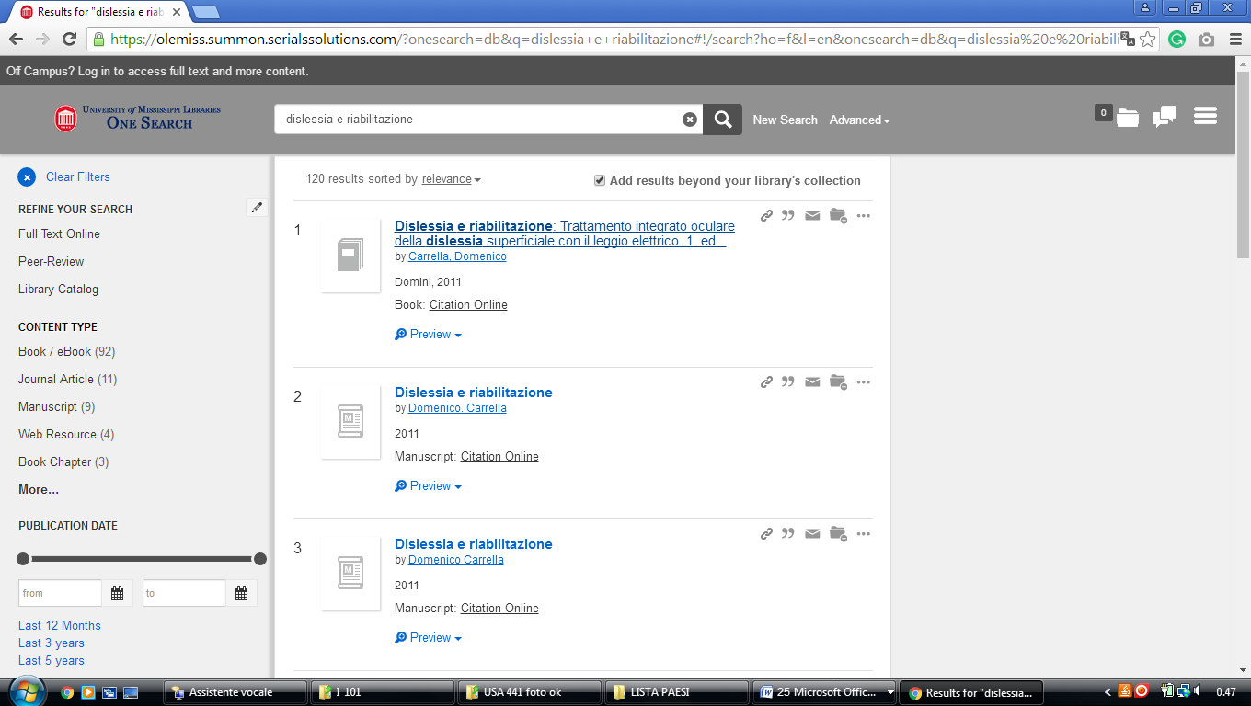<https://olemiss.summon.serialssolutions.com/?onesearch=db&q=dislessia+e+riabilitazione#!/search?ho=f&l=en&onesearch=db&q=dislessia%20e%20riabilitazione>