**MINNESOTA = 14**

### 1 [LIBRARY · CONCORDIA COLLEGE](https://www.concordiacollege.edu/library/) – (Moorhead, Minnesota, Usa)

<https://cord.on.worldcat.org/search?sortKey=LIBRARY&databaseList=&queryString=dislessia+e+riabilitazione&changedFacet=author&scope=&format=all&database=all&author=Carrella%2C+Domenico&year=all&yearFrom=&yearTo=&language=all&topic=all>

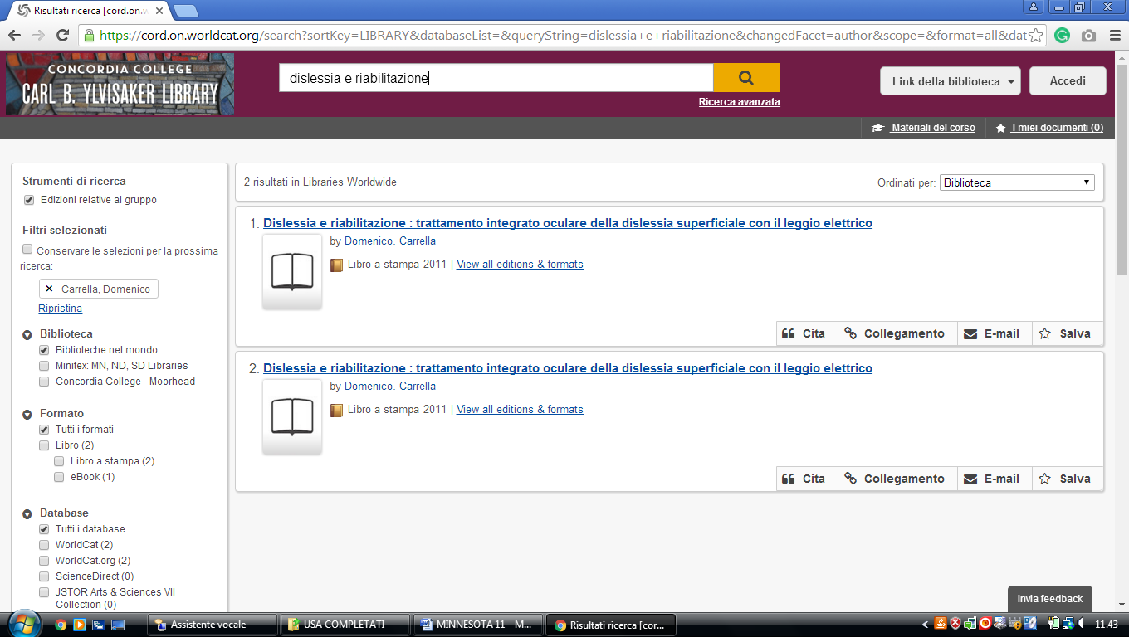

### 2 [ST. CATHERINE UNIVERSITY LIBRARIES, MEDIA SERVICES, & ARCHIVES ...](http://library.stkate.edu/) (st. Paul, Minnesota, Usa)

<https://clicsearch.stkate.edu/primo-explore/search?query=any,contains,dislessia%20e%20riabilitazione&tab=default_tab&search_scope=stkate&vid=STKATE&mode=Basic&sortby=rank&pcAvailability=true>

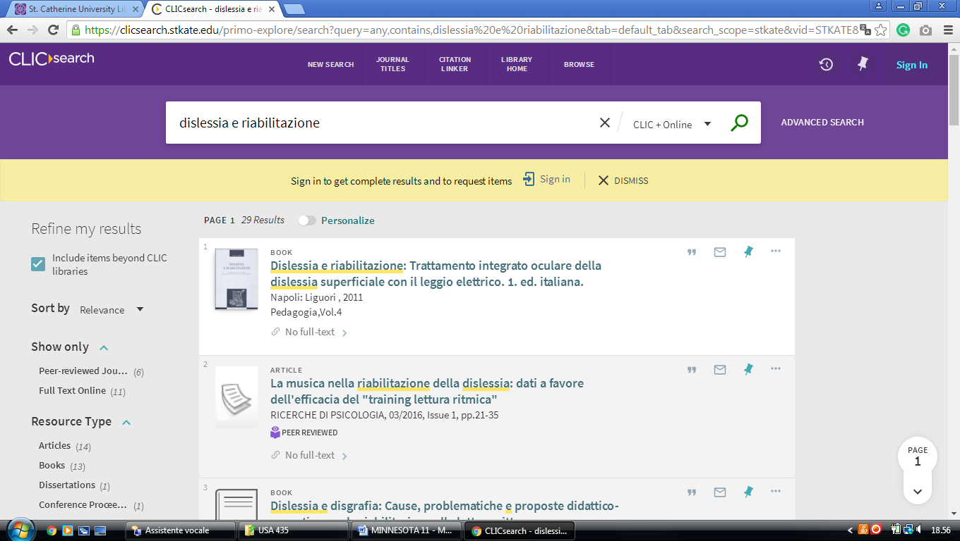

### 3 [DEWITT WALLACE LIBRARY - MACALESTER COLLEGE](https://www.macalester.edu/library/) - (St. Paul, Minnesota, Usa)

<https://macalester.on.worldcat.org/search?sortKey=LIBRARY&databaseList=&queryString=dislessia+e+riabilitazione&changedFacet=author&scope=&format=all&database=all&author=Carrella%2C+Domenico&year=all&yearFrom=&yearTo=&language=all&topic=all>

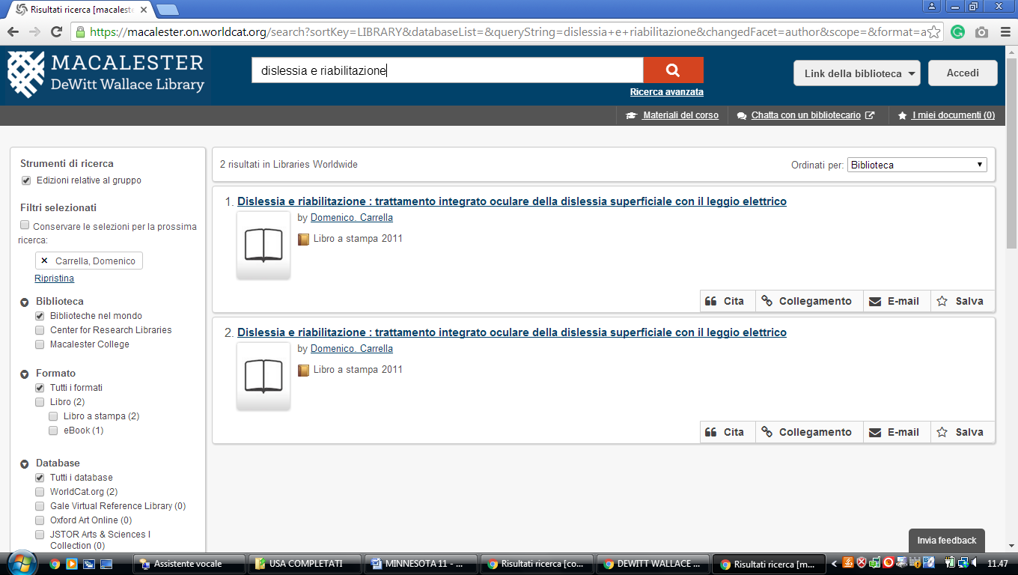

**4** [**GOULD LIBRARY**](http://apps.carleton.edu/campus/library/) **NORTHFIELD** – (Minnesota, Usa)

<https://carleton-primo.hosted.exlibrisgroup.com/primo-explore/search?vid=01BRC_CCO&tab=default_tab&search_scope=Everything&offset=0&query=any,contains,dislessia%20e%20riabilitazione&sortby=rank&pcAvailability=true>

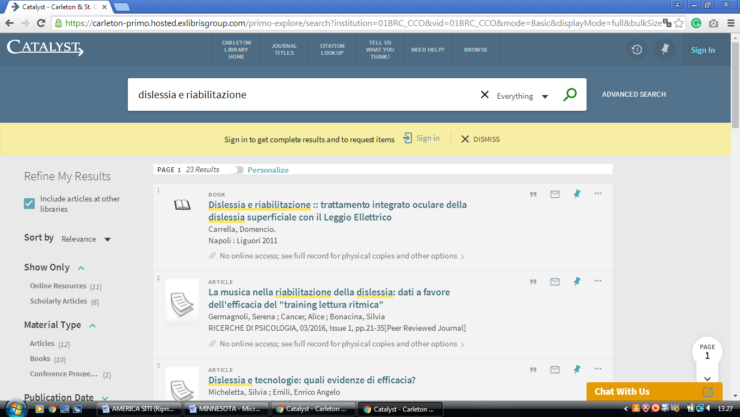

**5** [**LINDELL LIBRARY**](http://library.augsburg.edu/) - (Minneapolis, Minnesota, Usa)

<https://augsburg.on.worldcat.org/search?sortKey=BEST_MATCH&databaseList=&queryString=dislessia+e+riabilitazione&changedFacet=scope&clusterResults=on&stickyFacetsChecked=on&scope=&scope=sz%3A37159>

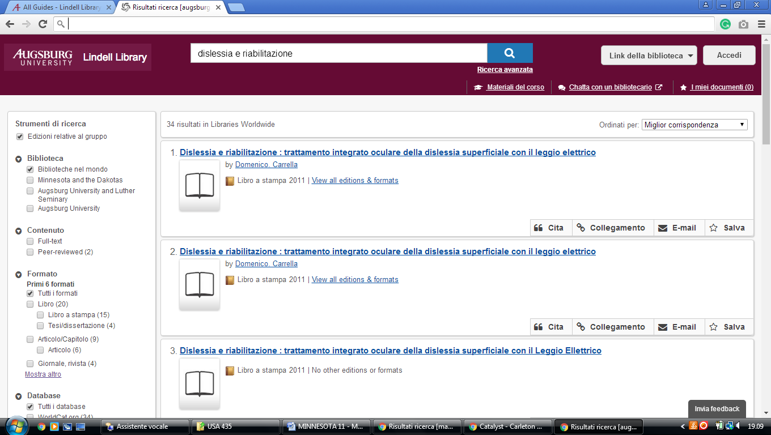

### 6 [LIBRARY - LUTHER SEMINARY](https://www.luthersem.edu/library/) – (St. Paul, Minnesota, Usa)

<https://luthersem.on.worldcat.org/search?sortKey=LIBRARY&databaseList=638&queryString=dislessia+e+riabilitazione&changedFacet=author&scope=&format=all&database=all&author=Carrella%2C+Domenico&year=all&yearFrom=&yearTo=&language=all&topic=all>

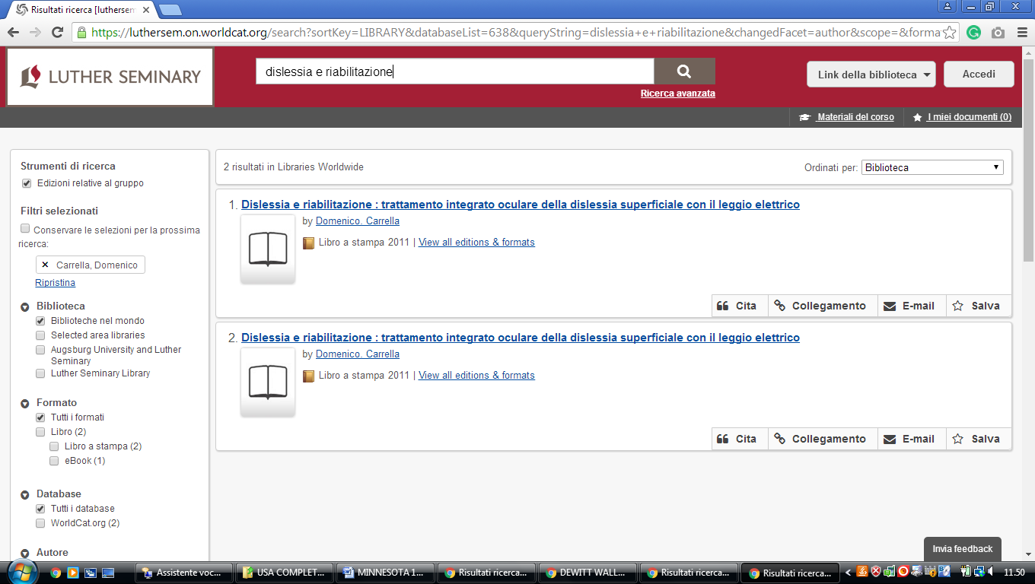

### 7 [MNLINK](https://mnlink.org/)

<https://mnlink.on.worldcat.org/search?sortKey=BEST_MATCH&databaseList=&queryString=dislessia+e+riabilitazione&changedFacet=scope&scope=&format=all&database=all&author=all&year=all&yearFrom=&yearTo=&language=all>

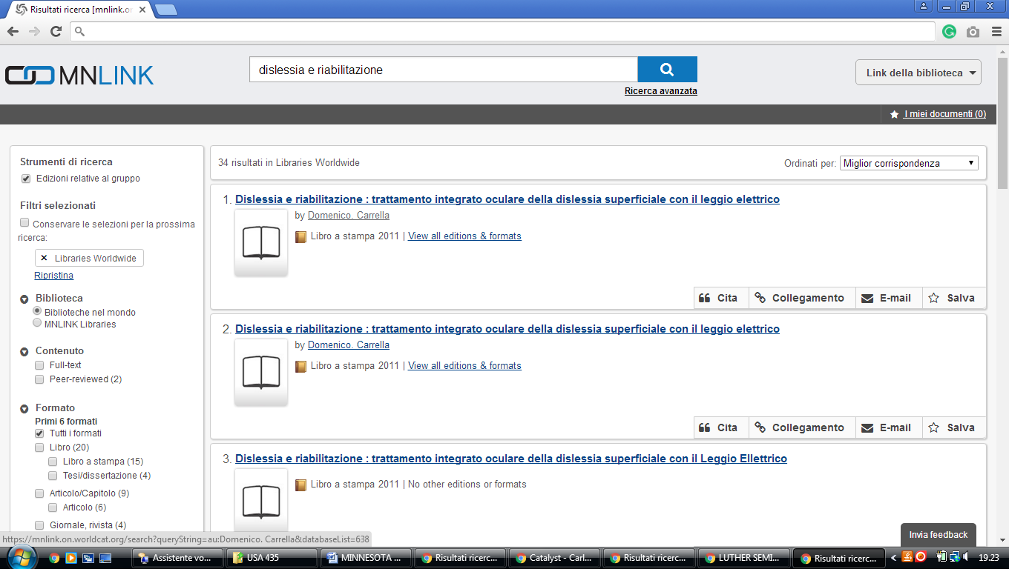

**8 MINNESOTA STATE UNIVERSITY LIBRARY – (**Mankato, Minnesota, Usa)

<http://mnsu.summon.serialssolutions.com/?s.q=dislessia+e+riabilitazione#!/search?ho=f&l=en&q=dislessia%20e%20riabilitazione>

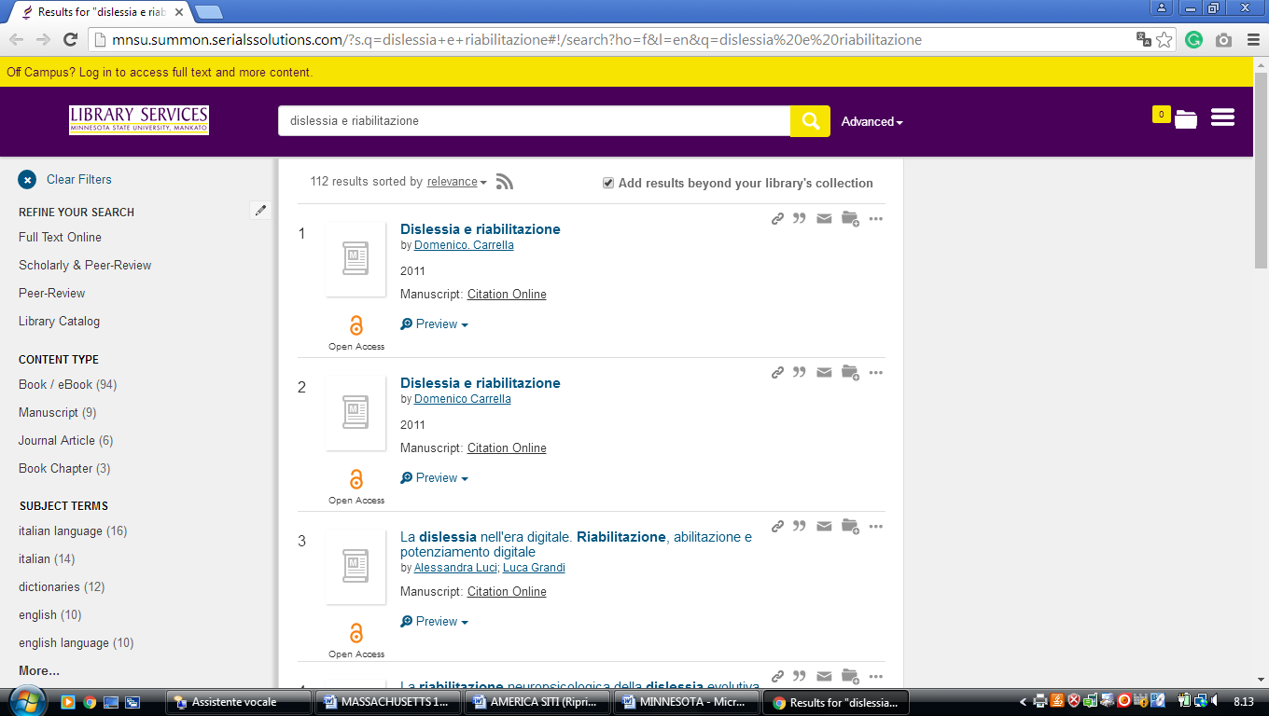

### 9 [LIBRARY – MINNESOTA STATE UNIVERSITY, MANKATO](http://lib.mnsu.edu/) – (Mankato, Minnesota, Usa)

<https://minnesotastateuniversity-mankato.on.worldcat.org/search?databaseList=&queryString=dislessia+e+riabilitazione>

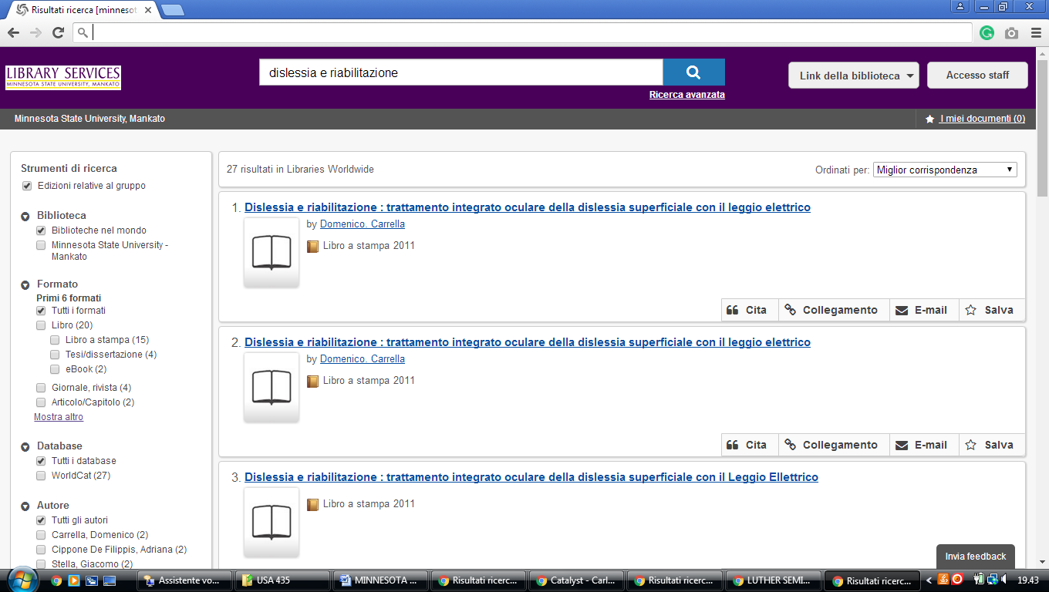

**10** [**ST. OLAF COLLEGE LIBRARIES**](http://www.stolaf.edu/library/index.cfm) - (Northfield, Minnesota, Usa)

<https://stolaf-primo.hosted.exlibrisgroup.com/primo-explore/search?vid=01BRC_SOC&tab=default_tab&search_scope=Everything&offset=0&query=any,contains,dislessia%20e%20riabilitazione&sortby=rank&pcAvailability=true>

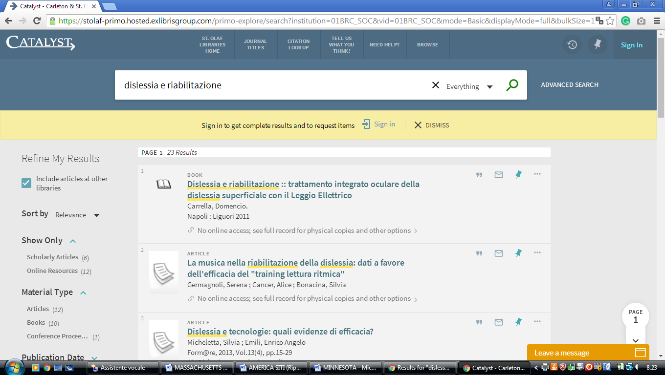

**11** [**CROWN COLLEGE LIBRARY**](https://www.crownlibrary.com/)[– ( st. Bonifacius](https://en.wikipedia.org/wiki/St._Bonifacius,_Minnesota), [Minnesota](https://en.wikipedia.org/wiki/Minnesota), [Usa](https://en.wikipedia.org/wiki/United_States" \o "United States))

### https://crownlibrary.on.worldcat.org/external-search?queryString=dislessia+e+riabilitazione

### 

### 12 [LIBRARIES – UNIVERSITY LIBRARIES – UNIVERSITY OF ST. THOMAS – MINNESOTA](https://www.stthomas.edu/libraries/)

### 12 [CLICSEARCH - CLIC](https://www.clic.edu/clicsearch)

### <https://clicsearch.bethel.edu/primo-explore/search?query=any,contains,dislessia%20e%20riabilitazione&tab=default_tab&search_scope=bethel&vid=BETHEL&offset=0&sortby=rank&pcAvailability=true>

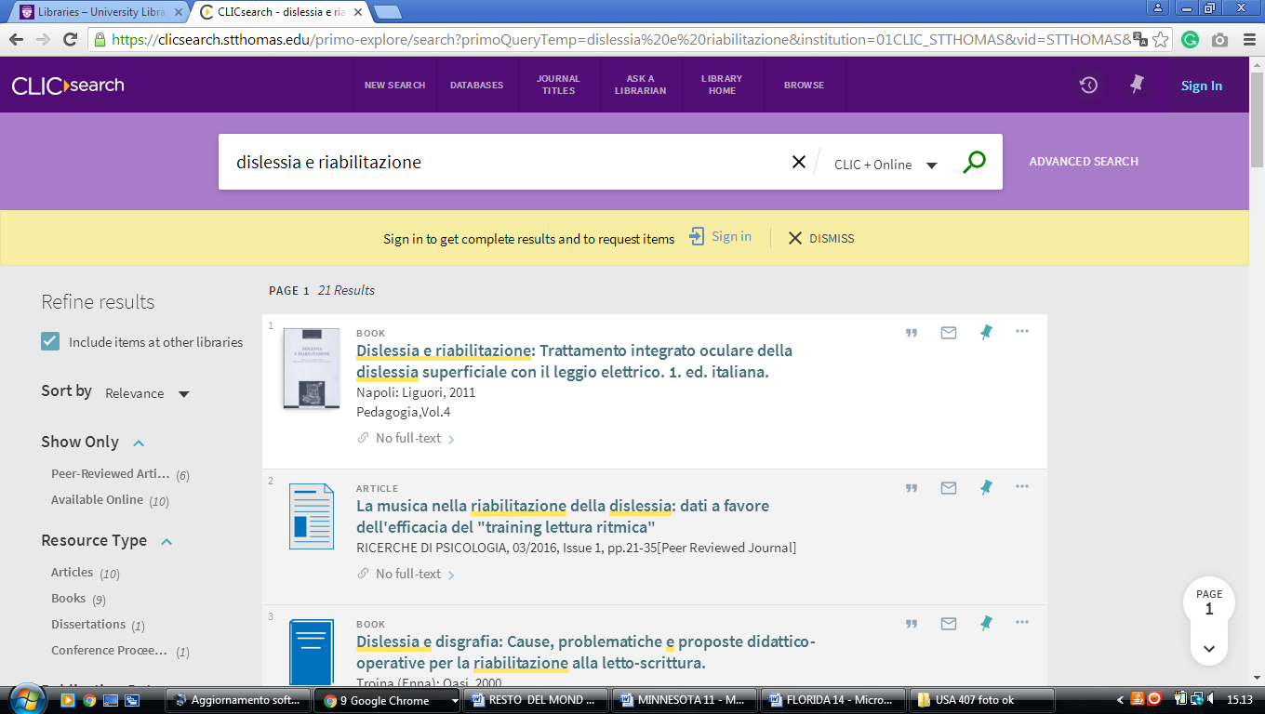

### 13 [LIBRARY - GUSTAVUS ADOLPHUS COLLEGE](https://gustavus.edu/library/) - ([St.Peter](https://en.wikipedia.org/wiki/St._Peter,_Minnesota" \o "St. Peter, Minnesota), [Minnesota](https://en.wikipedia.org/wiki/Minnesota), Usa)

<https://gustavusadolphuscollege.on.worldcat.org/search?sortKey=LIBRARY&databaseList=&queryString=kw%3Adislessia+e+riabilitazione&changedFacet=scope&clusterResults=on&scope=&scope=wz%3A1052>

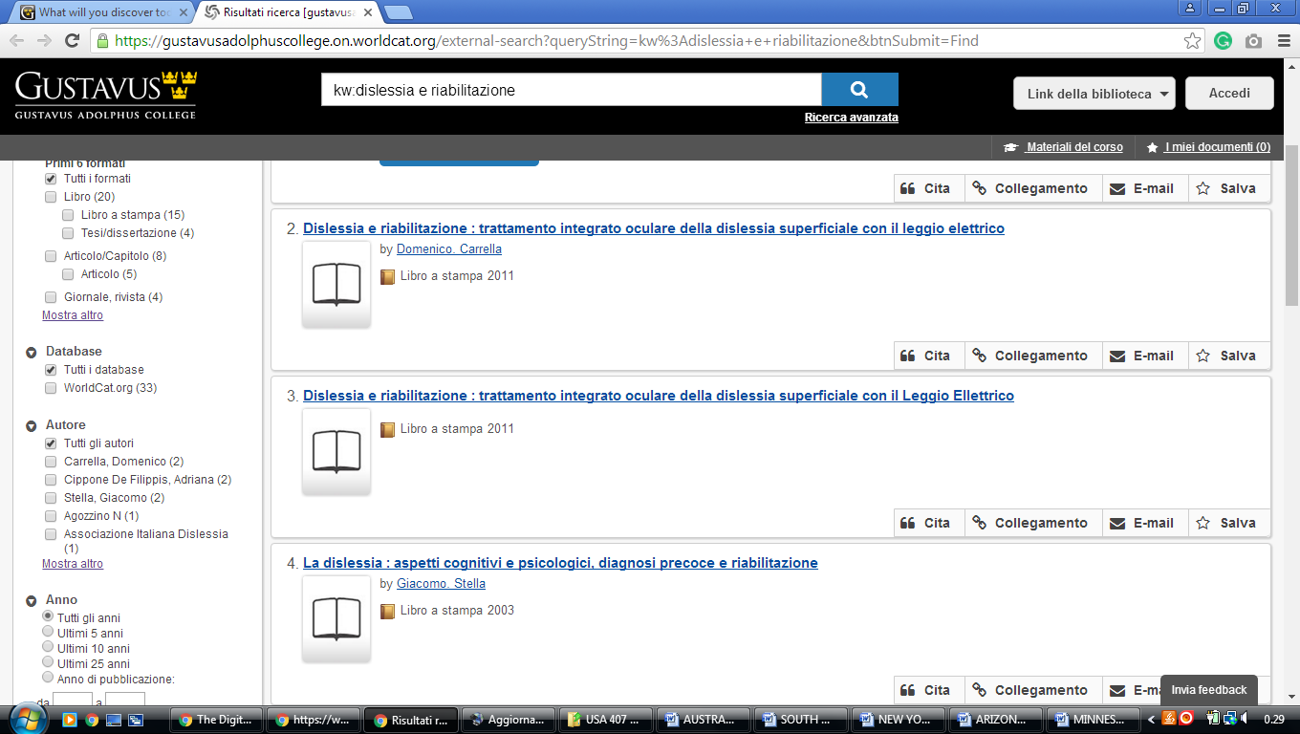

**14** [**CLICSEARCH – UNIVERSITY LIBRARIES - UNIVERSITY OF ST. THOMAS**](https://www.stthomas.edu/libraries/ask/clicsearch/) **-**  [(Minneapolis](https://en.wikipedia.org/wiki/Minneapolis,_MN), [Minnesota](https://en.wikipedia.org/wiki/Minnesota), [Usa](https://en.wikipedia.org/wiki/United_States" \o "United States))

<https://clicsearch.stthomas.edu/primo-explore/search?query=any,contains,dislessia%20e%20riabilitazione&tab=default_tab&search_scope=stthomas&vid=STTHOMAS&offset=0&sortby=rank&pcAvailability=true>

