**MICHIGAN = 14**

### 1 [OU LIBRARIES - OAKLAND UNIVERSITY](https://library.oakland.edu/) - (Rochester, Michigan, Usa)

<https://oakland.summon.serialssolutions.com/search?s.q=dislessia+e+riabilitazione#!/search?ho=f&l=en&q=dislessia%20e%20riabilitazione>

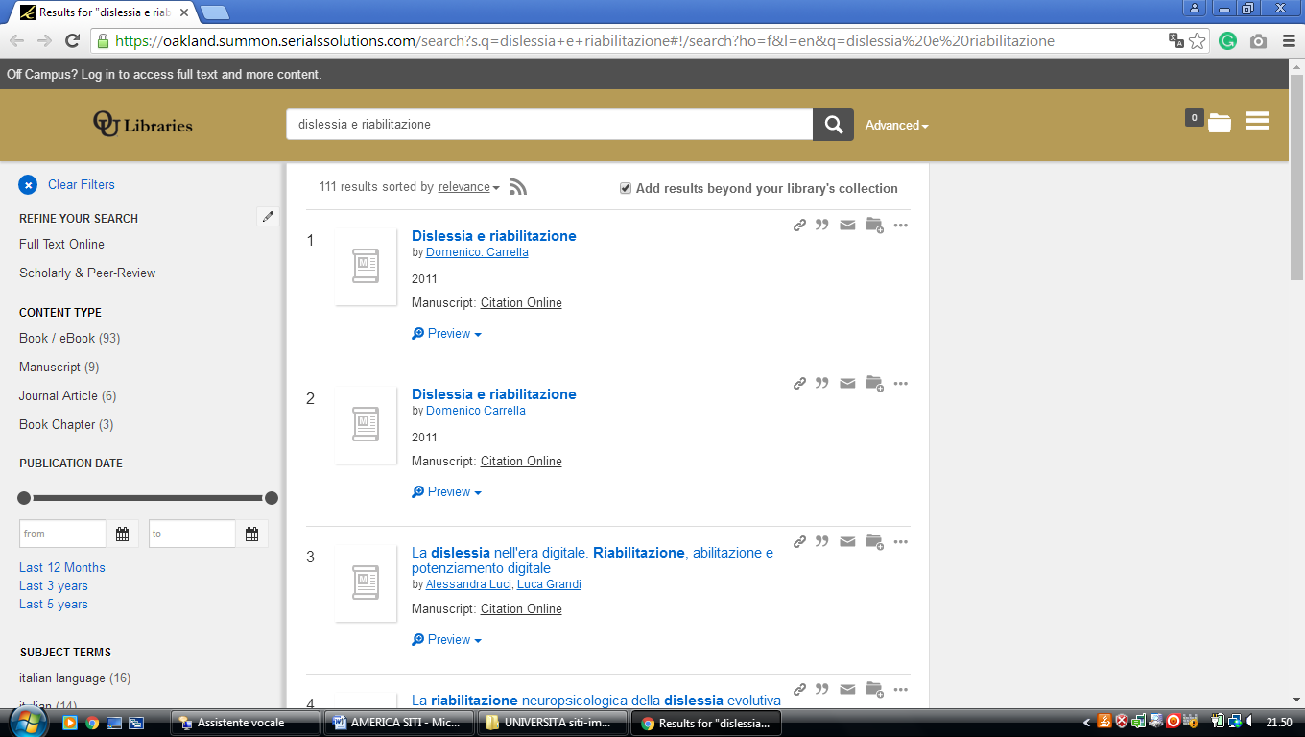

**2** [**MARDIGIAN LIBRARY**](http://library.umd.umich.edu/index.php) - (Dearborn, Michigan, Usa)

<https://umdearborn.summon.serialssolutions.com/search/results?q=dislessia+e+riabilitazione&spellcheck=true#!/search?ho=f&l=en&q=dislessia%20e%20riabilitazione>

**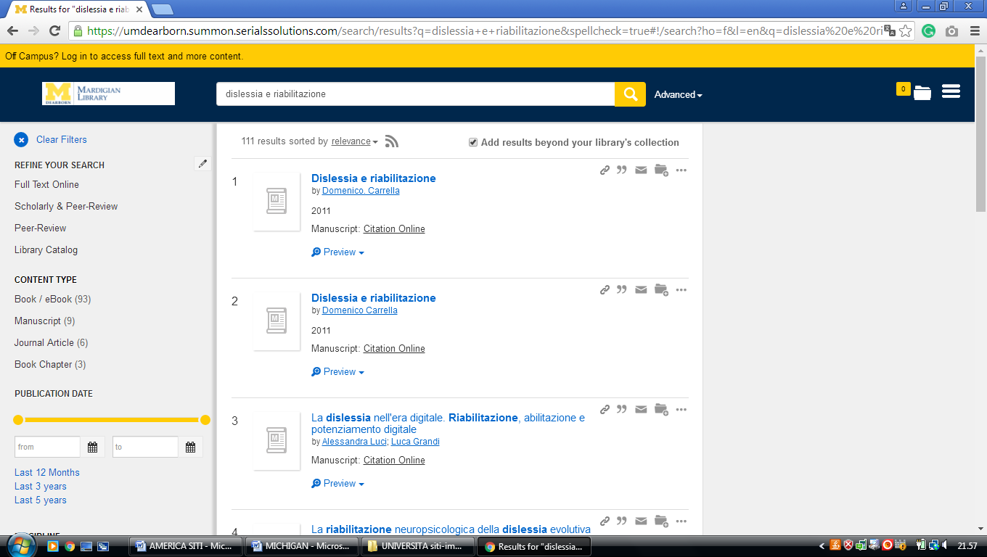**

**3** [**MILLER IBRARY**](http://library.cornerstone.edu/) - (Grand Rapids, Michigan, Usa)

<https://cornerstone.summon.serialssolutions.com/?#!/search?ho=f&fvf=ContentType,Newspaper%20Article,t%7CContentType,Book%20Review,t%7CContentType,Newpaper%20Article,t%7CContentType,Newsletter,t&l=en&q=dislessia%20e%20riabilitazione>

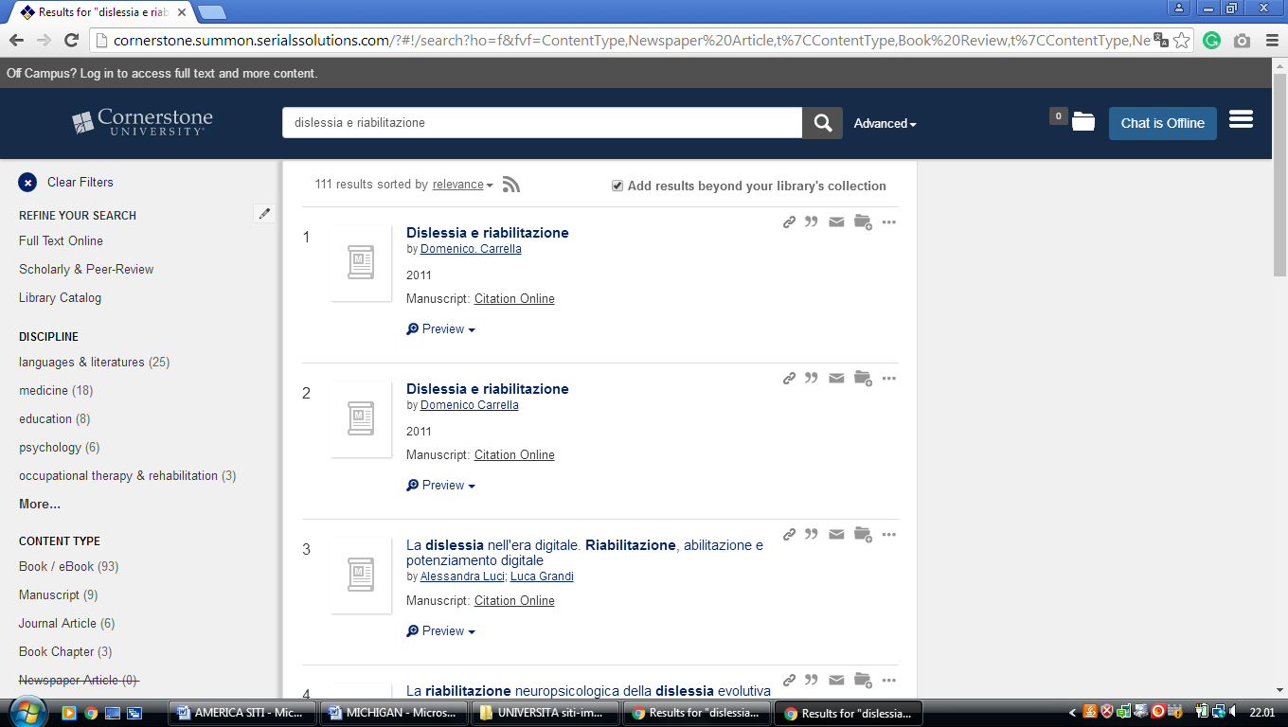

**4**  [**EASTERN MICHIGAN UNIVERSITY LIBRARY**](http://www.emich.edu/library/index.php) **– (**Ypsilanti , Michigan, Usa)

<https://emich.summon.serialssolutions.com/search?s.q=dislessia+e+riabilitazione&utf8=%E2%9C%93&s.fvf%5B%5D=ContentType%2CNewspaper+Article%2Ct&spellcheck=true&keep_r=true#!/search?ho=f&fvf=ContentType,Newspaper%20Article,t&l=en&q=dislessia%20e%20riabilitazione>

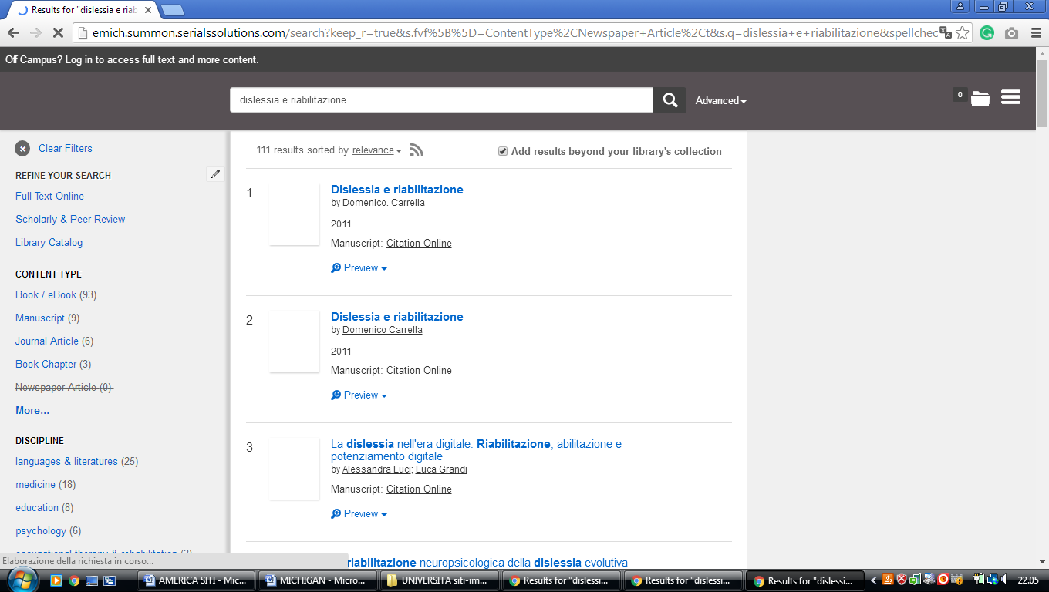

**5** [**GRACE HAUENSTEIN LIBRARY**](http://www.aquinas.edu/library/) – (Grand Rapids, Michigan, Usa)

<https://aquinas.summon.serialssolutions.com/#!/search?ho=f&l=en&q=dislessia%20e%20riabilitazione>

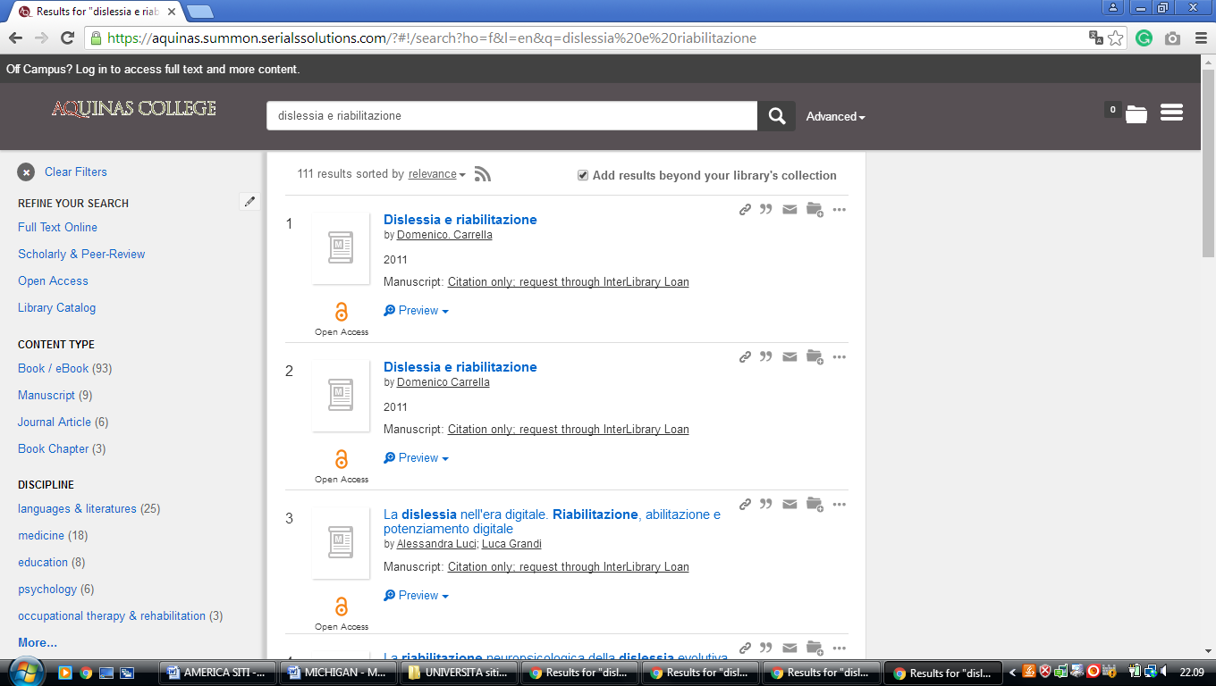

**6** **[GRAND VALLEY STATE UNIVERSITY](http://www.gvsu.edu/library/" \t "_blank" \o "Grand Valley State University Libraries) LIBRARIES - (**Allendale, Michigan, Usa)

<https://gvsu.summon.serialssolutions.com/search?spellcheck=true&s.q=dislessia+e+riabilitazione#!/search?ho=f&l=en&q=dislessia%20e%20riabilitazione>

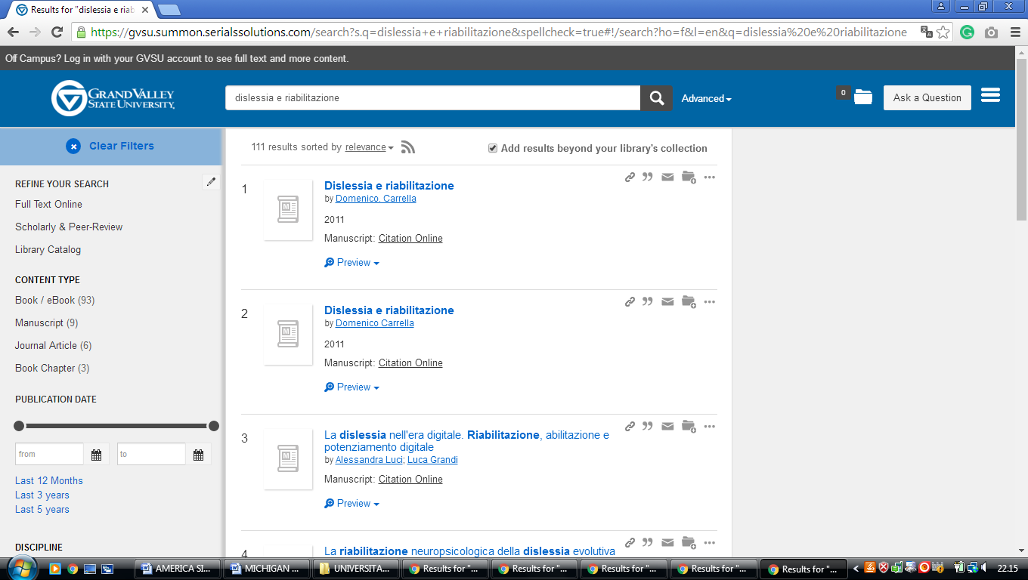

**7** [**HFCC ESHLEMAN LIBRARY**](http://library.hfcc.edu/) – (Dearborn, Michigan, Usa)

<https://hfcc.summon.serialssolutions.com/#!/search?ho=f&l=en&q=dislessia%20e%20riabilitazione>

**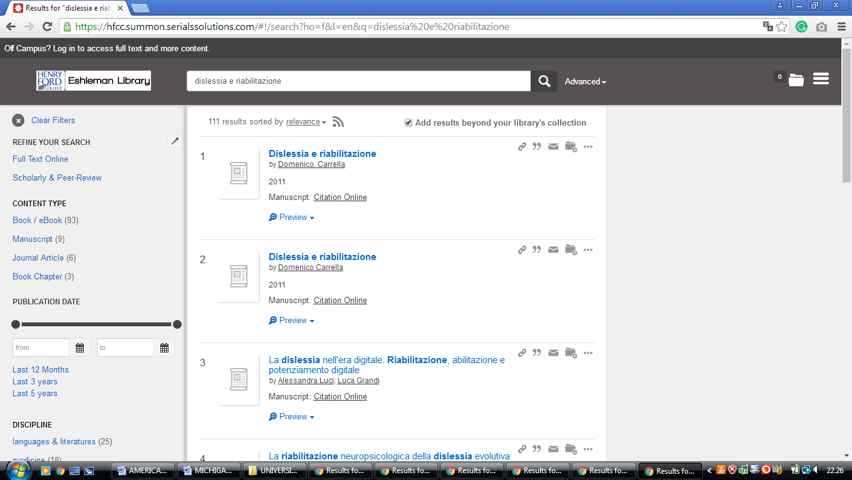**

**8** [**LAWRENCE TECH LIBRARY**](http://www.ltu.edu/library/index1.asp) – (Southfield, Michigan, Usa)

<https://ltu.on.worldcat.org/search?queryString=dislessia+e+riabilitazione>

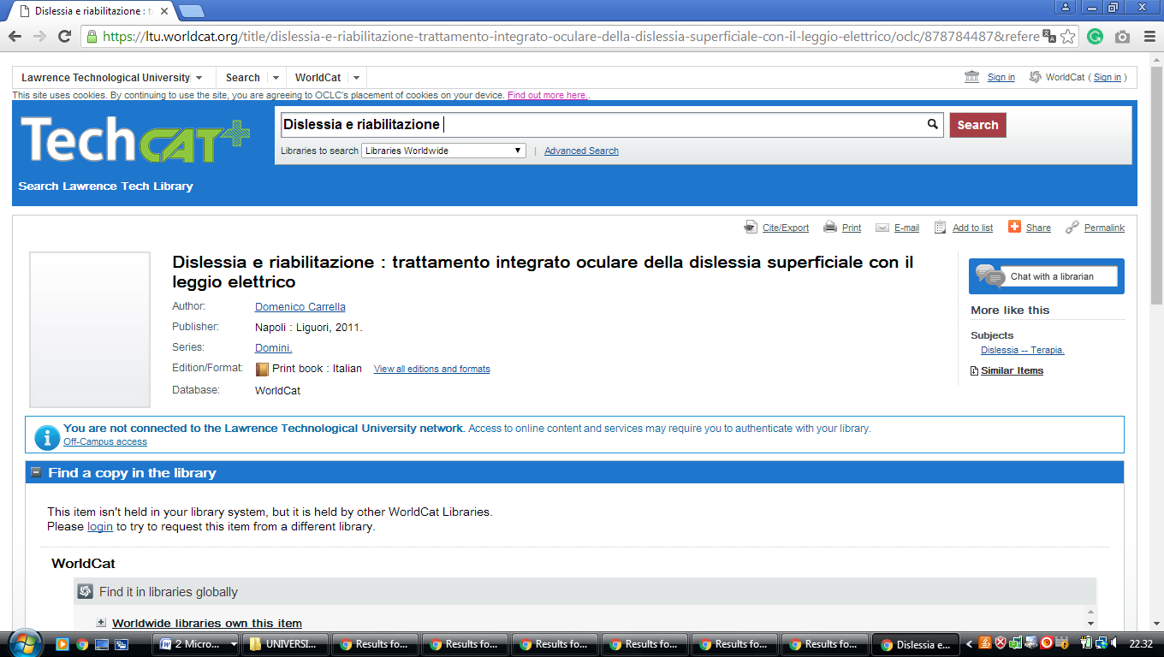

**9** [**LYDIA M. OLSON LIBRARY**](http://library.nmu.edu/)  - (Marquette, Michigan, Usa)

<https://nmu.summon.serialssolutions.com/search?q=dislessia+e+riabilitazione#!/search?ho=f&l=en&q=dislessia%20e%20riabilitazione>

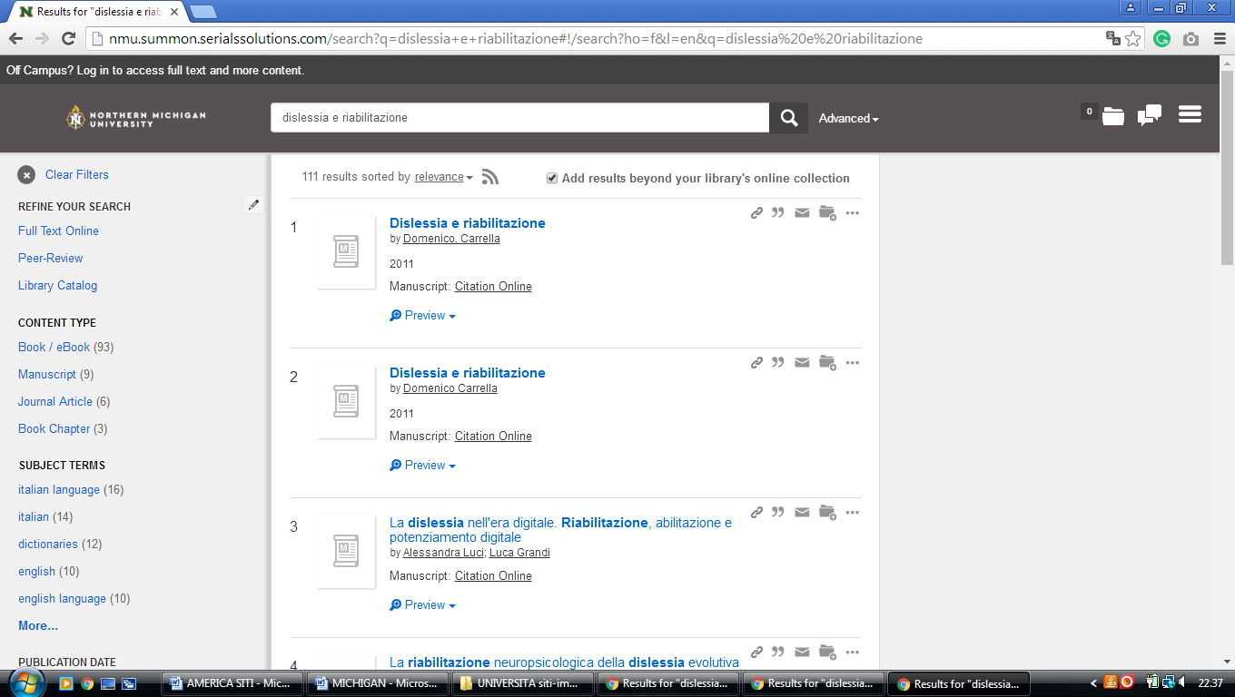

**10** [**MICHIGAN STATE UNIVERSITY LIBRARIES**](http://www.lib.msu.edu/) **– (**East Lansing, Michigan, Usa)

<http://msulibraries.summon.serialssolutions.com/advanced#!/search?ho=f&l=en&q=(dislessia%20e%20riabilitazione)>

**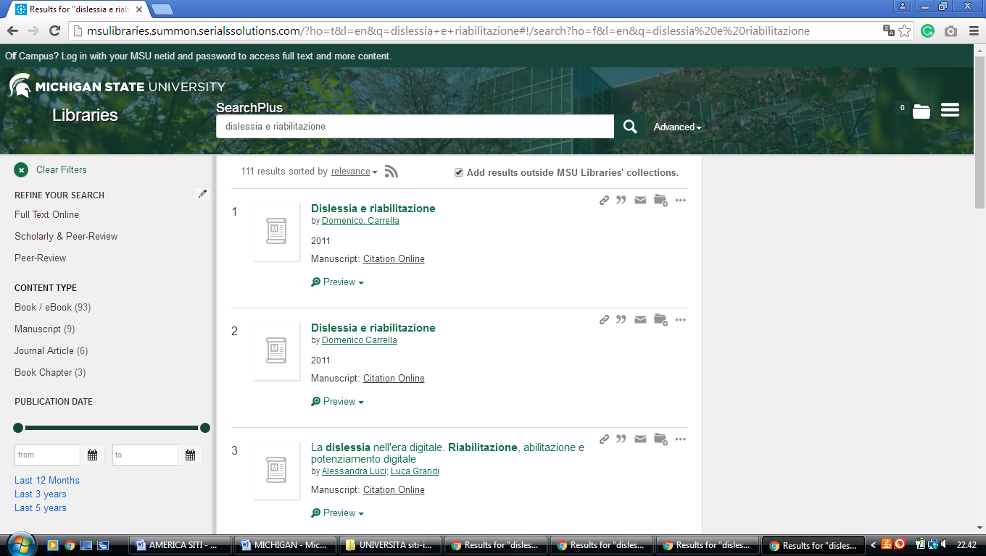**

**11** [**STOCKWELL-MUDD LIBRARY**](http://campus.albion.edu/library/) – (Albion, Michigan, Usa)

<http://albion.summon.serialssolutions.com/?#!/search?ho=f&l=en&q=dislessia%20e%20riabilitazione>

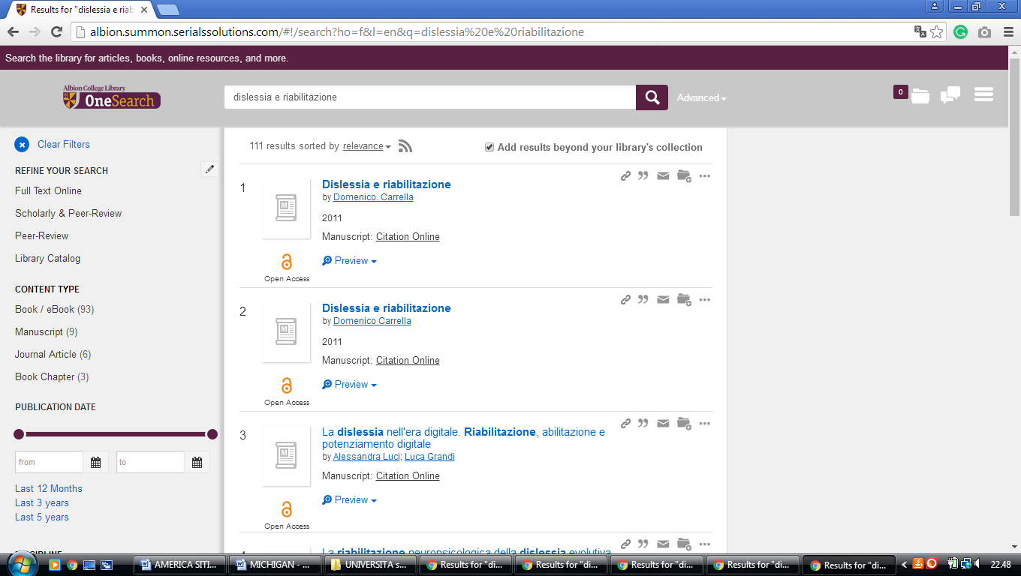

**12** [**WESTERN MICHIGAN UNIVERSITY LIBRARIES**](http://www.wmich.edu/library/) – **(**Kalamazoo, Michigan, Usa)

<https://primo-pmtna01.hosted.exlibrisgroup.com/primo-explore/search?vid=01WMU&search_scope=EVERYTHING&tab=default_tab&query=any,contains,dislessia%20e%20riabilitazione&offset=1&sortby=rank&lang=en_US&pcAvailability=true>

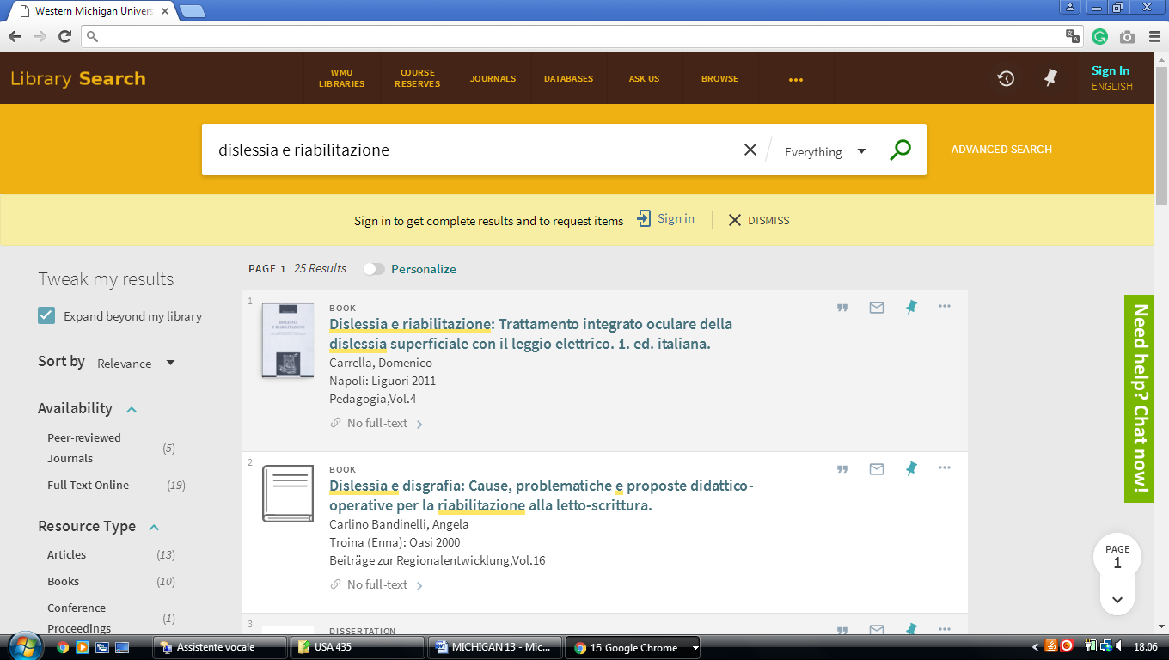

**13 EASTERN MICHIGAN UNIVERSITYLIBRARY –** (Ypsilanti, Michigan, Usa)

<https://emich.summon.serialssolutions.com/search?s.q=dislessia+e+riabilitazione&utf8=%E2%9C%93&s.fvf%5B%5D=ContentType%2CNewspaper+Article%2Ct&spellcheck=true&keep_r=true#!/search?ho=f&fvf=ContentType,Newspaper%20Article,t&l=en&q=dislessia%20e%20riabilitazione>

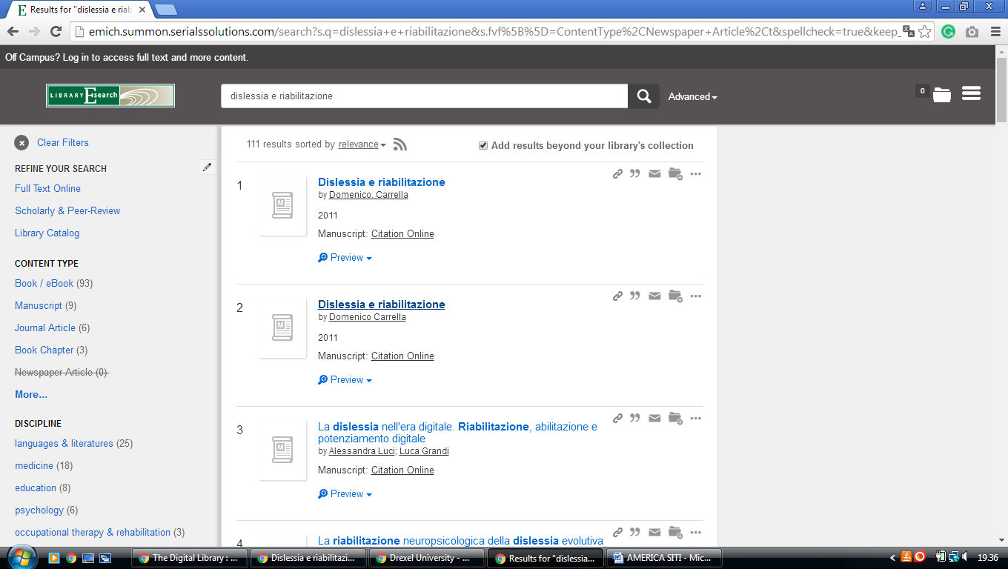

### 14 [HOMEPAGE | U-M LIBRARY - UNIVERSITY OF MICHIGAN](https://www.lib.umich.edu/) - ([Ann Arbor, Michigan](https://en.wikipedia.org/wiki/Ann_Arbor,_Michigan))

<https://search.lib.umich.edu/articles?query=dislessia+e+riabilitazione&filter.holdings_only=false>

