**MASSACHUSSETES = 20**

**1** [**AMELIA V. GALLUCCI-CIRIO LIBRARY**](http://www.fitchburgstate.edu/academics/library/) – (Fitchburg, Massachusetts, USA)

<https://fitchburgstate.summon.serialssolutions.com/search?utf8=%E2%9C%93&s.q=dislessia+e+riabilitazione#!/search?ho=f&l=en&q=dislessia%20e%20riabilitazione>

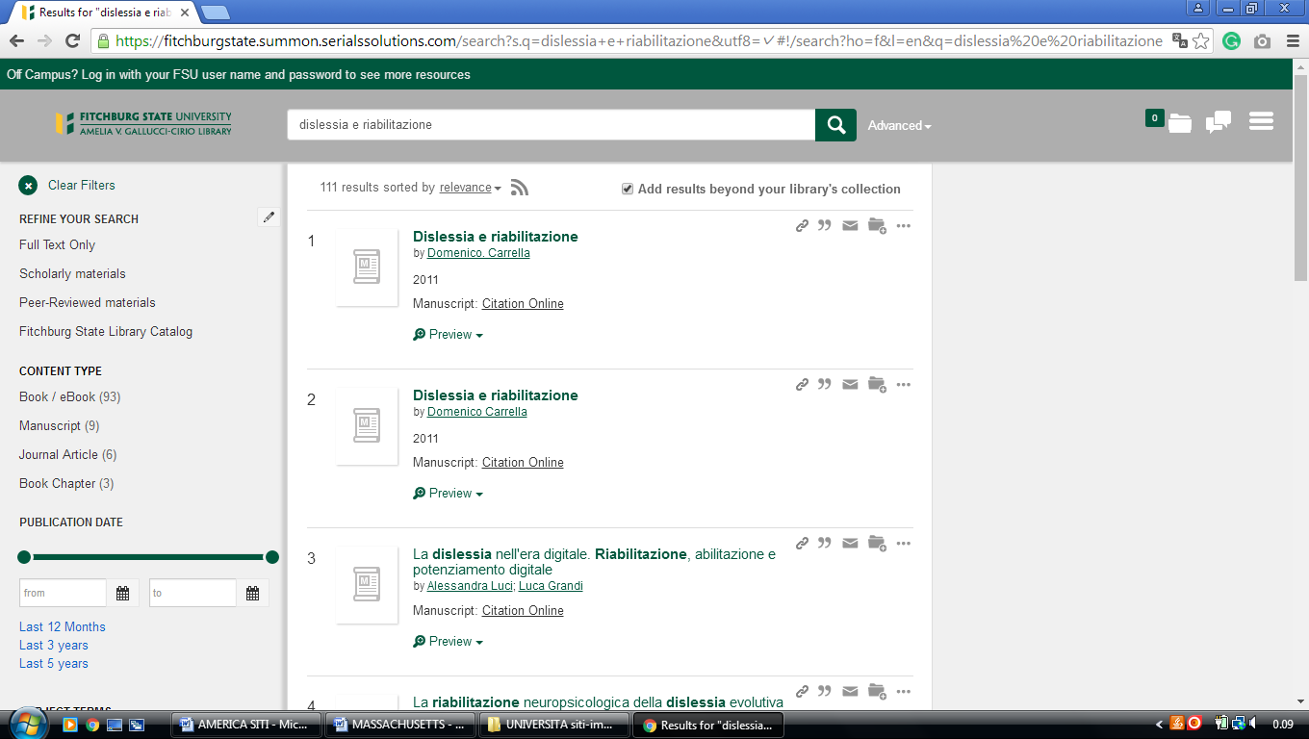

**2** [**BOSTON COLLEGE UNIVERSITY**](http://www.bc.edu/libraries/) **LIBRARIES – (**Chestnut Hill, MA, Usa)

<https://bc.on.worldcat.org/search?databaseList=&queryString=dislessia+riabilitazione>

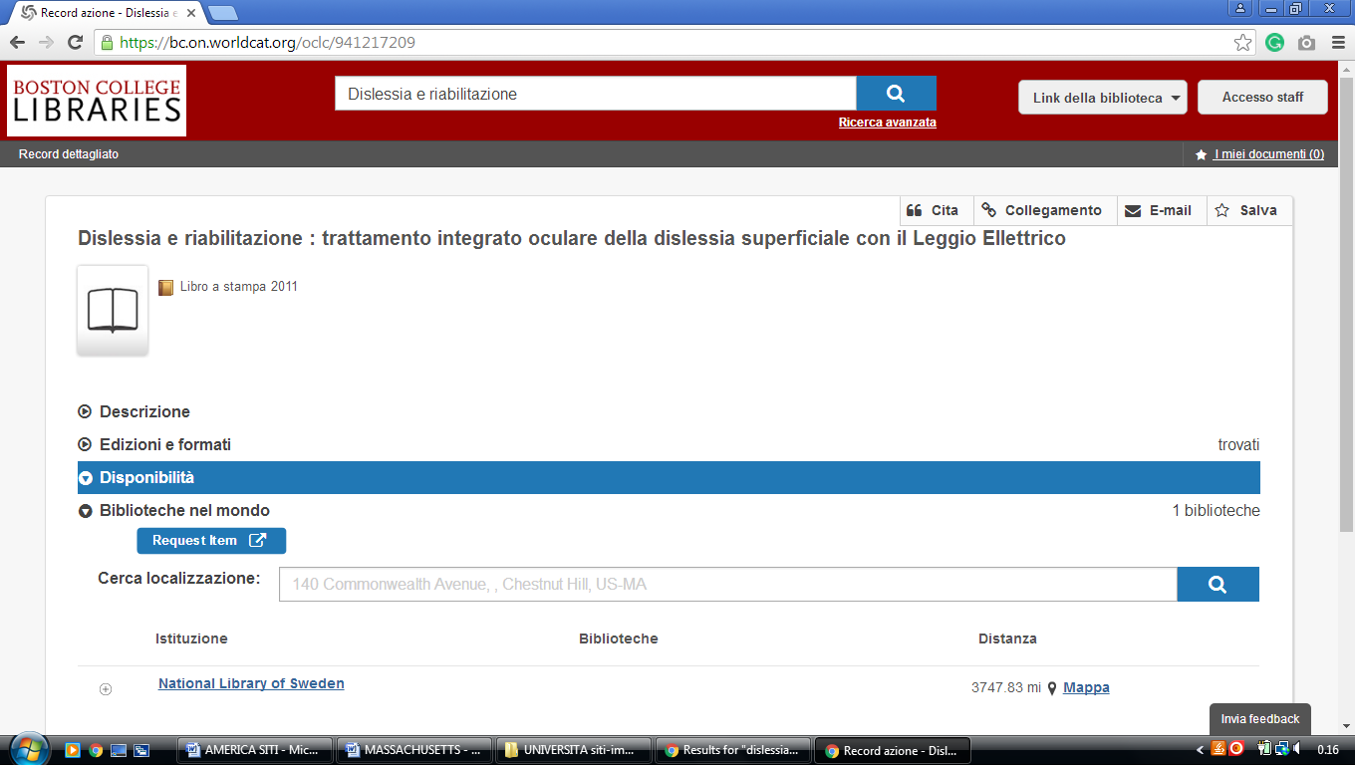

**3** [**UMASS BOSTON LIBRARY**](http://www.umb.edu/library) – ([Boston](https://en.wikipedia.org/wiki/Boston), [Massachusetts](https://en.wikipedia.org/wiki/Massachusetts), Usa)

https://umbrella.lib.umb.edu/primo-explore/search?query=any,contains,dislessia%20e%20riabilitazione&tab=default_tab&vid=01MA_UMB&mode=Basic&sortby=rank&lang=en_US

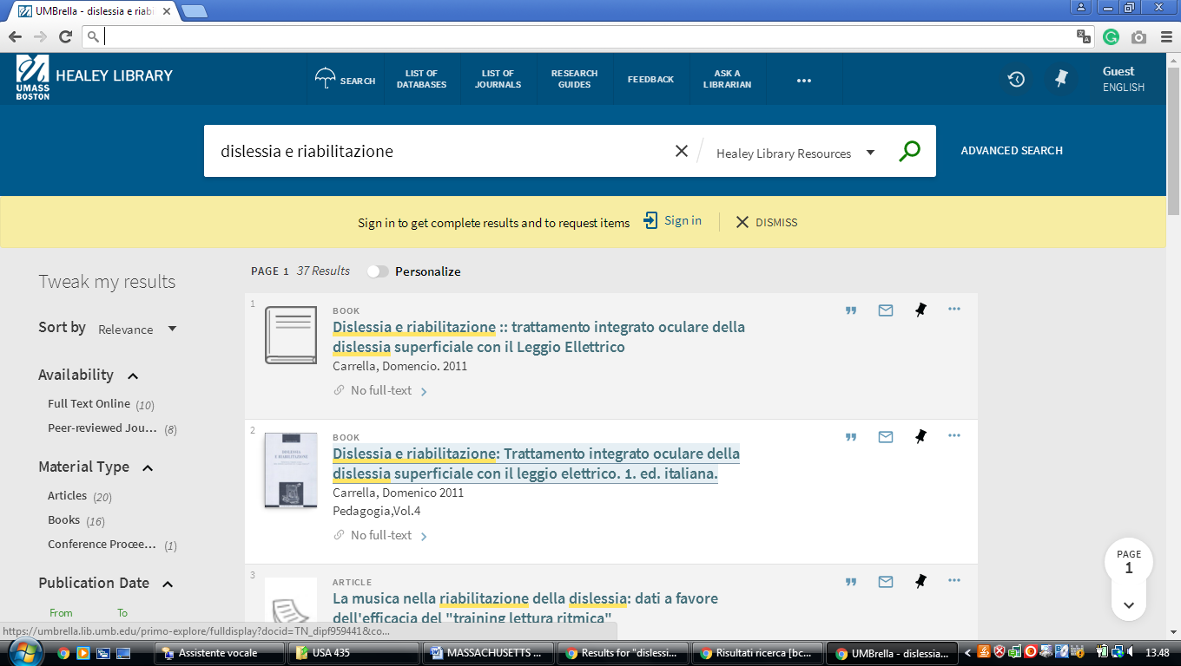

4 [**HEALEY LIBRARY | HOURS - UNIVERSITY OF MASSACHUSETTS BOSTON**](https://www.umb.edu/library/about/hours) [(Dorchester](https://en.wikipedia.org/wiki/Dorchester,_Boston), [Boston](https://en.wikipedia.org/wiki/Boston), [Massachusetts](https://en.wikipedia.org/wiki/Massachusetts), Usa)

<http://umassboston.worldcat.org/search?qt=wc_org_umassboston&q=dislessia+e+riabilitazione&scope=0&oldscope=&wcsbtn2w=Search&fq>=

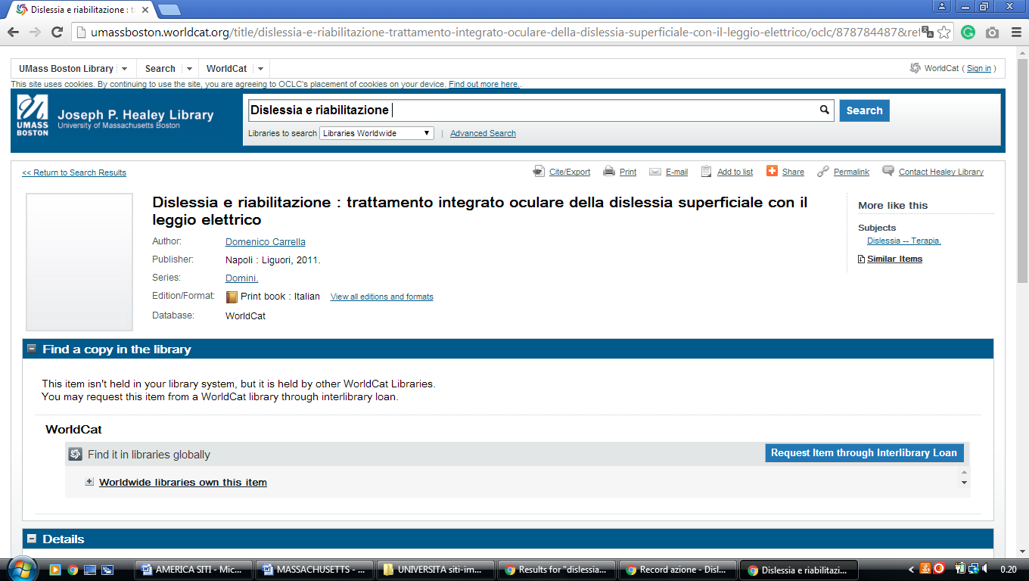

**5** **BRIDGEWATER STATE COLLEGE LIBRARY – (**Bridgewater, MS, Usa)

<https://bridgew.on.worldcat.org/search?queryString=dislessia+e+riabilitazione>

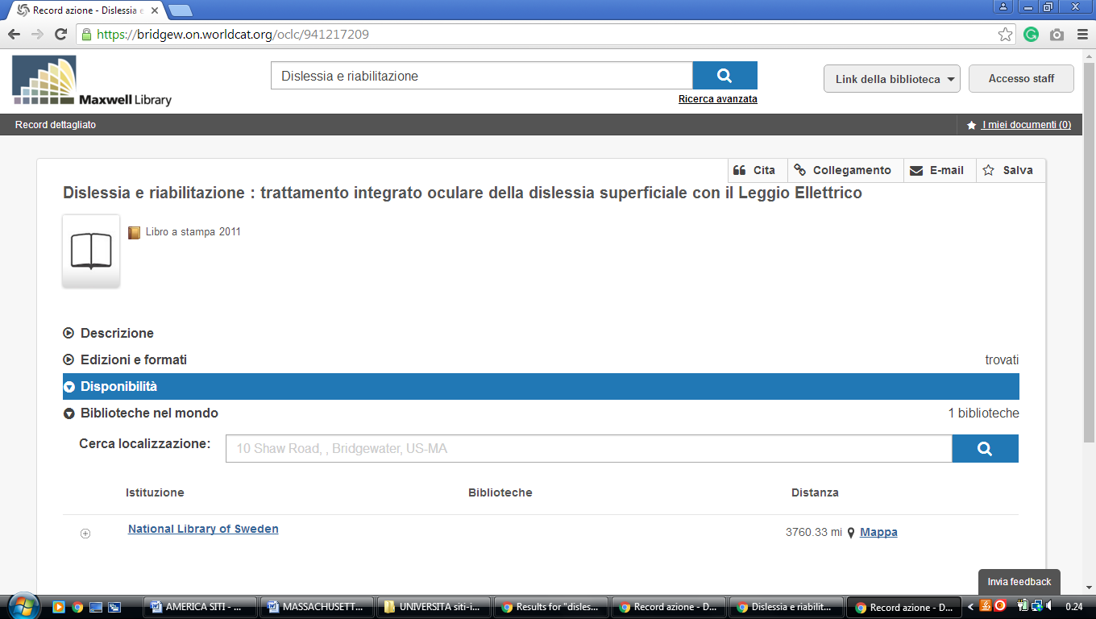

**6** [**EMMANUEL D'ALZON LIBRARY**](http://www1.assumption.edu/dept/library/default.html) **WORCESTER – (**Massachusetts, Usa)

<https://assumption.on.worldcat.org/search?sortKey=BEST_MATCH&databaseList=&queryString=dislessia+e+riabilitazione&changedFacet=scope&clusterResults=on&scope=&scope=wz%3A324&format>=

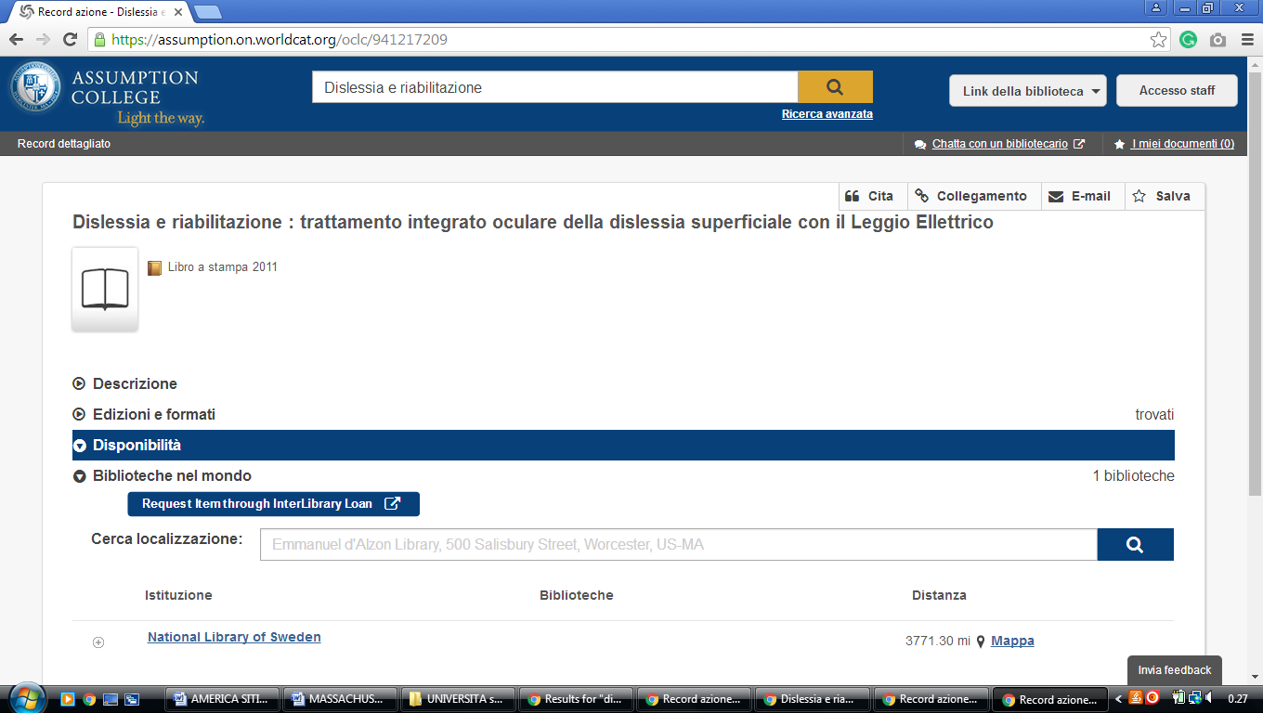

### 7 [GEORGE C. GORDON LIBRARY | | WPI - WORCESTER POLYTECHNIC INSTITUTE](https://www.wpi.edu/library) – (Worcester, Massachusetts, Usa)

<http://wpi.summon.serialssolutions.com/#!/search?ho=f&fvf=ContentType,Newspaper%20Article,t&l=en&q=dislessia%20e%20riabilitazione>

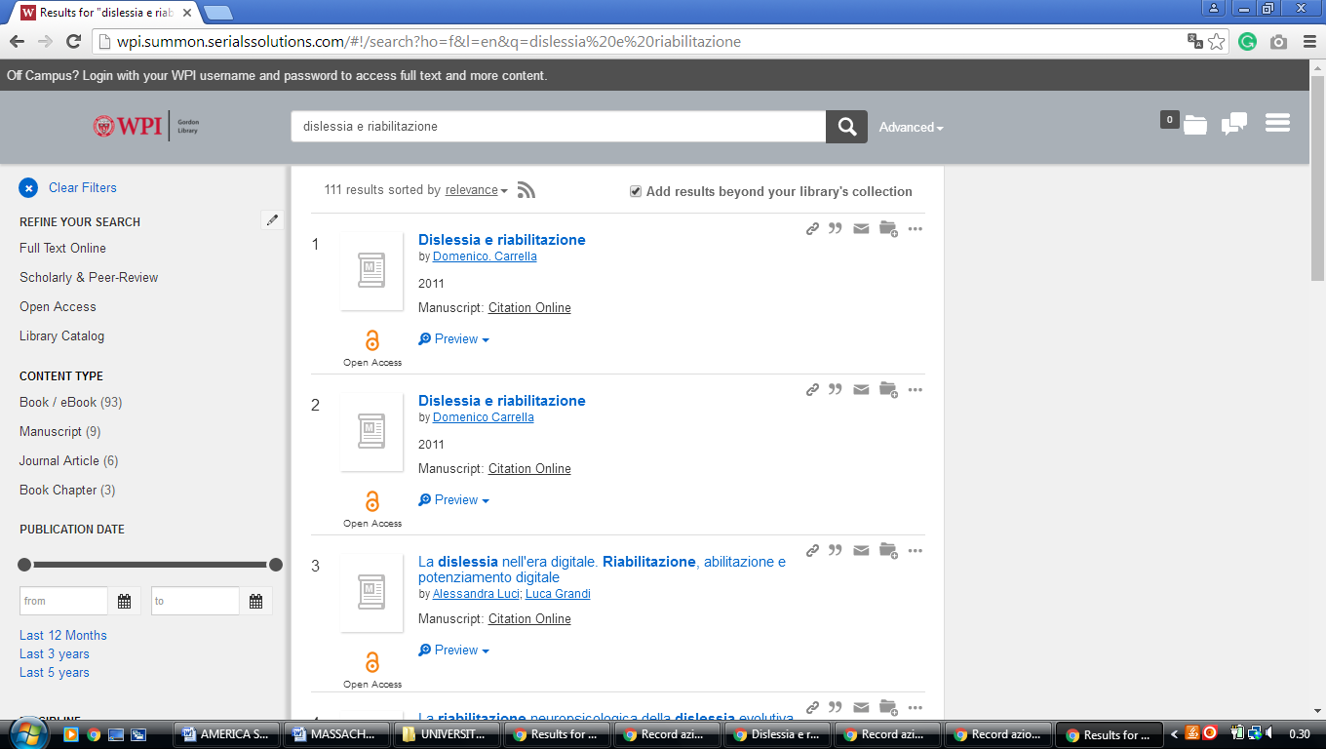

**8** [**HARVARD LIBRARY**](http://lib.harvard.edu/) - (Cambridge, Massachusetts, Usa)

<https://hollis.harvard.edu/primo-explore/search?vid=HVD2&tab=everything&search_scope=everything&query=any,contains,dislessia%20e%20riabilitazione>

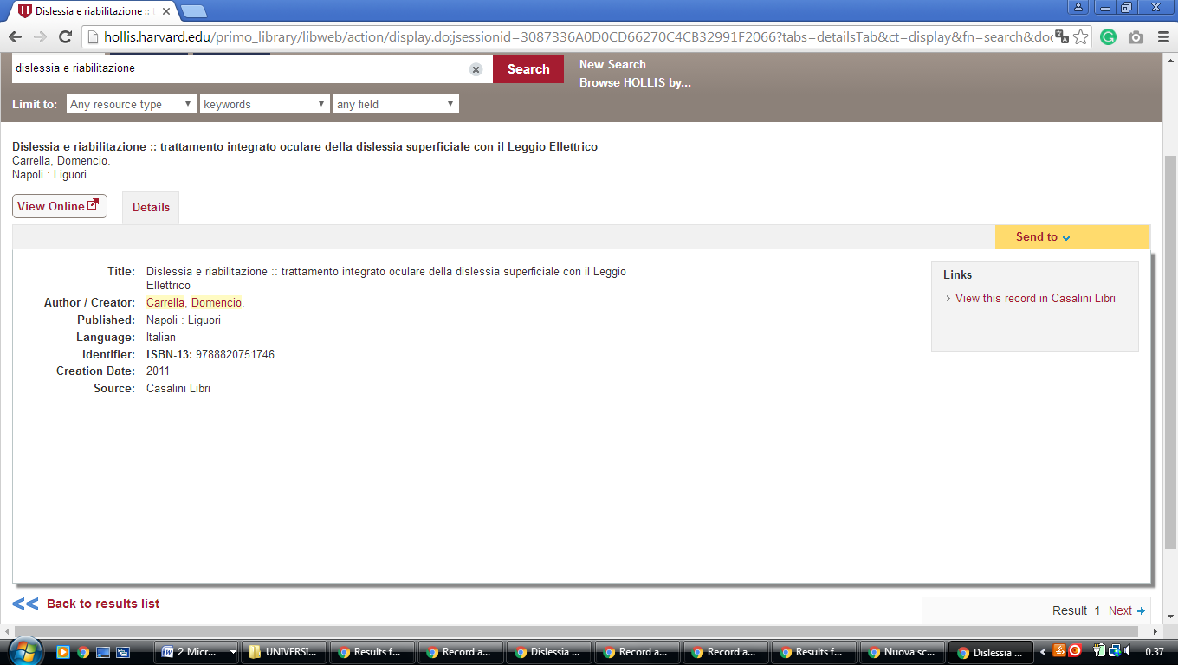

**9** [**HORN LIBRARY**](http://www.babson.edu/Academics/library/Pages/home.aspx) – (Babson Park, Massachusetts, Usa)

<https://babson.summon.serialssolutions.com/?#!/search?ho=f&l=en&q=dislessia%20e%20riabilitazione>

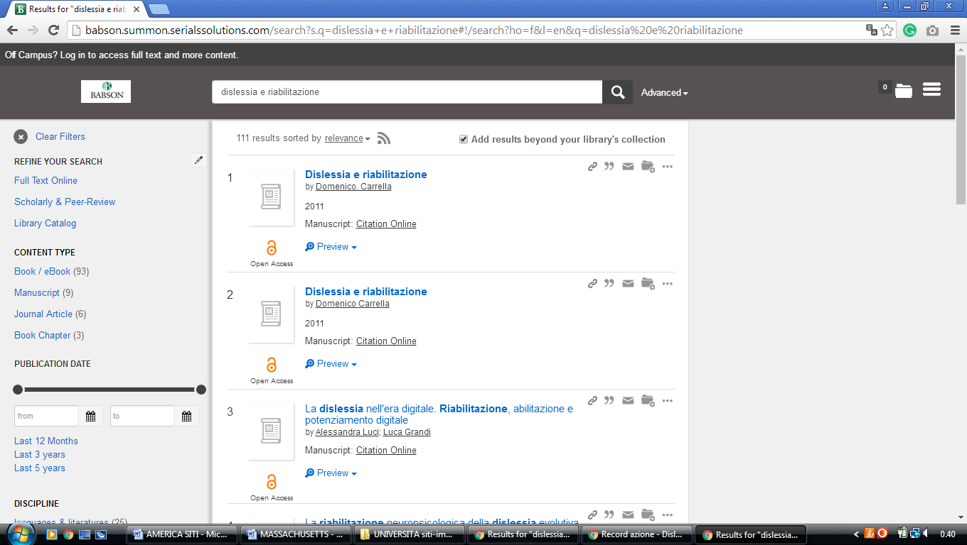

**10** [**LAMAR SOUTTER LIBRARY**](http://library.umassmed.edu/) – (Worcester, Massachusetts, Usa)

<http://umassmed.worldcat.org/search?qt=affiliate_wcl_all&ai=wclocal_umassmed&fq=&q=dislessia+e+riabilitazione&oldscope=&wcsbtn2w=Search+Print+Materials>

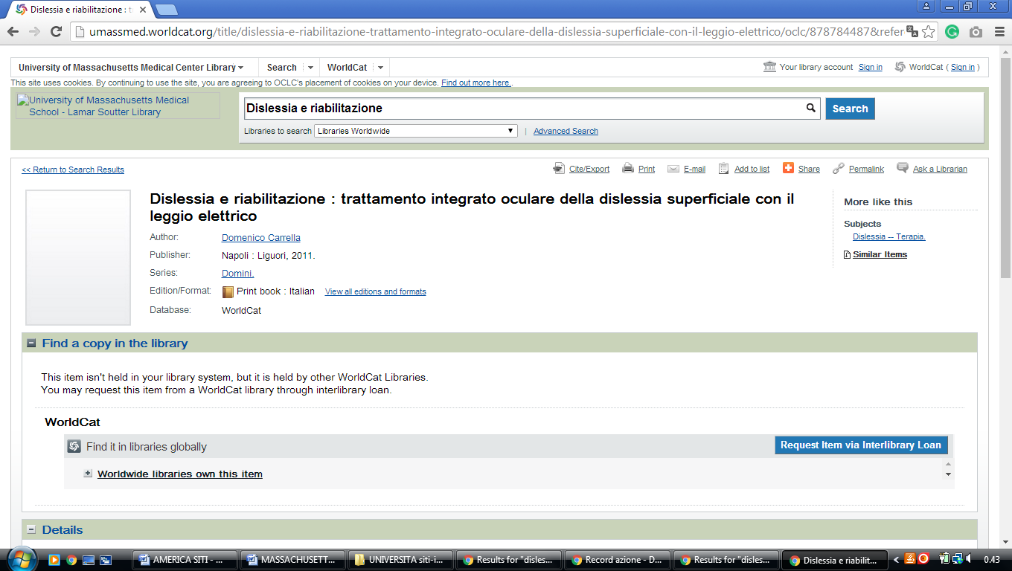

### 11 [SEARCH | MIT LIBRARIES](https://libraries.mit.edu/search/) – (Mass. Institute of Technology Libraries

### Cambridge, Usa)

<http://mit.worldcat.org/search?q=dislessia%20e%20riabilitazione>

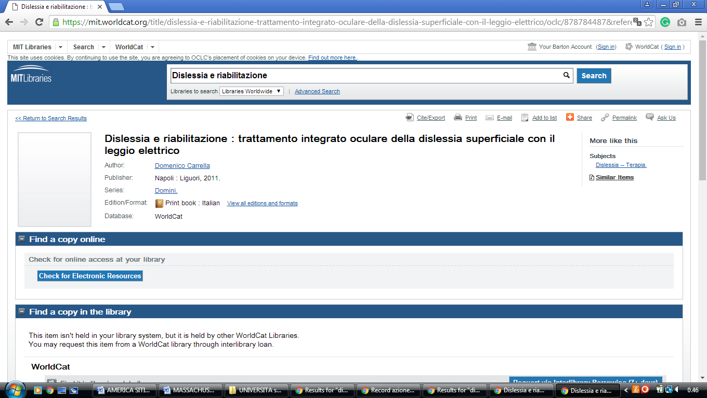

**12** [**MCQUADE LIBRARY**](http://www.merrimack.edu/library/) – (North Andover, Massachusetts, Usa)

<http://eds.b.ebscohost.com/eds/resultsadvanced?vid=1&sid=8198958f-e6c2-43af-8d9c-7e0cb885061e%40sessionmgr120&bquery=(dislessia+AND+e+AND+riabilitazione)&bdata=JnR5cGU9MSZzaXRlPWVkcy1saXZlJnNjb3BlPXNpdGU%3d>

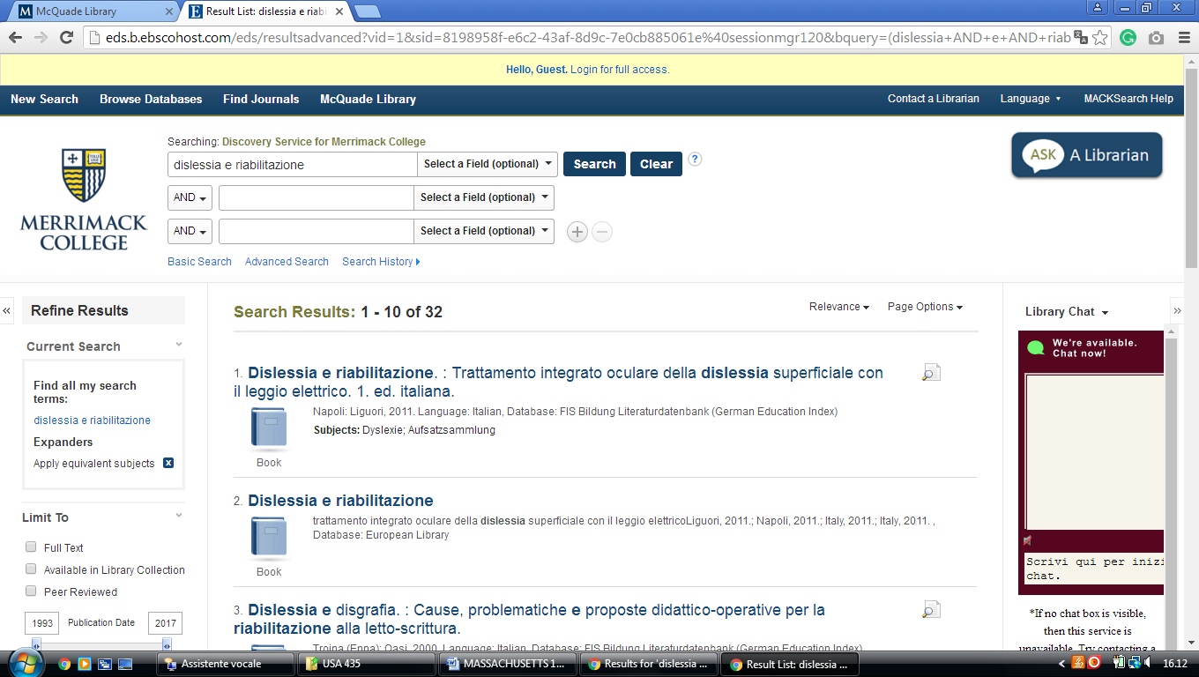

**13** **TUFTS UNIVERSITY LIBRARIES** – (Medford, Massachusetts, Usa)

<https://tufts-primo.hosted.exlibrisgroup.com/primo-explore/search?query=any,contains,dislessia%20e%20riabilitazione&tab=everything&search_scope=EVERYTHING&sortby=rank&vid=01TUN&lang=en_US&offset=0&pcAvailability=true>

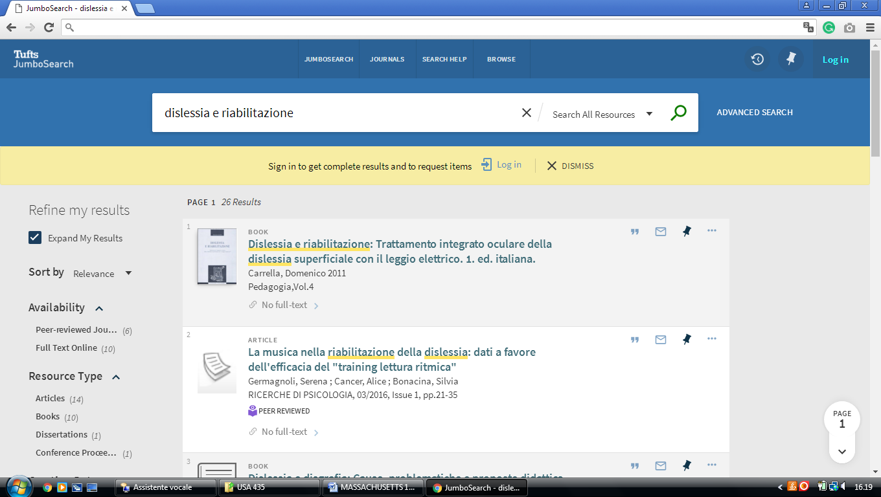

**14 TUFTS UNIVERSITY LIBRARIES** – (Medford, Massachusetts, Usa)

<https://tufts.on.worldcat.org/search?databaseList=&queryString=dislessia+e+riabilitazione>

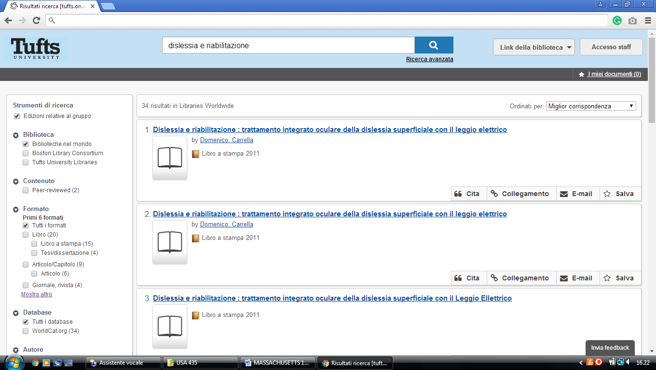

**15** [**UNIVERSITY OF MASS**](http://libweb.uml.edu/) **LOWELL LIBRARIES – (**Lowell, Massachusetts, Usa)

<http://uml.worldcat.org/search?q=kw%3Adislessia+e+riabilitazione&qt=advanced&dblist=2513%2C283>

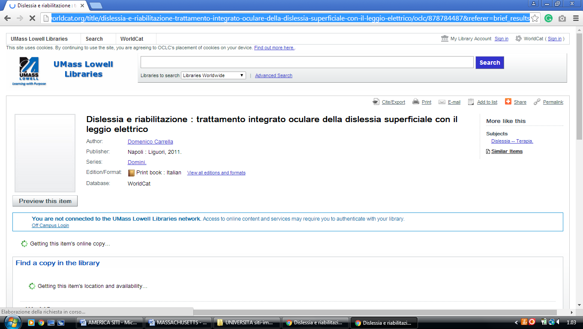

**16** [**WALLACE LIBRARY**](http://wheatoncollege.edu/library/library-research/) – (Norton, Massachusetts, Usa)

<https://wheatoncollege.on.worldcat.org/search?sortKey=RELEVANCE&databaseList=283&queryString=dislessia+e+riabilitazione&changedFacet=scope&clusterResults=on&stickyFacetsChecked=on&scope=&scope=wz%3A191>

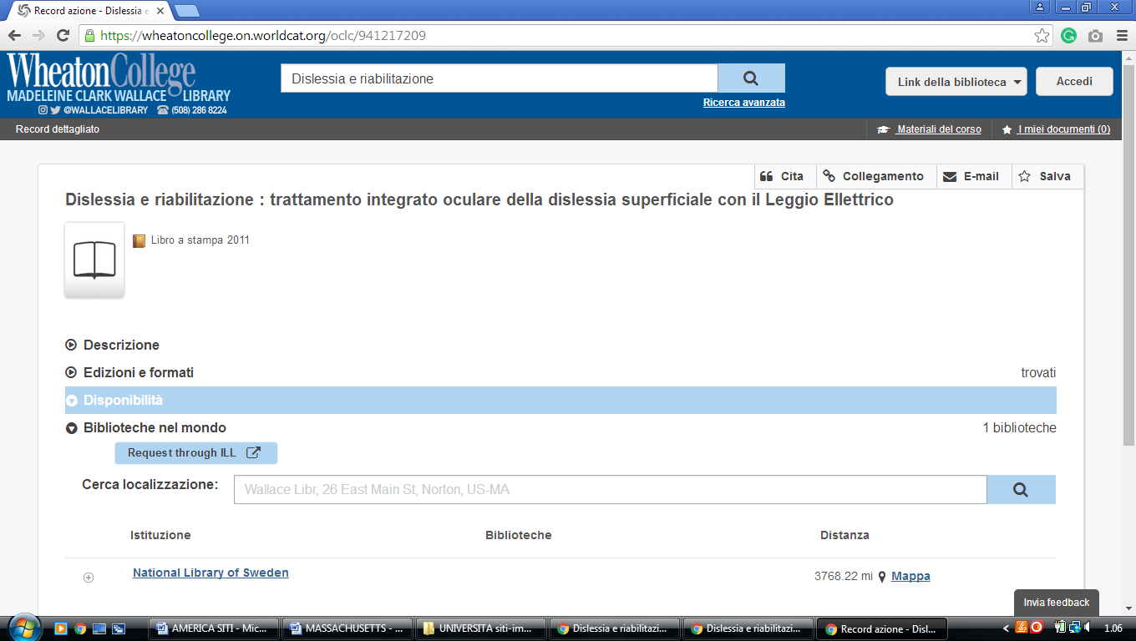

**17** [**WESTFIELD STATE UNIVERSITY**](http://lib.westfield.ma.edu/) **ELY LIBRARY – (**Westfield, Mass., Usa)

<https://westfield.on.worldcat.org/search?queryString=dislessia+e+riabilitazione&format=&scope>=

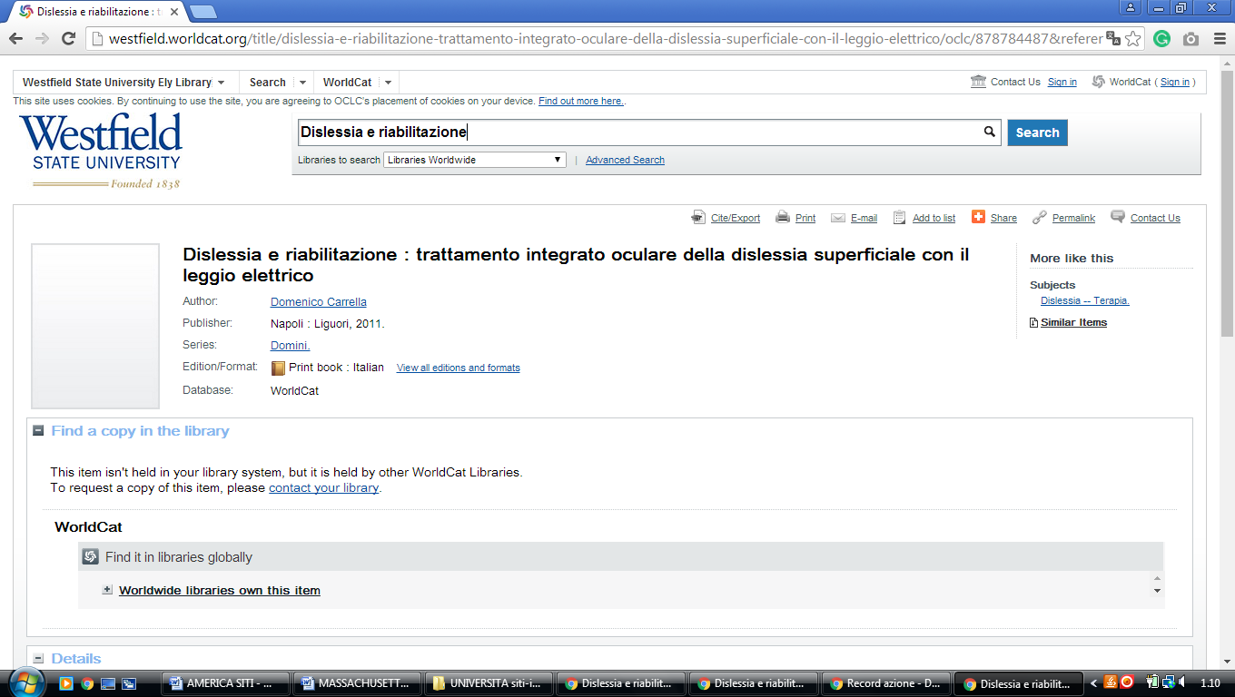

**18** [**BU LIBRARIES | BOSTON UNIVERSITY**](https://www.google.it/url?sa=t&rct=j&q=&esrc=s&source=web&cd=1&cad=rja&uact=8&ved=0ahUKEwimzuapka7VAhVDcRQKHVB3BzUQFggmMAA&url=http%3A%2F%2Fwww.bu.edu%2Flibrary%2F&usg=AFQjCNESzV9A2_KUja3wH5xGhm87PAW9rA) **- (**[Boston](https://en.wikipedia.org/wiki/Boston), Usa)

<https://buprimo.hosted.exlibrisgroup.com/primo-explore/search?query=any,contains,dislessia%20e%20riabilitazione&tab=worldcat&search_scope=WorldCat&vid=BU&lang=en_US&offset=0>

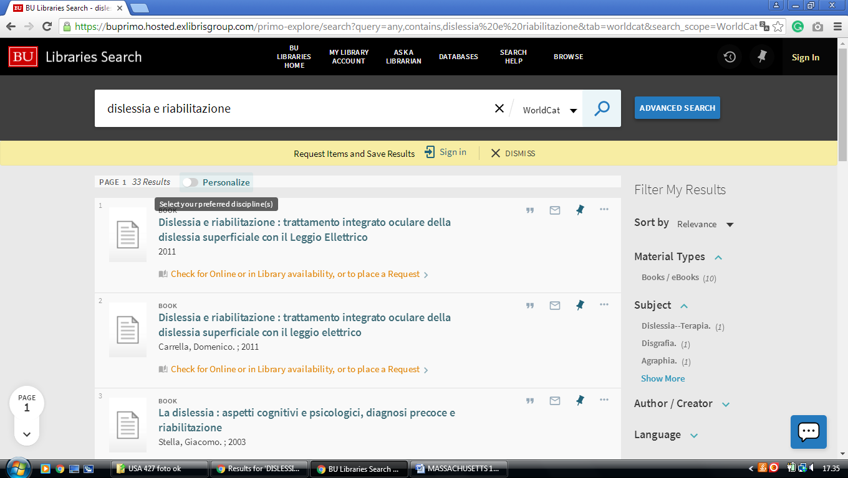

**19 FITCHBURG STATE UNIVERSITY LIBRARY - (**[Fitchburg, Massachusetts](https://en.wikipedia.org/wiki/Fitchburg,_Massachusetts), Usa)

<https://fitchburgstate.summon.serialssolutions.com/search?utf8=%E2%9C%93&s.q=dislessia+e+riabilitazione#!/search?ho=f&l=en&q=dislessia%20e%20riabilitazione>

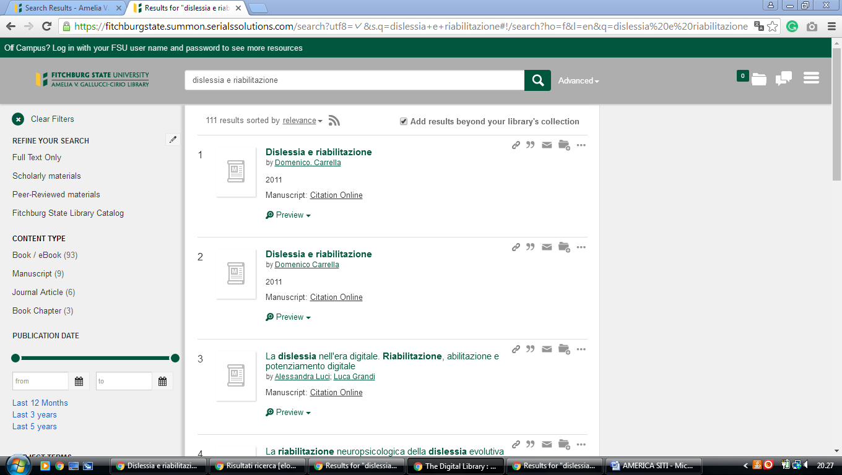

### 20 [JUMBOSEARCH - TISCH LIBRARY - TUFTS UNIVERSITY](https://tischlibrary.tufts.edu/find/jumbosearch) -

<https://tufts-primo.hosted.exlibrisgroup.com/primo-explore/search?query=any,contains,dislessia%20e%20riabilitazione&tab=everything&search_scope=EVERYTHING&sortby=rank&vid=01TUN&lang=en_US&offset=0&pcAvailability=true>

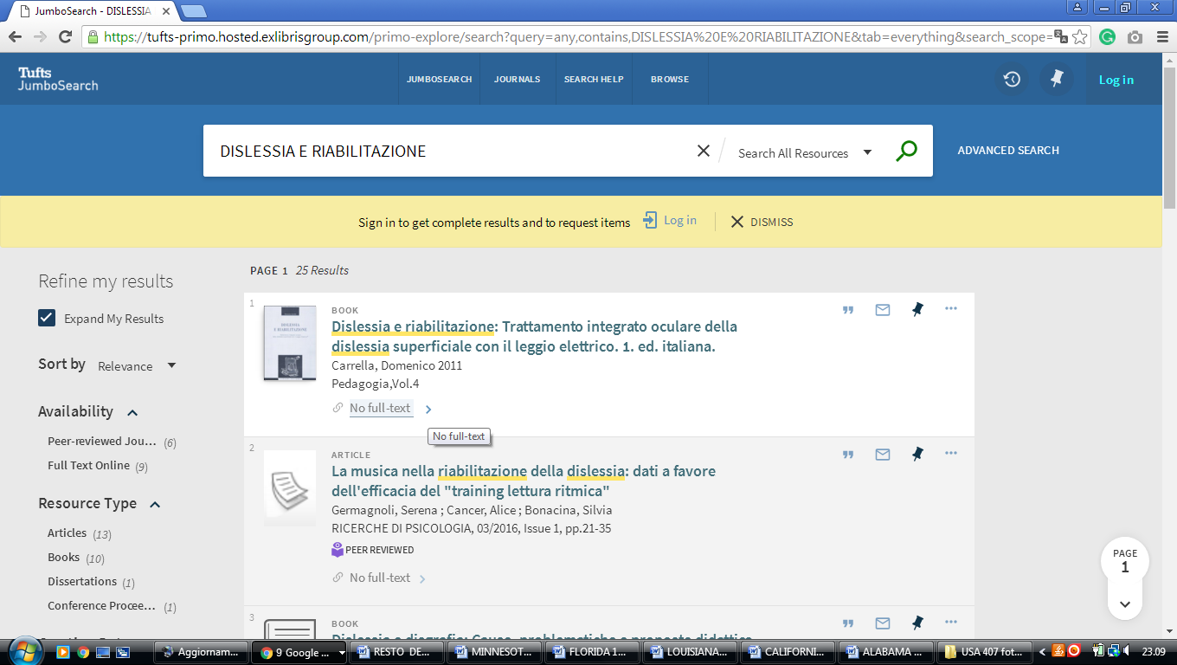

**Boston usa**

https://buprimo.hosted.exlibrisgroup.com/primo-explore/search?query=any,contains,dislessia%20e%20riabilitazione&tab=worldcat&search_scope=WorldCat&vid=BU&lang=en_US&offset=0

