**KANSAS = 3**

**1**  [**EMPORIA STATE UNIVERSITY**](http://www.emporia.edu/libsv/) **LIBRARIES – (**Emporia, Kansas, Usa)

<http://eds.a.ebscohost.com/eds/results?vid=5&sid=3a95c0da-1e29-4074-8abc-a66eeec649b3%40sessionmgr4007&bquery=AU+carrella+domenico&bdata=JnR5cGU9MCZzaXRlPWVkcy1saXZl>

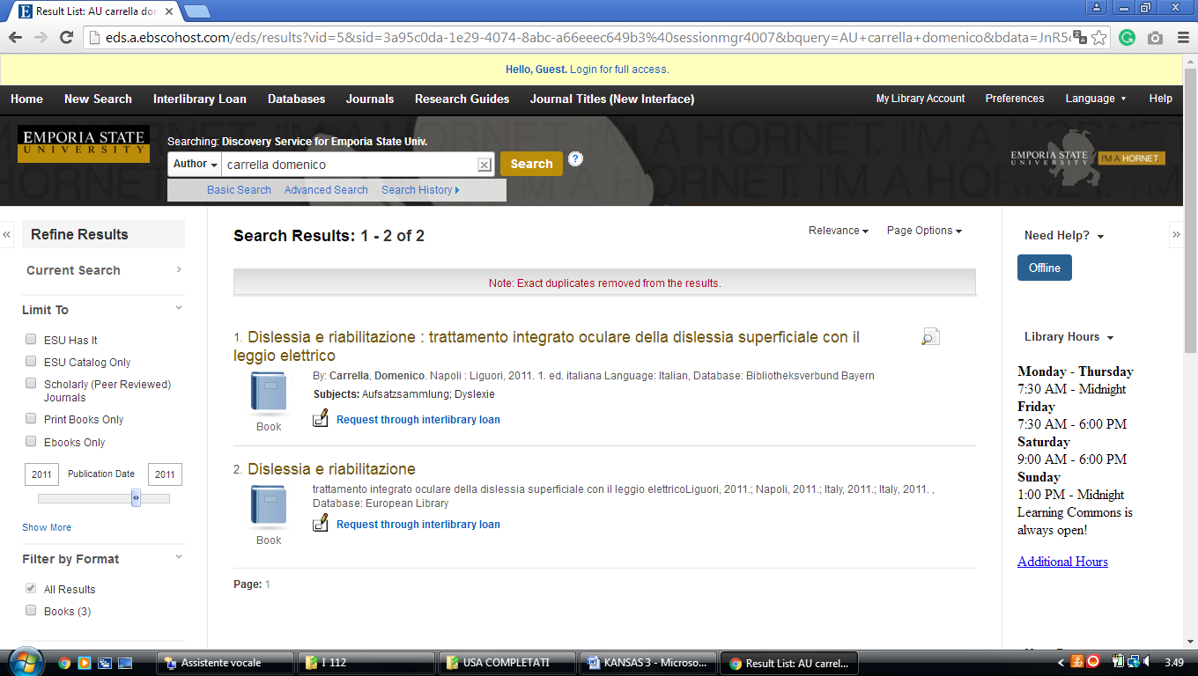

**2** [**LIBRARY HOME - UNIVERSITY LIBRARIES & ARCHIVES | EMPORIA STATE UNIVERSITY**](https://www.emporia.edu/libsv/) – (Kansas, Usa)

<http://eds.b.ebscohost.com/eds/detail/detail?vid=3&sid=cd92f46d-983b-42d1-9252-bf5ac29c1a5e%40sessionmgr103&bdata=JnNpdGU9ZWRzLWxpdmU%3d#AN=edsfis.959441&db=edsfis>

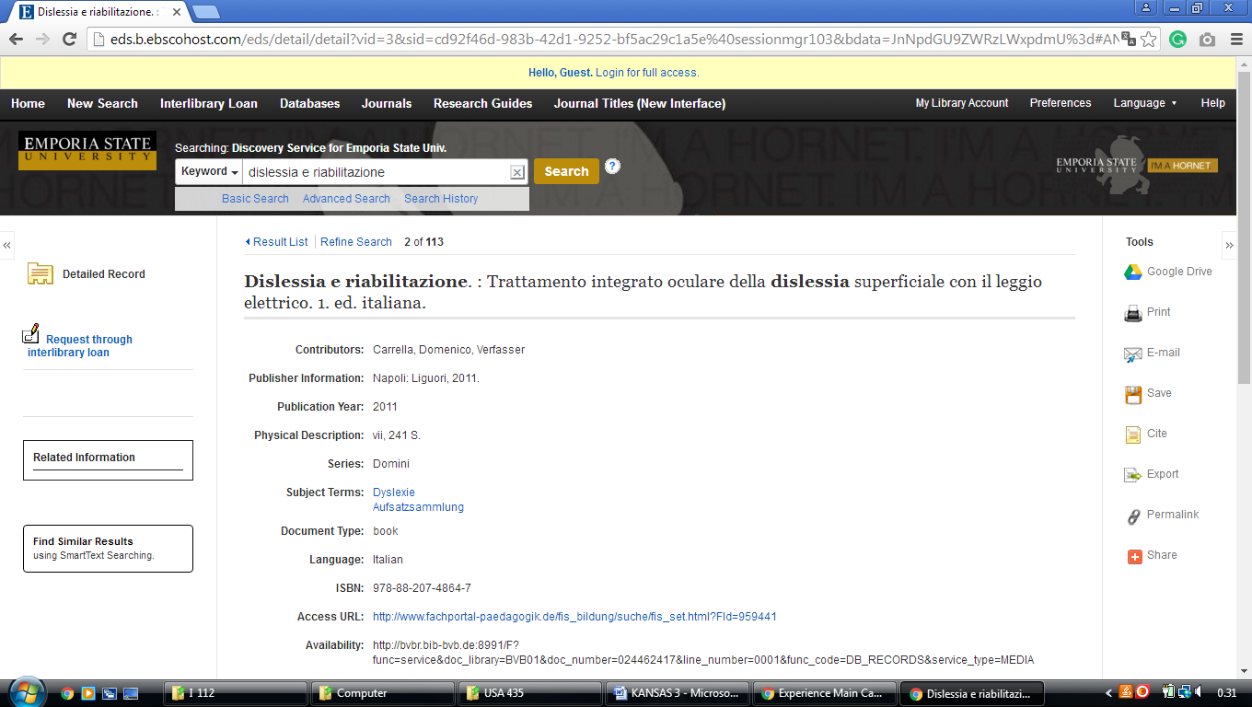

**3** [**LEONARD H. AXE LIBRARY**](http://axe.pittstate.edu/ktc/) – (Pittsburg, Kansas, Usa)

<http://pittsburgstate.summon.serialssolutions.com/search?s.q=dislessia+e+riabilitazione#!/search?ho=f&l=en&q=dislessia%20e%20riabilitazione>

