**HAWAII = 4**

**1 UNIVERSITY OF HAWAII MANOA LIBRARY** – (Mānoa, Hawaii, Usa)

<https://uhawaii-primo.hosted.exlibrisgroup.com/primo-explore/search?institution=OUZ&vid=OUZ&tab=default_tab&displayMode=full&bulkSize=10&highlight=true&dum=true&query=any,contains,dislessia%20e%20riabilitazione&displayField=all&pcAvailabiltyMode=true&sortby=rank&lang=en_US>

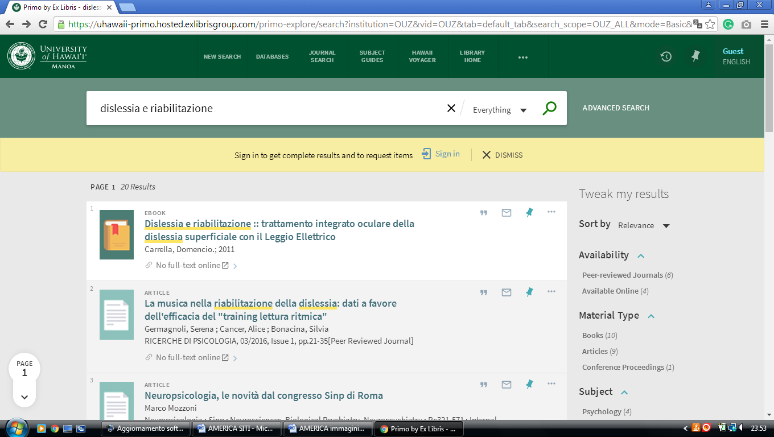

**2** [**LEEWARD COMMUNITY COLLEGE LIBRARY**](http://www.leeward.hawaii.edu/lib/) - (Pearl City, Hawaii, Usa)

<https://uhawaii-primo.hosted.exlibrisgroup.com/primo-explore/search?institution=OCL&vid=OCL&tab=ocl_all_tab&search_scope=OCL_ALL&mode=Basic&displayMode=full&bulkSize=10&highlight=true&dum=true&query=any,contains,%20dislessia%20e%20riabilitazione&displayField=all&pcAvailabiltyMode=true&queryTemp=%20dislessia%20e%20riabilitazione&sortby=rank&lang=en_US&pcAvailability=true>

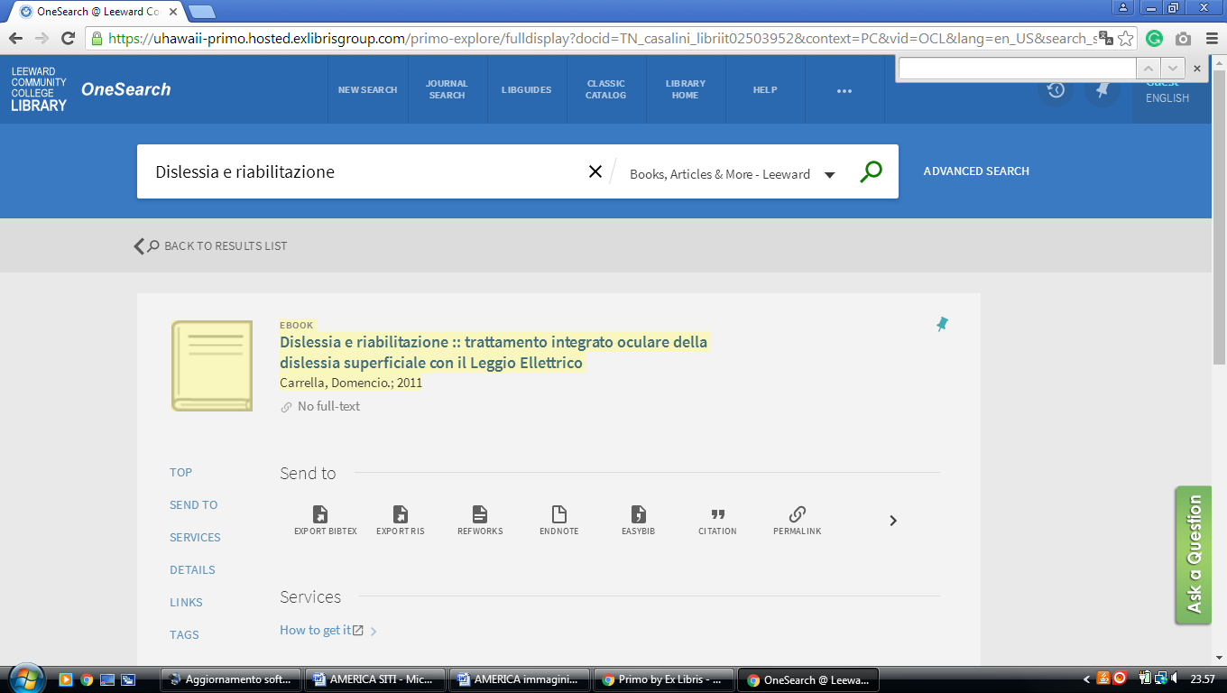

### 3 [LIBRARIES - HAWAII PACIFIC UNIVERSITY](https://www.hpu.edu/libraries/index.html) - (Bishop St, Honolulu, Usa)

<https://hpu.on.worldcat.org/search?sortKey=BEST_MATCH&databaseList=&queryString=dislessia+e+riabilitazione&changedFacet=scope&scope=&scope=wz%3A30769&format=all&database=all&author=all&year=all&yearFrom=&yearTo>=

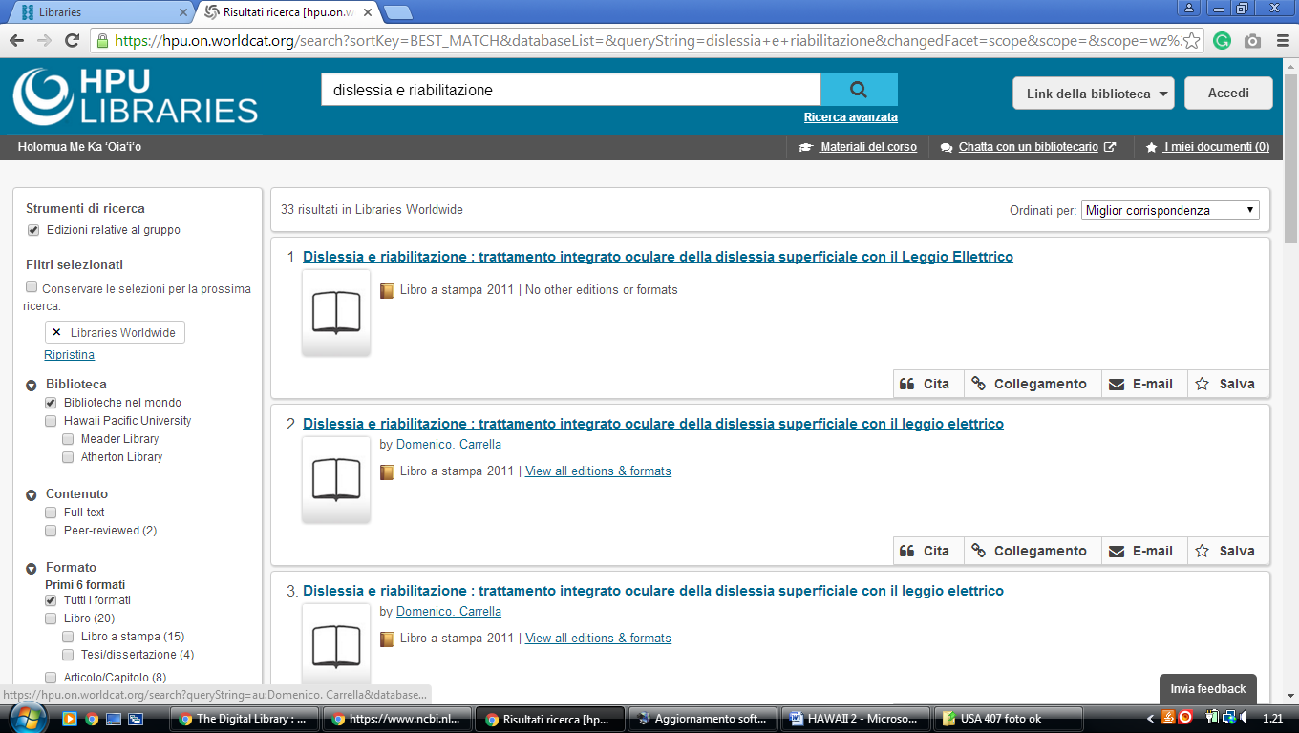

### 4 [LIBRARY & IT SERVICES - HAMILTON COLLEGE](https://www.hamilton.edu/offices/lits) - (Honolulu, Hawaii, Usa)

<https://hamilton.primo.exlibrisgroup.com/discovery/search?query=any,contains,dislessia%20e%20riabilitazione&tab=Everything&search_scope=MyInst_and_CI&vid=01HAMILTON_INST:01HAMILTON&lang=en&offset=0&sortby=rank&pcAvailability=true>

