**CONNECTICUT = 11**

**1** [**CENTRAL CONNECTICUT STATE UNIVERSITY**](http://library.ccsu.edu/) **LIBRARY - (**New Britain, Usa)

<https://cscu-ccsu-primo.hosted.exlibrisgroup.com/primo-explore/search?institution=CCSU&vid=CCSU_V1&tab=default_tab&search_scope=CCSU&mode=Basic&displayMode=full&bulkSize=25&highlight=true&dum=true&query=any,contains,dislessia%20e%20riabilitazione&displayField=all&pcAvailabiltyMode=true&sortby=rank&lang=en_US&pcAvailability=true>

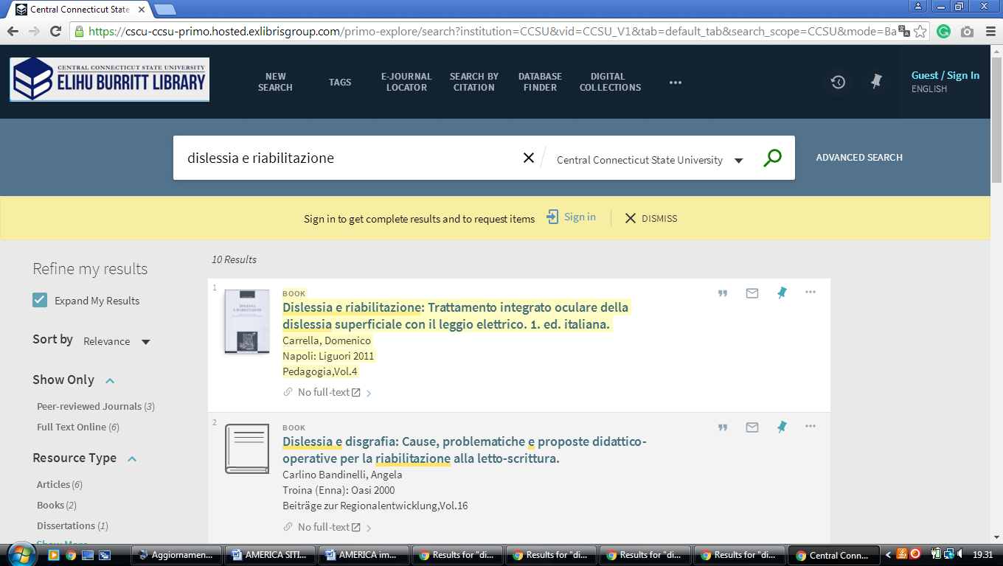

**2** [**EASTERN CONNECTICUT STATE UNIVERSITY**](http://www.easternct.edu/smithlibrary/) **LIBRARY –** (Willimantic, Usa)

<https://cscu-ecsu-primo.hosted.exlibrisgroup.com/primo-explore/search?institution=01CSCU_ECSU&vid=ECSU_V1&tab=default_tab&search_scope=ECSU&mode=Basic&displayMode=full&bulkSize=10&highlight=true&dum=true&query=any,contains,%20DISLESSIA%20E%20RIABILITAZIONE&displayField=all&pcAvailabiltyMode=true&sortby=rank&lang=en_US&pcAvailability=true>

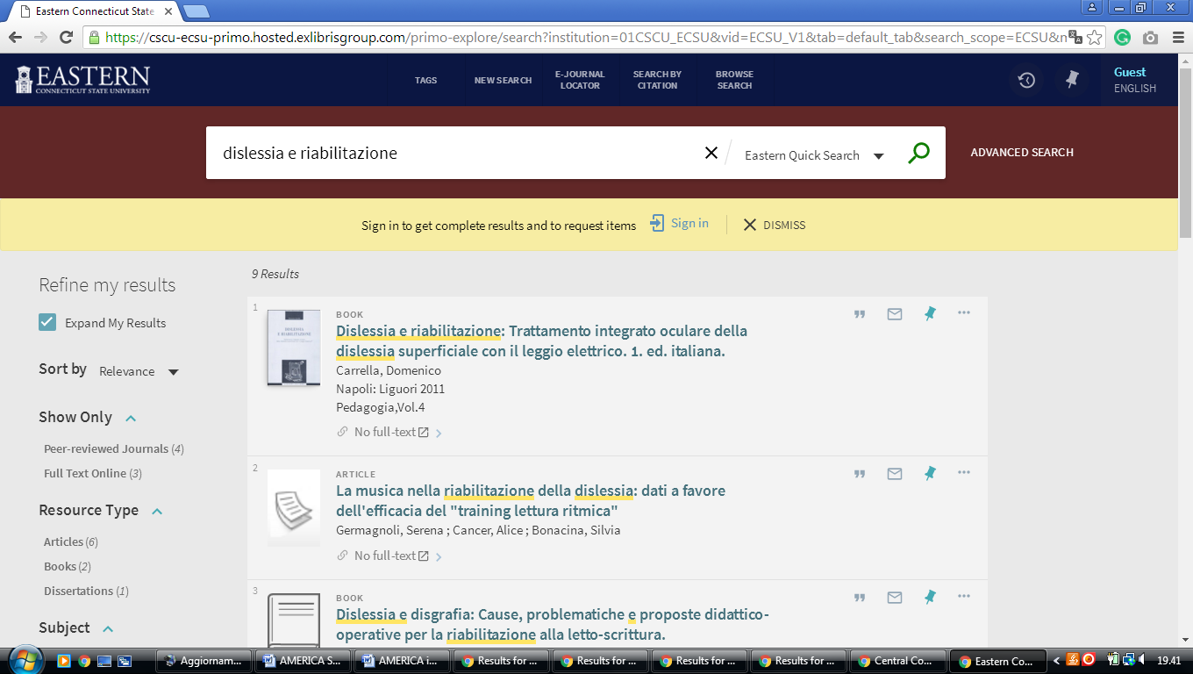

**3** [**TRINITY COLLEGE LIBRARY - CONNECTICUT**](http://www.trincoll.edu/LITC/Library/Pages/default.aspx) - (Hartford, Connecticut, Usa)

<https://trincoll-primo.hosted.exlibrisgroup.com/primo-explore/search?query=any,contains,dislessia%20e%20riabilitazione&institution=01CTW_TC&vid=CTWTC&tab=default_tab&search_scope=default_scope&displayMode=full&bulkSize=10&highlight=true&dum=true&primoQuery=hidden&displayField=all&sortby=rank>

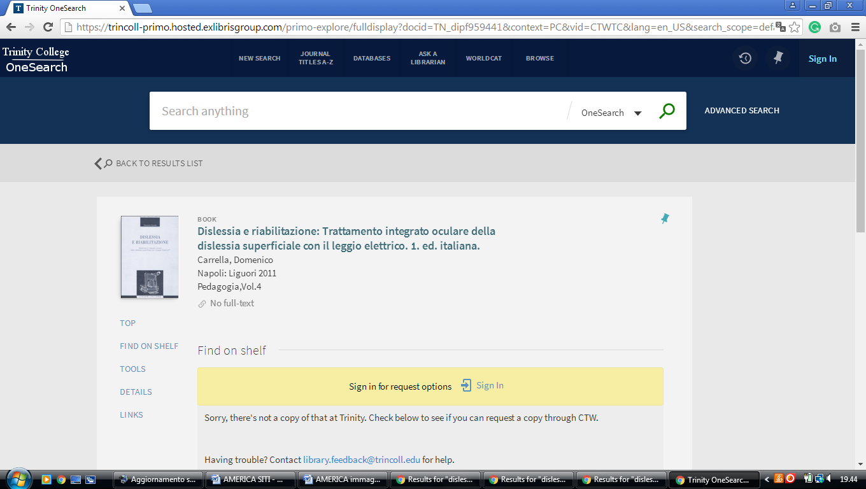

**4** [**US COAST GUARD ACADEMY LIBRARY**](http://www.uscga.edu/academics2.aspx?id=305) **-** (New London, Connecticut, Usa)

<https://uscga.summon.serialssolutions.com/search?s.q=dislessia+e+riabilitazione&s.cmd=addFacetValueFilters%28ContentType%2CNewspaper+Article%2Ct%7CContentType%2CBook+Review%2Ct%29#!/search?ho=f&fvf=ContentType,Newspaper%20Article,t%7CContentType,Book%20Review,t&l=en&q=dislessia%20e%20riabilitazione>

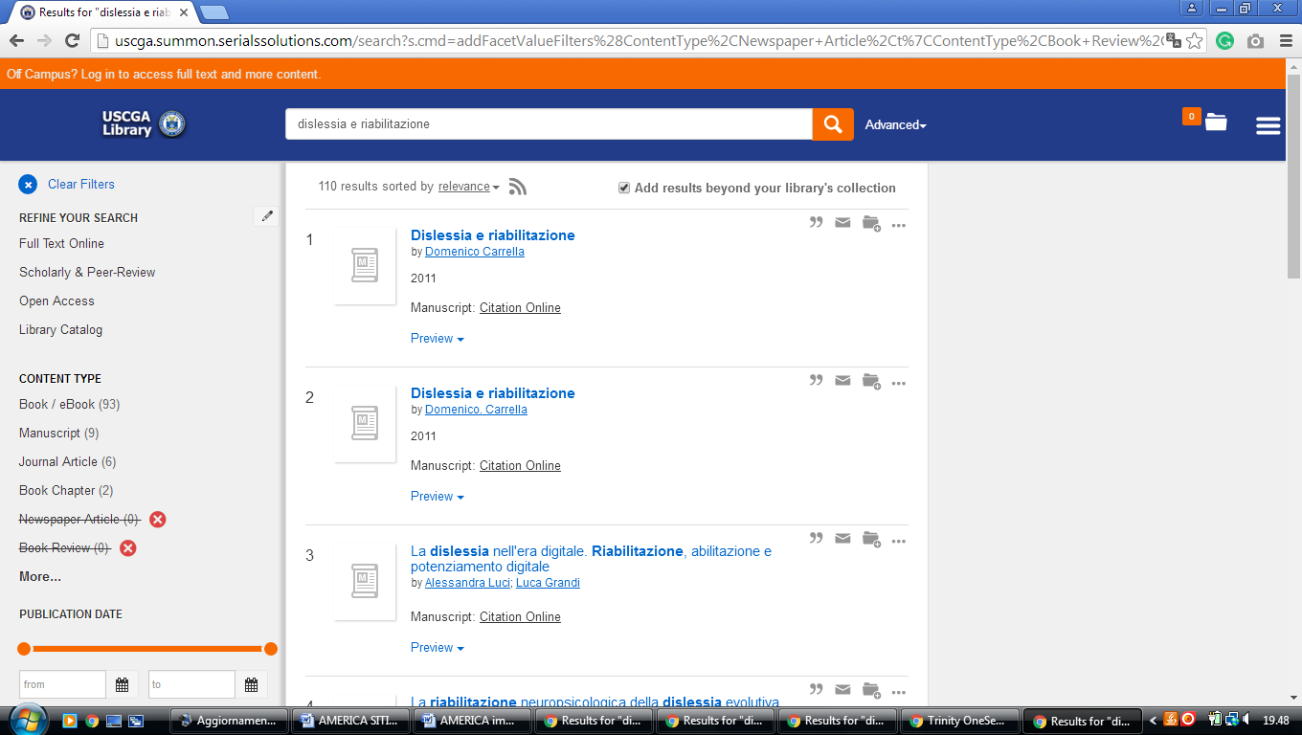

**5** [**UNIVERSITY OF CONNECTICUT LIBRARIES**](http://www.lib.uconn.edu/) - (Storrs, Connecticut, Usa)

<https://uconn.on.worldcat.org/search?fn=search&ct=search&initialSearch=true&institution=01UCT&mode=Basic&search_scope=EVERYTHING&displayMode=full&bulkSize=10&highlight=true&displayField=all&pcAvailabiltyMode=true&tab=default_tab&indx=1&dum=true&srt=rank&vid=01UCT&frbg=&queryString=dislessia+e+riabilitazione>

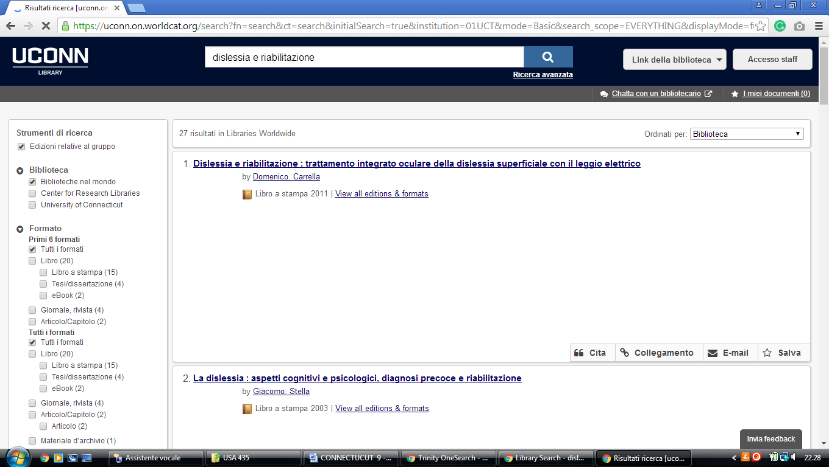

**6** [**WESTERN CONNECTICUT STATE**](http://library.wcsu.edu/)  **UNIVERSITY LIBRARY DANBURY**,

([Danbury](https://en.wikipedia.org/wiki/Danbury,_Connecticut), [Connecticut](https://en.wikipedia.org/wiki/Connecticut), Usa)

<https://cscu-wcsu-primo.hosted.exlibrisgroup.com/primo-explore/search?displayMode=full&bulkSize=%3C25%3E&highlight=true&dum=true&query=any,contains,dislessia%20e%20riabilitazione&displayField=all&pcAvailabiltyMode=true&institution=01CSCU-WCSU&vid=WCSU_V1&tab=default_tab&search_scope=WCSU&mode=Basic&sortby=rank&lang=en_US&pcAvailability=true>

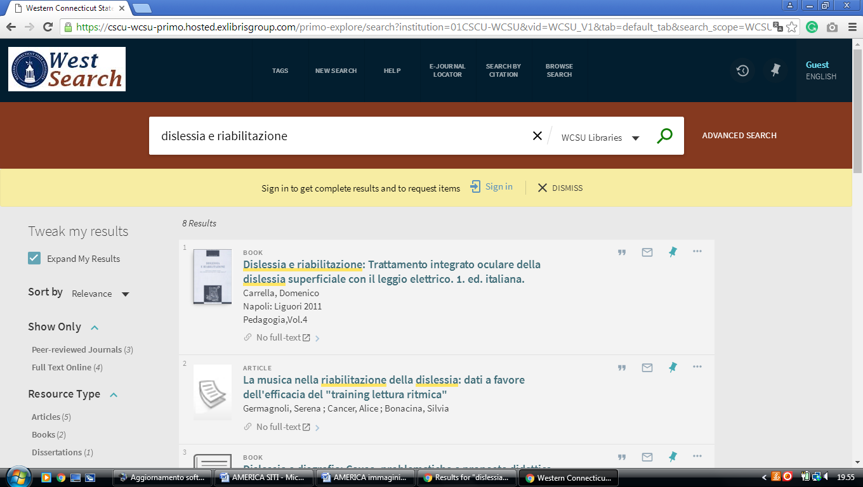

**7 UNIVERSITY OF YALE CUSHING/WHITNEY MEDICAL LIBRARY** – (New Haven, Connecticut, Usa)

<http://elibrary.med.yale.edu/catalog?utf8=%E2%9C%93&search_field=everything&q=dislessia+e+riabilitazione>

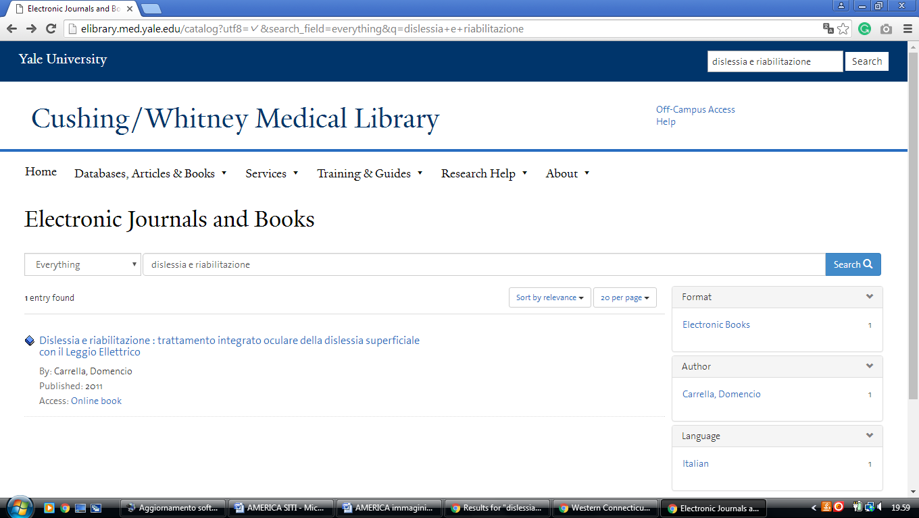

### 8 [CUSHING/WHITNEY MEDICAL LIBRARY - YALE UNIVERSITY](https://library.medicine.yale.edu/) - (New Haven, Connecticut, Usa)

<http://yale.summon.serialssolutions.com/#!/search?ho=f&l=it-IT&q=dislessia%20e%20riabilitazione>

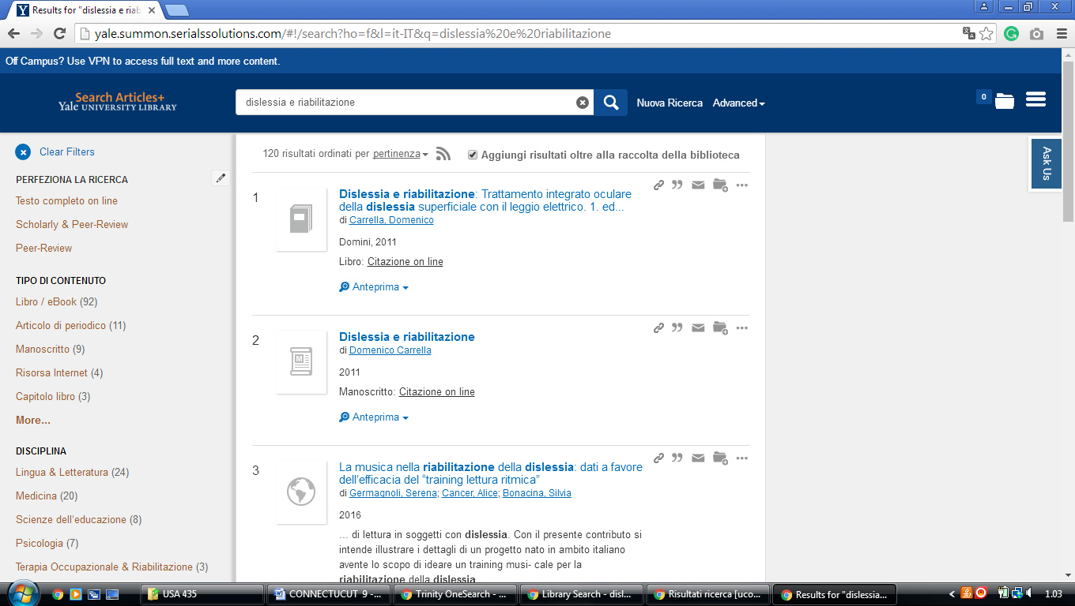

**9 UNIVERSITY OF YALE LIBRARY -** (New Haven, Connecticut, Usa)

<http://search.library.yale.edu/catalog/11669996?counter=1>

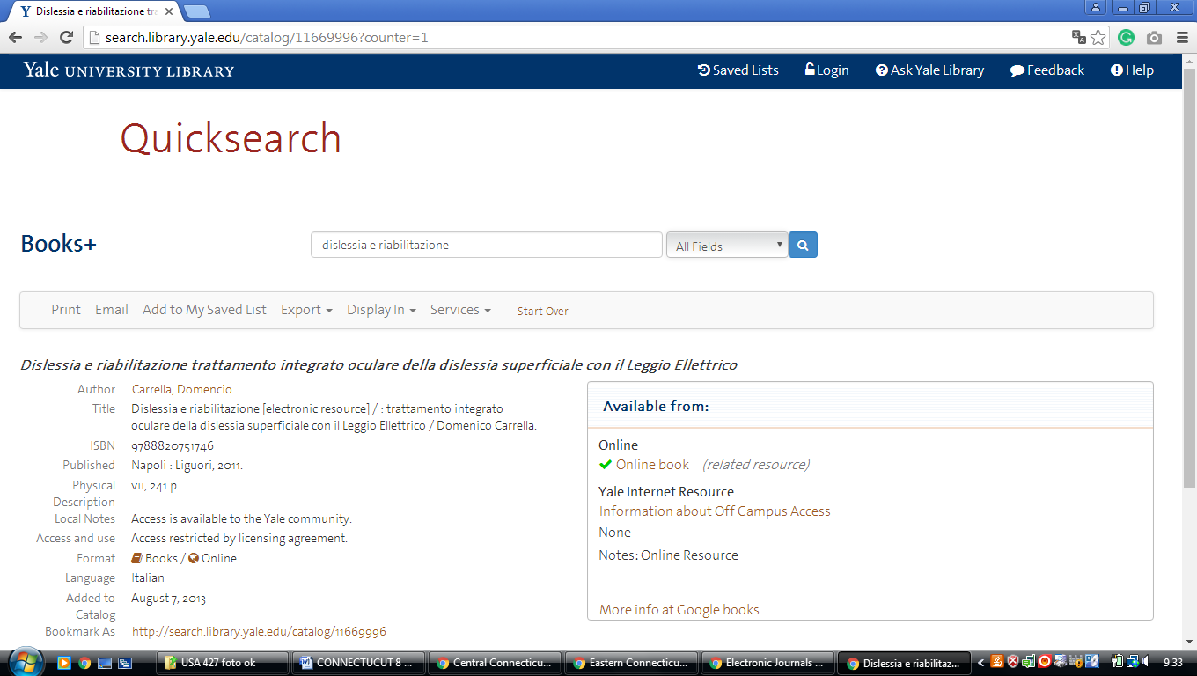

### 10 [YALE UNIVERSITY LIBRARY | THE HEART OF THE UNIVERSITY](http://web.library.yale.edu/) - ([New Haven, Connecticut](https://en.wikipedia.org/wiki/New_Haven,_Connecticut), Usa)

<http://search.library.yale.edu/articles?s.cmd=setHoldingsOnly%28false%29&s.ff%5B%5D=ContentType%2Cand%2C1%2C20&s.ff%5B%5D=Discipline%2Cand%2C1%2C20&s.ff%5B%5D=Language%2Cand%2C1%2C20&s.ho=t&s.pn=1&s.q=dislessia+e+riabilitazione&s.secure=f&search_field=&spellcheck=true>

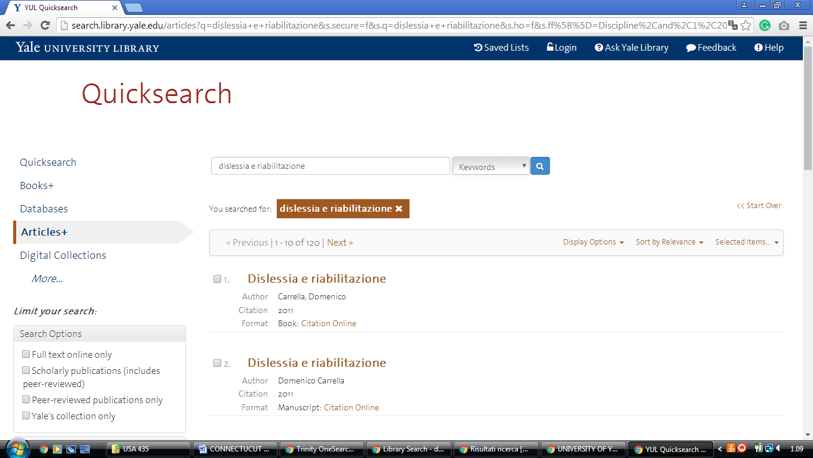

Hilton C. Buley Library

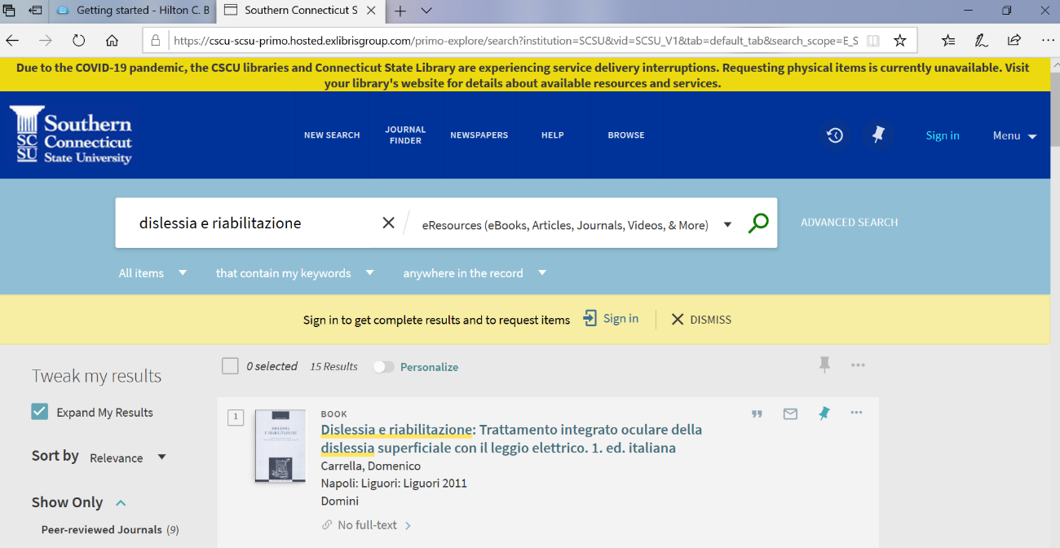https://cscu-scsu-primo.hosted.exlibrisgroup.com/primo-explore/search?institution=SCSU&vid=SCSU_V1&tab=default_tab&search_scope=E_SCSU&mode=Basic&displayMode=full&bulkSize=25&highlight=true&dum=true&query=any,contains,%20%20dislessia%20e%20riabilitazione&displayField=all&pcAvailabiltyMode=true&lang=en_US&pcAvailability=true