CALIFORNIA = 53

1 BUTTE COLLEGE LIBRARY – (Oroville, California, Usa)
http://butte.worldcat.org/search?q=dislessia+riabilitazione&qt=results_page&dblist=1708%2C638&scope=0&oldscope=1&fq=

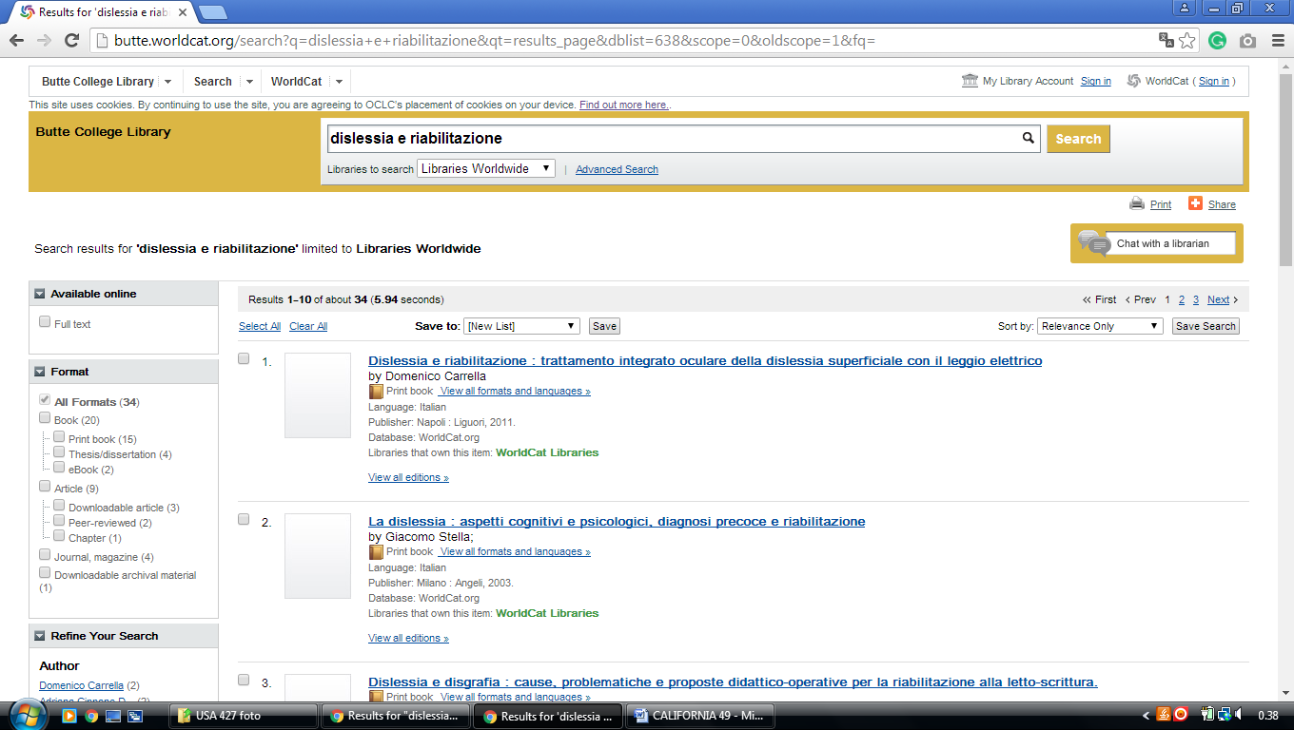

2 CALIFORNIA COLLEGE OF THE ARTS LIBRARIES – (San Francisco, California, Usa)
https://cca.summon.serialssolutions.com/?q=dislessia%20e%20riabilitazione#!/search?ho=f&l=en&q=dislessia%20e%20riabilitazione
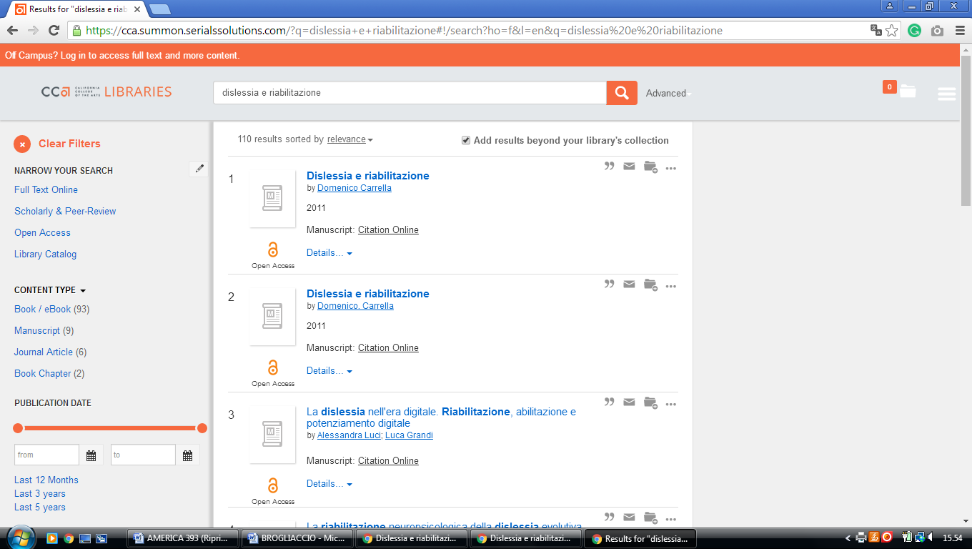

3 CALIFORNIA INSTITUTE OF THE ARTS LIBRARY – (Valencia, California, Usa)
https://calarts.worldcat.org/title/dislessia-e-riabilitazione-trattamento-integrato-oculare-della-dislessia-superficiale-con-il-leggio-elettrico/oclc/878784487&referer=brief_results

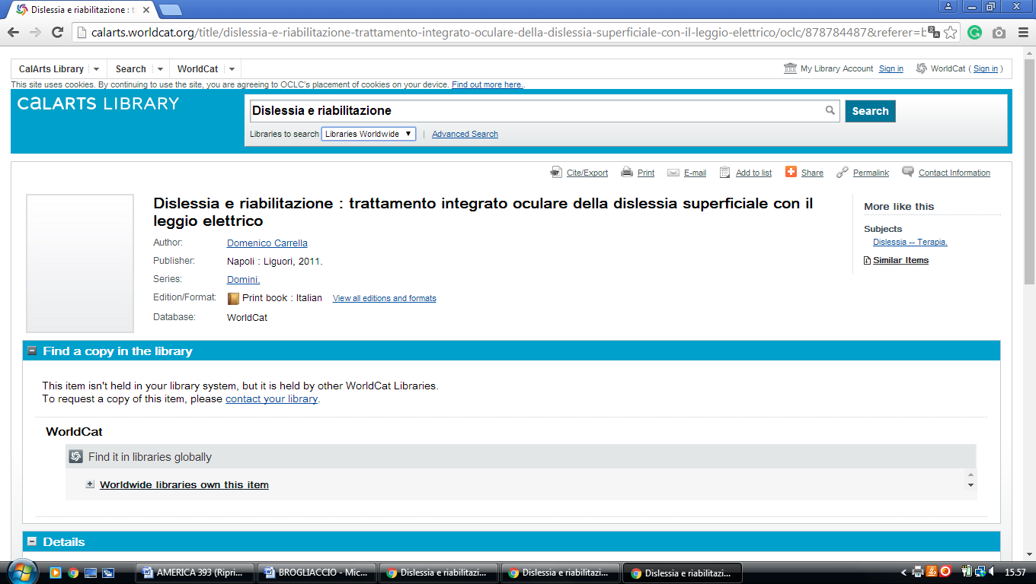

4 CSULB UNIVERSITY LIBRARY – (Long Beach, California, Usa)
https://csulb-primo.hosted.exlibrisgroup.com/primo-explore/search?institution=01CALS_ULB&vid=01CALS_ULB&tab=everything&search_scope=EVERYTHING&mode=Basic&displayMode=full&bulkSize=10&highlight=true&dum=true&query=any,contains,dislessia%20e%20riabilitazione&displayField=all&pcAvailabiltyMode=true&go=Submit&sortby=rank&lang=en_US

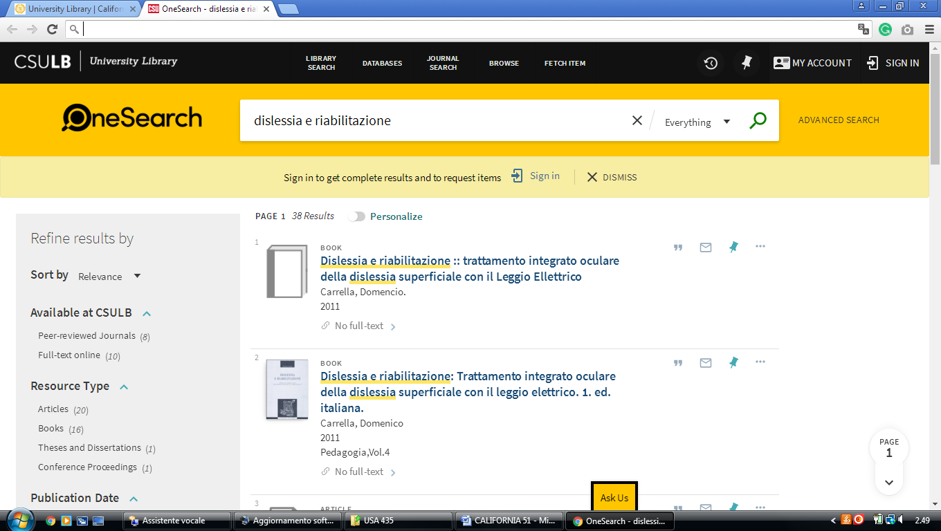

5 CSU CAMPUS LIBRARIES - CALIFORNIA STATE UNIVERSITY: CSU Bakersfield (Long Beach, California, Usa)
https://csub-primo.hosted.exlibrisgroup.com/primo-explore/search?institution=01CALS_UBA&vid=01CALS_UBA&query=any,contains,%20dislessia%20e%20riabilitazione&queryTemp=%20dislessia%20e%20riabilitazione&sortby=rank&lang=en_US

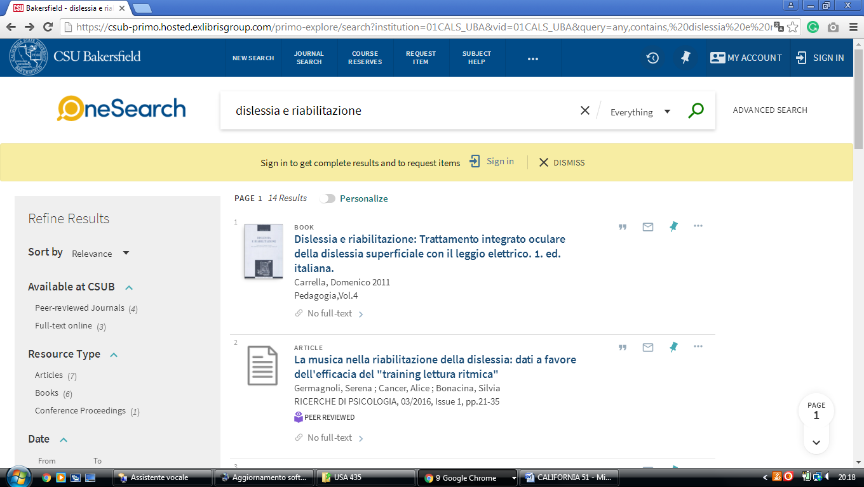

6 CSU CAMPUS LIBRARIES - CALIFORNIA STATE UNIVERSITY: CSU CHANNEL ISLANDS (John Spoor Broome Library, California. Usa)
https://californiastateuniversity-channelislands.worldcat.org/title/dislessia-e-riabilitazione-trattamento-integrato-oculare-della-dislessia-superficiale-con-il-leggio-elettrico/oclc/878784487&referer=brief_results

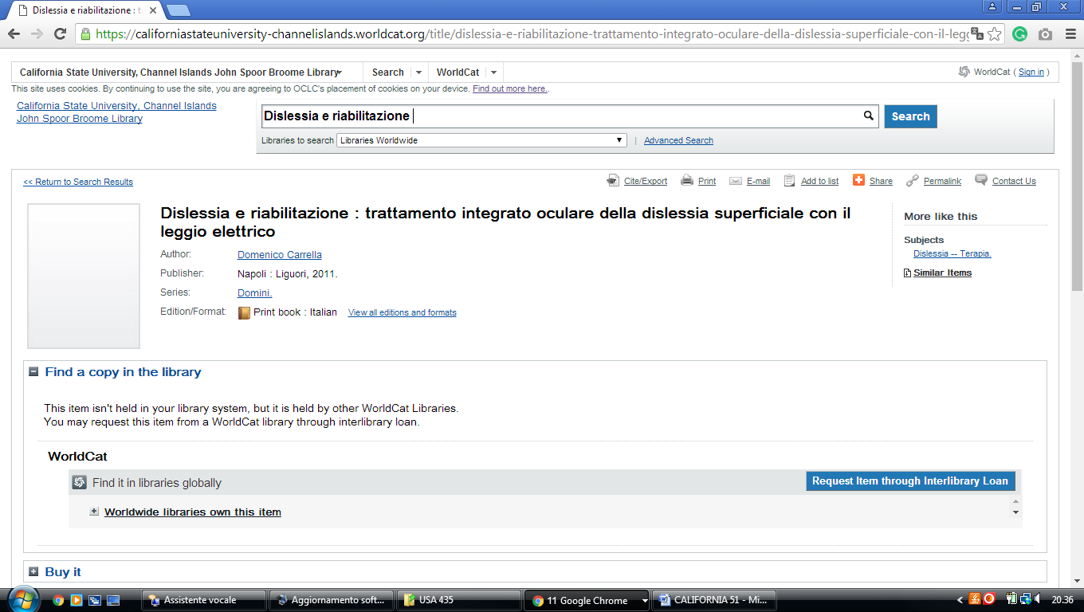

7 CLAREMONT COLLEGES LIBRARY – (Claremont, California, Usa)
https://ccl.on.worldcat.org/external-search?sortKey=LIBRARY&queryString=dislessia+e+riabilitazione#/oclc/878784487

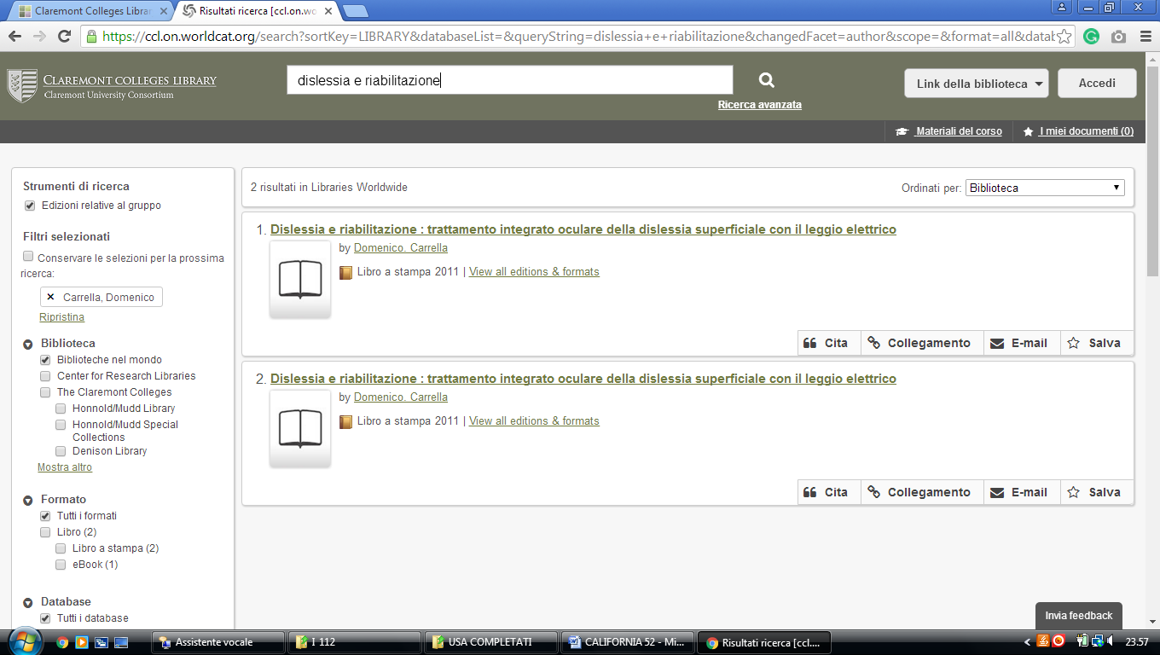

8 COLLEGE OF THE SEQUOIAS LIBRARY – (Visalia, California, Usa)
https://cos.on.worldcat.org/search?queryString=dislessia+e+riabilitazione&scope=

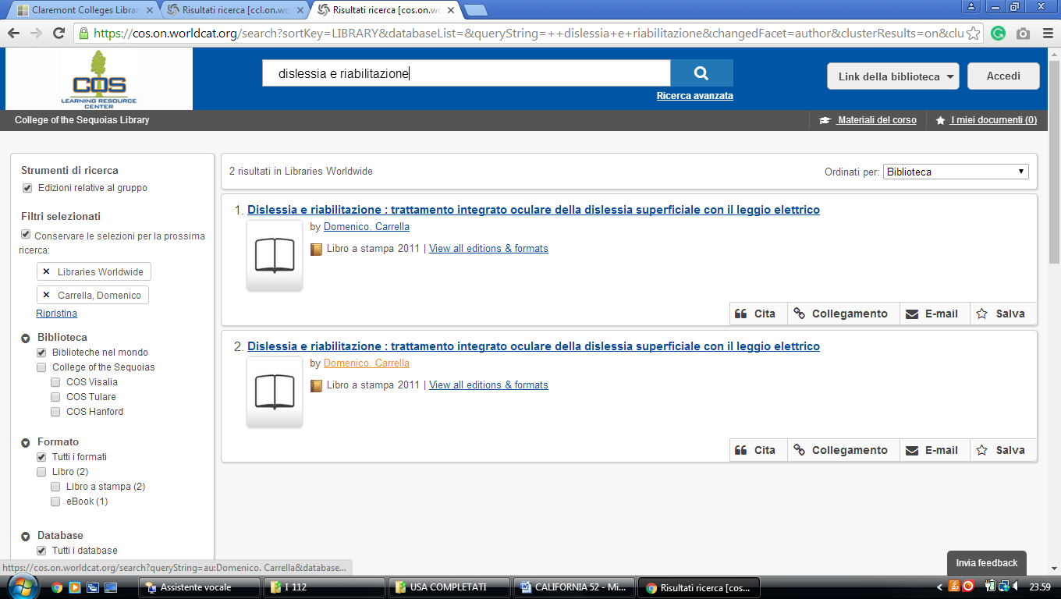

9 COLLEGE OF THE SISKIYOUS LIBRARY – (Weed, California, Usa)
http://siskiyous.worldcat.org/title/dislessia-e-riabilitazione-trattamento-integrato-oculare-della-dislessia-superficiale-con-il-leggio-elettrico/oclc/878784487&referer=brief_results

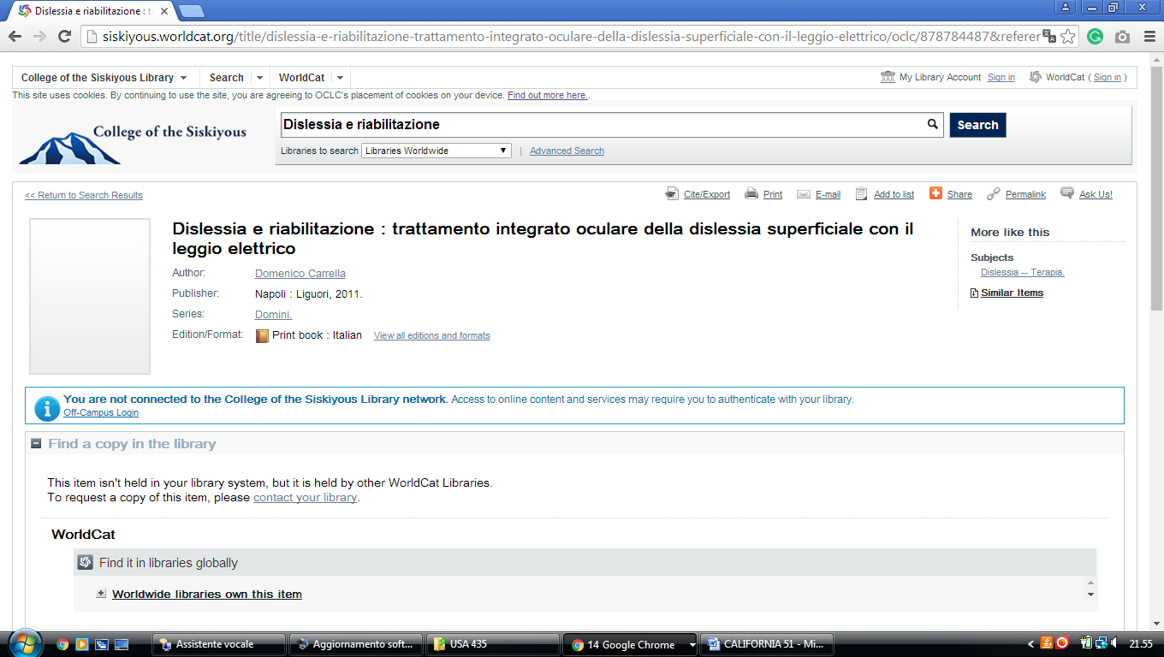

10 Fuller Library – (Pasadena, California, Usa)
https://fuller.on.worldcat.org/external-search?queryString=dislessia+e+riabilitazione&t=all&count=100&dblist=283%252C197%252C1674#/oclc/878784487

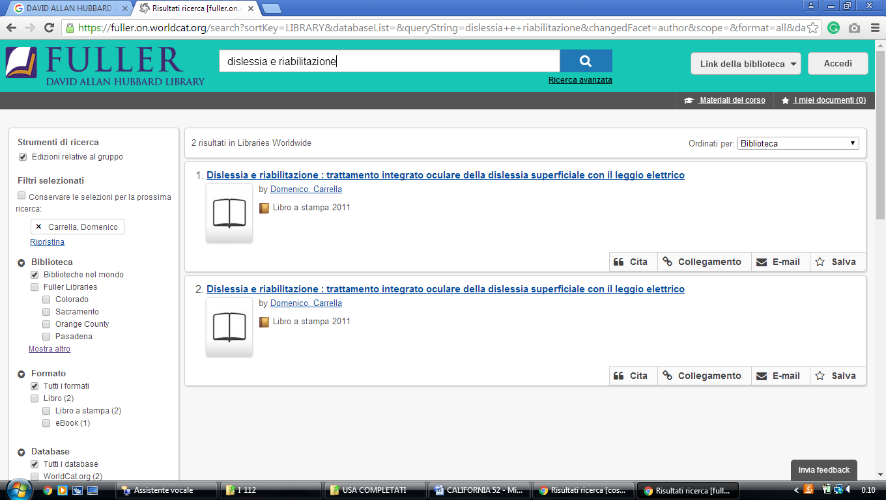

11 DE ANZA COLLEGE LIBRARY - (Cupertino, California, USA)
http://deanza.worldcat.org/title/dislessia-e-riabilitazione-trattamento-integrato-oculare-della-dislessia-superficiale-con-il-leggio-elettrico/oclc/878784487&referer=brief_results

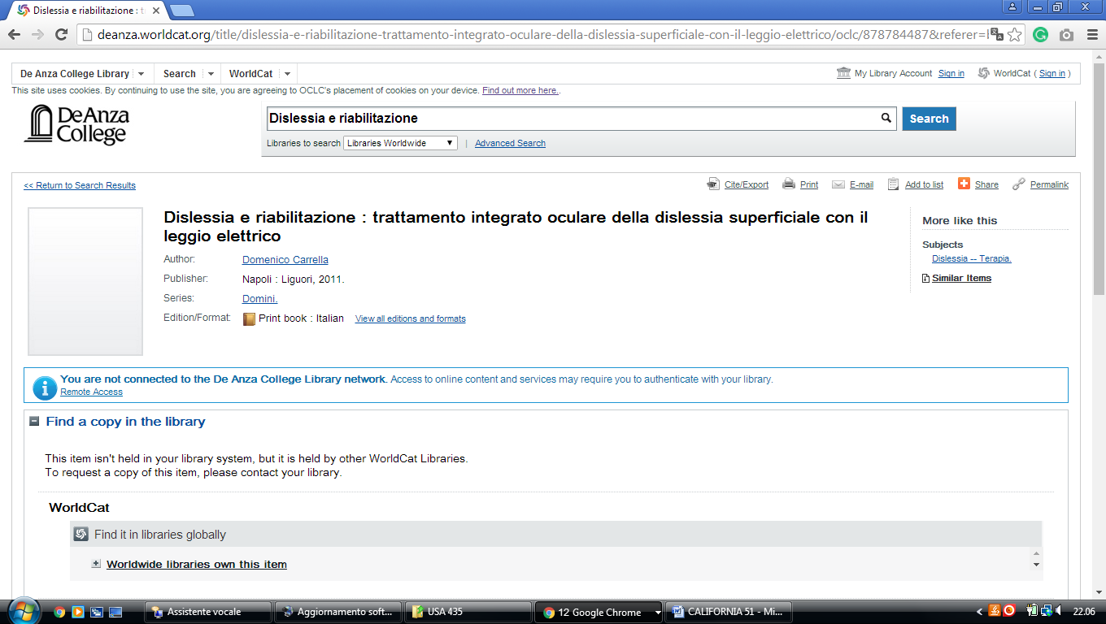

12 DOMINICAN UNIVERSITY OF CALIFORNIA LIBRARY – (San Rafael, Usa)
https://dominican.worldcat.org/search?q=dislessia+e+riabilitazione

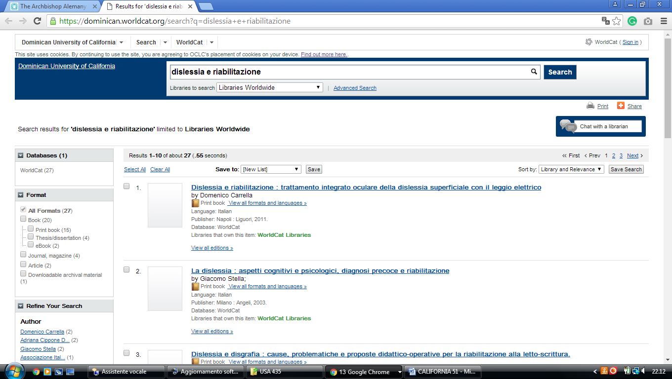

13 GELLERT LIBRARY - (Belmont, California, USA)
https://ndnu.on.worldcat.org/external-search?queryString=dislessia+e+riabilitazione#/oclc/878784487

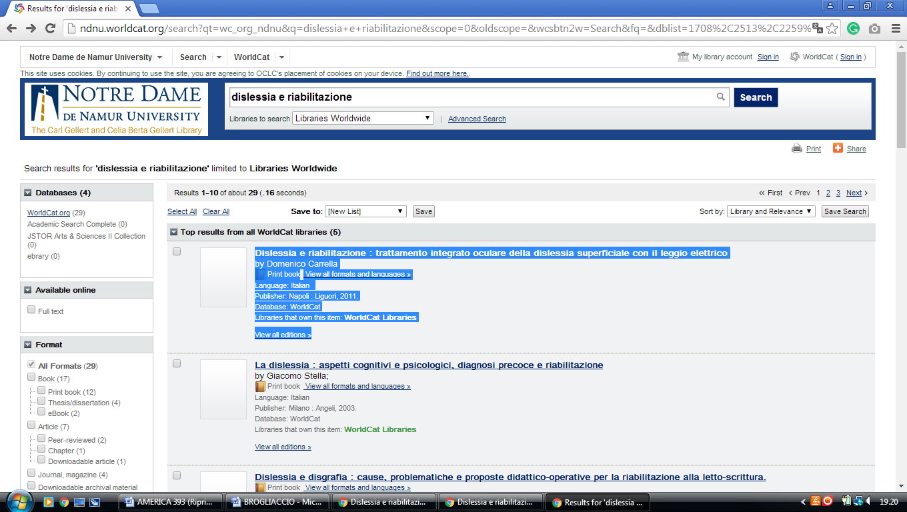

14 GETTY RESEARCH INSTITUTE LIBRARY – (Los Angeles, California, Usa)
http://primo.getty.edu/primo_library/libweb/action/search.do?ct=facet&pcAvailabiltyMode=true&pcAvailClicked=true&frbg=&vl(96033584UI1)=all_items&&indx=1&fn=search&dscnt=0&scp.scps=scope%3A(GETTY_ROSETTA)%2Cscope%3A(GETTY_ALMA)%2Cprimo_central_multiple_fe&vl(1UIStartWith0)=contains&vl(21781791UI0)=any&vid=GRI&mode=Basic&ct=search&srt=rank&tab=all_gri&dum=true&vl(freeText0)=dislessia%20e%20riabilitazione&dstmp=1521235127372
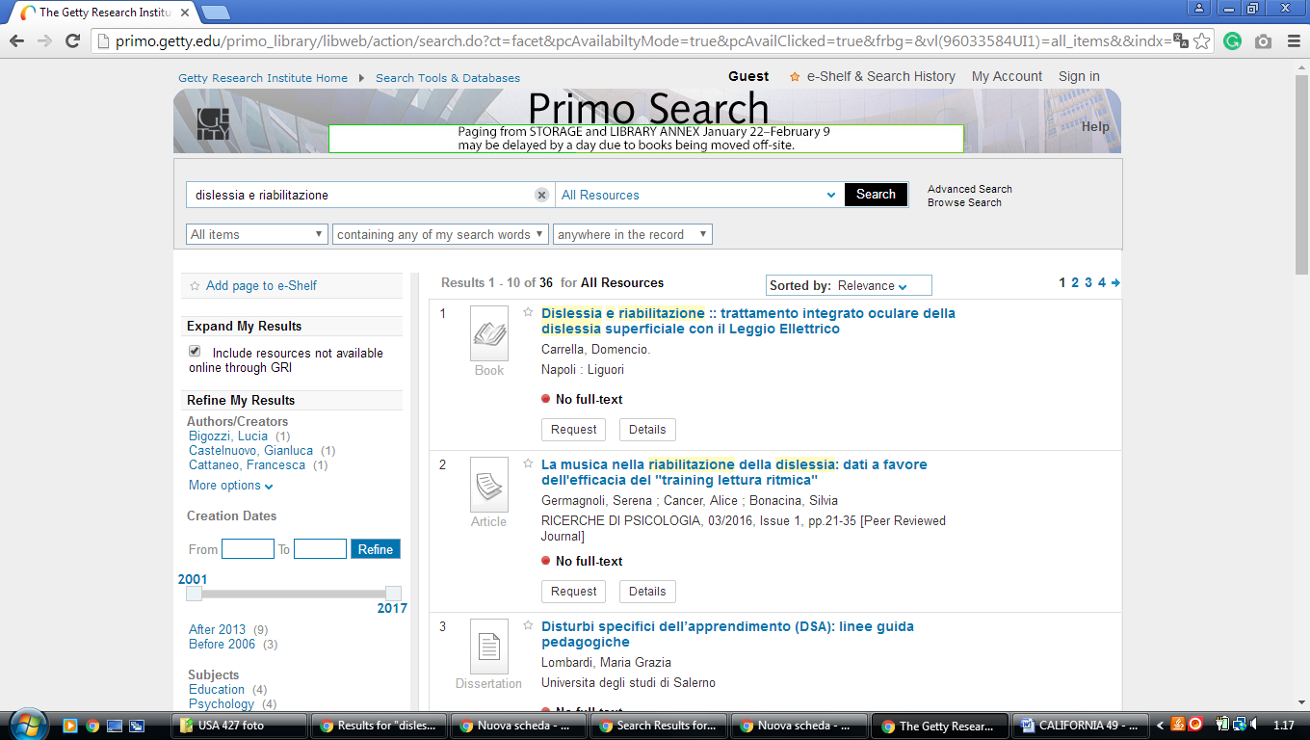

15 GLENDALE COMMUNITY COLLEGE LIBRARY - (Glendale, California, Usa)
https://gcc.on.worldcat.org/search?sortKey=LIBRARY&databaseList=2276%2C2229%2C2603%2C2625%2C2646%2C2602%2C2624%2C2007%2C2601%2C2645%2C2623%2C2006%2C2600%2C2622%2C1895%2C2643%2C2620%2C2641%2C2585%2C638%2C2605%2C2604%2C2626%2C2584%2C2483%2C2482%2C2260%2C2513%2C2259%2C2617%2C2638%2C2616%2C2615%2C2637&queryString=dislessia+e+riabilitazione&changedFacet=scope&scope=&scope=wz%3A2324&format=all&database=all&author=all&year=all&yearFrom=&yearTo=&language=all#/oclc/878784487

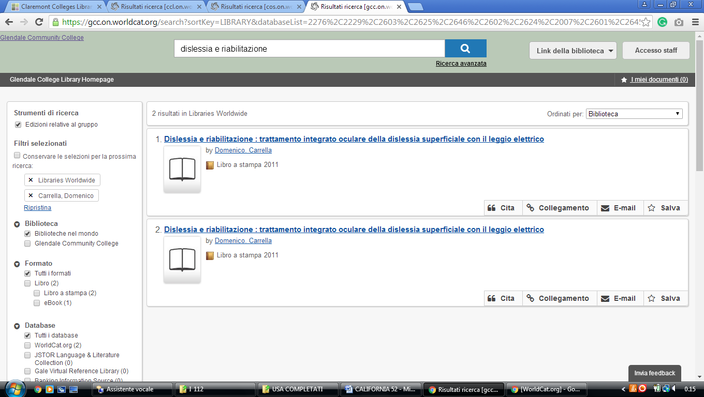

16 GOLDEN GATE UNIVERSITY LIBRARY - (San Francisco, California, Usa)
http://ggu.summon.serialssolutions.com/#!/search?ho=f&l=en&q=dislessia%20e%20riabilitazione

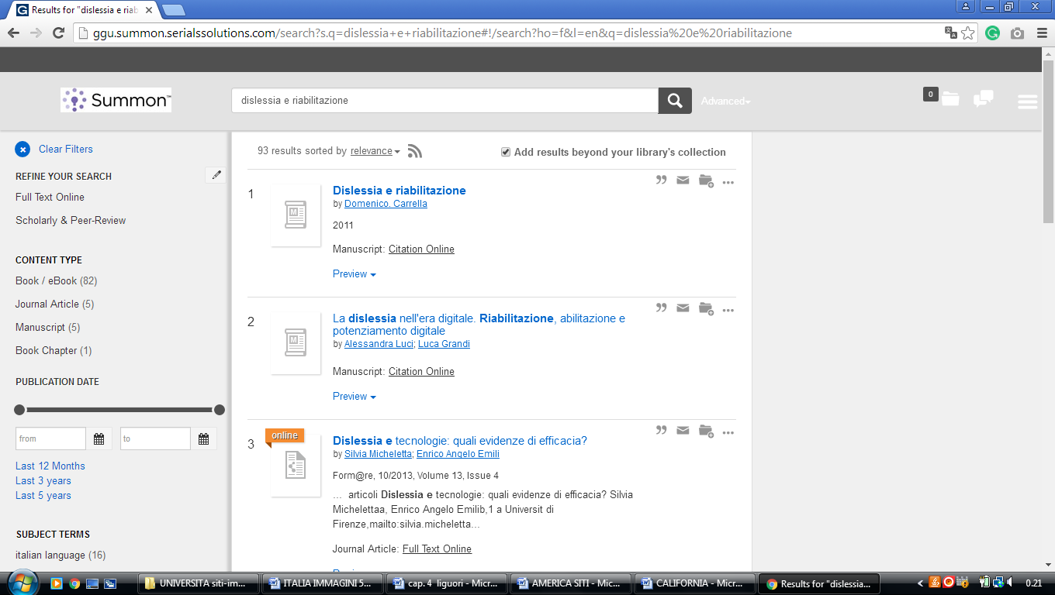

17 CALIFORNIA GROUP CATALOG LIBRARY
http://california.worldcat.org/title/dislessia-e-riabilitazione-trattamento-integrato-oculare-della-dislessia-superficiale-con-il-leggio-elettrico/oclc/878784487&referer=brief_results
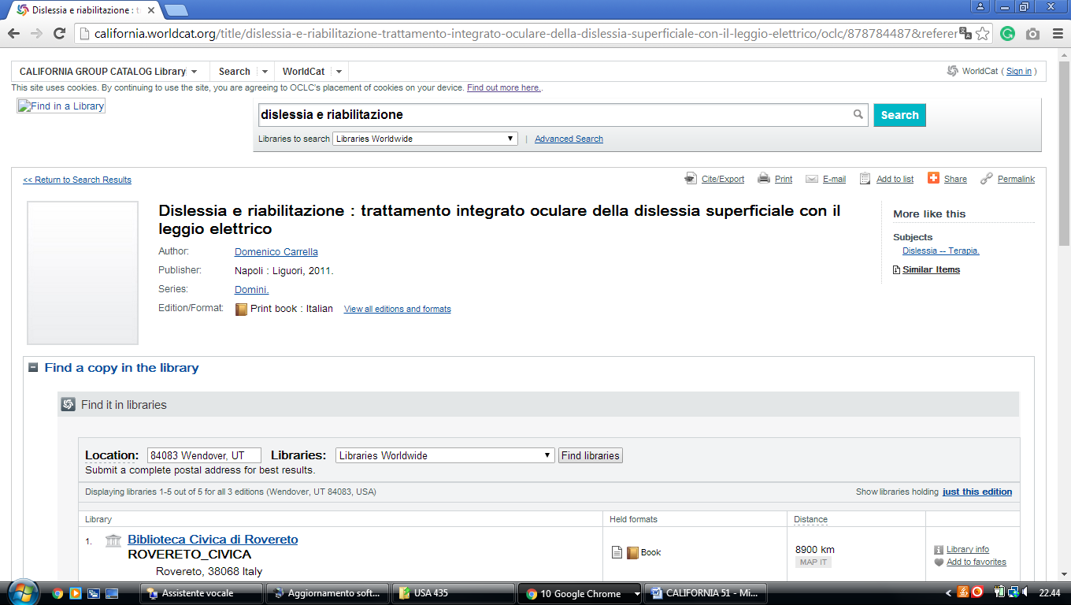

18 HUGH AND HAZEL DARLING LIBRARY - (Fullerton, California, Usa)
https://hiu.on.worldcat.org/external-search?queryString=dislessia+e+riabilitazione

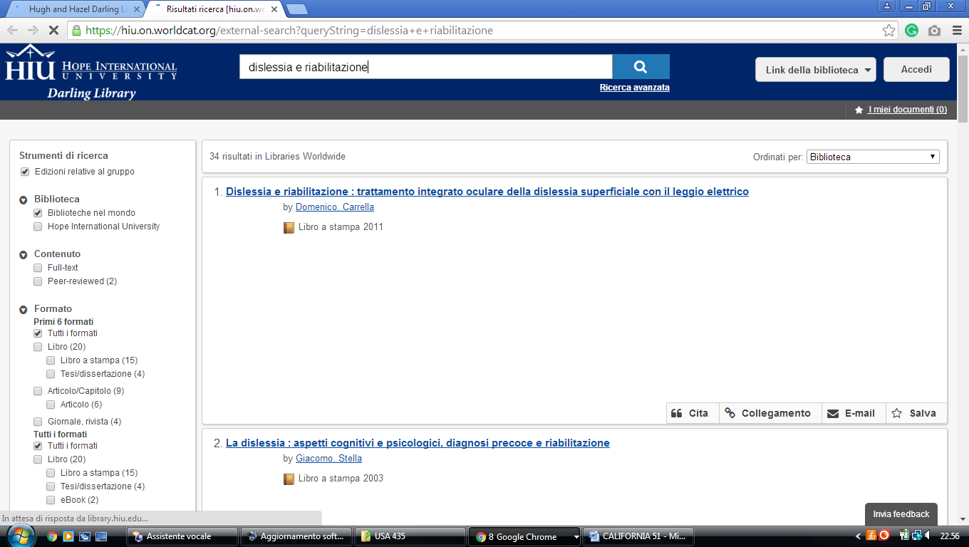

19 IRVINE VALLEY COLLEGE LIBRARY - (California, Usa)
http://ivc.worldcat.org/title/dislessia-e-riabilitazione-trattamento-integrato-oculare-della-dislessia-superficiale-con-il-leggio-elettrico/oclc/878784487&referer=brief_results

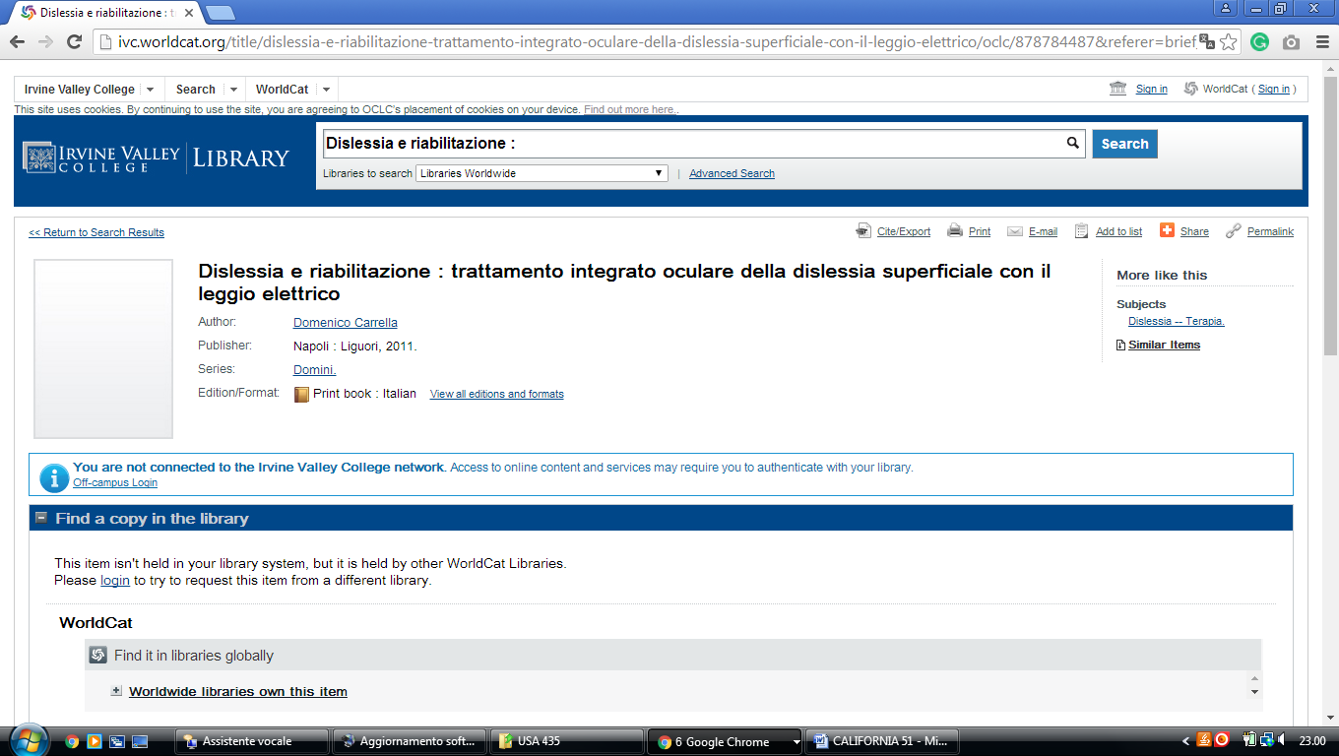

20 MASTER'S COLLEGE LIBRARY - (Santa Clarita, California, Usa)
https://masters.on.worldcat.org/search?sortKey=LIBRARY&databaseList=638&queryString=kw%3A%28DISLESSIA+E+RIABILITAZIONE%29&changedFacet=author&scope=&format=all&database=all&author=Carrella%2C+Domenico&year=all&yearFrom=&yearTo=&language=all&topic=all
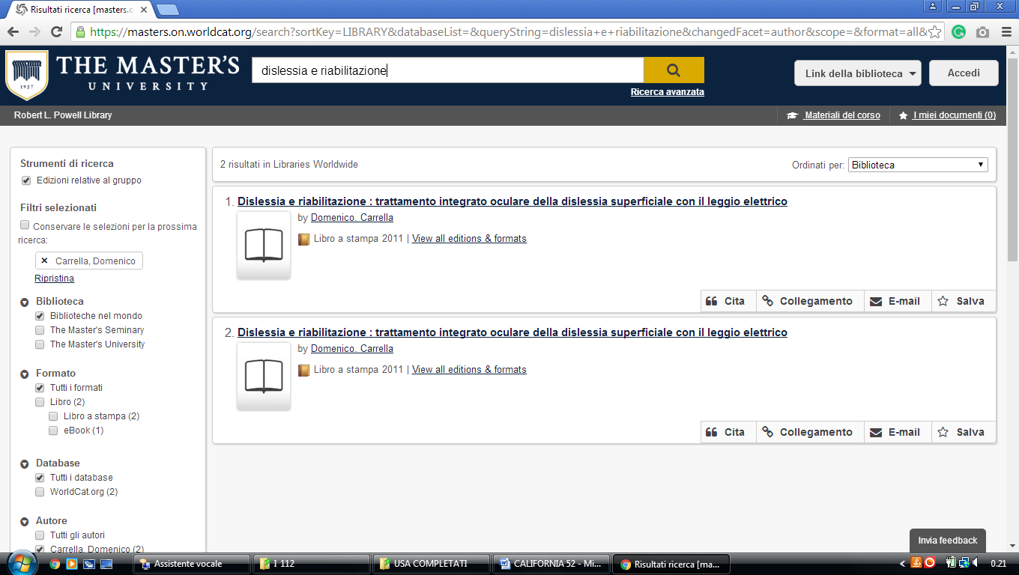

21 MENIFEE VALLEY CAMPUS LIBRARY – (California, Usa)
http://msjc.worldcat.org/title/dislessia-e-riabilitazione-trattamento-integrato-oculare-della-dislessia-superficiale-con-il-leggio-elettrico/oclc/878784487&referer=brief_results

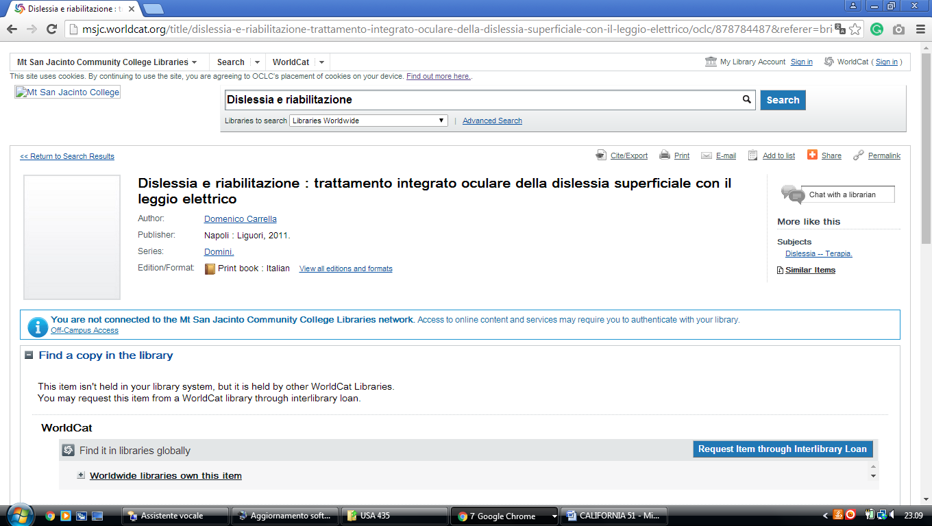

22 MODESTO JUNIOR COLLEGE LIBRARY – (Modesto, California, Usa)
https://mjc.on.worldcat.org/search?sortKey=LIBRARY&databaseList=&queryString=dislessia+e+riabilitazione&changedFacet=author&scope=&format=all&database=all&author=Carrella%2C+Domenico&year=all&yearFrom=&yearTo=&language=all&topic=all

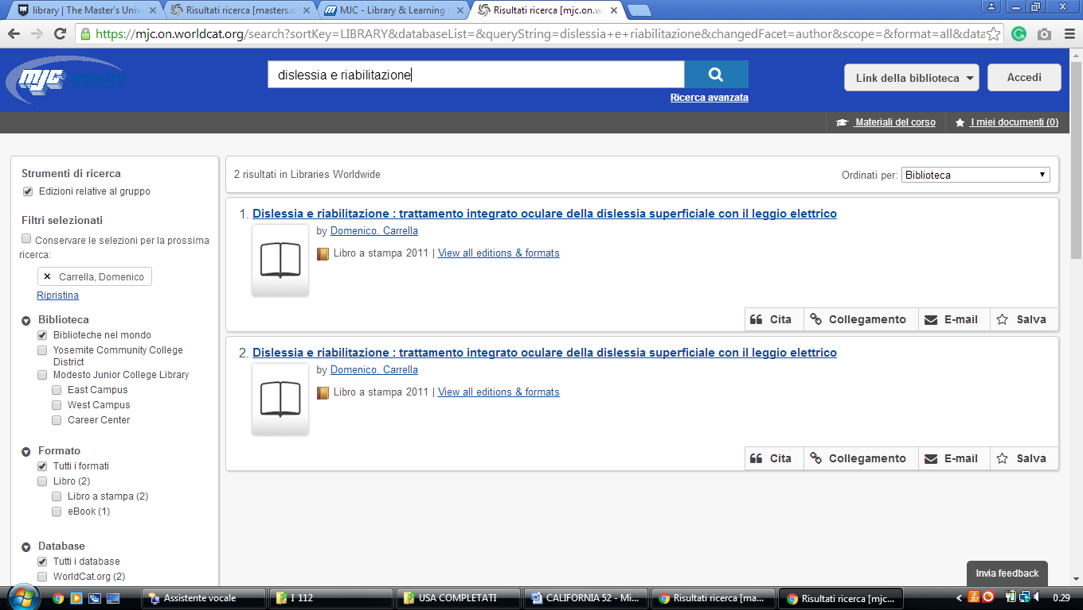

23 MOORPARK COLLEGE LIBRARY - (Moorpark, California, Usa)
http://primo.vcccd.edu:1701/primo_library/libweb/action/search.do?ct=facet&pcAvailabiltyMode=true&dscnt=0&scp.scps=primo_central_multiple_fe&frbg=&tab=default_tab&dstmp=1521238483441&srt=rank&ct=search&mode=Basic&&dum=true&indx=1&vl(freeText0)=dislessia%20e%20riabilitazione&fn=search&vid=MOORPARK

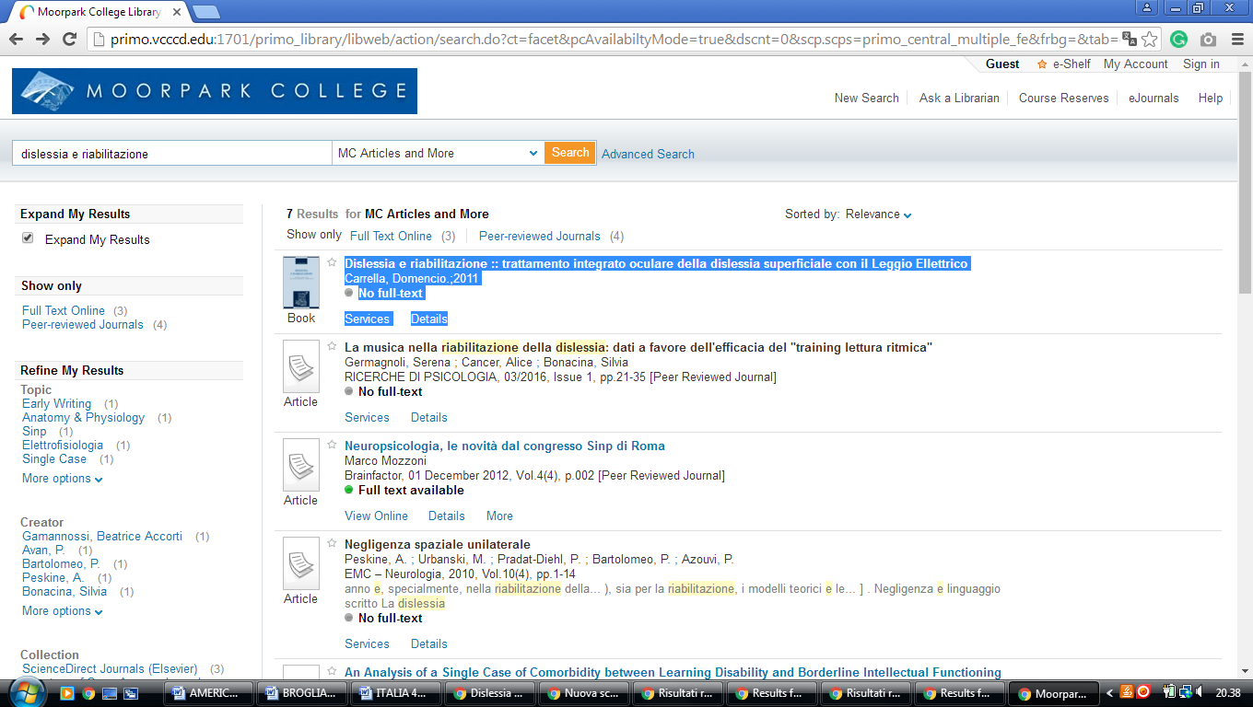

24 MT. SAN ANTONIO COLLEGE LIBRARY – (Walnut, California, Usa)
https://mtsac.on.worldcat.org/search?sortKey=LIBRARY&databaseList=&queryString=dislessia+e+riabilitazione&changedFacet=author&stickyFacetsChecked=on&scope=&format=all&database=all&author=Carrella%2C+Domenico&year=all&yearFrom=&yearTo=&language=all&topic=all

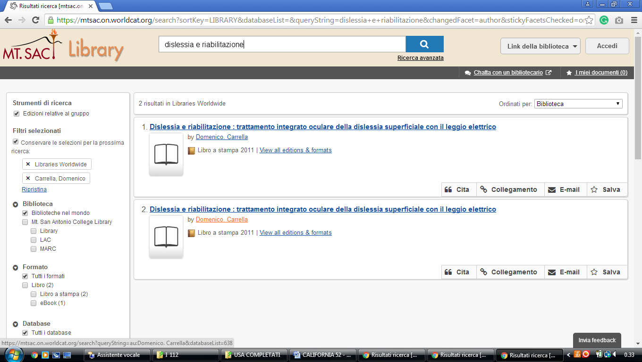

25 NAVAL POSTGRADUATE SCHOOL LIBRARY – (Monterey, California, Usa)
https://nps.primo.exlibrisgroup.com/discovery/fulldisplay?docid=dipf959441&context=PC&vid=01NPS_INST:01NPS&lang=en&search_scope=MyInst_and_CI&adaptor=Primo%20Central&tab=Everything&query=any,contains,%20dislessia%20e%20riabilitazione&sortby=rank&pcAvailability=true

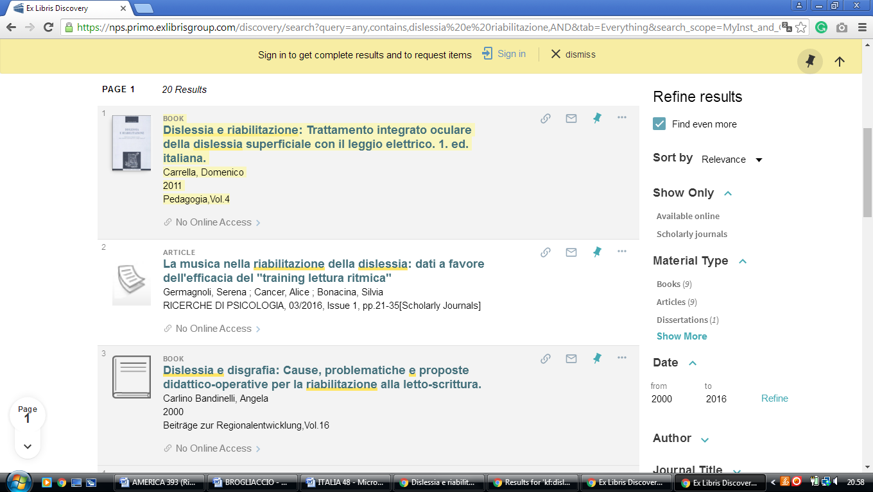

26 NATIONAL UNIVERSITY LIBRARY SYSTEM - (La Jolla, California, Usa)
https://primo-tc-na01.hosted.exlibrisgroup.com/primo-explore/search?vid=NATL&tab=default_tab&search_scope=all_scope&mode=basic&query=any,contains,dislessia%20e%20riabilitazione&pcAvailability=true&facet=&sortby=rank&lang=en_US

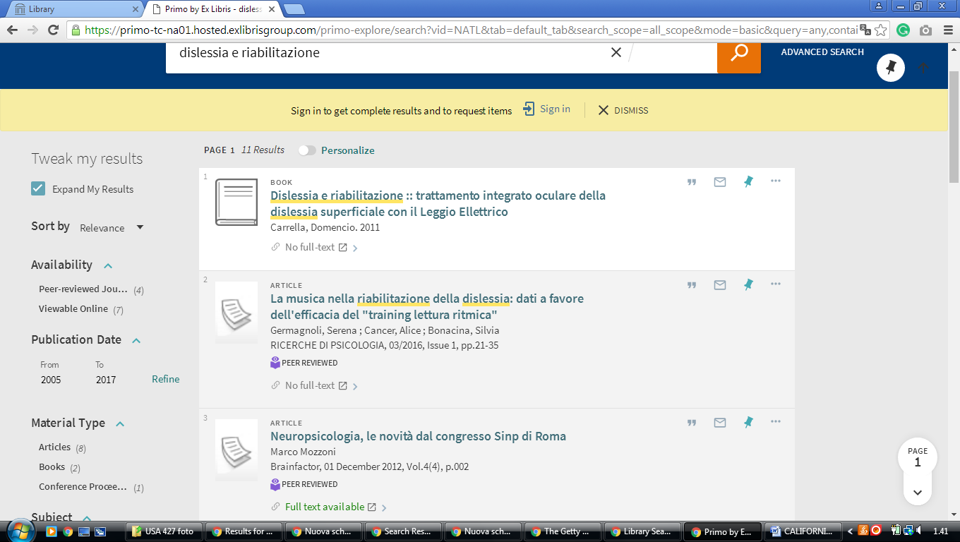

27 OCCIDENTAL COLLEGE LIBRARY – (Los Angeles, California, Usa)
http://oxy.worldcat.org/title/dislessia-e-riabilitazione-trattamento-integrato-oculare-della-dislessia-superficiale-con-il-leggio-elettrico/oclc/878784487&referer=brief_results

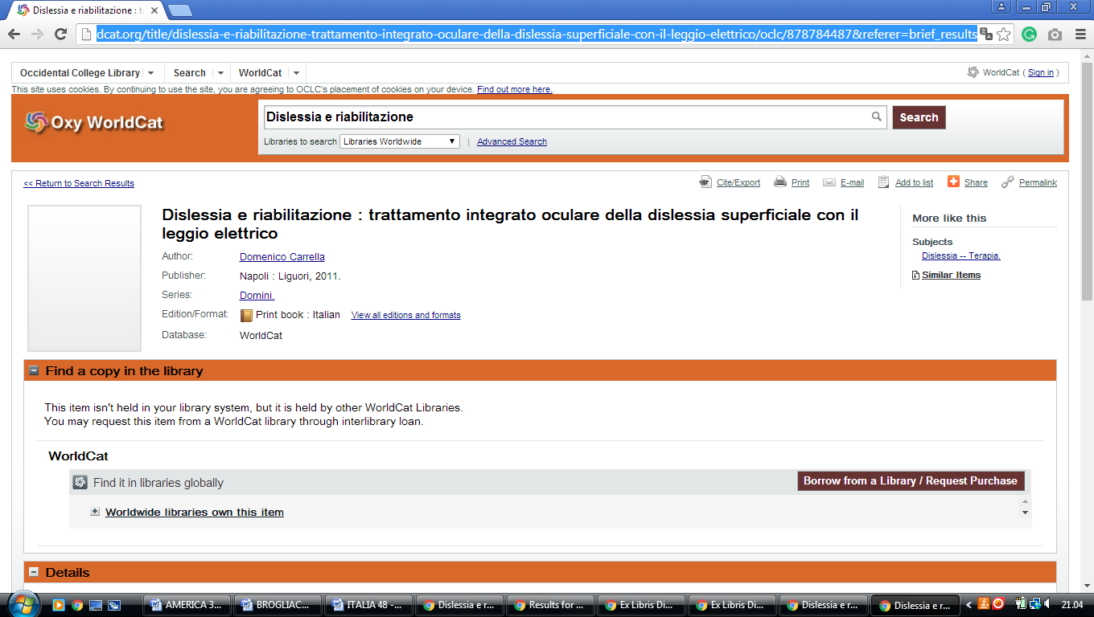

28 PALOMAR COLLEGE LIBRARY – (San Marcos, California, Usa)
https://palomar.worldcat.org/search?q=dislessia+e+riabilitazione&qt=results_page&dblist=638&scope=0&oldscope=1&fq=

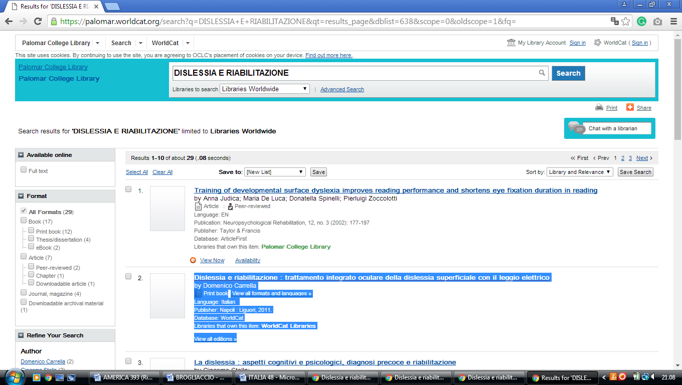

29 PEPPERDINE UNIVERSITY LIBRARIES - (Malibu, California, Usa)
https://pepperdine.worldcat.org/title/dislessia-e-riabilitazione-trattamento-integrato-oculare-della-dislessia-superficiale-con-il-leggio-elettrico/oclc/878784487&referer=brief_results

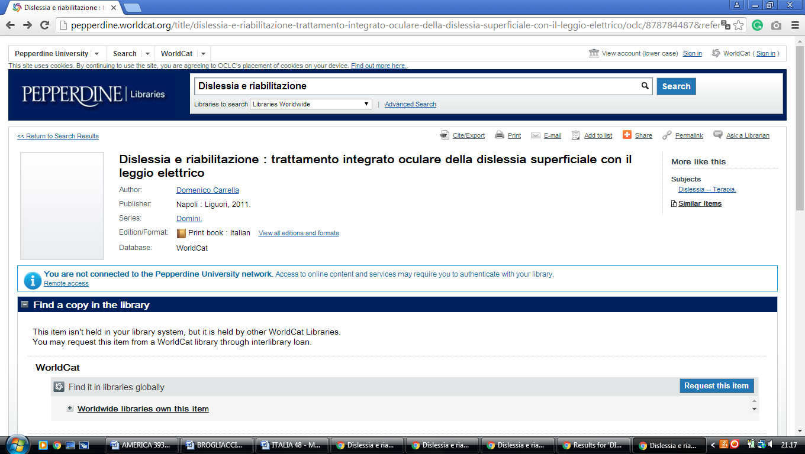

30 REEDLEY COLLEGE LIBRARY - (Reedley, California, Usa)
http://reedleycollege.worldcat.org/title/dislessia-e-riabilitazione-trattamento-integrato-oculare-della-dislessia-superficiale-con-il-leggio-elettrico/oclc/878784487&referer=brief_results

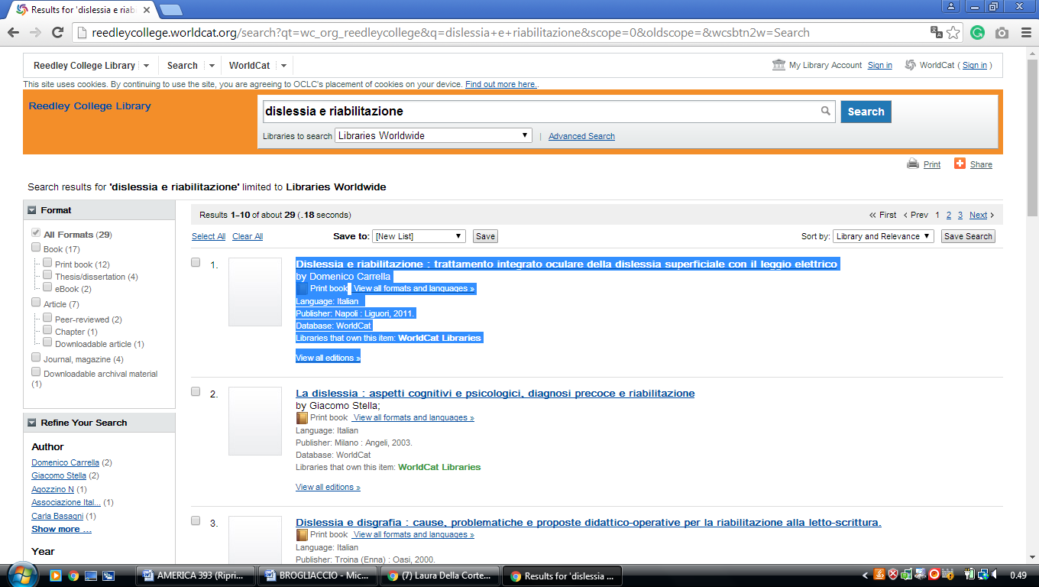

31 RYAN LIBRARY - (San Diego, California, Usa)
http://pointloma.worldcat.org/search?q=dislessia+e+riabilitazione

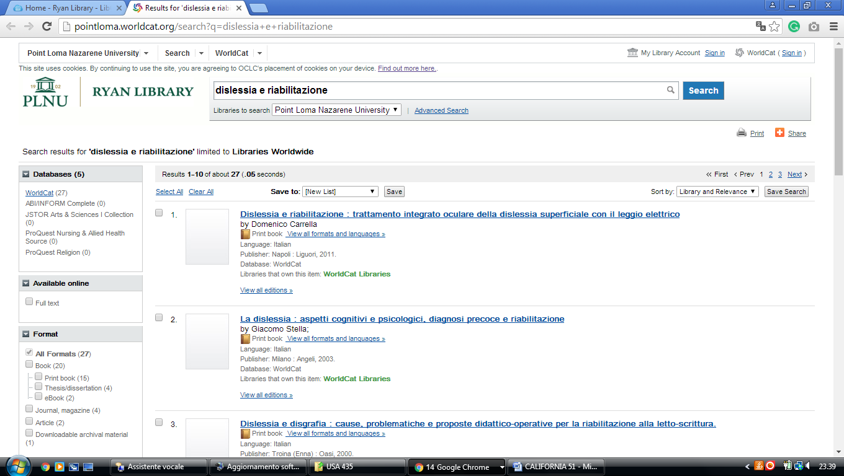

32 SADDLEBACK COLLEGE LIBRARY – (Mission Viejo, California, Usa)
https://saddleback.on.worldcat.org/search?sortKey=LIBRARY&databaseList=&queryString=dislessia+e+riabilitazione&changedFacet=author&clusterResults=on&scope=&format=all&database=all&author=Carrella%2C+Domenico&year=all&yearFrom=&yearTo=&language=all&topic=all
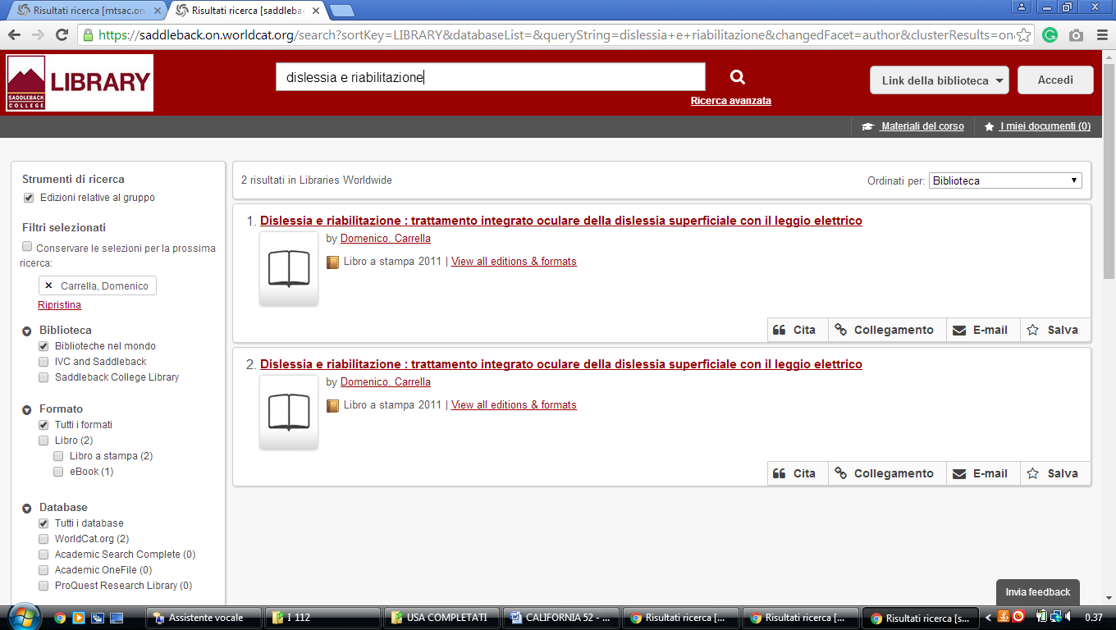

33 SYRACUSE UNIVERSITY LIBRARIES - (Syracuse, New York, Usa)

https://syracuse.summon.serialssolutions.com/search?q=dislessia+e+riabilitazione#!/search?ho=f&l=en&q=dislessia%20e%20riabilitazione
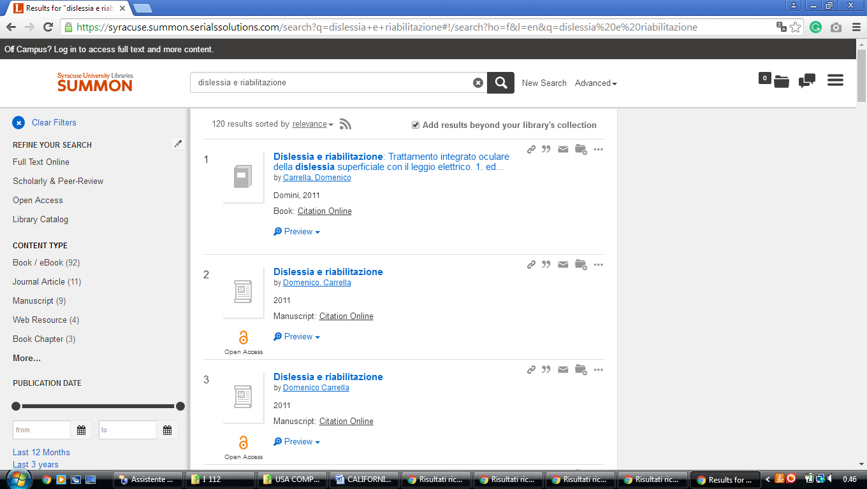

34 SU LIBRARY - (Redding, CA, USA)
https://sulibrary.on.worldcat.org/search?sortKey=LIBRARY_PLUS_RELEVANCE&databaseList=&queryString=dislessia+e+riabilitazione&changedFacet=scope&clusterResults=on&scope=&scope=wz%3A14518#/oclc/878784487
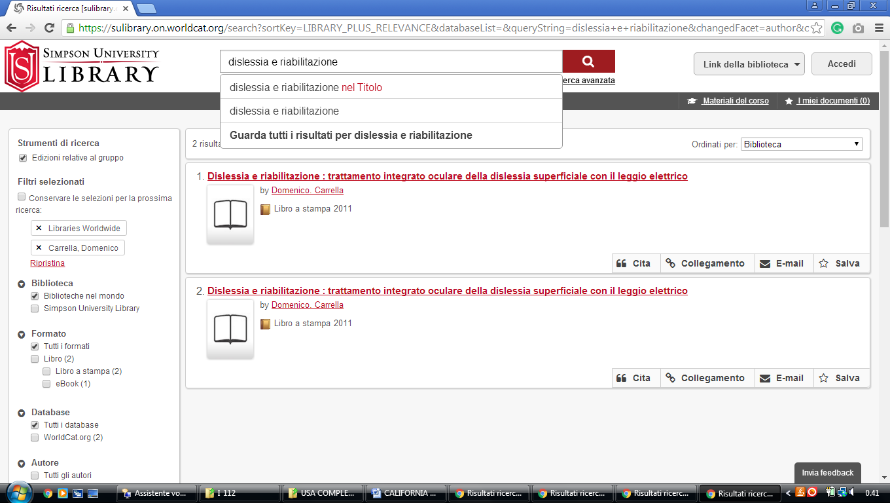

35 UNIVERSITY OF CALIFORNIA - DAVIS LIBRARY - (Davis, California, Usa)
http://ucdavis.worldcat.org/search?qt=wc_org_ucdavis&q=dislessia+e++riabilitazione&scope=0&oldscope=1&wcsbtn2w=Search&dblist=283

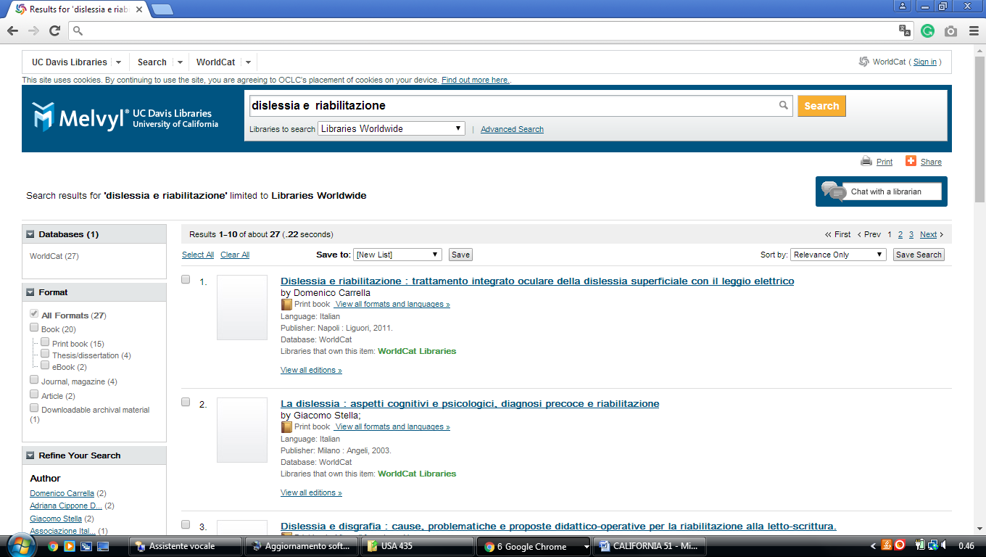

36 UCSD LIBRARY - (University Of California)
http://ucsd.worldcat.org/wcpa/servlet/org.oclc.lac.search.SearchServlet?dblist=1708%2C1875%2C2446%2C2217%2C3404%2C3697%2C1931%2C143%2C2214%2C3039%2C1834%2C1847%2C3652%2C1271%2C2668%2C2130%2C3967%2C1595%2C3909%2C3281%2C2502%2C2503%2C3282%2C1476%2C3570%2C3589%2C3572%2C3587%2C1953%2C2229%2C217%2C1505%2C1469%2C3336%2C2233%2C3255%2C2237%2C2259%2C2260%2C2261%2C2268%2C2262%2C2263%2C2264%2C2267%2C2281%2C2328%2C3201%2C3284%2C3684%2C3978%2C2270%2C3205%2C3209%2C2506%2C2277%2C2433%2C2005%2C2146%2C2148%2C3879%2C2482%2C2642%2C4026%2C1941%2C1726%2C3421%2C2153%2C3369%2C3371%2C2868%2C2158%2C239%2C2038%2C2007%2C2369%2C2443%2C2507%2C2006%2C2175%2C1978%2C1732%2C3433%2C3036%2C1672%2C2223%2C2221%2C3384%2C3410%2C2375%2C1525%2C2162%2C2164%2C2166%2C3535%2C3494%2C3313%2C2236%2C1769%2C2879%2C1441%2C4062%2C3976%2C2897%2C3413%2C2215%2C283%2C285%2C638&q=dislessia+e+riabilitazione&qt=owc_search&oldscope=&scope=0
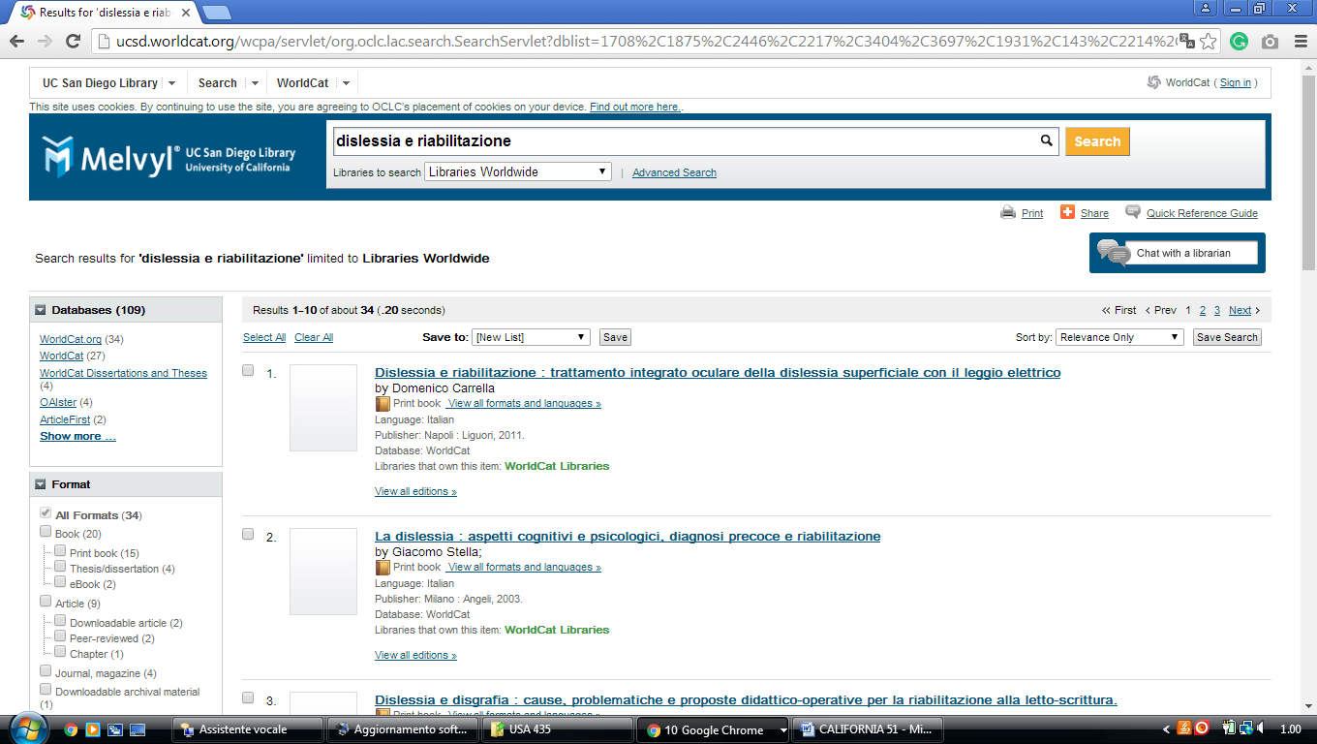

37 UCSF Library - (University of San Francisco, California, Usa)
https://ucsf.summon.serialssolutions.com/?#!/search?ho=f&l=en&q=dislessia%20e%20riabilitazione

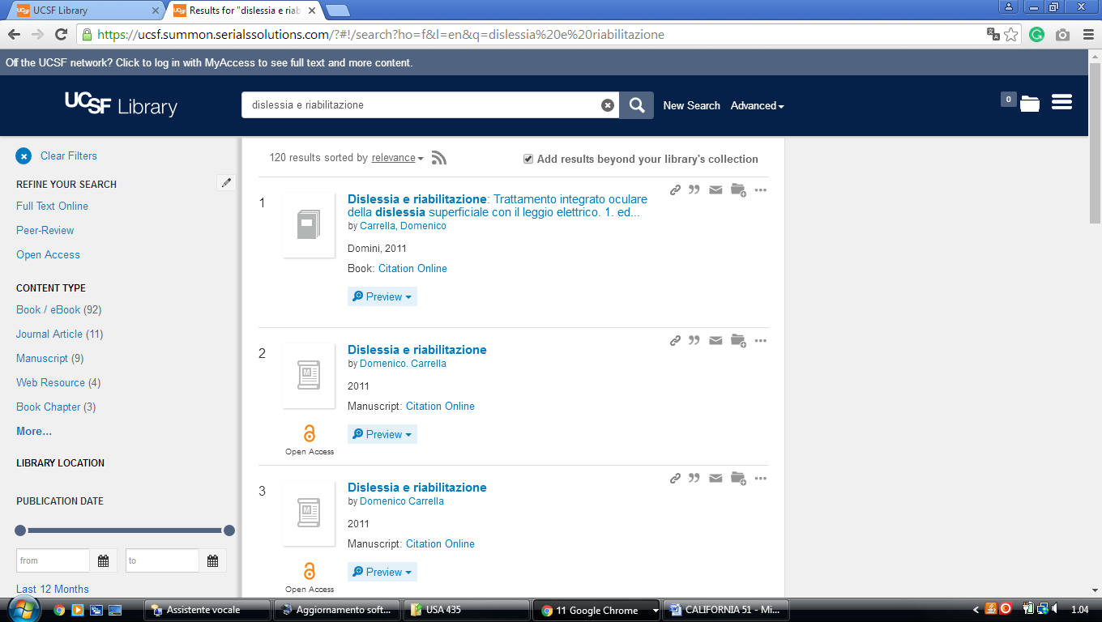

38 UCSB Library | - (University Of California ,Santa Barbara USA)
http://ucsb.worldcat.org/wcpa/servlet/org.oclc.lac.search.SearchServlet?dblist=1708%2C1875%2C3404%2C3697%2C3218%2C1931%2C143%2C2214%2C3633%2C1834%2C1847%2C3652%2C1271%2C2668%2C2130%2C3967%2C1595%2C3909%2C3281%2C2502%2C2503%2C3282%2C1476%2C3570%2C3589%2C3572%2C3587%2C1953%2C2229%2C217%2C1505%2C1469%2C3336%2C2233%2C3255%2C2237%2C2259%2C2260%2C2261%2C2268%2C2262%2C2263%2C2264%2C2267%2C2281%2C2328%2C3201%2C3284%2C3684%2C3978%2C2270%2C3205%2C3209%2C2506%2C2277%2C2433%2C2005%2C2148%2C3879%2C2482%2C2642%2C4026%2C1941%2C1726%2C3421%2C2153%2C3369%2C3371%2C2868%2C2158%2C239%2C2038%2C2007%2C2369%2C2443%2C2507%2C2006%2C2175%2C1732%2C3433%2C3036%2C1672%2C2223%2C2221%2C3384%2C3410%2C2375%2C1525%2C2162%2C2164%2C2166%2C3535%2C3494%2C3313%2C2236%2C1769%2C2879%2C1441%2C4062%2C3976%2C2897%2C3413%2C283%2C285%2C638&q=kw:dislessia%20e%20riabilitazione&qt=wc_org_ucsb&oldscope=&scope=0&wcsbtn2w=Search&wcsbtn2w.y=0&wcsbtn2w.x=0

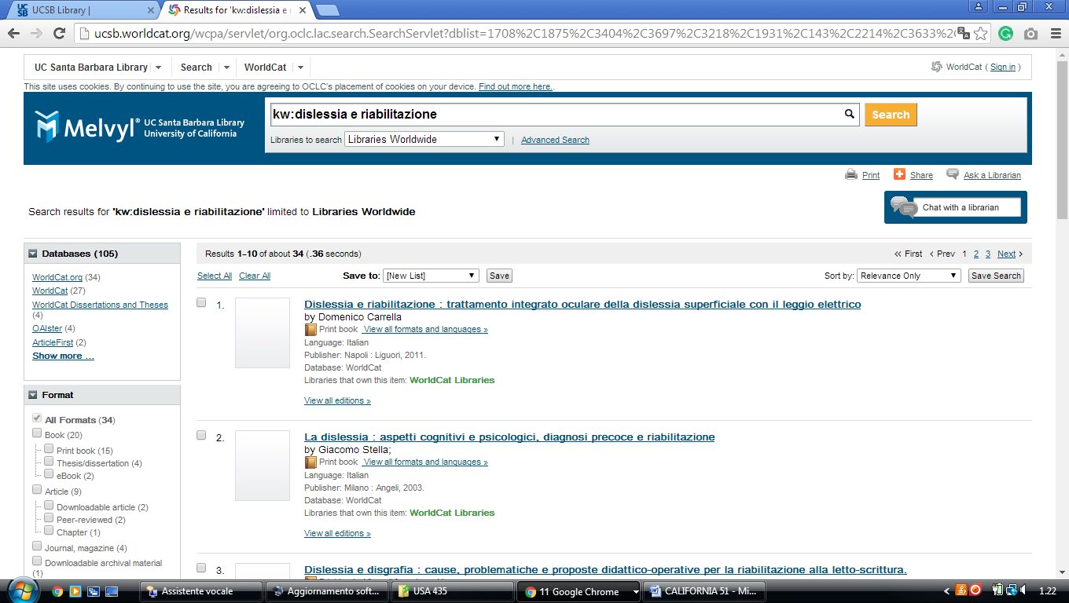

39 UC IRVINE LIBRARY - (Irvine, University Of California, USA)
http://uci.worldcat.org/wcpa/servlet/org.oclc.lac.search.SearchServlet?dblist=1708%2C1875%2C2446%2C2217%2C3697%2C3218%2C143%2C2214%2C3039%2C1834%2C1847%2C1271%2C2668%2C2130%2C1595%2C3281%2C2502%2C2503%2C3282%2C1476%2C3570%2C3589%2C3587%2C1953%2C2229%2C217%2C1505%2C1469%2C3336%2C2233%2C3255%2C2237%2C2259%2C2260%2C2261%2C2268%2C2262%2C2263%2C2264%2C2267%2C2281%2C2328%2C3201%2C3284%2C2270%2C3205%2C2273%2C3209%2C2506%2C2277%2C2433%2C2005%2C2146%2C2148%2C2482%2C2642%2C1941%2C1726%2C3421%2C2153%2C3369%2C3371%2C2868%2C2158%2C239%2C2038%2C2007%2C2369%2C2443%2C2507%2C2006%2C2175%2C1732%2C3433%2C3036%2C2223%2C2221%2C3544%2C3384%2C3410%2C2375%2C1525%2C2162%2C2164%2C2166%2C3535%2C3494%2C3313%2C1769%2C2879%2C1441%2C2897%2C3413%2C2215%2C283%2C285%2C638&q=dislessia%20e%20riabilitazione&qt=results_page&oldscope=2&scope=0
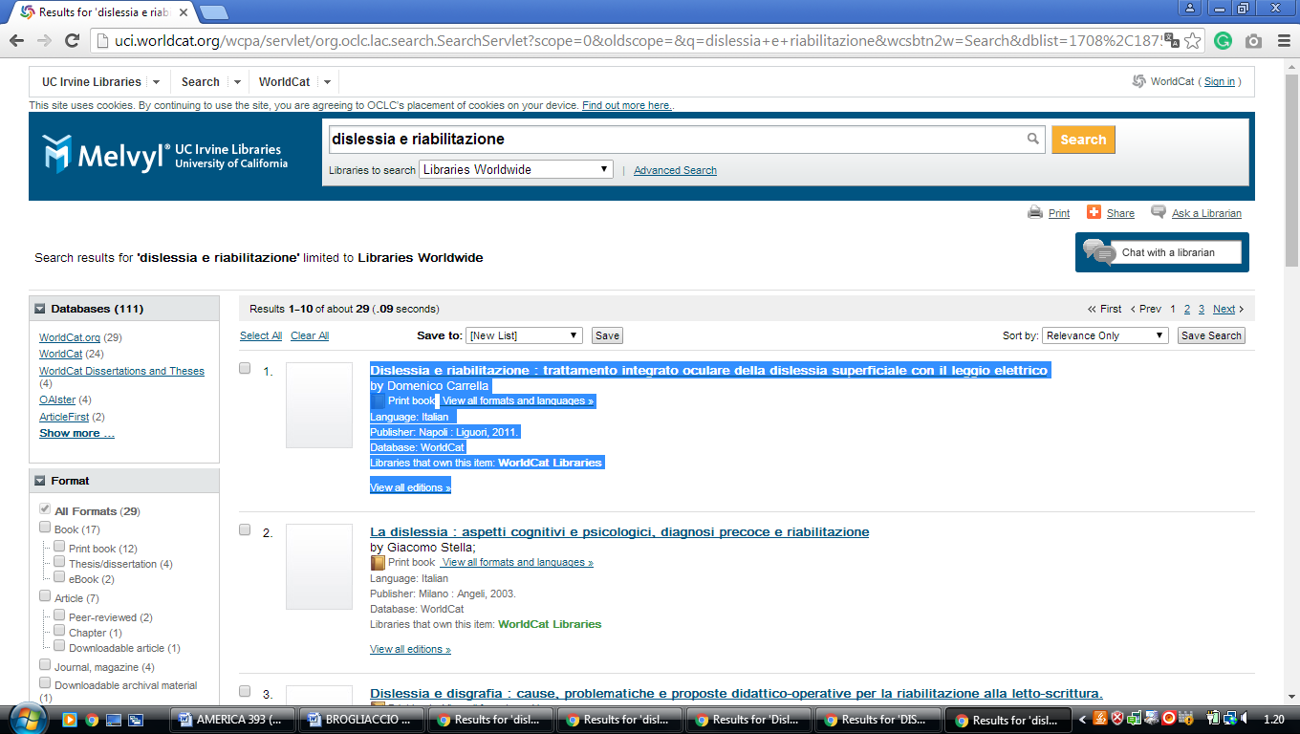

40 UC SANTA CRUZ LIBRARY - (University Of California, USA)
https://ucsc.worldcat.org/search?q=kw%3Adislessia+e+riabilitazione&qt=results_page&dblist=1708%2C1875%2C2446%2C2217%2C3697%2C3218%2C1931%2C143%2C2214%2C3633%2C1834%2C1847%2C3652%2C1271%2C2668%2C2130%2C3967%2C1595%2C3909%2C3281%2C2502%2C2503%2C3282%2C1476%2C3570%2C3589%2C3572%2C3587%2C1953%2C2229%2C217%2C1505%2C1469%2C3336%2C2233%2C3255%2C2237%2C2259%2C2260%2C2261%2C2268%2C2262%2C2263%2C2264%2C2267%2C2281%2C2328%2C3201%2C3284%2C3684%2C3978%2C2270%2C3205%2C3209%2C2506%2C2277%2C2433%2C2005%2C2146%2C2148%2C3879%2C2482%2C2642%2C1941%2C1726%2C3421%2C2153%2C3369%2C3371%2C2868%2C2158%2C239%2C2038%2C2007%2C2369%2C2443%2C2507%2C2006%2C2175%2C1732%2C3433%2C3036%2C1672%2C2223%2C2221%2C3200%2C3410%2C2375%2C1525%2C2162%2C2164%2C2166%2C3535%2C3494%2C3313%2C2236%2C1769%2C2879%2C1441%2C4062%2C3976%2C2897%2C3413%2C283%2C285%2C638&scope=0&oldscope=1
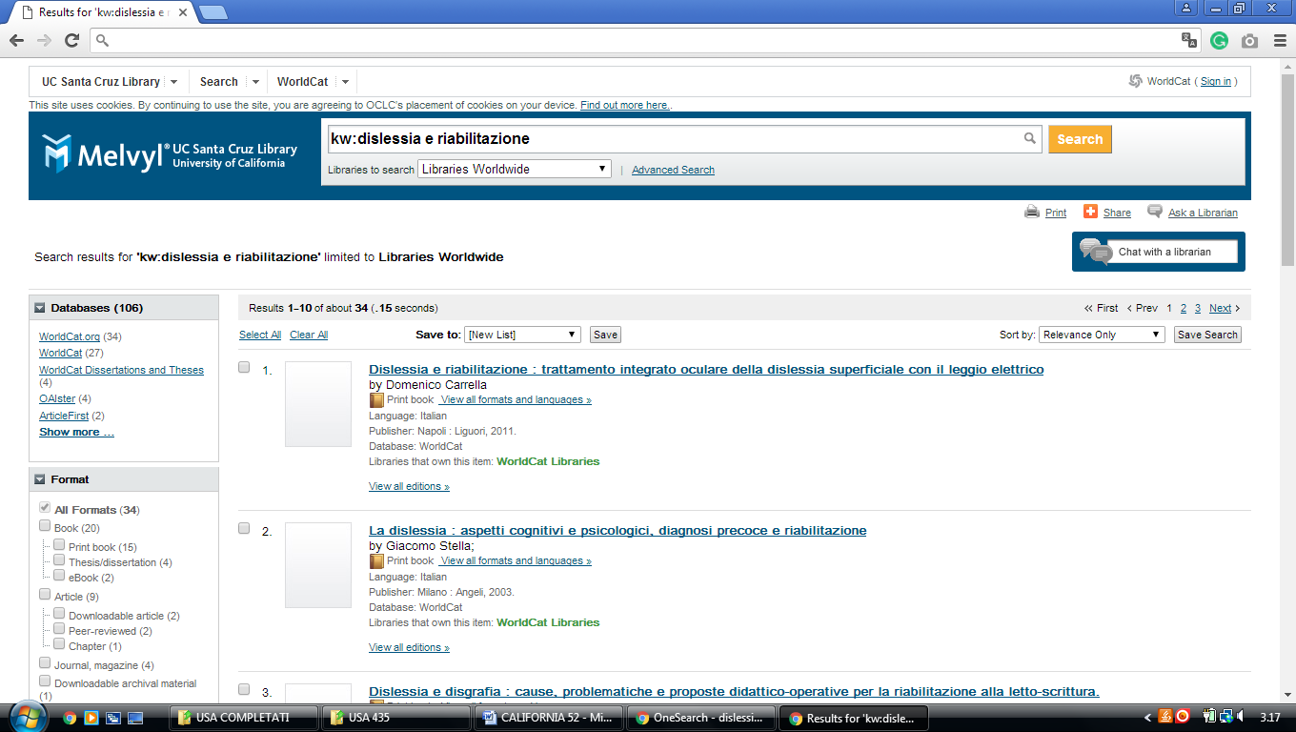

41 UC BERKELEY LIBRARY - (University Of California)
http://eds.a.ebscohost.com/eds/results?vid=0&sid=e5aa7184-872a-4924-92bc-55c5a37d8563%40sdc-v-sessmgr01&bquery=dislessia%2Be%2Briabilitazione&bdata=JnR5cGU9MCZzZWFyY2hNb2RlPUFuZCZzaXRlPWVkcy1saXZl

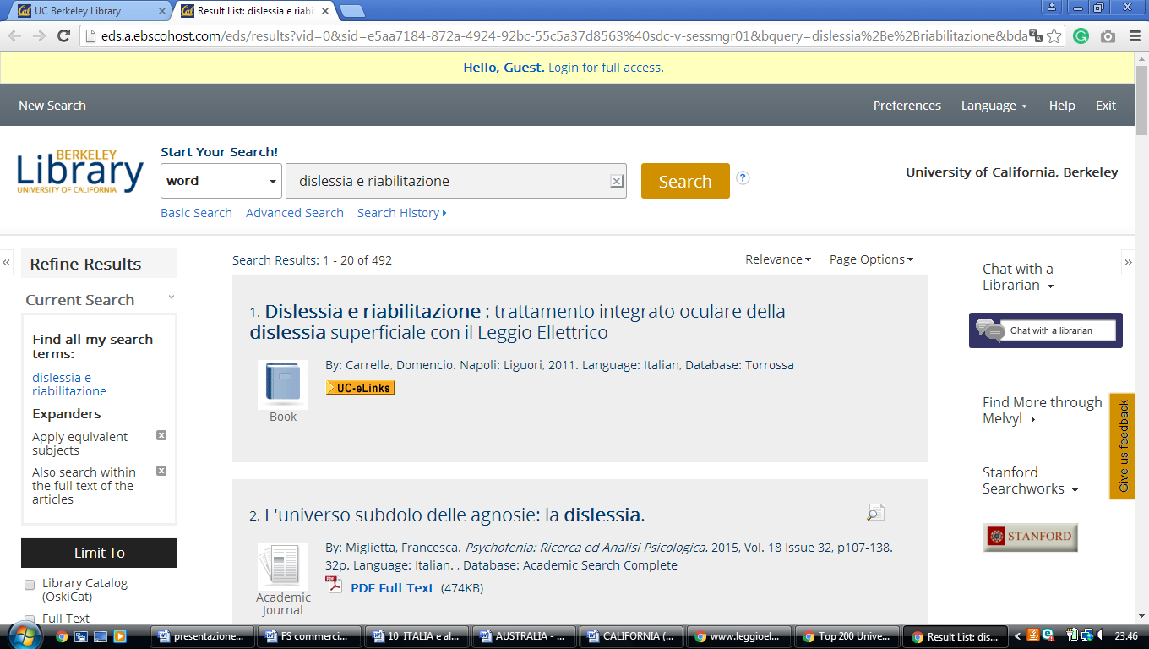

42 UNIVERSITY OF LA VERNE LIBRARIES - (California, Usa)
http://ulvlibrary.on.worldcat.org/external-search?queryString=dislessia+e+riabilitazione&scope=

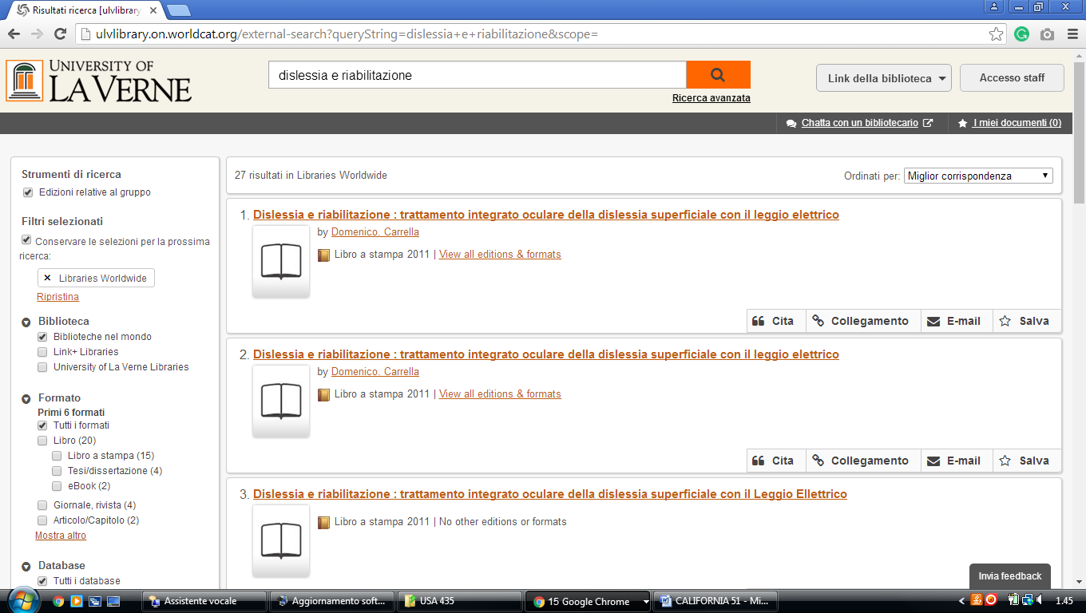

43 USC Libraries | - (University Of Southern California, Los Angeles,Usa)
https://usc-primo.hosted.exlibrisgroup.com/primo-explore/search?institution=01USC_INST&vid=01USC&search_scope=EVERYTHING&mode=Basic&facet=&displayMode=full&bulkSize=25&highlight=true&dum=true&query=any,contains,dislessia%20e%20riabilitazione&displayField=all&pcAvailabiltyMode=true&sortby=rank&lang=en_US&pcAvailability=true
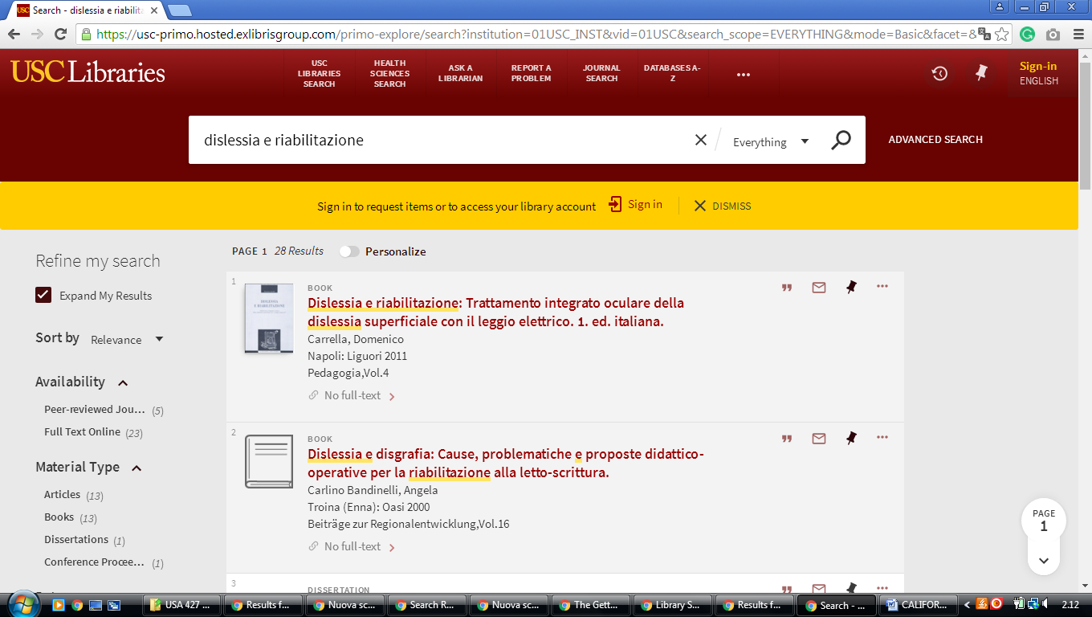

44 WALTER W. STIERN LIBRARY - CSU BAKERSFIELD - ( California, USA)
https://csub-primo.hosted.exlibrisgroup.com/primo-explore/search?institution=01CALS_UBA&vid=01CALS_UBA&query=any,contains,%20dislessia%20e%20riabilitazione&queryTemp=%20dislessia%20e%20riabilitazione&sortby=rank&lang=en_US
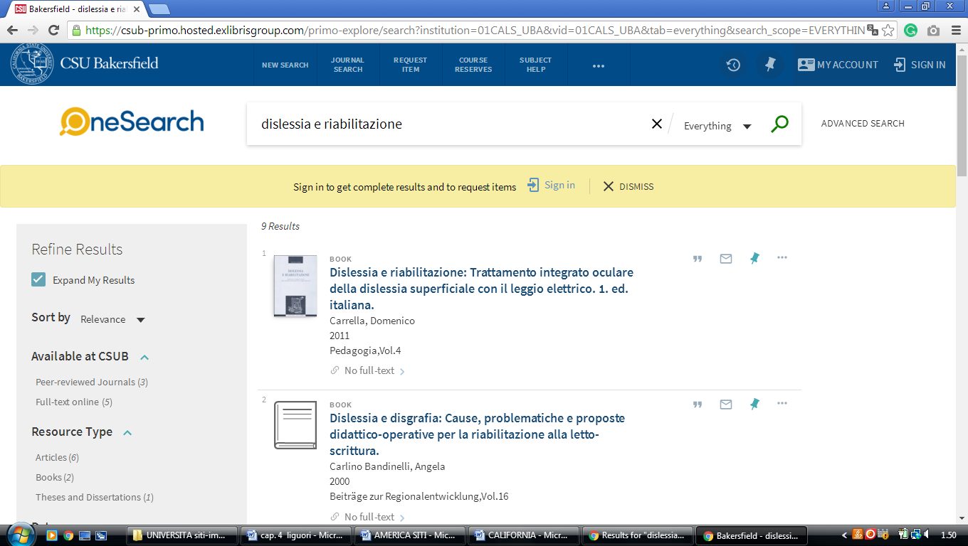

45 WEST LOS ANGELES COLLEGE LIBRARY- (Culver City, California, Usa)
http://wlac.summon.serialssolutions.com/?#!/search?ho=f&l=en&q=dislessia%20e%20riabilitazione

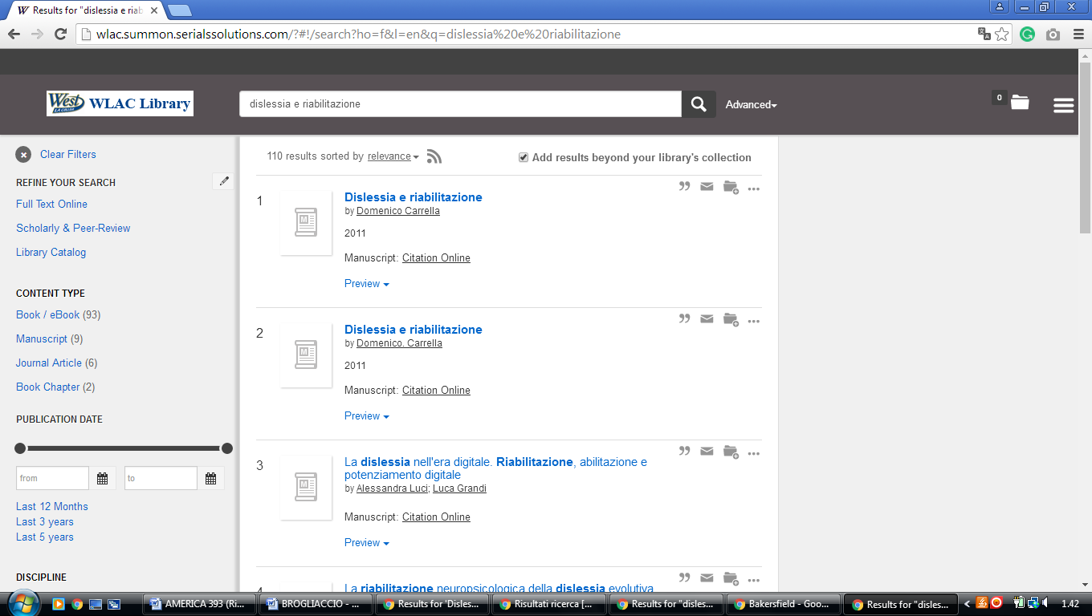

46 WESTMONT COLLEGE LIBRARY - (Santa Barbara, California, Usa)
http://westmont.worldcat.org/search?qt=affiliate&ai=wclocal_westmont&q=dislessia+e+riabilitazione&scope=0&oldscope=

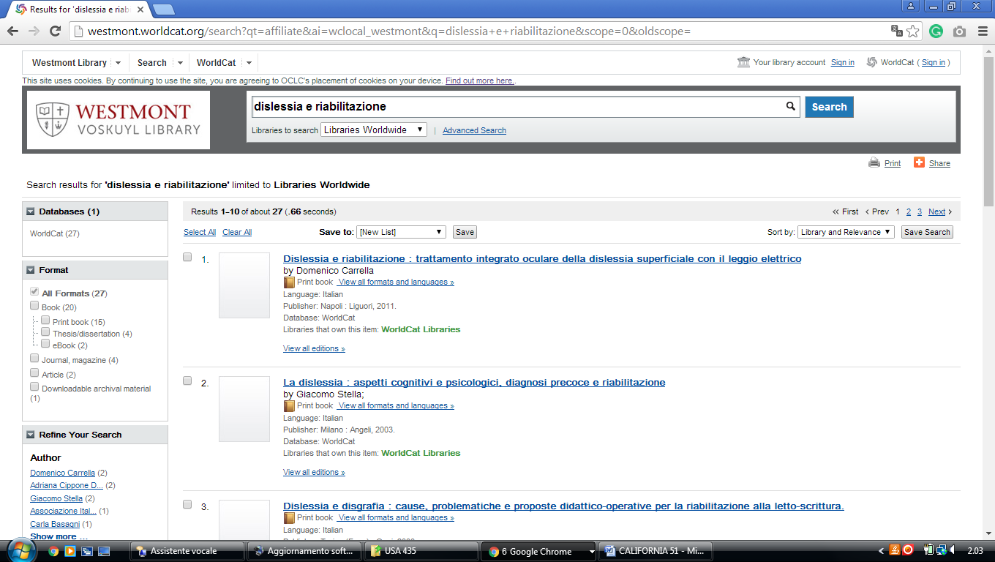

47 WOODBURY UNIVERSITY LIBRARY - (Burbank, California, Usa)
https://woodbury.on.worldcat.org/external-search?queryString=dislessia+e+riabilitazione&wcsbtn2.x=21&wcsbtn2.y=22&wcsbtn2=Search&sortKey=LIBRARY&scope=ALL_LIBRARIES

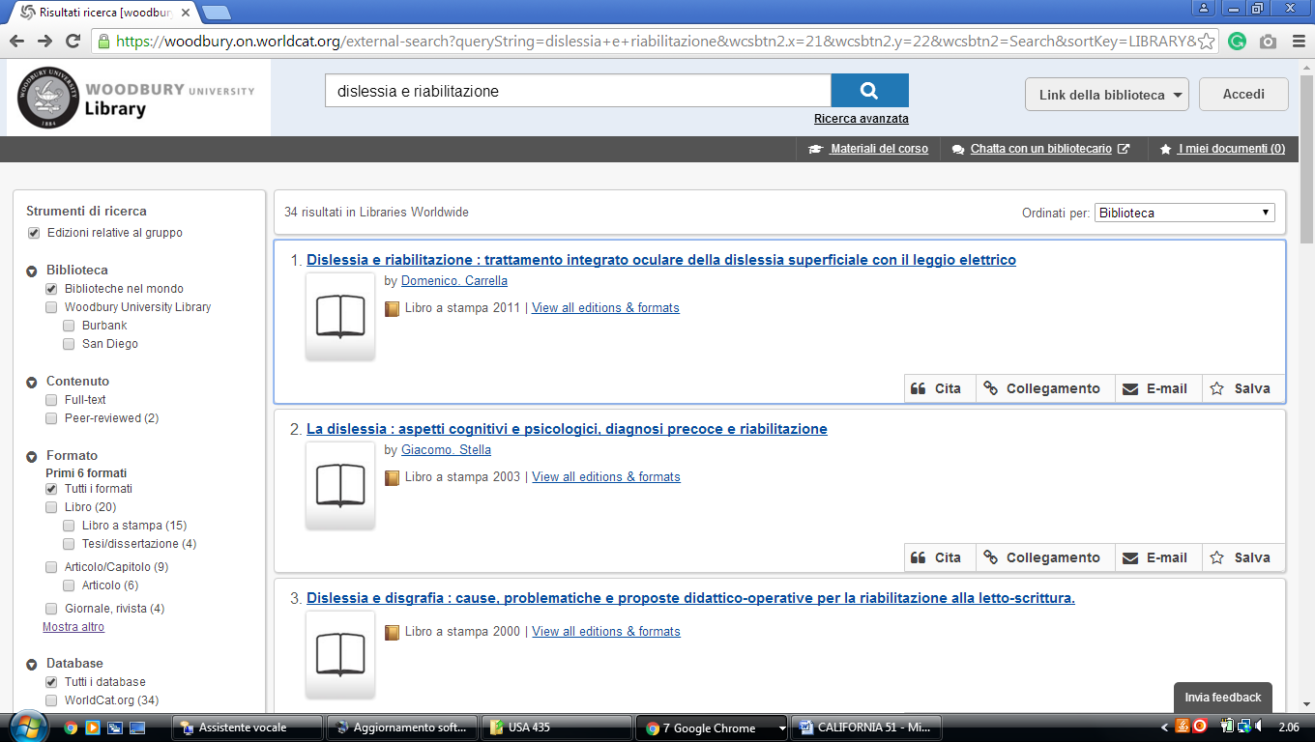

48 UC MERCED LIBRARY - (Merced, California, Usa)
https://ucmerced.worldcat.org/wcpa/servlet/org.oclc.lac.search.SearchServlet?dblist=1708%2C1875%2C2217%2C3504%2C3404%2C3697%2C3218%2C1931%2C143%2C2214%2C1834%2C1847%2C3652%2C1271%2C2668%2C2130%2C3967%2C1595%2C3909%2C3281%2C2502%2C2503%2C3282%2C1476%2C3571%2C3589%2C3572%2C3587%2C1953%2C2229%2C217%2C1505%2C1469%2C3336%2C2233%2C3255%2C2237%2C2259%2C2260%2C2261%2C2268%2C2262%2C2263%2C2264%2C2267%2C2281%2C2328%2C3201%2C3284%2C3684%2C3978%2C2270%2C3205%2C3209%2C2506%2C2277%2C2433%2C2005%2C2146%2C2148%2C3879%2C2482%2C2642%2C4026%2C1941%2C1726%2C3421%2C2153%2C3369%2C3371%2C2868%2C2158%2C239%2C2038%2C2007%2C2369%2C2507%2C2006%2C2175%2C1732%2C3433%2C3036%2C1672%2C2223%2C2221%2C3384%2C3410%2C2375%2C1525%2C2162%2C2164%2C2166%2C3535%2C3494%2C3313%2C2236%2C1769%2C2879%2C1441%2C4062%2C3976%2C2897%2C3413%2C2215%2C283%2C285%2C638&q=dislessia+e+riabilitazione&qt=wc_org_ucmerced&oldscope=&scope=0&wcsbtn2w=Search
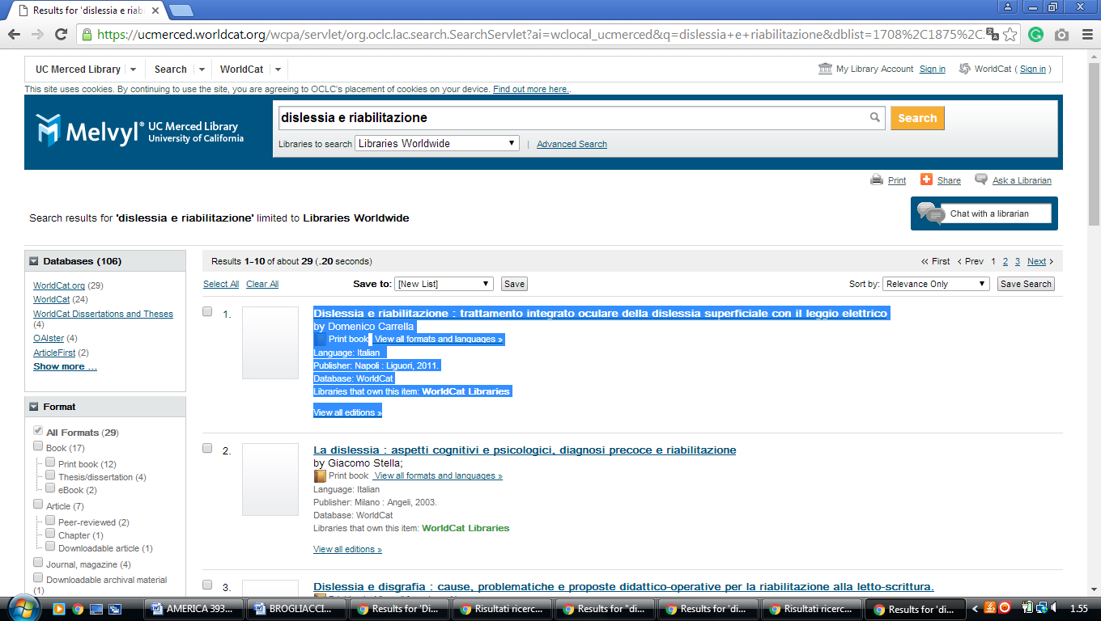

49 UCLA LIBRARY UNIVERSITY OF CALIFORNIA – (Los Angeles, USA)
http://ucla.worldcat.org/search?q=dislessia+e+riabilitazione&qt=results_page&dblist=1708%2C1875%2C2217%2C3504%2C3404%2C3697%2C3218%2C1931%2C143%2C2214%2C3039%2C3633%2C1834%2C1847%2C3652%2C1271%2C2668%2C2130%2C3967%2C1595%2C3909%2C3281%2C2502%2C2503%2C3282%2C1476%2C3570%2C3589%2C3572%2C3587%2C1953%2C2229%2C217%2C1505%2C1469%2C3336%2C2233%2C3255%2C2237%2C2259%2C2260%2C2261%2C2268%2C2262%2C2263%2C2264%2C2267%2C2281%2C2328%2C3201%2C3284%2C3684%2C3978%2C2270%2C3205%2C3209%2C2275%2C2506%2C2277%2C2433%2C2005%2C2146%2C2148%2C3879%2C2482%2C2642%2C4026%2C1941%2C1726%2C3421%2C2153%2C3369%2C3371%2C2868%2C2158%2C239%2C2038%2C2007%2C2369%2C2443%2C2507%2C2006%2C2175%2C1732%2C3433%2C3036%2C1672%2C2223%2C2221%2C3544%2C3384%2C3410%2C2375%2C1525%2C2162%2C2164%2C2166%2C3535%2C3494%2C3313%2C2236%2C1769%2C2879%2C1441%2C4062%2C3976%2C2897%2C3413%2C2215%2C283%2C285%2C638&scope=0&oldscope=1
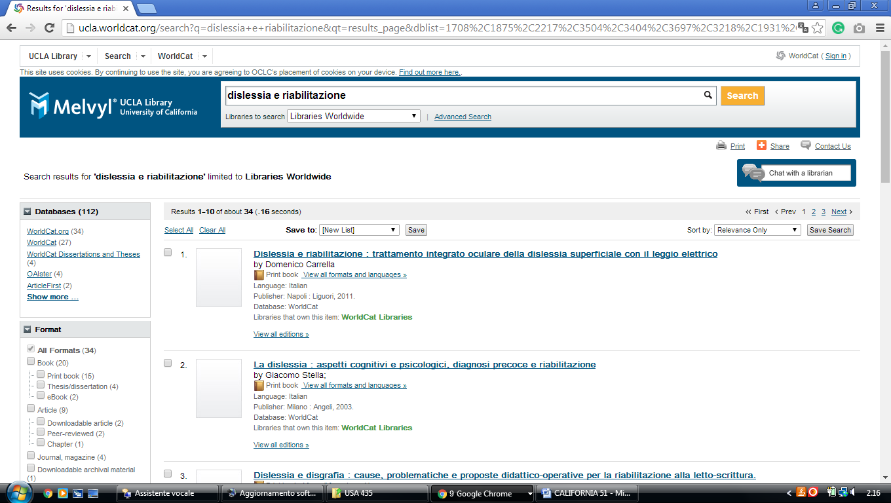

50 UC RIVERSIDE LIBRARIES - (Riverside, California, Usa)
http://ucr.worldcat.org/search?q=dislessia+e+riabilitazione&qt=results_page&dblist=1708%2C1875%2C2446%2C3504%2C3404%2C3697%2C3218%2C1931%2C143%2C2214%2C1834%2C1847%2C3652%2C1271%2C2668%2C2130%2C3967%2C1595%2C3909%2C3281%2C2502%2C2503%2C3282%2C1476%2C3572%2C1953%2C2229%2C217%2C1505%2C1469%2C3336%2C2233%2C3255%2C2237%2C2259%2C2260%2C2261%2C2268%2C2262%2C2263%2C2264%2C2267%2C2281%2C2328%2C3201%2C3284%2C3684%2C3978%2C2270%2C3205%2C3209%2C2275%2C2506%2C2277%2C2433%2C2005%2C2146%2C2148%2C3879%2C2482%2C2642%2C4026%2C1941%2C1726%2C3421%2C3369%2C3371%2C2868%2C2158%2C239%2C2038%2C2007%2C2369%2C2507%2C2006%2C2175%2C1978%2C1732%2C3433%2C3036%2C1672%2C2223%2C2221%2C3544%2C3384%2C3410%2C1525%2C2162%2C2164%2C2166%2C3535%2C3494%2C3313%2C2236%2C1769%2C2879%2C1441%2C4062%2C3976%2C2897%2C3413%2C2215%2C283%2C285%2C638&scope=0&oldscope=1
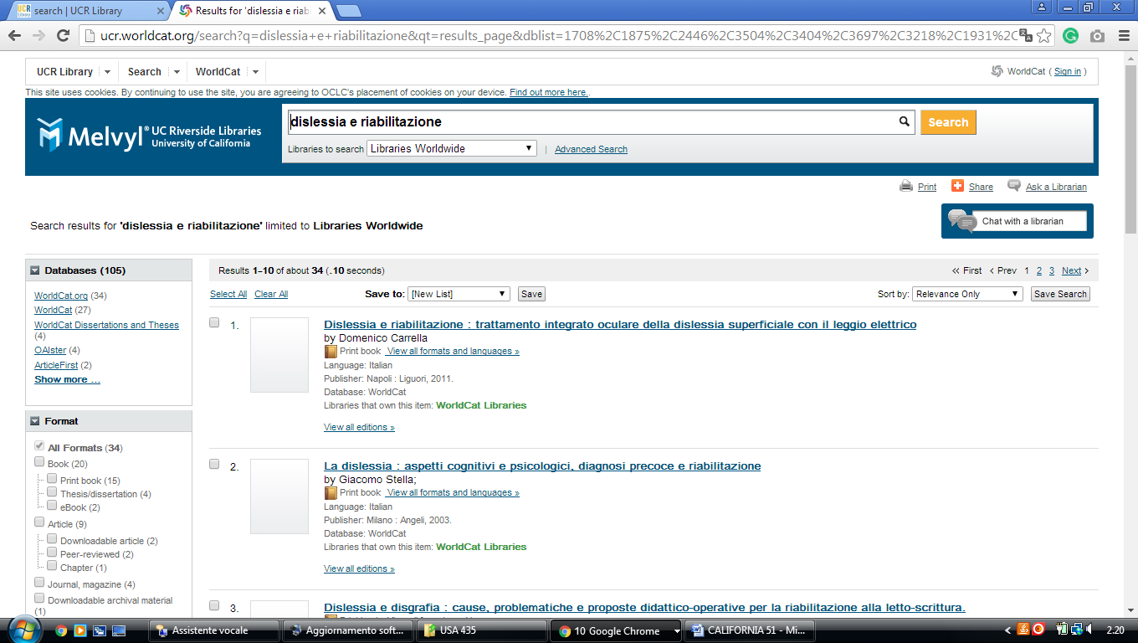

51 WELCOME TO THE UCLA LIBRARY - (University California, Usa)
http://ucla.worldcat.org/search?q=dislessia+e+riabilitazione&qt=results_page&dblist=1708%2C1875%2C2217%2C3504%2C3404%2C3697%2C3218%2C1931%2C143%2C2214%2C3039%2C3633%2C1834%2C1847%2C3652%2C1271%2C2668%2C2130%2C3967%2C1595%2C3909%2C3281%2C2502%2C2503%2C3282%2C1476%2C3570%2C3589%2C3572%2C3587%2C1953%2C2229%2C217%2C1505%2C1469%2C3336%2C2233%2C3255%2C2237%2C2259%2C2260%2C2261%2C2268%2C2262%2C2263%2C2264%2C2267%2C2281%2C2328%2C3201%2C3284%2C3684%2C3978%2C2270%2C3205%2C3209%2C2275%2C2506%2C2277%2C2433%2C2005%2C2146%2C2148%2C3879%2C2482%2C2642%2C4026%2C1941%2C1726%2C3421%2C2153%2C3369%2C3371%2C2868%2C2158%2C239%2C2038%2C2007%2C2369%2C2443%2C2507%2C2006%2C2175%2C1732%2C3433%2C3036%2C1672%2C2223%2C2221%2C3544%2C3384%2C3410%2C2375%2C1525%2C2162%2C2164%2C2166%2C3535%2C3494%2C3313%2C2236%2C1769%2C2879%2C1441%2C4062%2C3976%2C2897%2C3413%2C2215%2C283%2C285%2C638&scope=0&oldscope=1

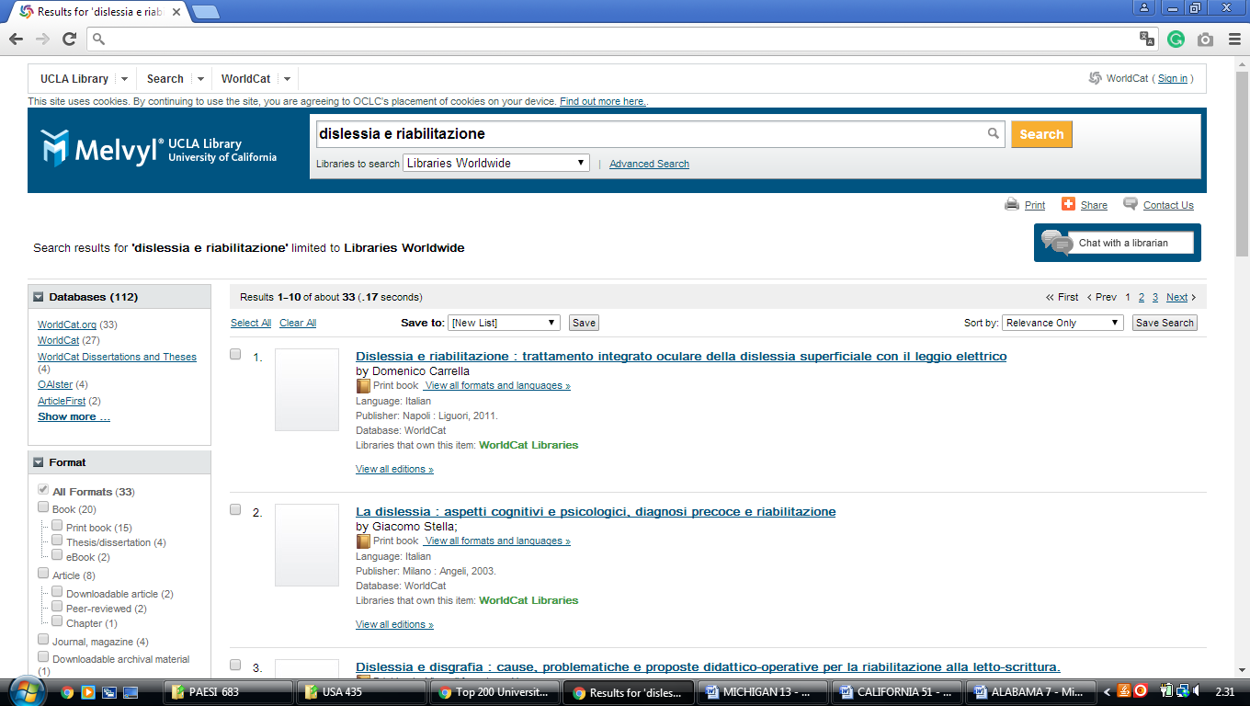

52 CUSHING LIBRARY | - (holy names university in oakland, California, Usa)
http://hnulibrary.worldcat.org/title/dislessia-e-riabilitazione-trattamento-integrato-oculare-della-dislessia-superficiale-con-il-leggio-elettrico/oclc/878784487&referer=brief_results
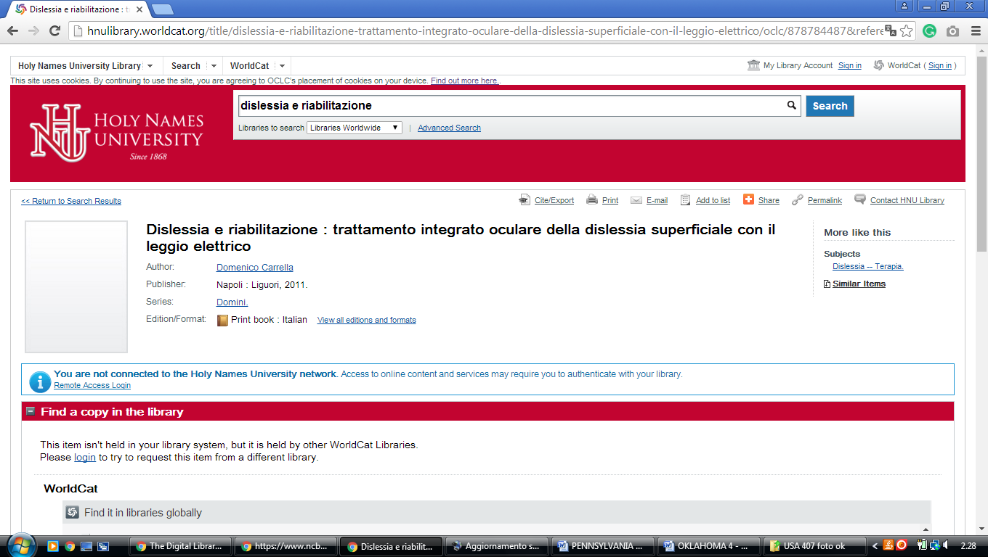

53 STANFORD LIBRARIES - STANFORD UNIVERSITY – (California , Usa)
https://searchworks.stanford.edu/articles?q=dislessia+e+riabilitazione

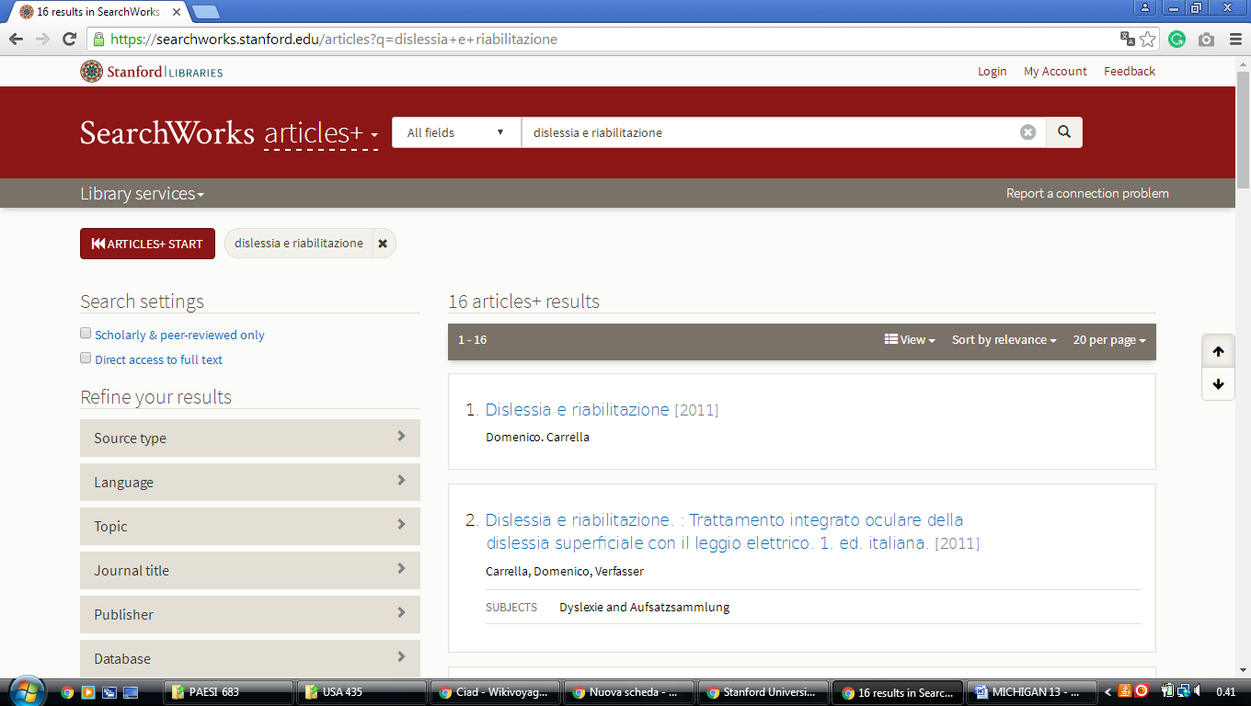

54 NEALLEY LIBRARY - SANTA ANA COLLEGE - (El Salvador)
https://sac.on.worldcat.org/search?sortKey=BEST_MATCH&databaseList=&queryString=dislessia+e+riabilitazione&changedFacet=scope&clusterResults=on&stickyFacetsChecked=on&scope=&scope=sz%3A35088&subformat=Book%3A%3Abook_printbook&subformat=Book%3A%3Abook_digital&subformat=Book%3A%3Abook_thsis&subformat=Book%3A%3Abook_mic&subformat=Book%3A%3Abook_largeprint&subformat=Book%3A%3Abook_braille&subformat=Book%3A%3Abook_continuing

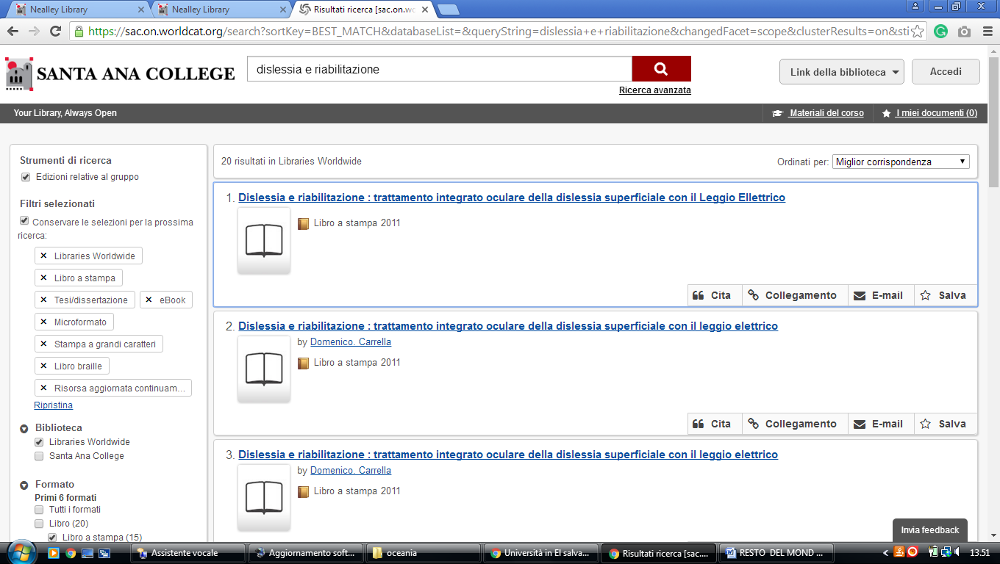

CALIFORNIA INSTITUTE OF TECHNOLOGY (Caltech,) Pasadena, CALIFORNIA, US

Refine Search - Caltech Library
https://www.library.caltech.edu/eds?query=DISLESSIA%20E%20RIABILITAZIONE

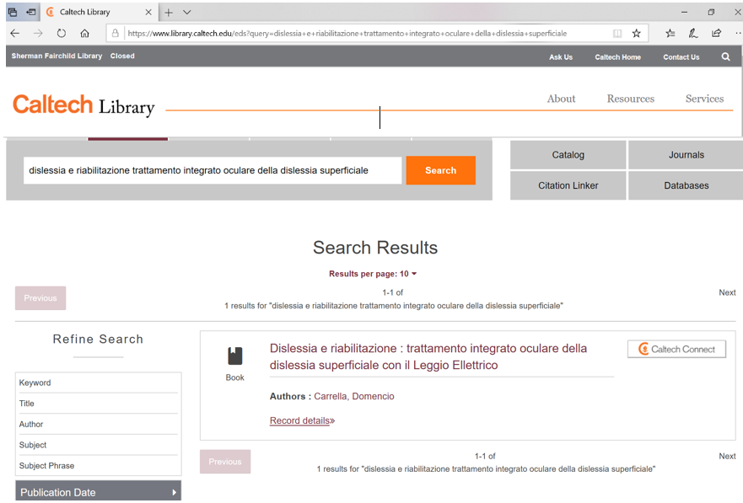

National University Library
https://nu.primo.exlibrisgroup.com/discovery/search?vid=01NATIONAL_INST:NATL&tab=Everything&search_scope=MyInst_and_CI&mode=basic&query=any,contains,dislessia%20e%20riabilitazione&pcAvailability=true&facet=&sortby=rank&lang=en
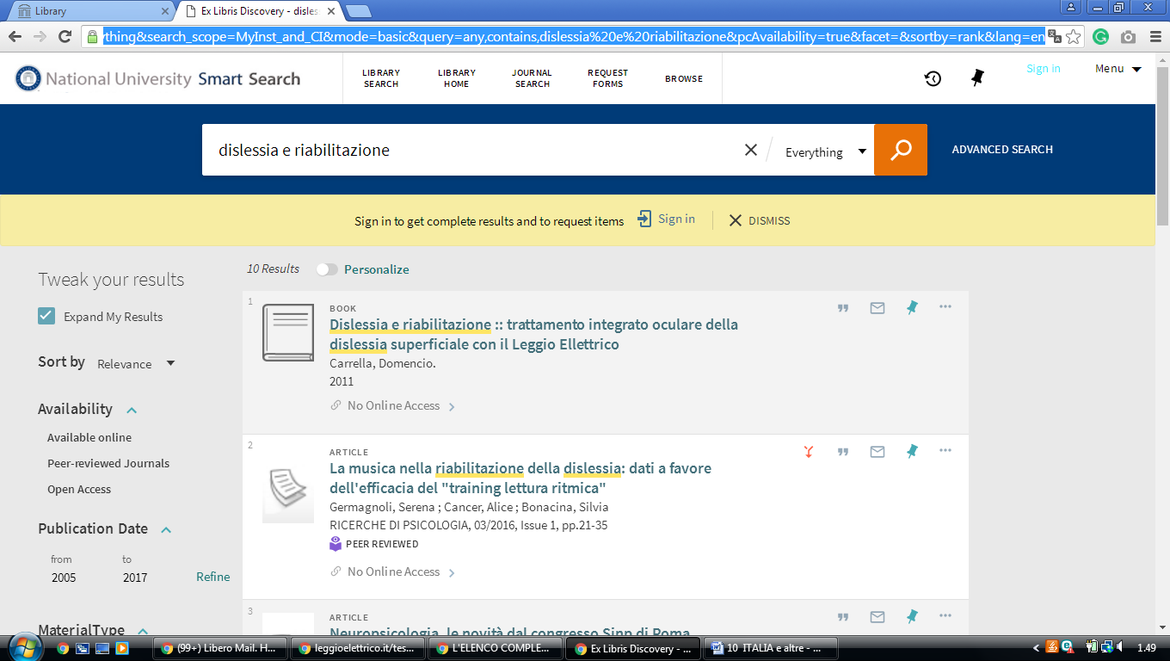

library West Coast University (WCU)

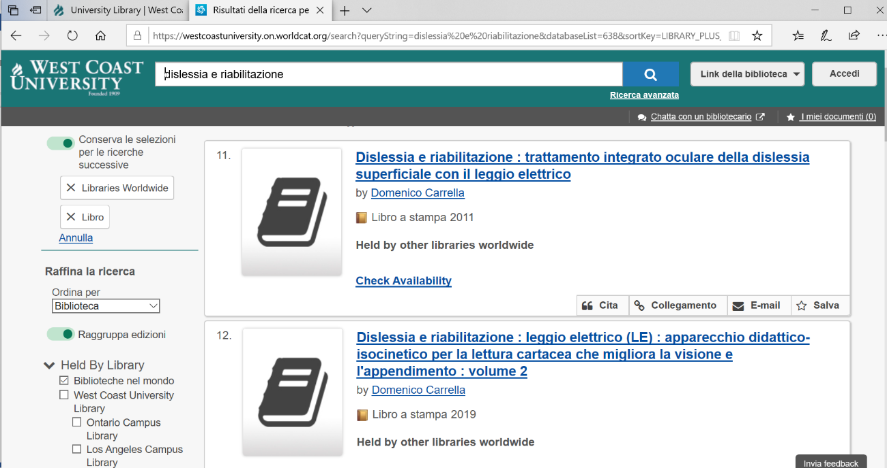
https://westcoastuniversity.on.worldcat.org/search?queryString=dislessia%20e%20riabilitazione&databaseList=638&sortKey=LIBRARY_PLUS_RELEVANCE&clusterResults=true&translateSearch=false&queryTranslationLanguage=en&expandSearch=false&scope=&format=Book&subformat=Book::book_printbook&subformat=Book::book_digital&subformat=Book::book_thsis&subformat=Book::book_large

