**ALABAMA = 9**

**1**  [**ALABAMA STATE UNIVERSITY**](http://www.lib.alasu.edu/)**, LIBRARY – (**Montgomery, Alabama, Usa)

<https://alasu.on.worldcat.org/search?sortKey=BEST_MATCH&databaseList=638&queryString=dislessia+e+riabilitazione&changedFacet=scope&clusterResults=on&scope=&scope=wz%3A2801>

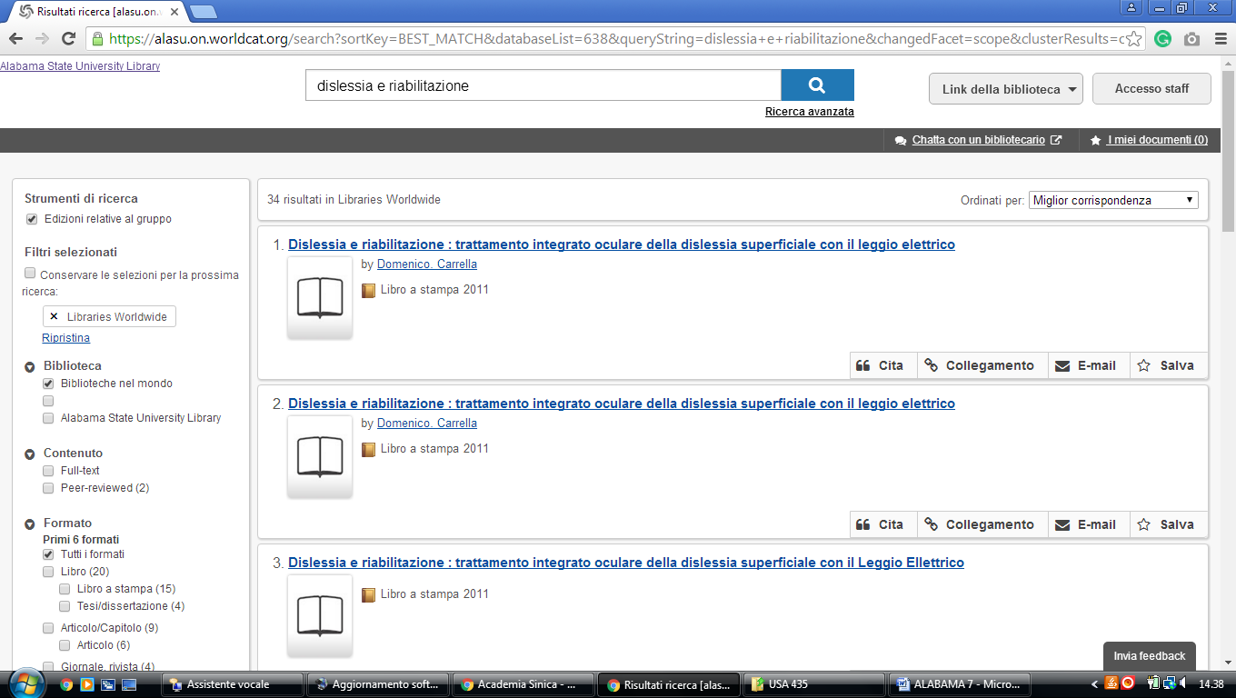

**2** [**BURKE MEMORIAL LIBRARY**](http://libguides.shc.edu/burkelibrary) **– (**Mobile, Alabama, Usa)

<http://shclibrary.worldcat.org/title/dislessia-e-riabilitazione-trattamento-integrato-oculare-della-dislessia-superficiale-con-il-leggio-elettrico/oclc/878784487&referer=brief_results>

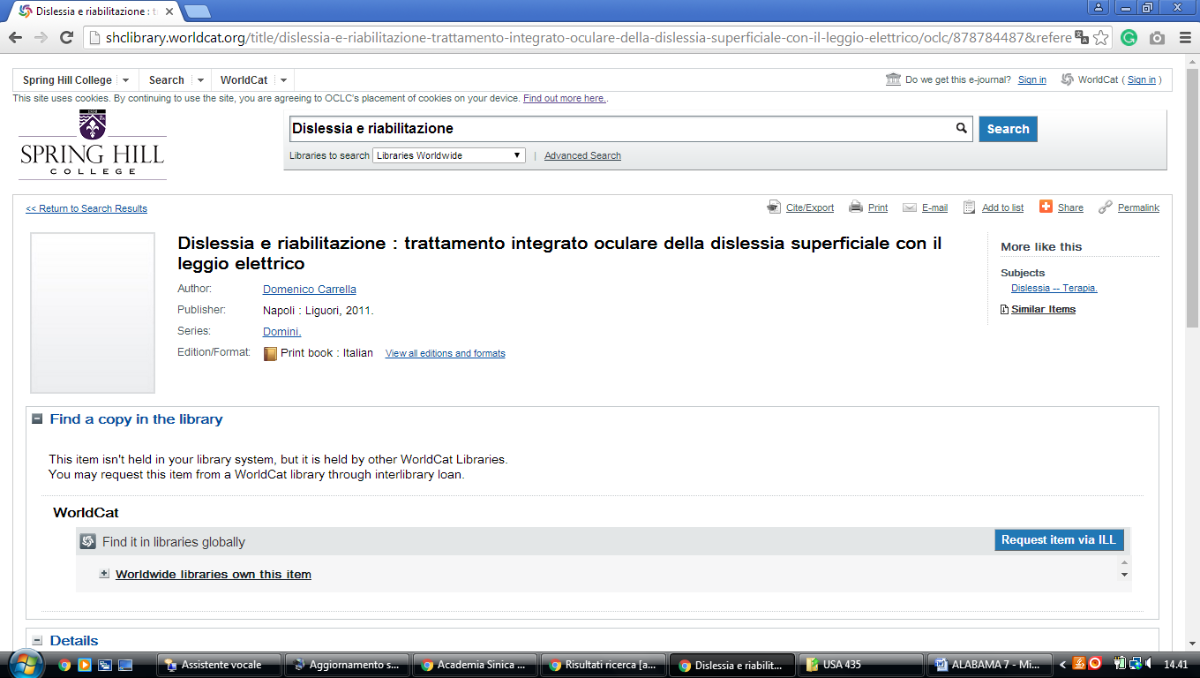

**3**  [**HUNTINGDON COLLEGE**](http://library.huntingdon.edu/) **LIBRARY** – (Montgomery, Alabama, Usa)

<https://huntingdoncollege.on.worldcat.org/external-search?queryString=dislessia+e+riabilitazione#/oclc/878784487>

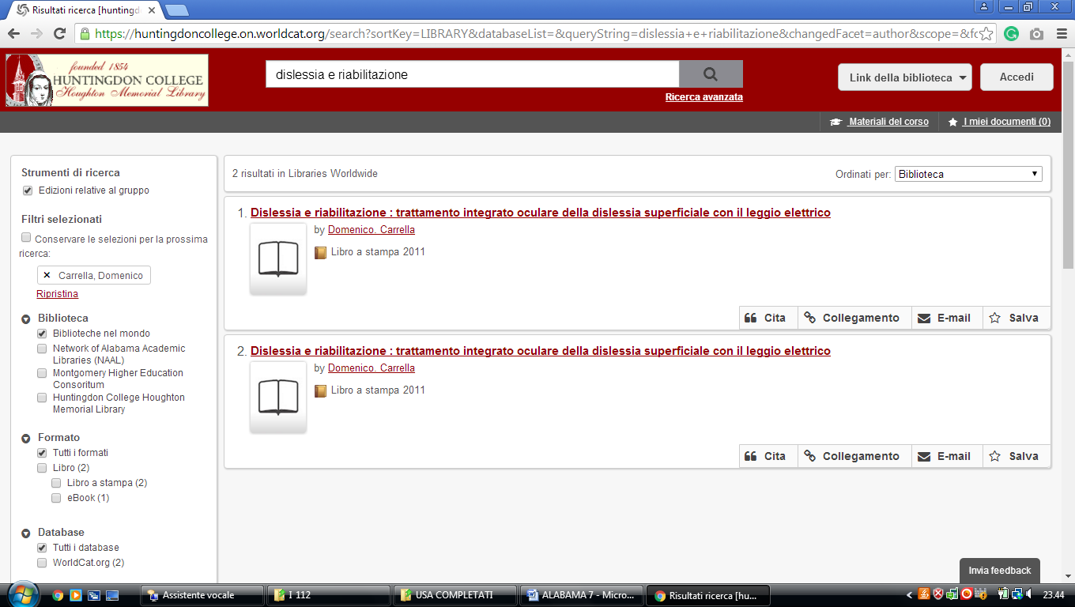

**4** [**UNIVERSITY OF MONTEVALLO**](http://libguides.montevallo.edu/index)**,LIBRARY WORDLCAT – (**Alabama, Usa)

<http://montevallo.worldcat.org/title/dislessia-e-riabilitazione-trattamento-integrato-oculare-della-dislessia-superficiale-con-il-leggio-elettrico/oclc/878784487&referer=brief_results>

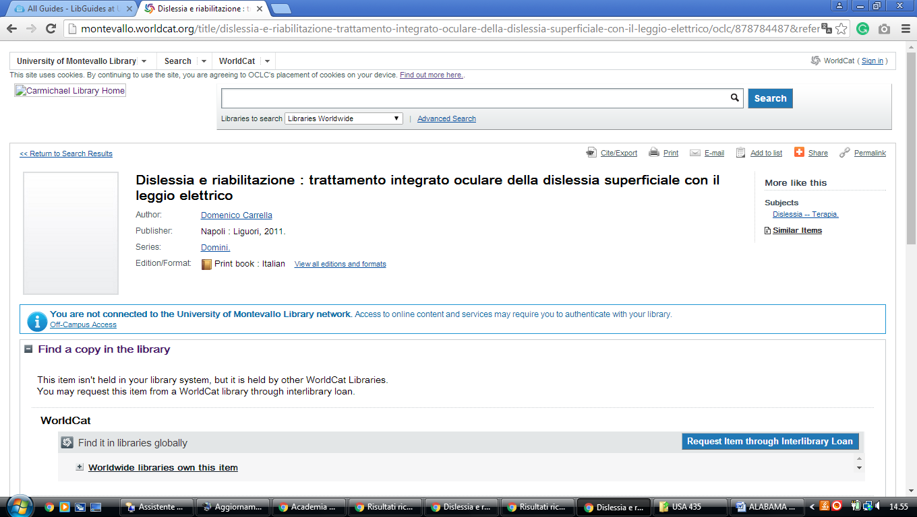

**5 [UNIVERSITY OF ALABAMA AT BIRMINGHAM'S LISTER HILL LIBRARY OF](http://www.uab.edu/lister/" \t "_blank)**

**[THE HEALTH](http://www.uab.edu/lister/" \t "_blank)**[**SCIENCES**](http://www.uab.edu/lister/) – ([Birmingham](https://en.wikipedia.org/wiki/Birmingham,_Alabama), [Alabama](https://en.wikipedia.org/wiki/Alabama), Usa)

<https://uab-primo.hosted.exlibrisgroup.com/primo-explore/search?institution=01UALB&vid=Lister_Hill&mode=Basic&displayMode=full&bulkSize=10&highlight=true&dum=true&query=any,contains,dislessia%20e%20riabilitazione&displayField=all&pcAvailabiltyMode=true&search_scope=EVERYTHING&sortby=rank&lang=en_US&pcAvailability=true>

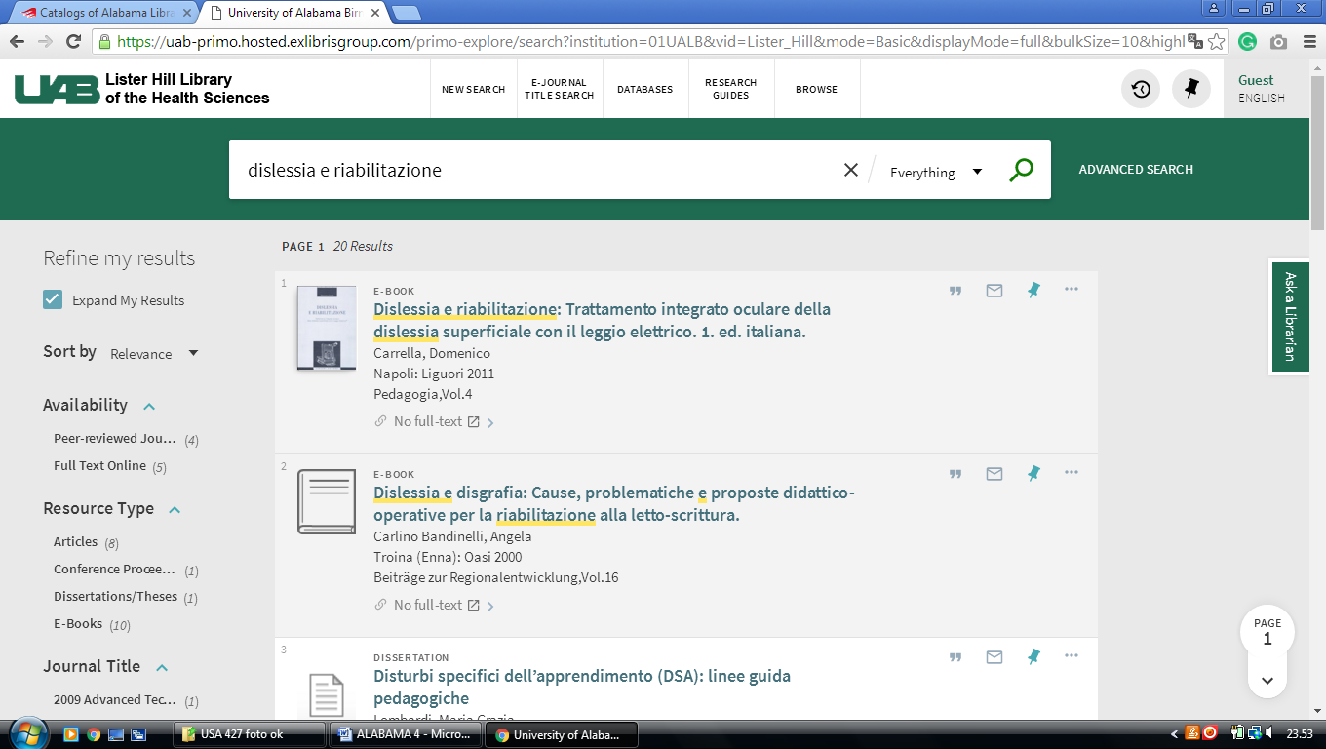

**6** [**Alabama State University Library**](http://www.lib.alasu.edu/) - ([Montgomery](https://en.wikipedia.org/wiki/Montgomery,_Alabama), [Alabama](https://en.wikipedia.org/wiki/Alabama), Usa)

<https://alasu.on.worldcat.org/search?sortKey=BEST_MATCH&databaseList=&queryString=dislessia+e+riabilitazione&changedFacet=scope&clusterResults=on&scope=&scope=wz%3A2801>

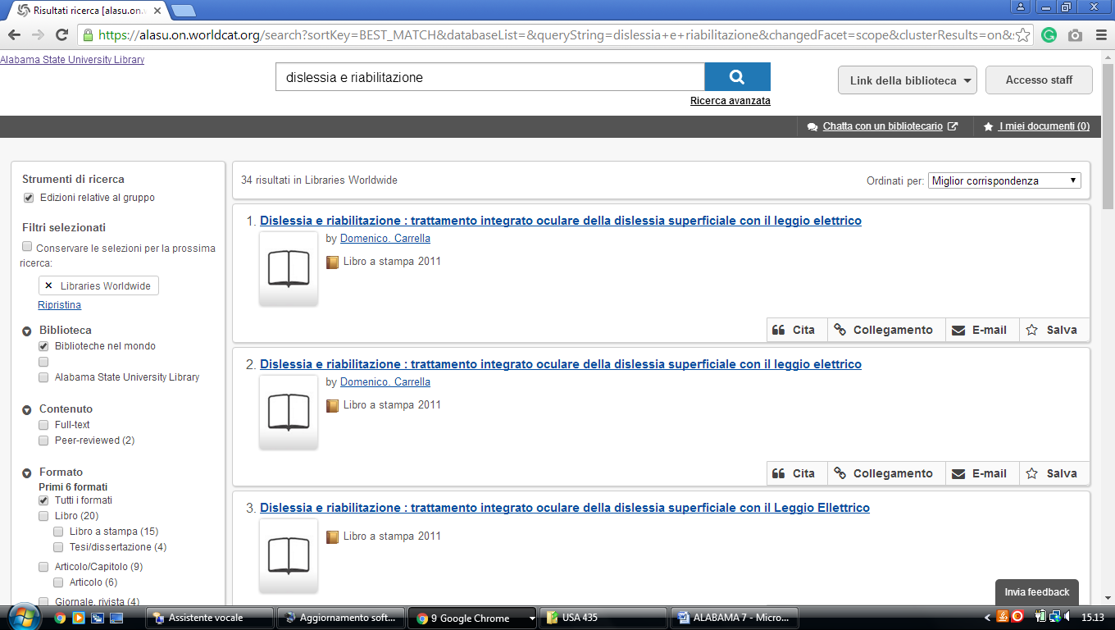

[alabama College of Osteopathic Medicine Acom Library |,](https://www.acom.edu/library/)

http://acom.summon.serialssolutions.com/?s.q=dislessia+e+riabilitazione#!/search?ho=f&l=en&q=dislessia%20e%20riabilitazione

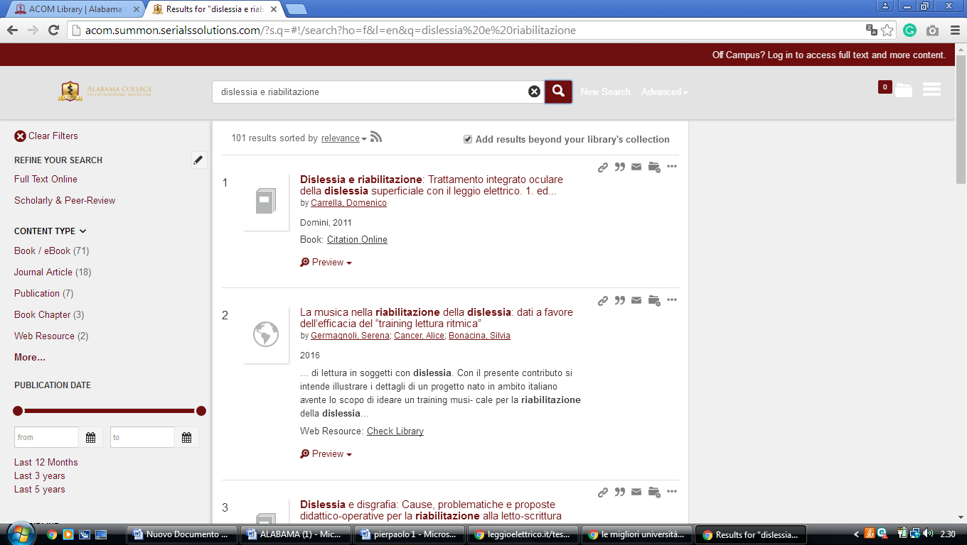

### [Auburn University Libraries,](https://www.lib.auburn.edu/)

https://eds.b.ebscohost.com/eds/results?vid=0&sid=9d05d2d3-277e-4289-822b-72180a8c906a%40pdc-v-sessmgr05&bquery=TI%2B%28dislessia%2Be%2Briabilitazione%29&bdata=JnR5cGU9MCZzZWFyY2hNb2RlPUFuZCZzaXRlPWVkcy1saXZlJnNjb3BlPXNpdGU%3d

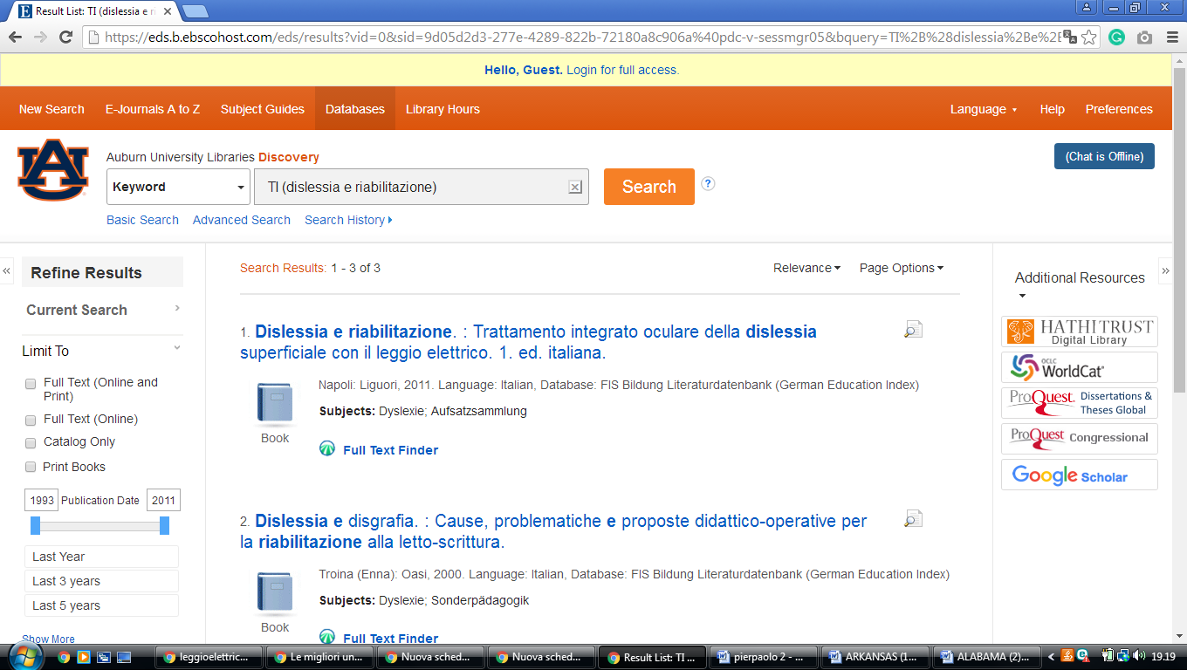

### [Auburn University Libraries,](https://www.lib.auburn.edu/)

**Troy University Libraries**

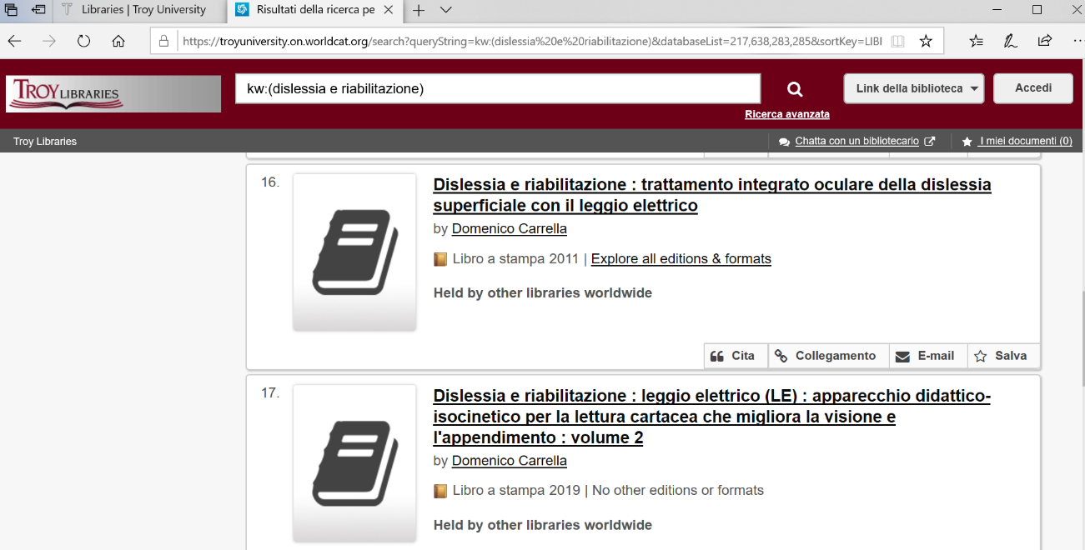https://troyuniversity.on.worldcat.org/search?queryString=kw:(dislessia%20e%20riabilitazione)&databaseList=217,638,283,285&sortKey=LIBRARY&clusterResults=true&translateSearch=false&queryTranslationLanguage=en&expandSearch=false&scope=&page=2