**LIBRARY CHRISTIAN UNIVERSITY,** [**Mukono**](https://en.wikipedia.org/wiki/Mukono)**, UGANDA**

[Private University Libraries - CUUL](https://www.google.it/url?sa=t&rct=j&q=&esrc=s&source=web&cd=2&cad=rja&uact=8&ved=2ahUKEwiZ1OSE-M_oAhXEpYsKHbz6AiIQFjABegQIChAE&url=https%3A%2F%2Fcuul.or.ug%2Findex.php%2Fcuul-members%2Fprivate-university-libraries&usg=AOvVaw39GPfPwDGPBd7L8efjp7tG)

[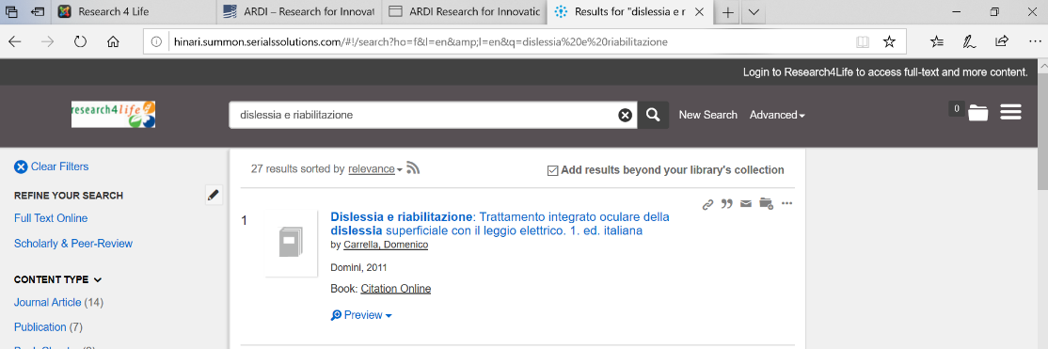](https://www.google.it/url?sa=t&rct=j&q=&esrc=s&source=web&cd=2&cad=rja&uact=8&ved=2ahUKEwiZ1OSE-M_oAhXEpYsKHbz6AiIQFjABegQIChAE&url=https%3A%2F%2Fcuul.or.ug%2Findex.php%2Fcuul-members%2Fprivate-university-libraries&usg=AOvVaw39GPfPwDGPBd7L8efjp7tG)