**1 ASSUMPTION UNIVERSITY LIBRARY** **- (**Bangkok, [Samut Prakan](https://en.wikipedia.org/wiki/Samut_Prakan_Province" \o "Samut Prakan Province),[Thailand](https://en.wikipedia.org/wiki/Thailand))

[http://au.summon.serialssolutions.com/?#!/search?ho=f&l=en&q=DISLESSIA%20E%20RIABILITAZIONE](http://au.summon.serialssolutions.com/?%23!/search?ho=f&l=en&q=DISLESSIA%20E%20RIABILITAZIONE)

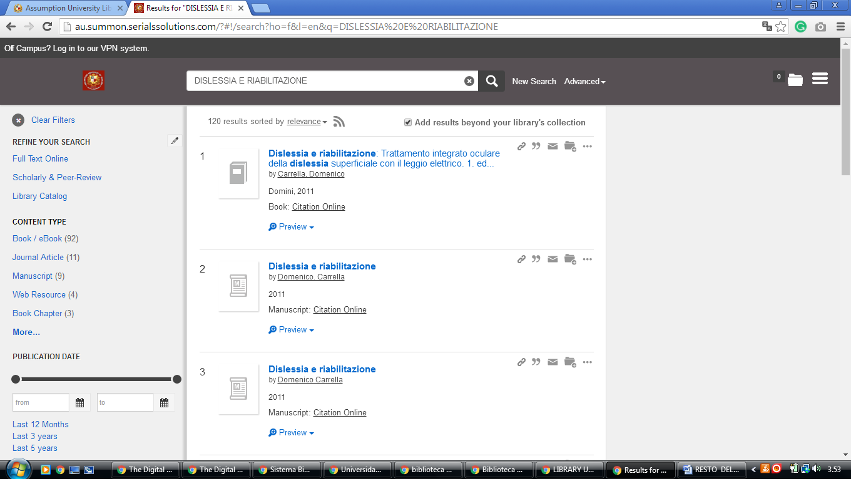

LLLLLLLLLLLLLLL

**2 CHULA.ON.WORLDCAT.ORG/ - (**[Chulalongkorn University](http://www.car.chula.ac.th/) Library, Bangkok, Thailand)

<https://chula.on.worldcat.org/search?databaseList=&queryString=dislessia+e+riabilitazione>

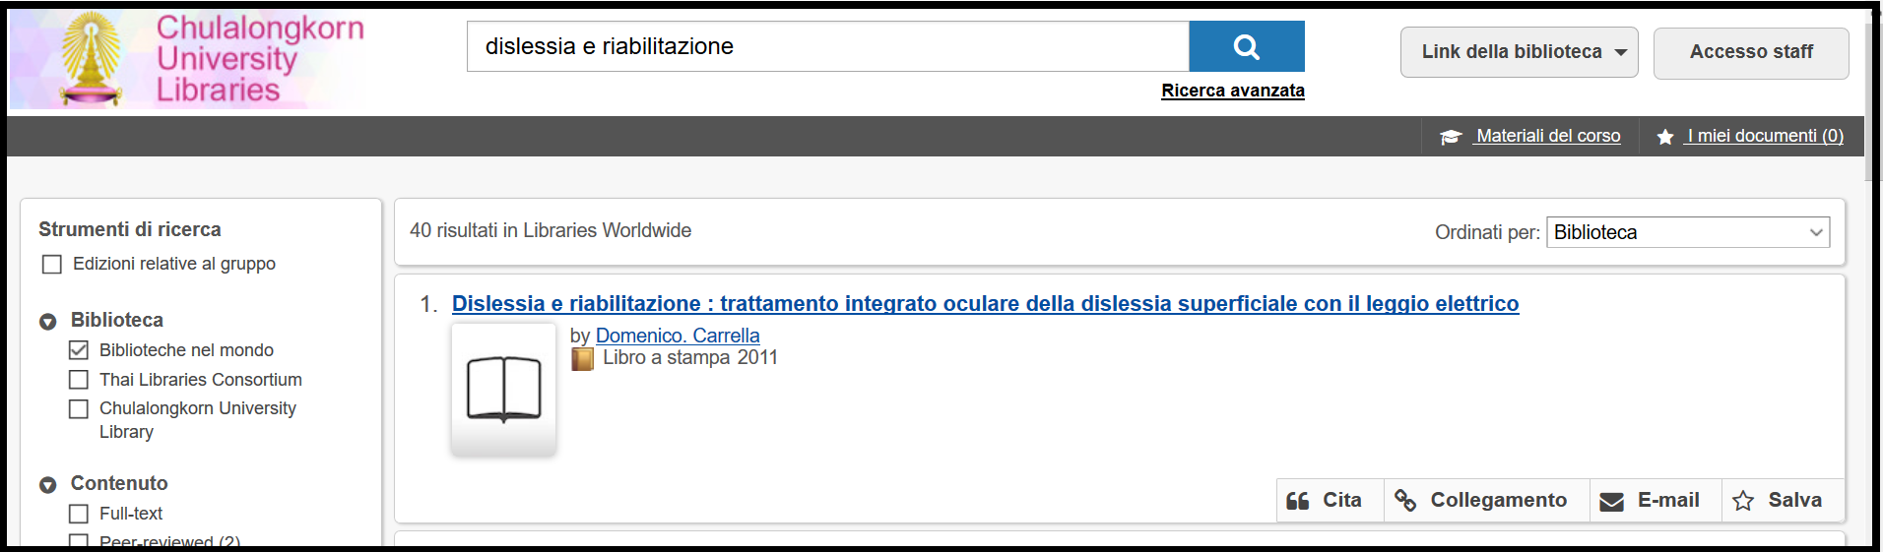

[**3 MAHASARAKHAMUNIV.WORLDCAT.ORG/**](http://mahasarakhamuniv.worldcat.org/) - ([Mahasarakham University](http://www.library.msu.ac.th/web/" \t "_blank" \o "Mahasarakham University) Library, Mahasarakham, Thailand)

<http://mahasarakhamuniv.worldcat.org/title/dislessia-e-riabilitazione-trattamento-integrato-oculare-della-dislessia-superficiale-con-il-leggio-elettrico/oclc/878784487&referer=brief_results>

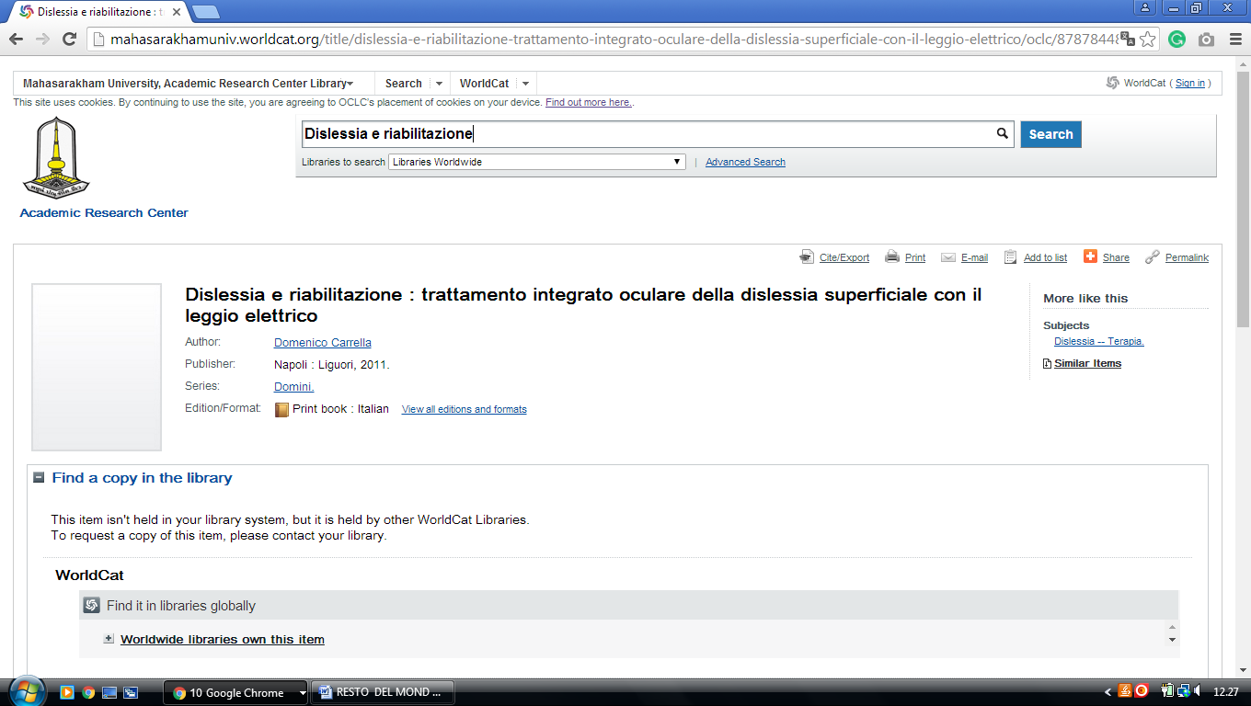

[**4 PRINCE OF SONGKLA UNIVERSITY LIBRARY - PHUKET**](http://library.phuket.psu.ac.th/) - (Phuket, Thailand)

[http://eds.b.ebscohost.com/eds/detail/detail?vid=1&sid=4165f2fd-92ce-4236-b867-2aa5b414ea17%40pdc-v-sessmgr01&bdata=JnNpdGU9ZWRzLWxpdmU%3d#AN=EDSBVB.BV039611798&db=edsbvb](http://eds.b.ebscohost.com/eds/detail/detail?vid=1&sid=4165f2fd-92ce-4236-b867-2aa5b414ea17%40pdc-v-sessmgr01&bdata=JnNpdGU9ZWRzLWxpdmU%3d%23AN=EDSBVB.BV039611798&db=edsbvb)

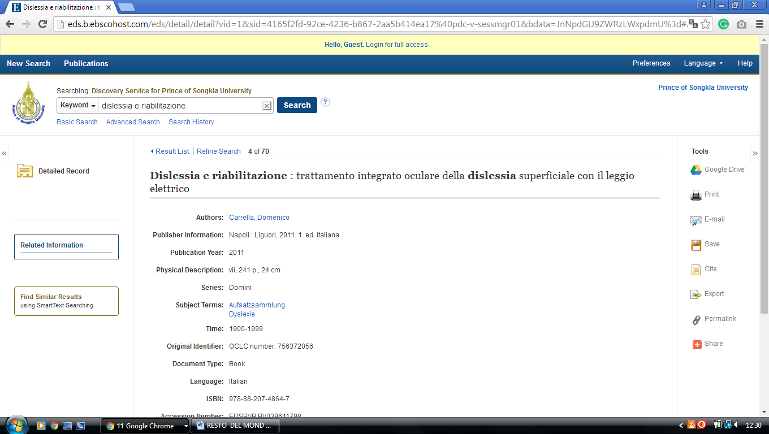

[**5 SRINAKHARINWIROT UNIVERSITY**](http://lib.swu.ac.th/th/) **LIBRARY** - (Bangkok, Thailand)

<http://search.swu.ac.th:1701/primo-explore/search?vid=SWU&query=any,contains,dislessia%20e%20riabilitazione&search_scope=default_scope&sortby=rank&lang=en_US&pcAvailability=true>

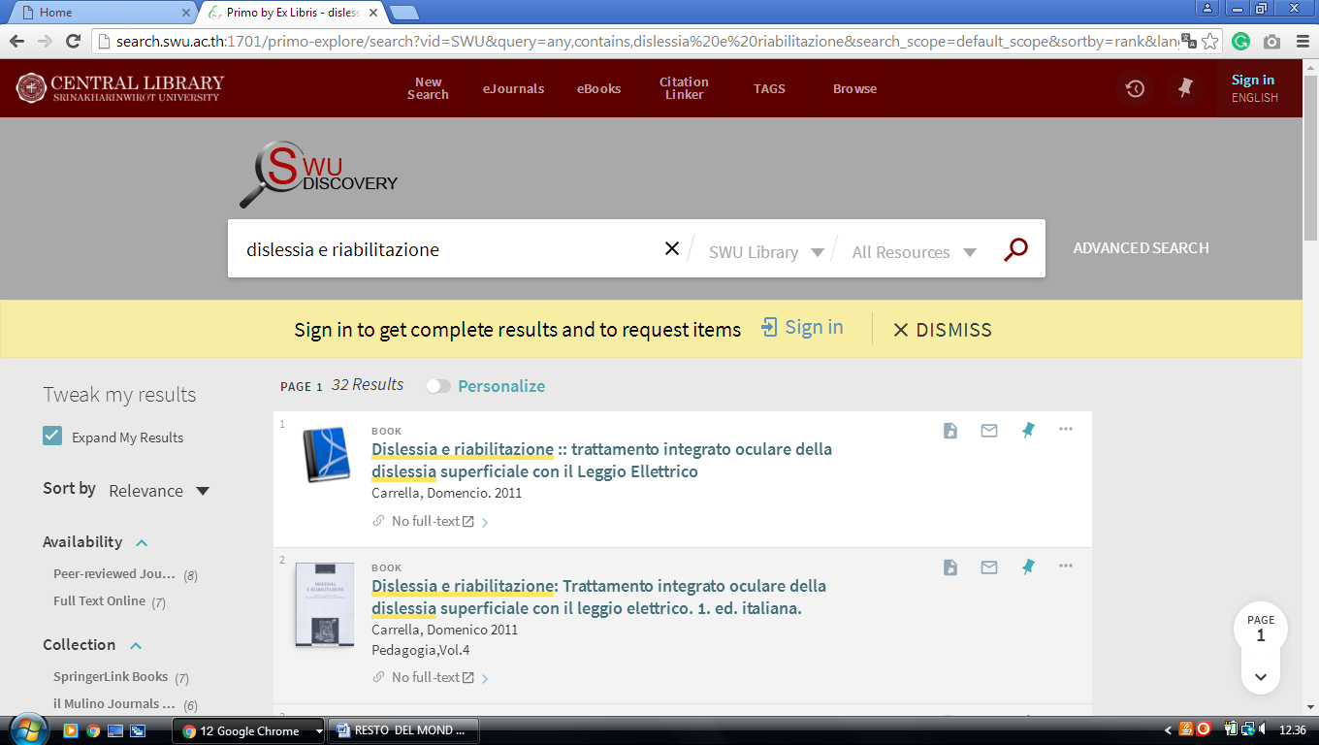-------------------------------------------------------------------------------------------------------------------------------

**6 KHON KAEN UNIVERSITY, MEDICAL LIBRARY – (**[Khon Kaen](https://en.wikipedia.org/wiki/Khon_Kaen_Province" \o "Khon Kaen Province), [Thailand](https://en.wikipedia.org/wiki/Thailand))

<http://eds.b.ebscohost.com/eds/results?vid=2&sid=81bfe53c-6467-4fde-b4b3-1f4286b350ab%40sessionmgr101&bquery=(dislessia+AND+e+AND+riabilitazione)&bdata=JnR5cGU9MCZzaXRlPWVkcy1saXZl>

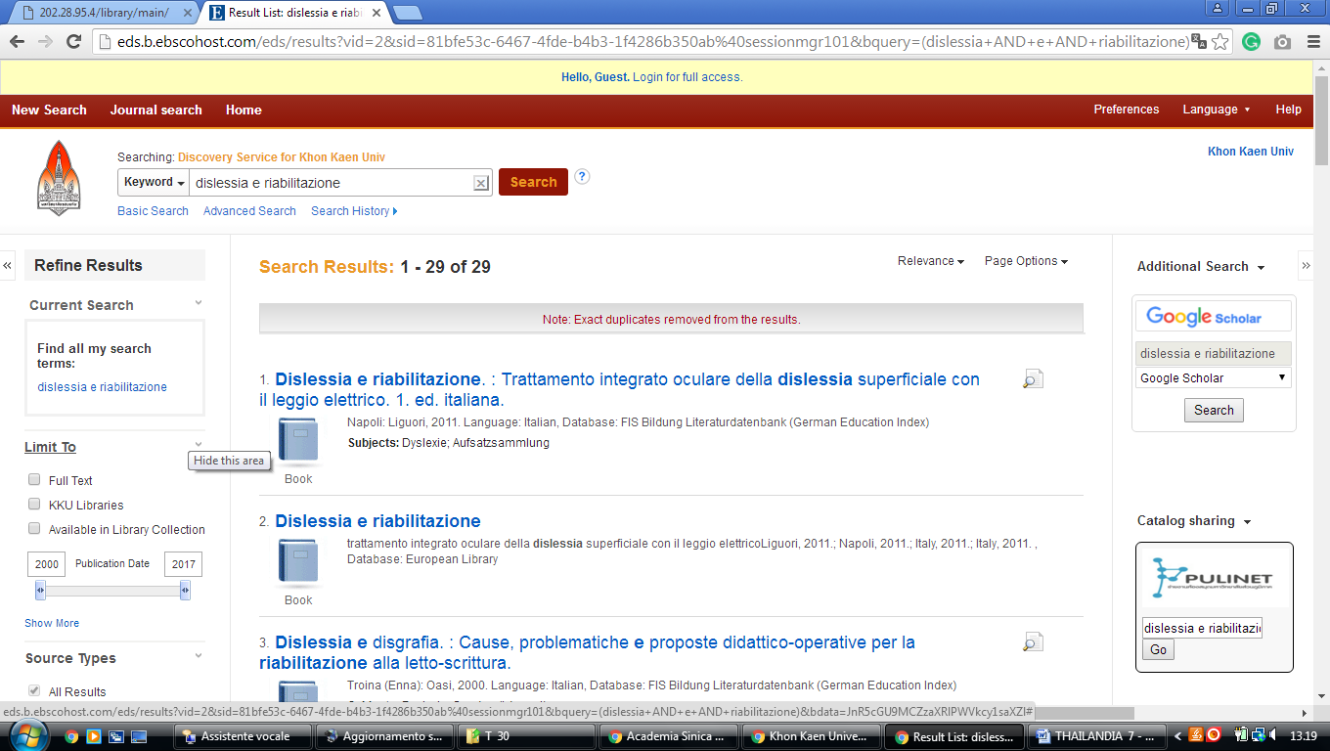



[**Huachiew Chalermprakiet University Library**](http://www.lib.hcu.ac.th/)

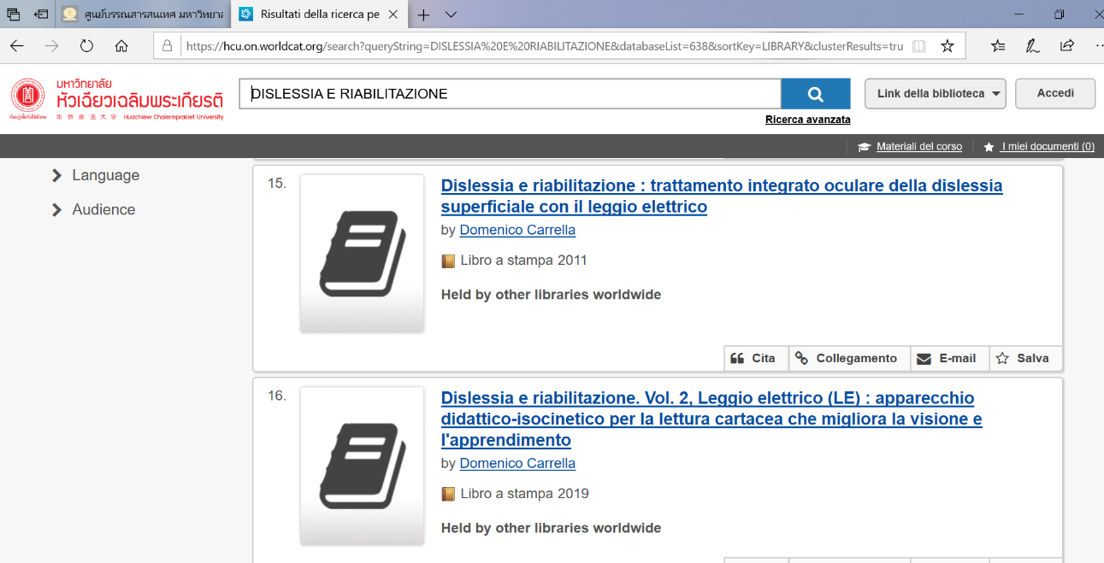https://hcu.on.worldcat.org/search?queryString=DISLESSIA%20E%20RIABILITAZIONE&databaseList=638&sortKey=LIBRARY&clusterResults=true&scope=&page=2

### [BUU LIBRARY.. Burapha University Library](https://www.lib.buu.ac.th/)

http://eds.b.ebscohost.com/eds/results?vid=4&sid=ec9be98e-fe4a-4bc7-9fe6-2510097583e2%40sessionmgr102&bquery=TI+dislessia+e+riabilitazione&bdata=Jmxhbmc9aXQmdHlwZT0wJnNlYXJjaE1vZGU9QW5kJnNpdGU9ZWRzLWxpdmU%3d

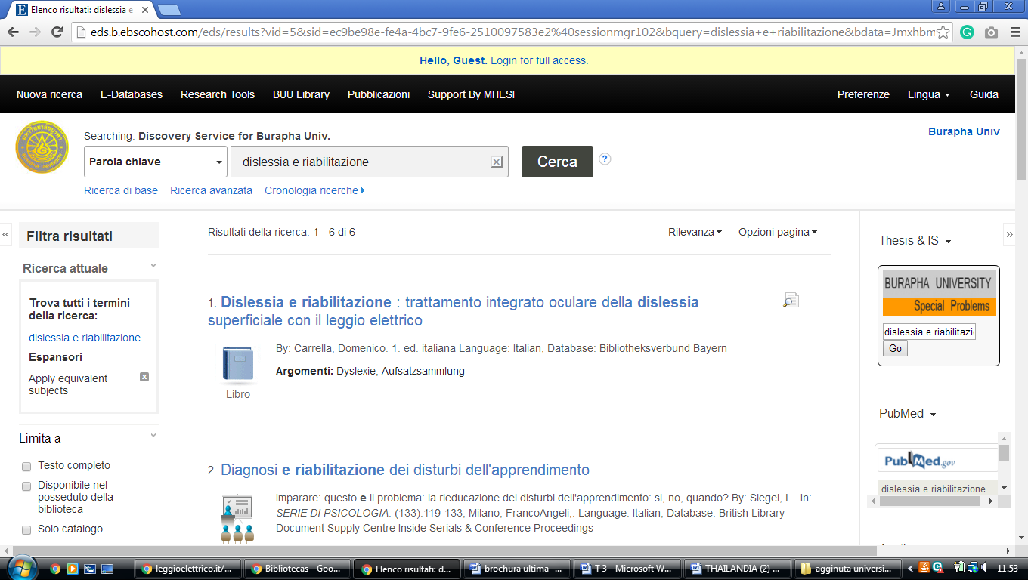

[Huachiew Chalermprakiet University Library](http://www.lib.hcu.ac.th/),

https://hcu.on.worldcat.org/search?queryString=dislessia+e+riabilitazione&submit=Search

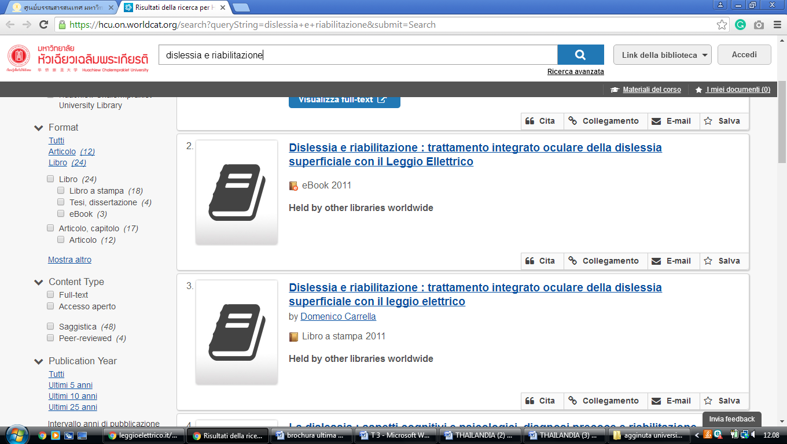

### [**Kasetsart University Library / Learning Center (KULC) สำนัก .**](http://www.lib.ku.ac.th/web-ezproxy/index.php/en)

https://kasetsartunivlibrary.worldcat.org/title/dislessia-e-riabilitazione-trattamento-integrato-oculare-della-dislessia-superficiale-con-il-leggio-elettrico/oclc/878784487&referer=brief\_results

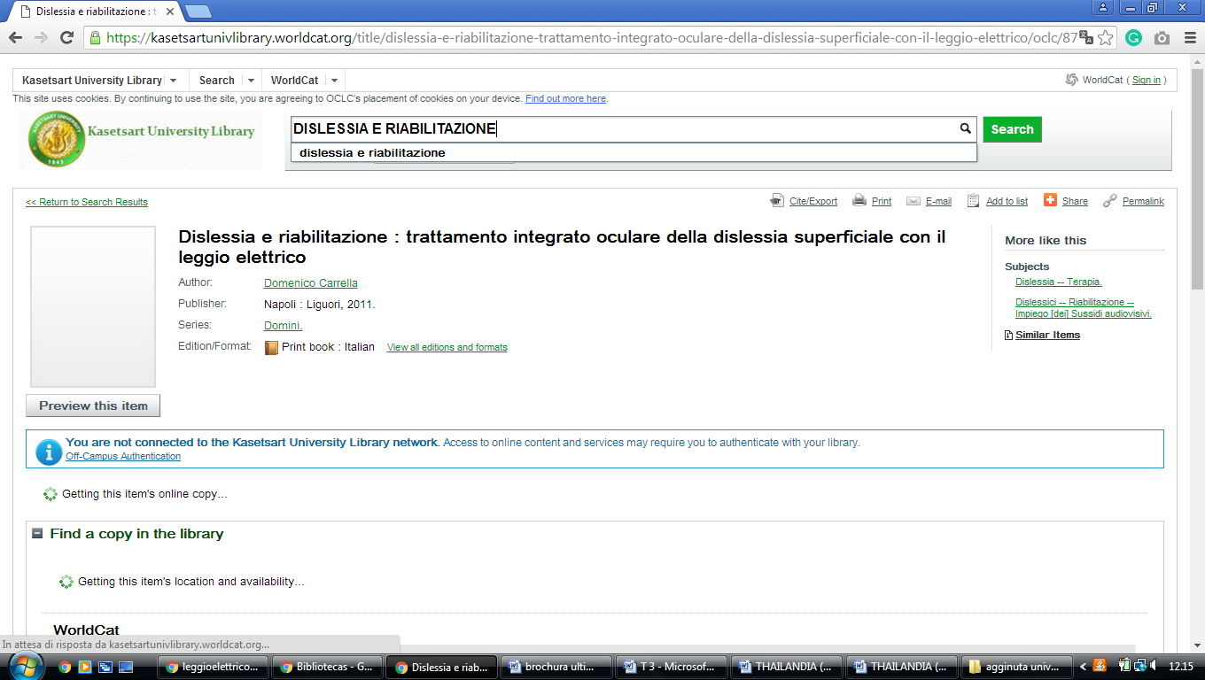

[**Mahidol University Library and Information Center**](http://www.li.mahidol.ac.th/)**,**

http://eds.a.ebscohost.com/eds/detail/detail?vid=6&sid=9c14734c-aa82-46ea-a71e-e16c4009ec16%40sessionmgr4008&bdata=JnNpdGU9ZWRzLWxpdmU%3d#AN=edsbvb.BV039611798&db=edsbvb

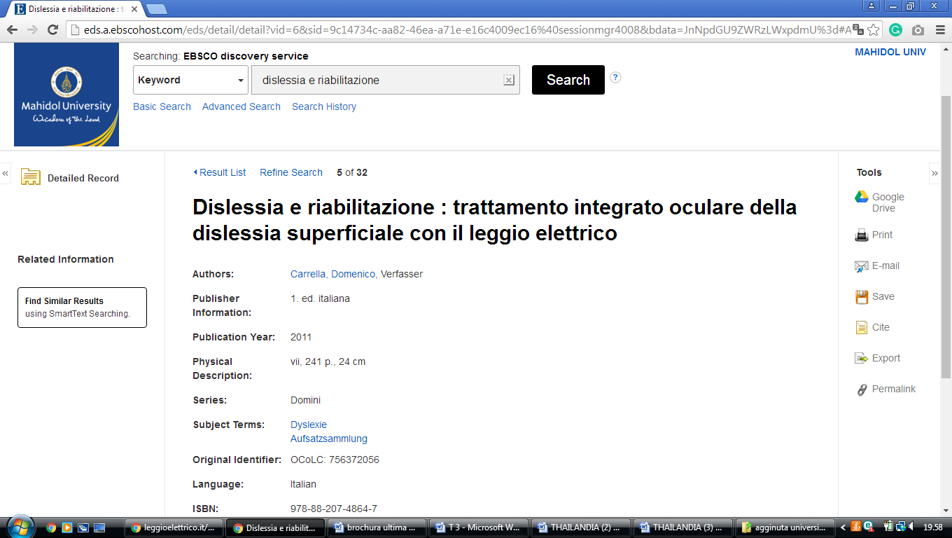

[**Silpakorn University Central Library**](http://www.lib.su.ac.th/) **,**

http://eds.a.ebscohost.com/eds/results?vid=3&sid=9ee2c278-eff6-483d-a79e-0c597094c00e%40sdc-v-sessmgr02&bquery=dislessia+e+riabilitazione&bdata=JnR5cGU9MCZzZWFyY2hNb2RlPUFuZCZzaXRlPWVkcy1saXZl

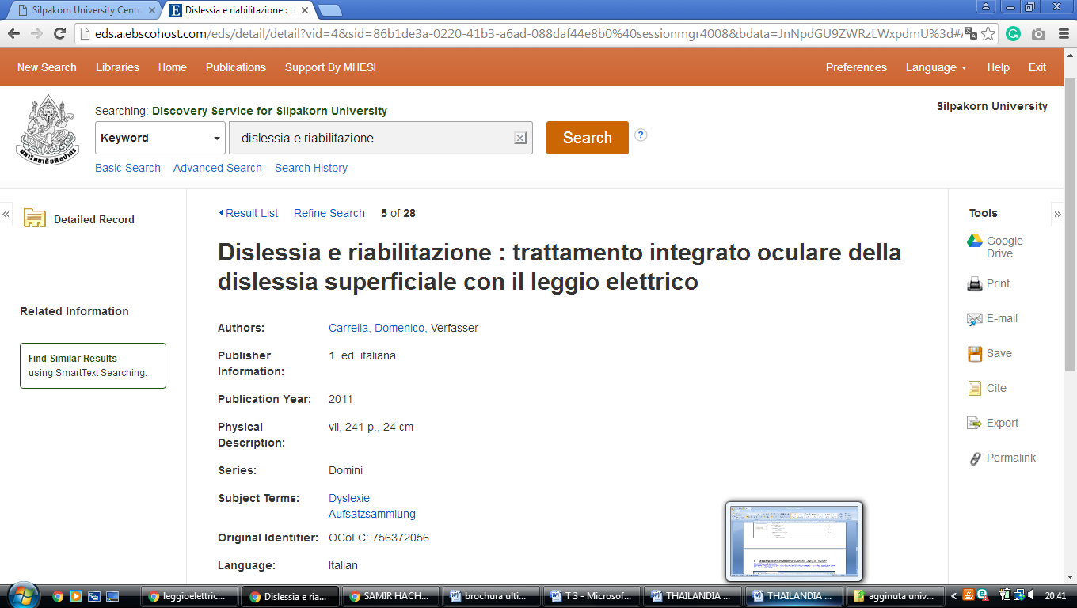

[**Srinakharinwirot University, Central Library**](http://www.swu.ac.th/lib/)**,**

[http://lib.swu.ac.th](http://lib.swu.ac.th/)

http://search.swu.ac.th:1701/primo-explore/search?institution=SWULIBRARY&vid=SWU&tab=default\_tab&mode=Basic&displayMode=full&bulkSize=10&highlight=true&dum=true&query=any,contains,dislessia%20e%20riabilitazione&displayField=all&pcAvailabiltyMode=true&search\_scope=default\_scope&sortby=rank&lang=en\_US&pcAvailability=true

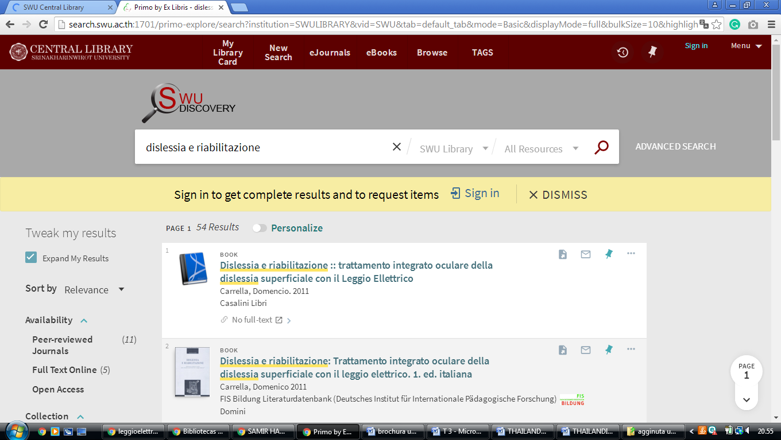

[**Thammasat University Library System**](http://library.tu.ac.th/)**,**

https://thammasatuniv.on.worldcat.org/search?queryString=dislessia+e+riabilitazione&scope=

