**UNIVERSITY OF ESWATINI,** [**Kwaluseni**](https://en.wikipedia.org/wiki/Kwaluseni)**, SWAZILAND**

[Uniswa Library Website](https://www.google.com/url?sa=t&rct=j&q=&esrc=s&source=web&cd=1&cad=rja&uact=8&ved=2ahUKEwj8icvF1tvoAhWYzMQBHRJnCrAQFjAAegQIBRAB&url=http%3A%2F%2Fwww.library.uniswa.sz%2F&usg=AOvVaw2eaZ5pSOzbHsJ7EsavCuIm&cshid=1586446753798682)

[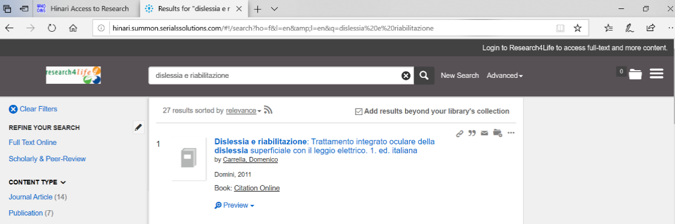](https://www.google.com/url?sa=t&rct=j&q=&esrc=s&source=web&cd=1&cad=rja&uact=8&ved=2ahUKEwj8icvF1tvoAhWYzMQBHRJnCrAQFjAAegQIBRAB&url=http%3A%2F%2Fwww.library.uniswa.sz%2F&usg=AOvVaw2eaZ5pSOzbHsJ7EsavCuIm&cshid=1586446753798682)