**RAJARATA UNIVERSITY OF SRI LANKA, Mihintale, SRI LANKA**

[RUSL Library - Rajarata University of Sri Lanka](https://www.google.com/url?sa=t&rct=j&q=&esrc=s&source=web&cd=11&cad=rja&uact=8&ved=2ahUKEwi8nPvOltzoAhUCQhUIHT_uBZA4ChAWMAB6BAgEEAE&url=http%3A%2F%2Fwww.rjt.ac.lk%2Flibrary%2F&usg=AOvVaw2iMoh6jiBpKgIZ7EGz1JzU)

[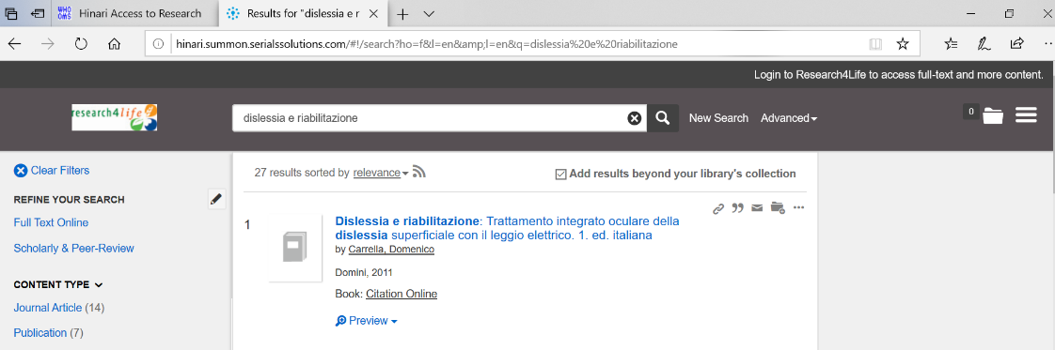](https://www.google.com/url?sa=t&rct=j&q=&esrc=s&source=web&cd=11&cad=rja&uact=8&ved=2ahUKEwi8nPvOltzoAhUCQhUIHT_uBZA4ChAWMAB6BAgEEAE&url=http%3A%2F%2Fwww.rjt.ac.lk%2Flibrary%2F&usg=AOvVaw2iMoh6jiBpKgIZ7EGz1JzU)