**1 IE BUSINESS SCHOOLLIBRARY -**  (Madrid, Spagna)

<https://ie.on.worldcat.org/search?lang=en&queryString=dislessia+e+riabilitazione&scope>=

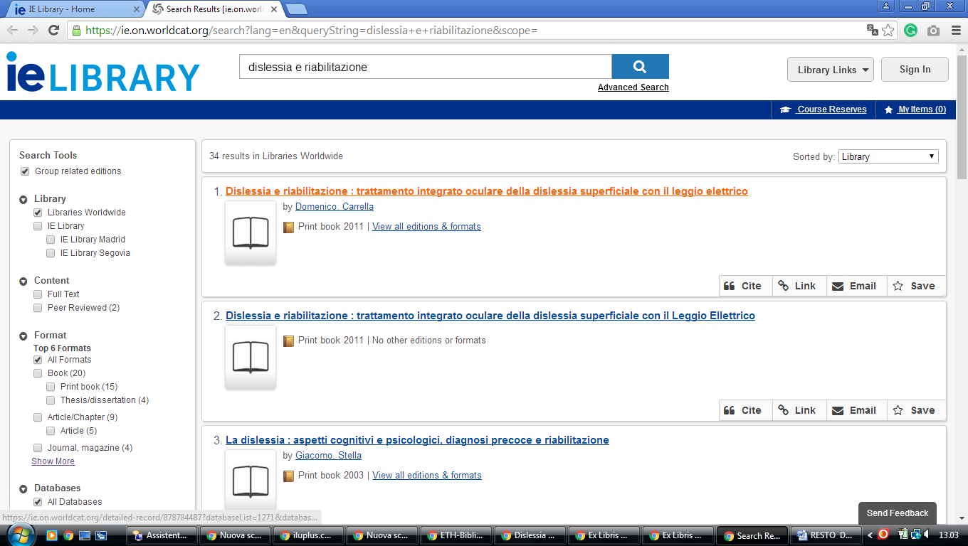

**2 LIBRARY UNIVEERSIDAD COMPLUTENSE MADRID –** (Madrid, Spagna)

<http://ucm.summon.serialssolutions.com/en/#!/search?ho=f&fvf=ContentType,Newspaper%20Article,t&l=en&q=dislessia%20e%20riabilitazione>

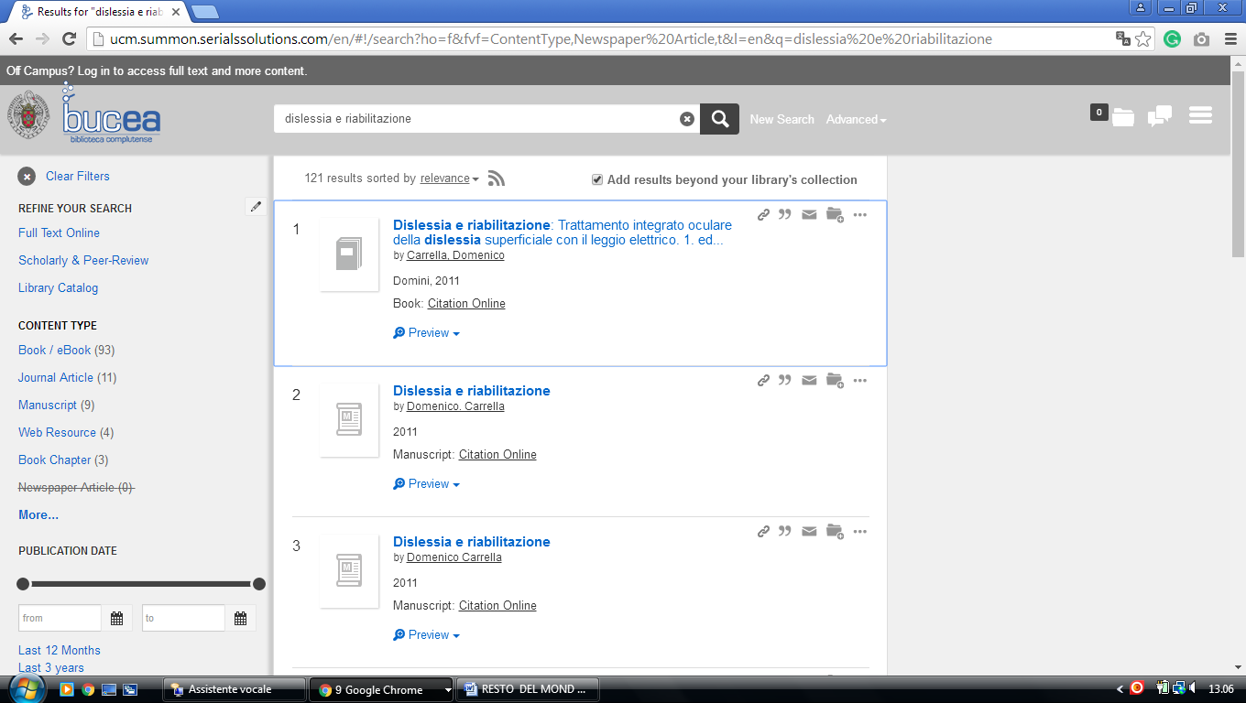

[**3 NATIONAL LIBRARY UNIVERSITY OF DISTANCE EDUCATION**](http://portal.uned.es/portal/page?_pageid=93,505432&_dad=portal&_schema=PORTAL) **–** (Madrid, Spain)

<http://uned.summon.serialssolutions.com/search/results?s.fvf%5B%5D=ContentType%2CNewspaper+Article%2Ct&s.q=dislessia+e+riabilitazione#!/search?ho=f&fvf=ContentType,Newspaper%20Article,t&l=es-ES&q=dislessia%20e%20riabilitazione>

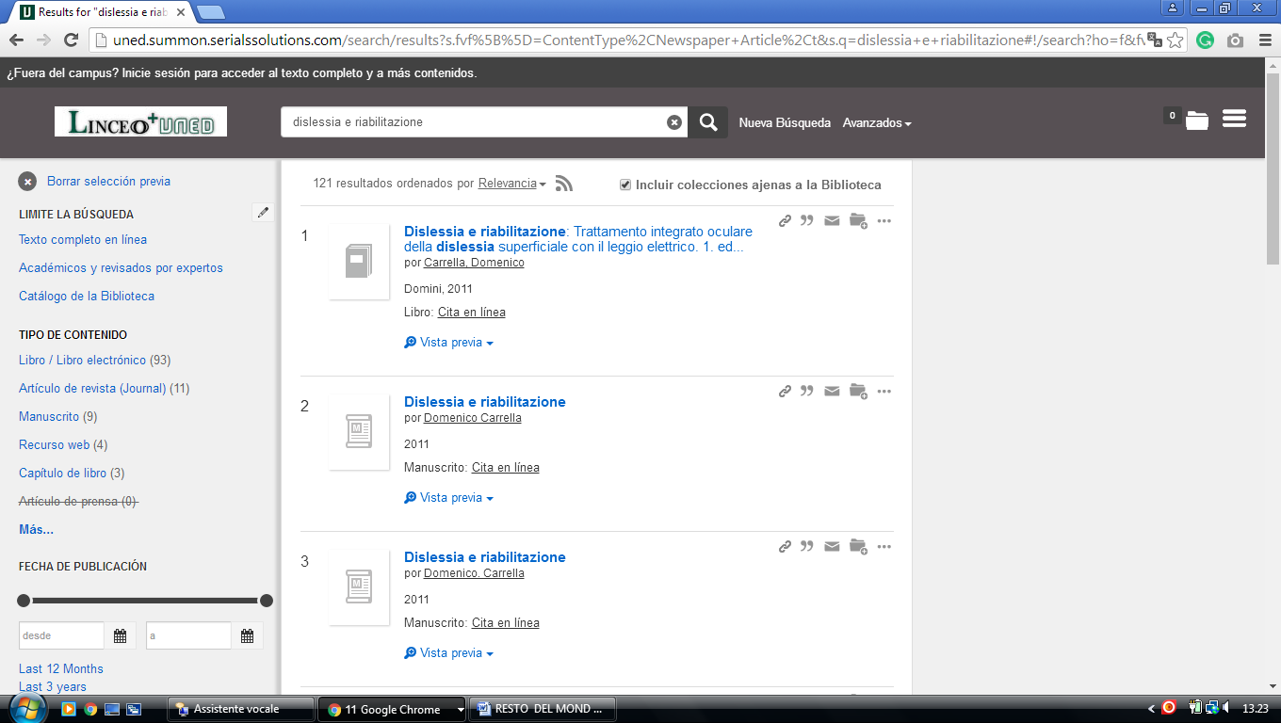

### [4 UOC (Universitat Oberta de Catalunya)](http://www.uoc.edu/portal/en/) - Barcelona, Spain

<http://uoc.summon.serialssolutions.com/search?ho=t&l=ca&q=dislessia+e+riabilitazione#!/search?ho=f&l=ca&q=dislessia%20e%20riabilitazione>

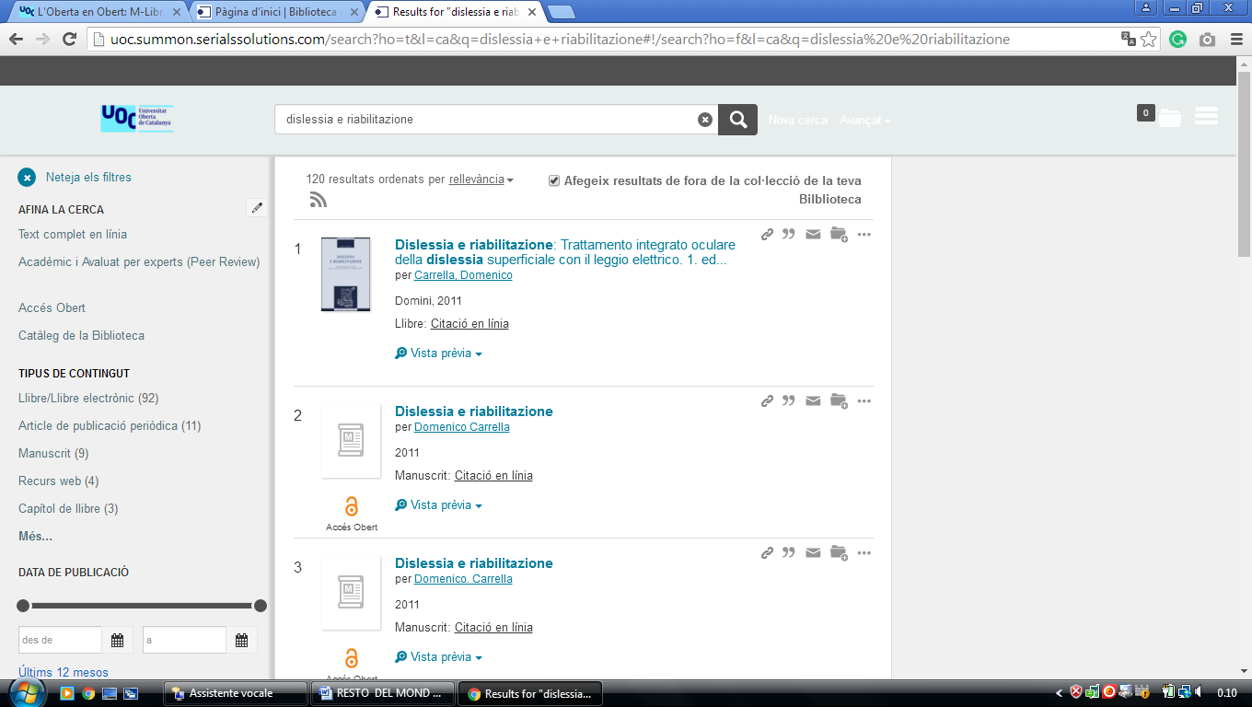

**5 BIBLIOTEK** [**PABLO DE OLAVIDE UNIVERSITY**](http://www.upo.es/biblioteca/)- (Seville, Spain)

<http://upo.summon.serialssolutions.com/?q=dislessia+e+riabilitazione&searchImageSumbitComponent=Buscar#!/search?ho=f&l=en&q=dislessia%20e%20riabilitazione&searchImageSumbitComponent=Buscar>

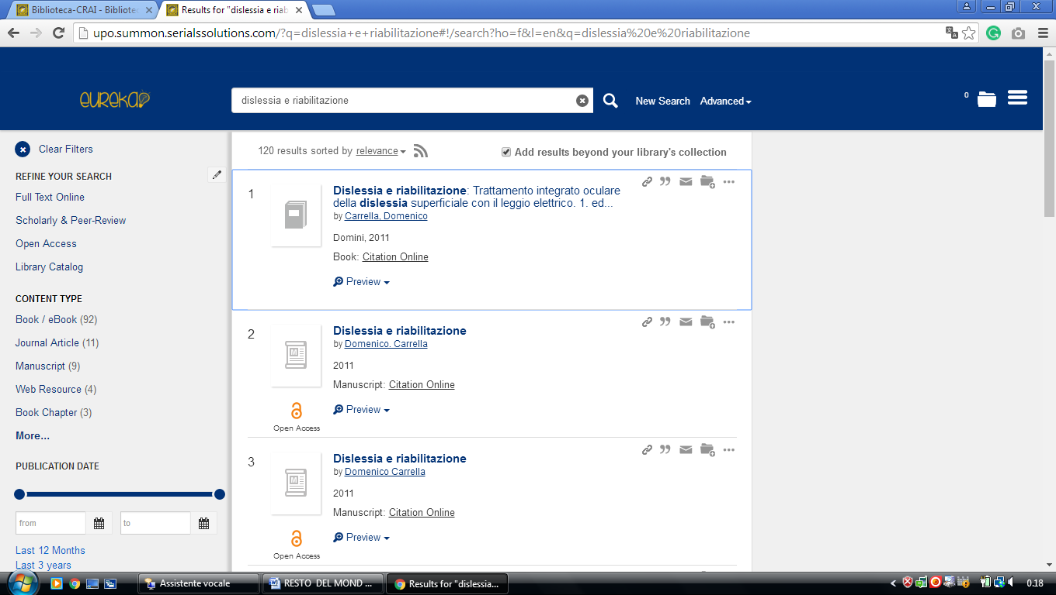

### [6 BIBLIOTECA-CRAI - BIBLIOTECACRAI - UPO](https://www.upo.es/biblioteca/), - ([Sevilla](https://es.wikipedia.org/wiki/Sevilla), [España](https://es.wikipedia.org/wiki/Espa%C3%B1a))

<http://upo.summon.serialssolutions.com/?q=dislessia+e+riabilitazione#!/search?ho=f&l=en&q=dislessia%20e%20riabilitazione>



### 7 BIBLIOTECA DE LA UNIVERSIDAD DE ALCALÁ - UAH MADRID – (Spain)

<https://uah.summon.serialssolutions.com/search?s.q=dislessia+e+riabilitazione&s.fvf%5B%5D=ContentType%2CNewspaper+Article%2Ct&keep_r=true#!/search?ho=f&fvf=ContentType,Newspaper%20Article,t&l=es-ES&q=dislessia%20e%20riabilitazione>

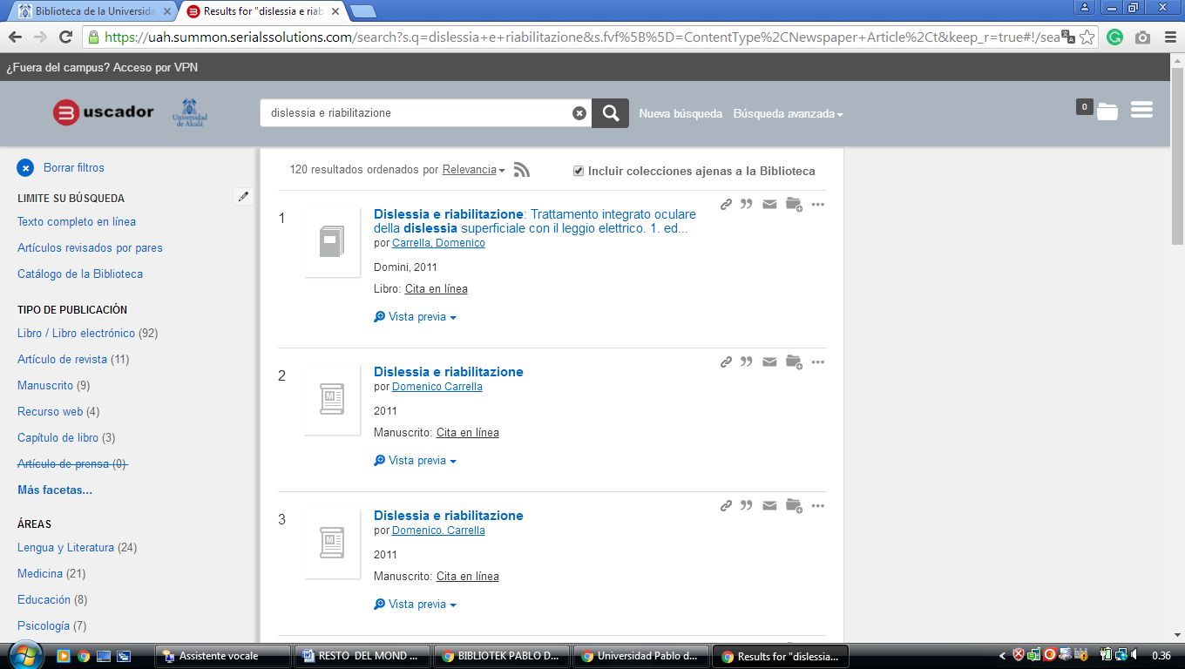

### 8 [BUC - UNICAN](https://web.unican.es/buc) - (Biblioteca University Of Cantabria, Santander, Spain)

<http://unican.summon.serialssolutions.com/search?q=dislessia+e+riabilitazione#!/search?ho=f&l=es-ES&q=dislessia%20e%20riabilitazione>

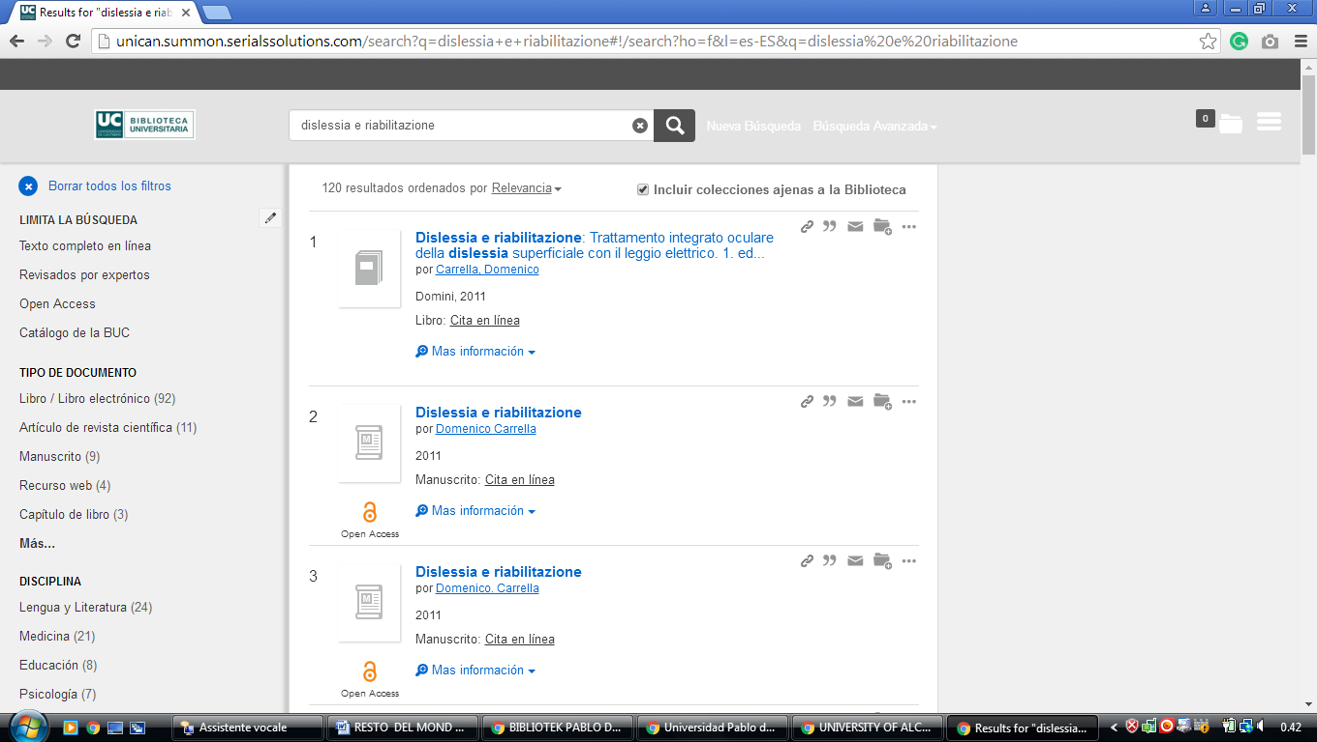

### [9 BIBLIOTECA UNIVERSIDAD DE CÓRDOBA - UCO](http://www.uco.es/servicios/biblioteca/) - (Spain)

<http://uco.summon.serialssolutions.com/search?utf8=%3F&s.q=DISLESSIA+E+RIABILITAZIONE&submit=Buscar#!/search?ho=f&l=es-ES&q=DISLESSIA%20E%20RIABILITAZIONE>

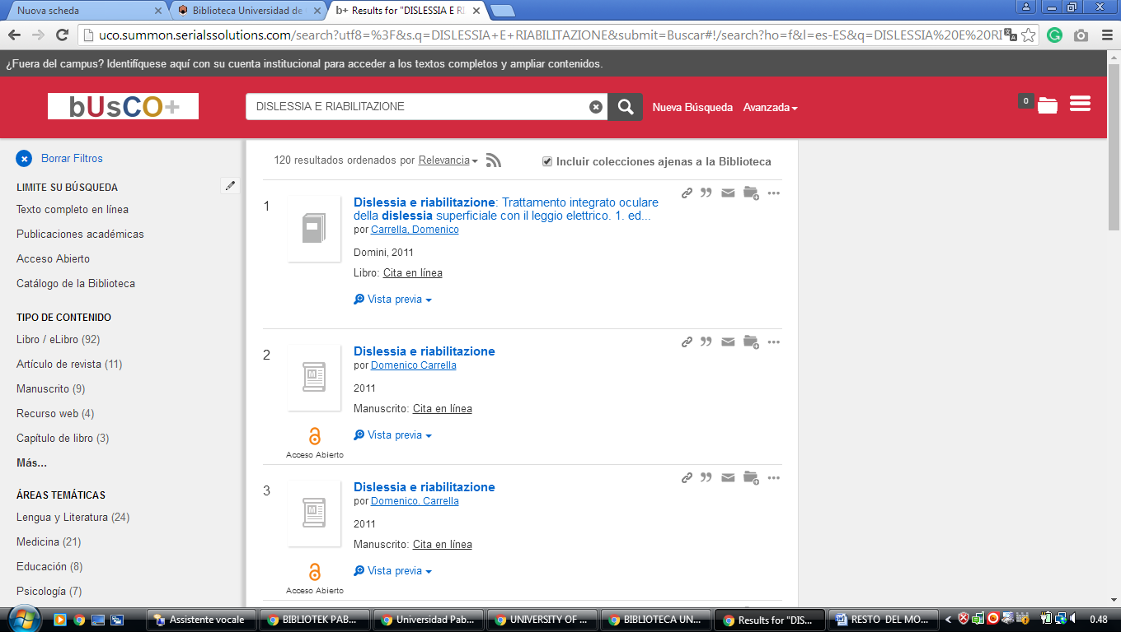

**10 CATALOGOBIBLIOTECA.UCLM.ES** - (EDSCO Discovery Service -

Spain)

<https://catalogobiblioteca.uclm.es/cgi-bin/abnetopac/O7068/ID3dc1af34/NT5?ACC=170&DOC=1>

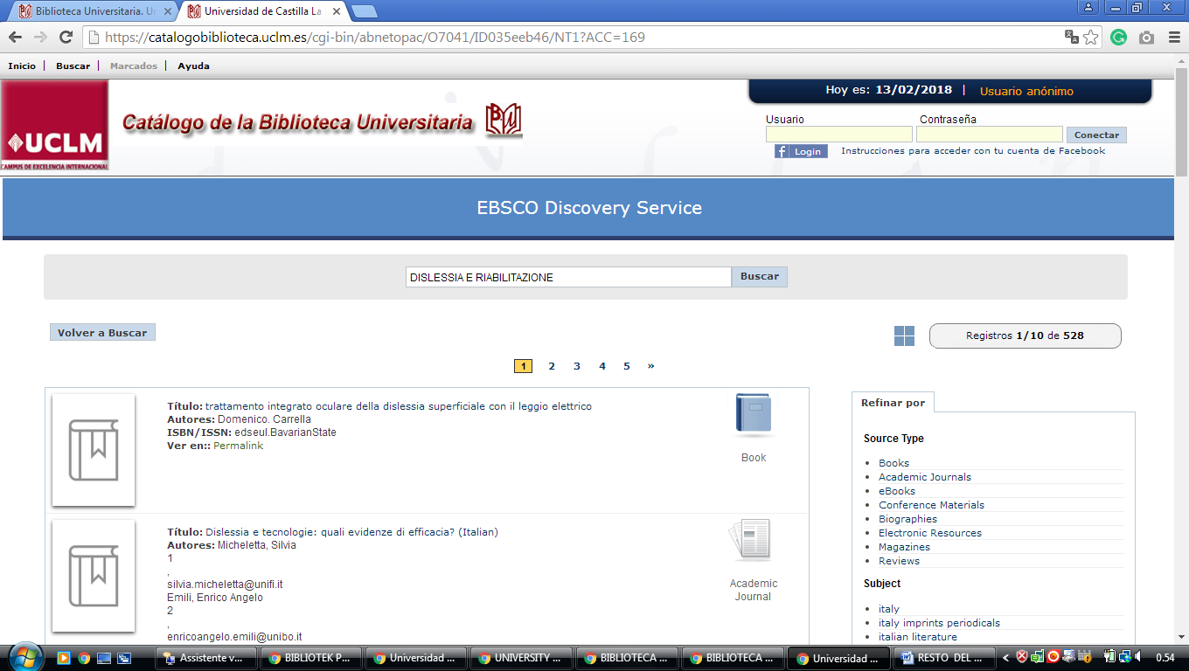

**11 BIBLIOTECA** [**UNIVERSITY OF LA RIOJA**](http://biblioteca.unirioja.es/) **–** (La Rioja, Spain)

<http://eds.b.ebscohost.com/eds/results?vid=0&sid=afd01368-0c39-444c-8589-b43e3535aba9%40sessionmgr120&bquery=dislessia+e+riabilitazione&bdata=Jmxhbmc9ZXMmdHlwZT0wJnNpdGU9ZWRzLWxpdmU%3d>

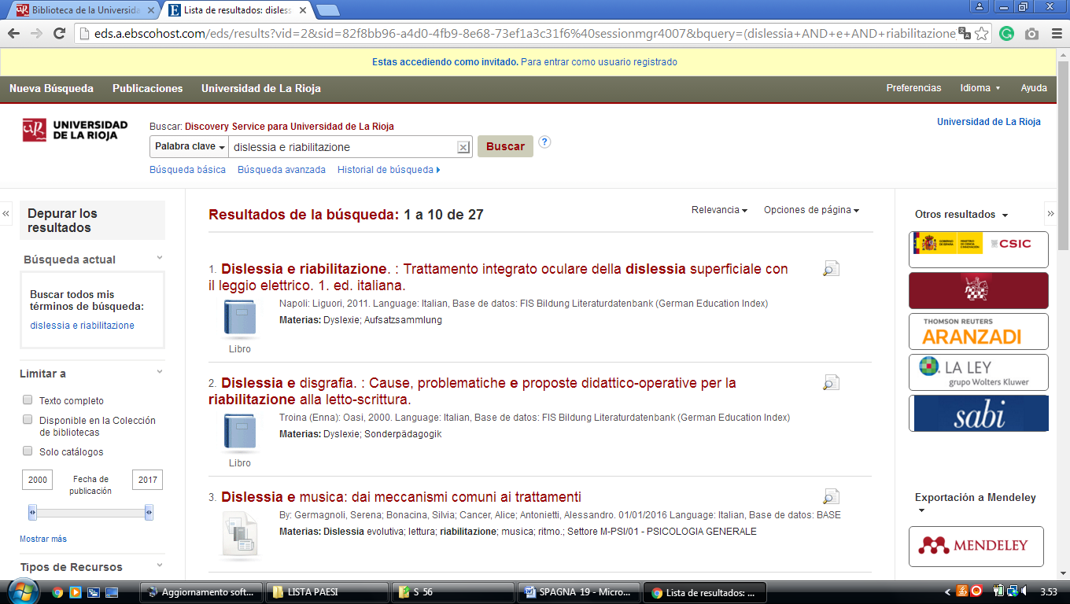

**12 BIBLIOTECA** [**UNIVERSITY OF SALAMANCA**](http://bibliotecas.usal.es/) - (Salamanca, Spain)

<http://usal.worldcat.org/title/dislessia-e-riabilitazione-trattamento-integrato-oculare-della-dislessia-superficiale-con-il-leggio-elettrico/oclc/878784487&referer=brief_results>

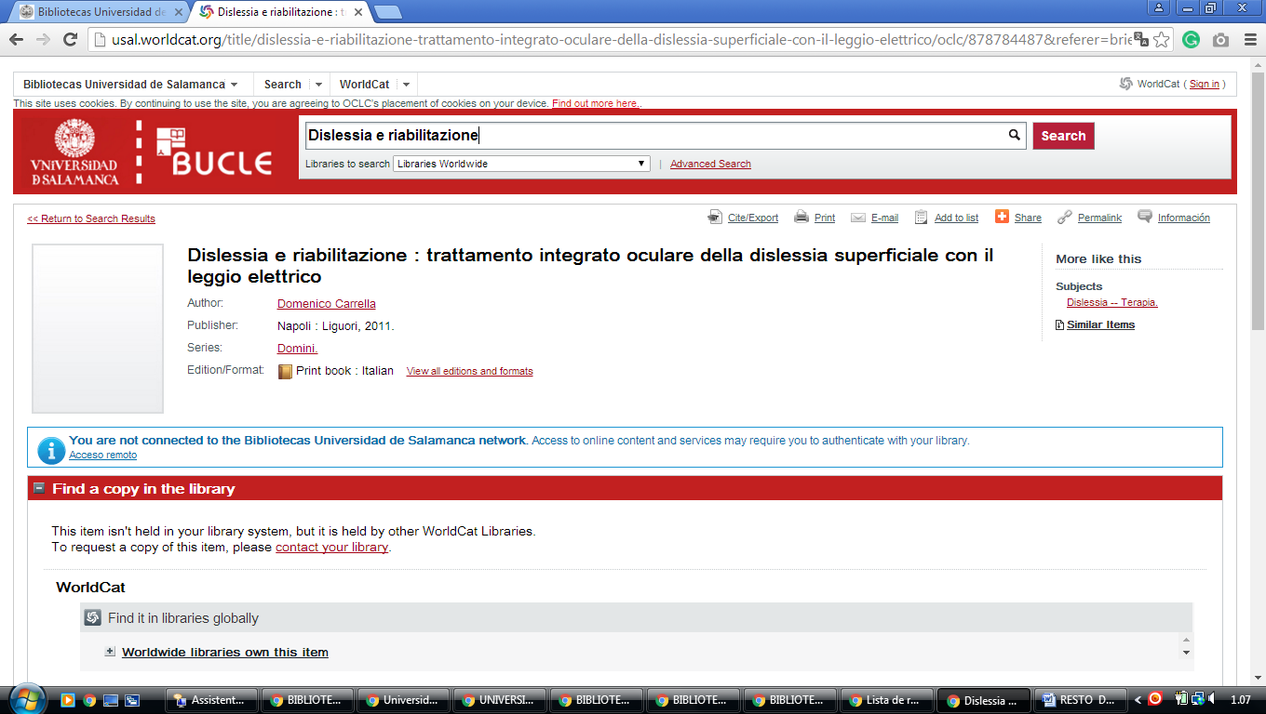

**13 BIBLIOTECA** [**UNIVERSITY OF BURGOS LIBRARY**](http://www.ubu.es/bubu/es?locale=es_ES) - (Burgos, Spain)

<https://ubu.on.worldcat.org/search?databaseList=&queryString=dislessia%20riabilitazione#/oclc/941217209>

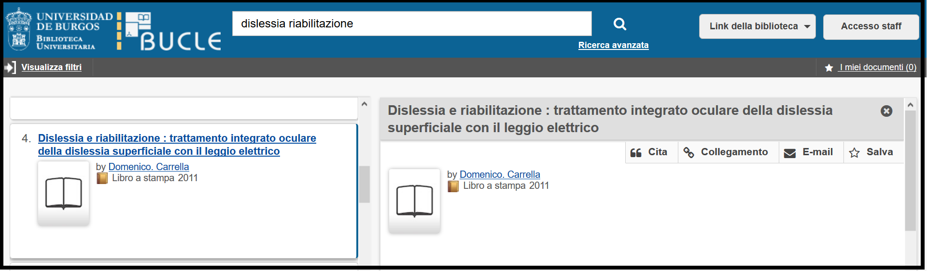

[**14 CATALOCO COLECTIVO MADRONO**](https://www.google.it/search?rlz=1C1CHIK_itIT460IT464&q=cataloco+colectivo+madrono+spagna&nfpr=1&sa=X&ved=0ahUKEwiauM-cv_XUAhXHaRQKHVYPBq0QvgUIJCgB)  - (Spagna)

[https://consorciomadrono.summon.serialssolutions.com/?#!/search?ho=f&l=es&q=DISLESSIA%20E%20RIABILITAZIONE](https://consorciomadrono.summon.serialssolutions.com/?%23!/search?ho=f&l=es&q=DISLESSIA%20E%20RIABILITAZIONE)

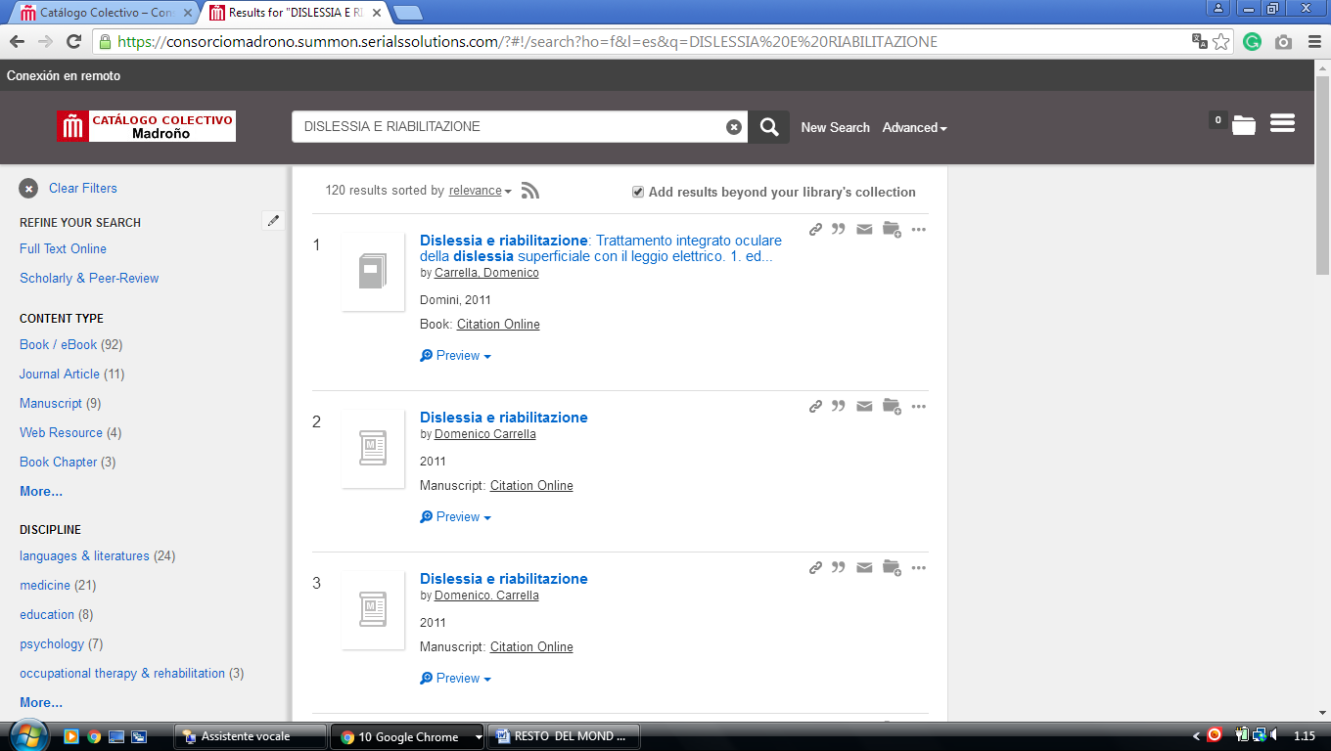

-------------------------------------------------------------------------------------------------------------------------------

### [15 BIBLIOTECA UAM - UNIVERSIDAD AUTÓNOMA DE MADRID](http://biblioteca.uam.es/) – (SPAIN)

[http://uam.summon.serialssolutions.com/?#!/search?ho=f&l=es-ES&q=DISLESSIA%20E%20RIABILITAZIONE](http://uam.summon.serialssolutions.com/?%23!/search?ho=f&l=es-ES&q=DISLESSIA%20E%20RIABILITAZIONE)

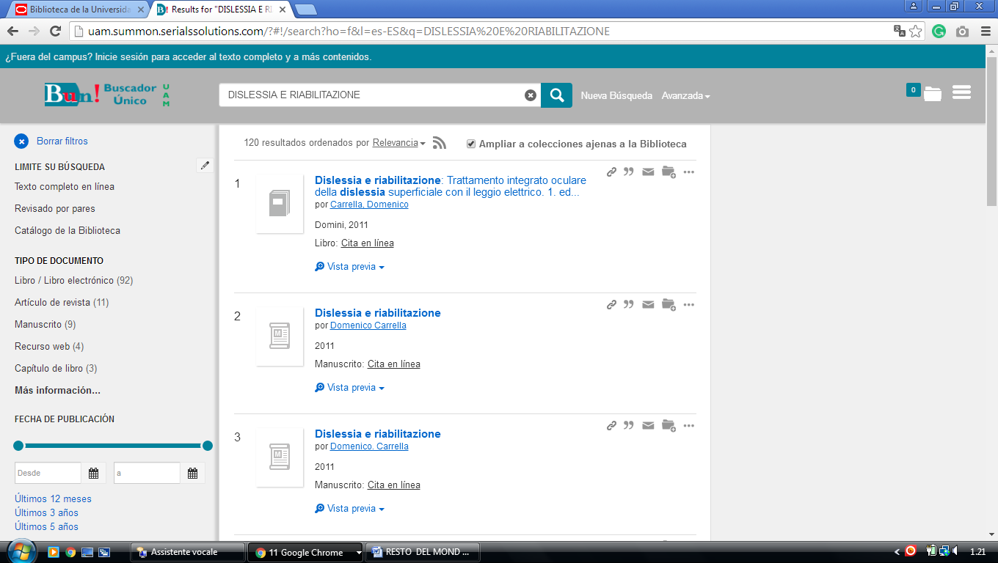

[**16 UNIVERSIDAD DE ZARAGOZA – BIBLIOTECA -**](http://biblioteca.unizar.es/)(Spain)

<http://eds.a.ebscohost.com/eds/results?vid=0&sid=4b4d53f8-66ec-4cf5-aa1f-c9d17bd65632%40sessionmgr4007&bquery=dislessia+e+riabilitazione&bdata=Jmxhbmc9ZXMmdHlwZT0wJnNpdGU9ZWRzLWxpdmU%3d>

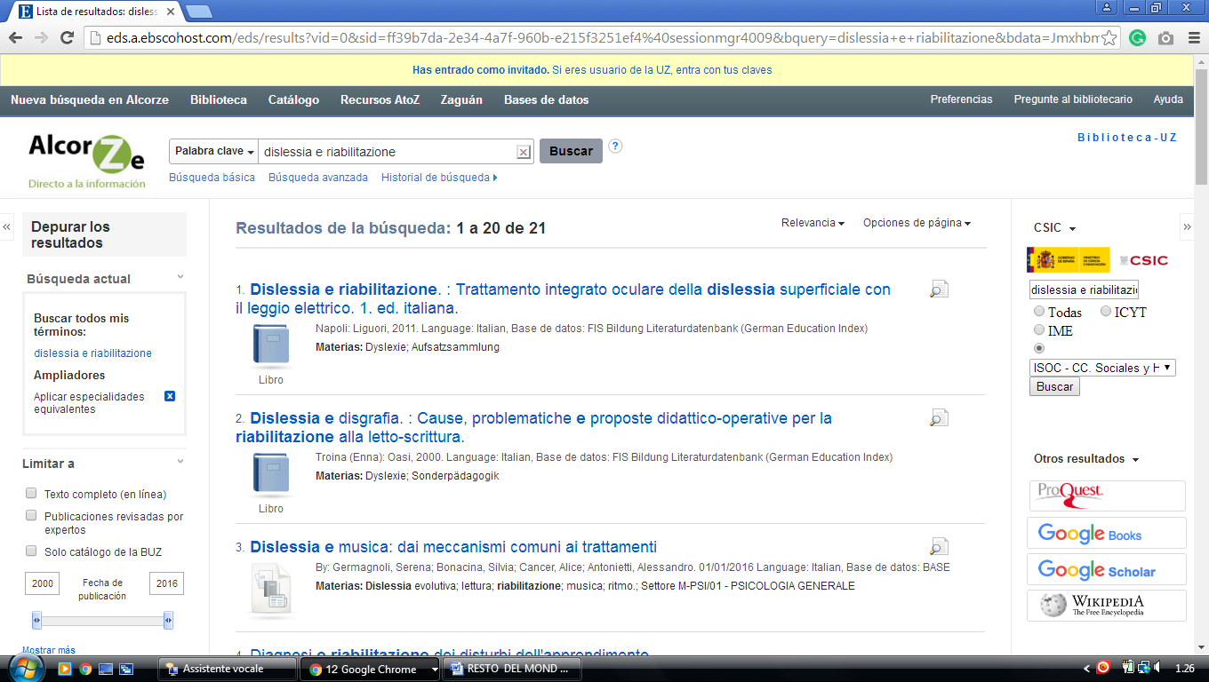

**17** [**LIBRARY | UC3M**](https://www.uc3m.es/ss/Satellite/Biblioteca/en/PortadaMiniSite/1371212251593/Library) **-** (Carlos Iii University Library Service Madrid, Spain)

### [http://uc3m.summon.serialssolutions.com/#!/search?ho=f&l=es&q=dislessia%20e%20riabilitazione](%20%20http:/uc3m.summon.serialssolutions.com/%23!/search?ho=f&l=es&q=dislessia%20e%20riabilitazione)

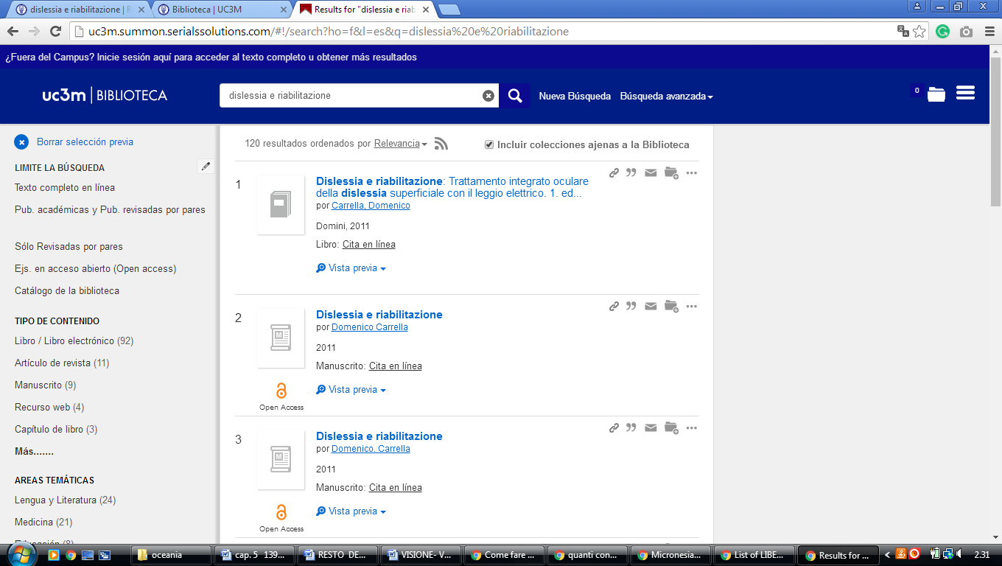

### 18 [LIBRARY OF THE UNIVERSITY OF ALICANTE. UNIVERSITY LIBRARY](https://biblioteca.ua.es/en/library-of-the-university-of-alicante.html), (Spagna)

[https://ua.on.worldcat.org/external-search?queryString=dislessia+e+riabilitazione#/oclc/878784487](https://ua.on.worldcat.org/external-search?queryString=dislessia+e+riabilitazione%23/oclc/878784487)

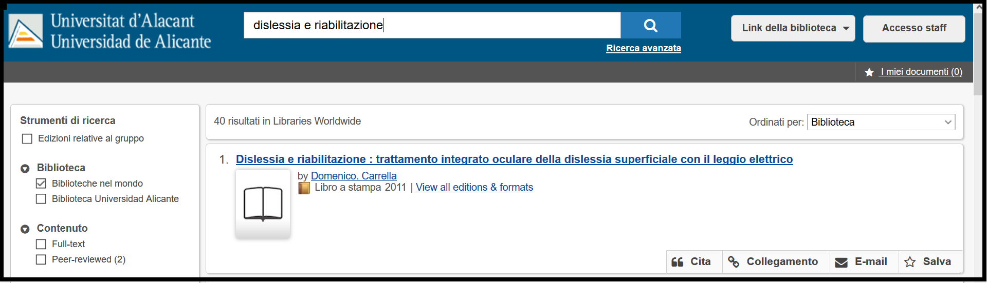

### 19 [THE EUROPEAN LIBRARY - BIBLIOTECA UCM - UNIVERSIDAD COMPLUTENSE ...](http://biblioteca.ucm.es/european-library) (Library of Madrid)

<http://www.theeuropeanlibrary.org/tel4/search?query=advanced((ANY%2Cdislessia+e+riabilitazione)AND(CONTRIBUTOR%2CP01364))&locale=es>

<http://www.theeuropeanlibrary.org/tel4/search?query=dislessia%20e%20riabilitazione&locale=es>

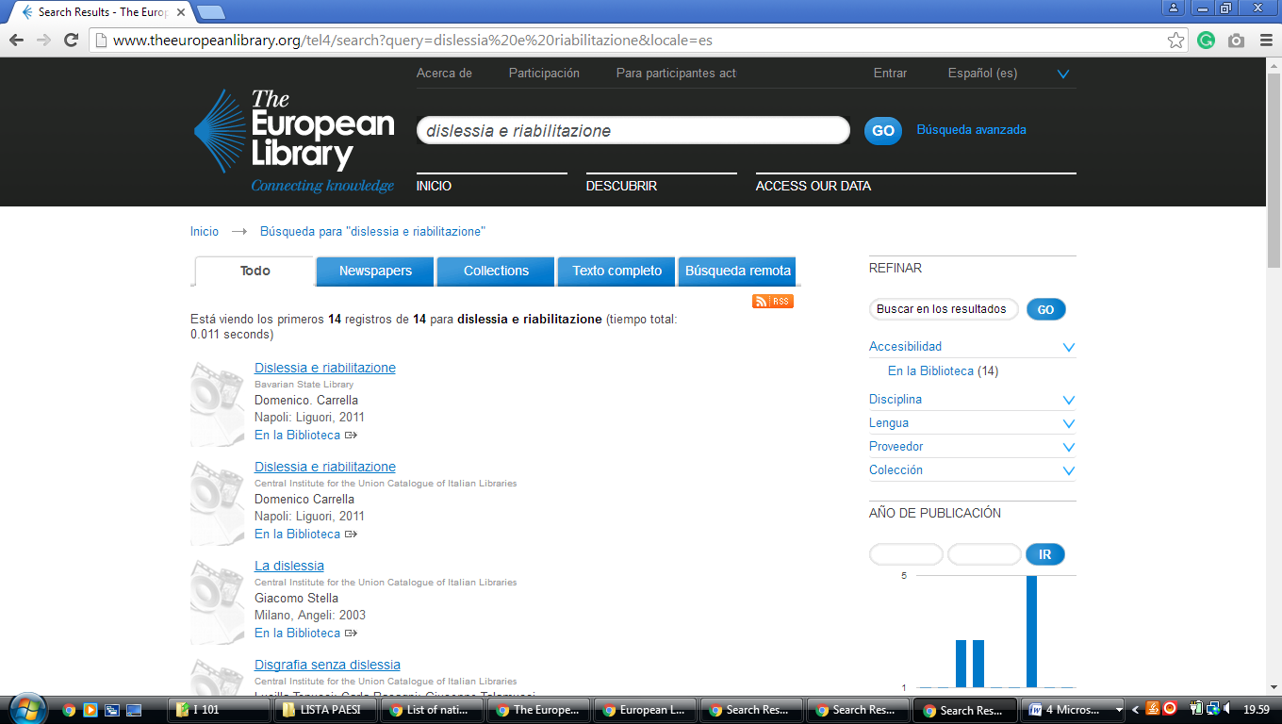

### 20 [UNED | BIBLIOTECA DE LA UNED](http://portal.uned.es/pls/portal/url/page/UNED_MAIN/BIBLIOTECA/) - ([Universidad Nacional de Educación a Distancia](http://portal.uned.es/), universidad pública Madrid de España)

[http://uned.summon.serialssolutions.com/search/results?s.fvf%5B%5D=ContentType%2CNewspaper+Article%2Ct&s.q=dislessia+e+riabilitazione#!/search?ho=f&fvf=ContentType,Newspaper%20Article,t&l=es-ES&q=dislessia%20e%20riabilitazione](http://uned.summon.serialssolutions.com/search/results?s.fvf%5B%5D=ContentType%2CNewspaper+Article%2Ct&s.q=dislessia+e+riabilitazione%23!/search?ho=f&fvf=ContentType,Newspaper%20Article,t&l=es-ES&q=dislessia%20e%20riabilitazione)

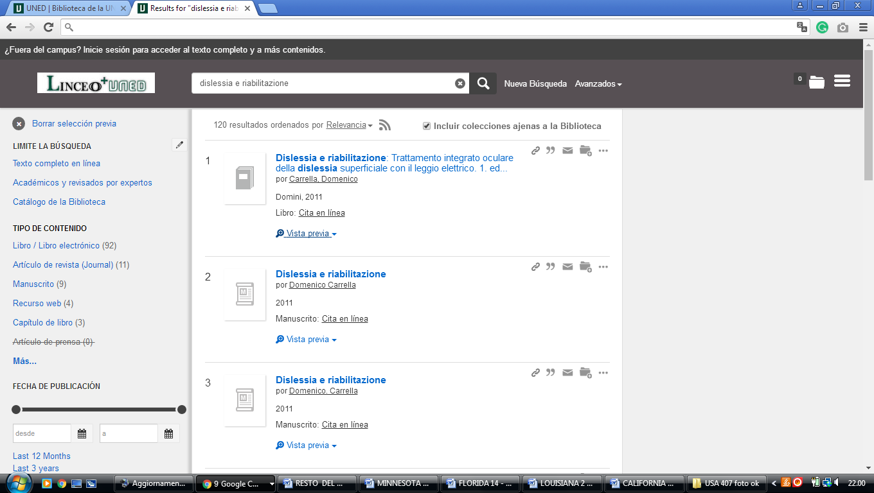

**Library Services | University of Granada**

<https://granatensis.ugr.es/discovery/search?query=any,contains,dislessia%20e%20riabilitazione&tab=Granada&search_scope=CentralIndex&vid=34CBUA_UGR:VU1&lang=es&offset=0&>

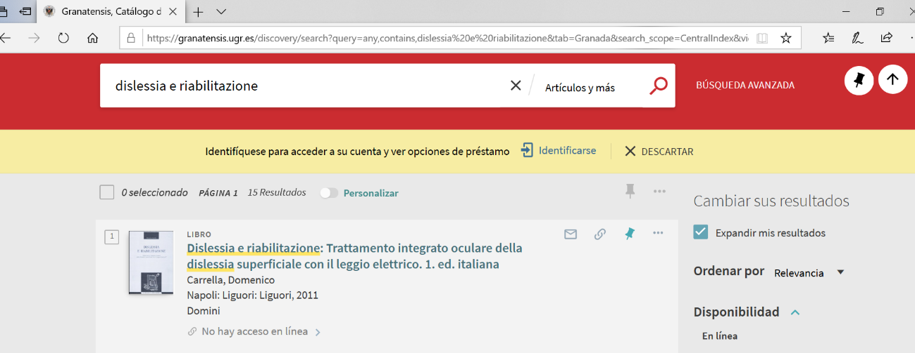

Joan Lluís Vives Virtual Library UNIVERSITÀ DI VALENCIA

https://uves.summon.serialssolutions.com/search?l=es&ho=t&q=dislessia+e+riabilitazione#!/search?ho=f&l=es&q=dislessia%20e%20riabilitazione

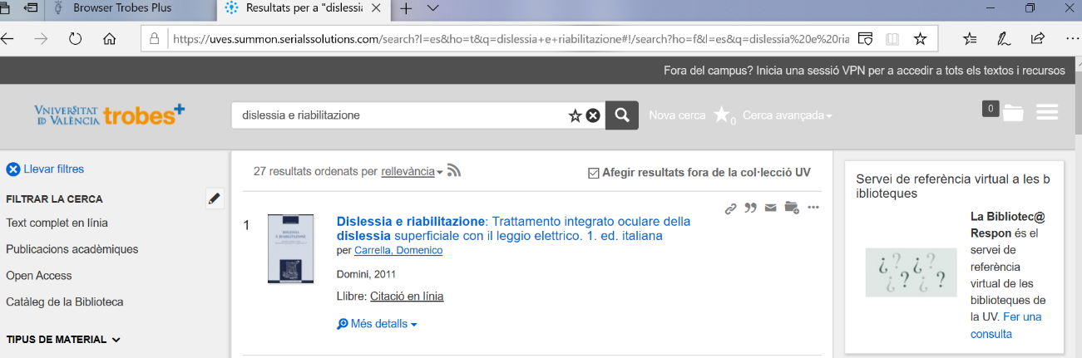

### [Library - UNM-Valencia - University of New Mexico](http://valencia.unm.edu/library/)

https://vclibrary.on.worldcat.org/search?sortKey=BEST_MATCH&databaseList=&queryString=dislessia+e+riabilitazione&changedFacet=scope&overrideStickyFacetDefault=&selectSortKey=BEST_MATCH&scope=&scope=wz%3A21413&format=all&year=all&yearFrom=&yearTo=&author=all&database=all&language=all&materialtype=all

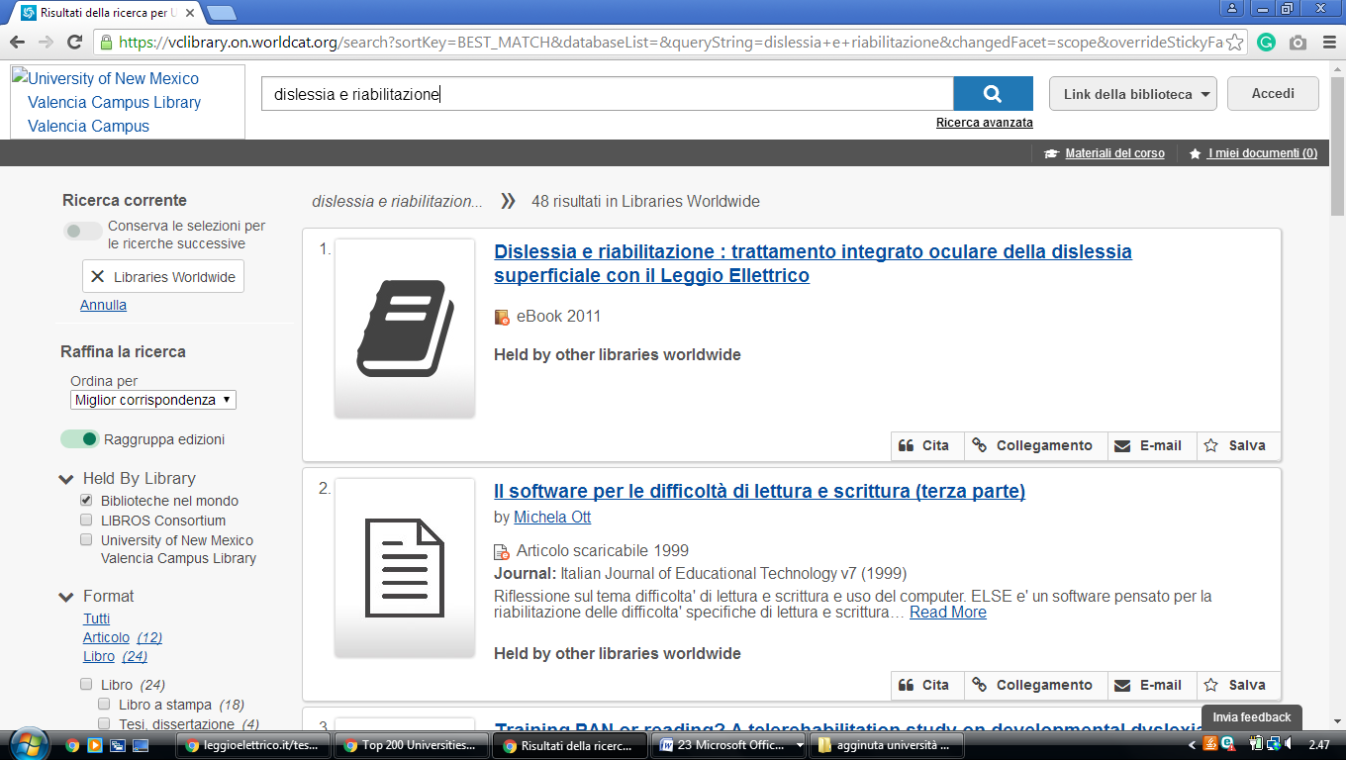

### [Universidad Complutense of Madrid - Ucm-Library](https://biblioteca.ucm.es/en)

## Biblioteca de la Facultad de Medicina

**Universidad Complutense de Madrid**

https://ucm.on.worldcat.org/search?sortKey=LIBRARY&databaseList=&queryString=dislessia+e+riabilitazione&changedFacet=scope&overrideStickyFacetDefault=&stickyFacetsChecked=on&selectSortKey=LIBRARY&clusterResults=off&scope=&scope=sz%3A37703&scope=sz%3A37628&format=all&year=all&yearFrom=&yearTo=&author=all&language=all&database=all

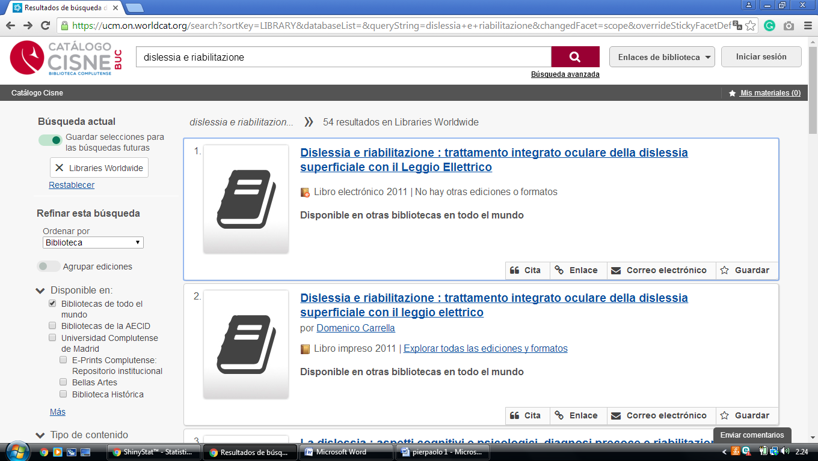

**95 nazioni + 5 (color**