### 1 [DIGITAL LIBRARY (DIKUL) - UNIVERSITY OF LJUBLJANA](https://www.uni-lj.si/libraries/digital_library_dikul/) – (Slovenia)

http://eds.b.ebscohost.com/eds/results?vid=1&sid=6c7c581f-7aa3-450d-9df2-a2ca6d5c429b%40sessionmgr101&bquery=dislessia+e+riabilitazione&bdata=Jmxhbmc9c2wmdHlwZT0wJnNpdGU9ZWRzLWxpdmU%3d

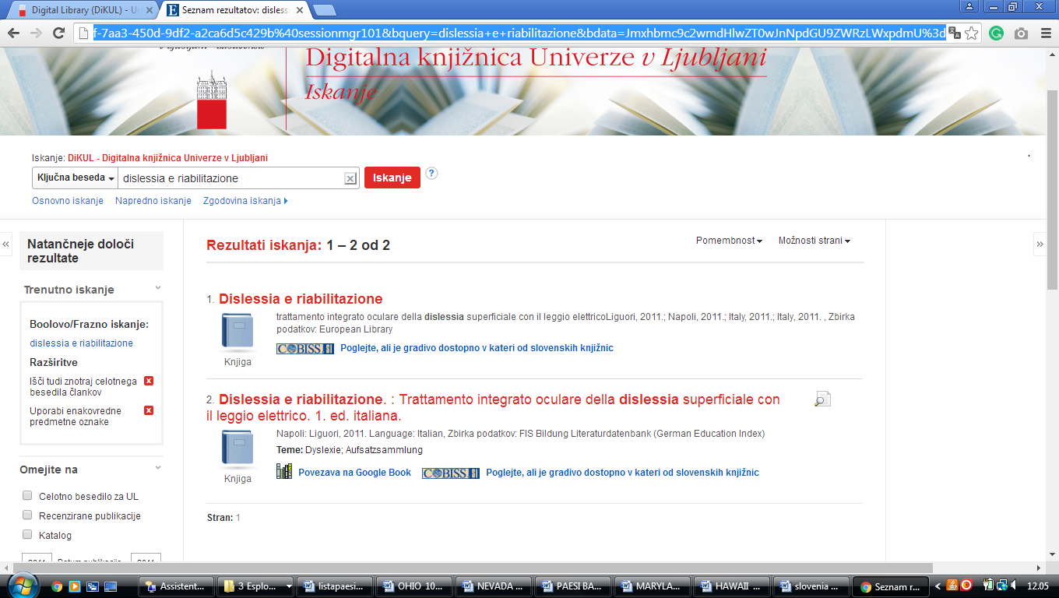

**Knjižnično dokumentacijski centar**

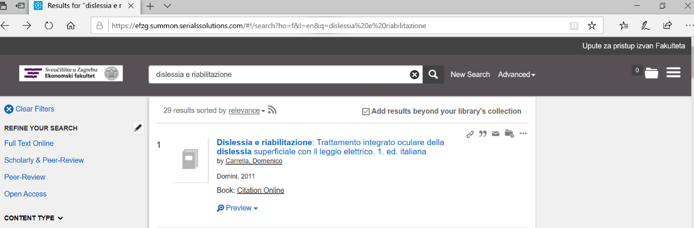https://efzg.summon.serialssolutions.com/#!/search?ho=f&l=en&q=dislessia%20e%20riabilitazione