**1 NSU UNIVERSITY OF SINGAPORE LIBRARY** [– (Singapore](https://en.wikipedia.org/wiki/Singapore))

<http://nus.summon.serialssolutions.com/search?s.q=DISLESSIA%20E%20RIABILITAZIONE&s.fvf%5B%5D=ContentType,Newspaper%20Article,t&s.fvf%5B%5D=ContentType,Book%20Review,t#!/search?ho=f&fvf=ContentType,Newspaper%20Article,t%7CContentType,Book%20Review,t&l=en&q=DISLESSIA%20E%20RIABILITAZIONE>

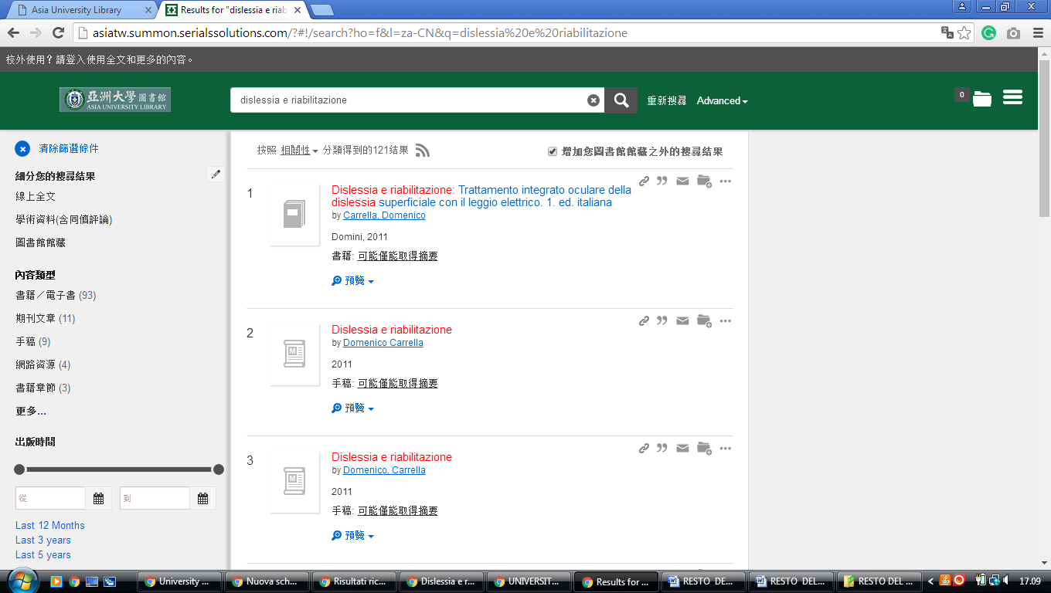

### 2 [US LIBRARIES - HOME](http://www.lib.nus.edu.sg/) - (Università Nazionale Di Singapore, Nus)

<http://nus.summon.serialssolutions.com/search?s.q=DISLESSIA%20E%20RIABILITAZIONE&s.fvf%5B%5D=ContentType,Newspaper%20Article,t&s.fvf%5B%5D=ContentType,Book%20Review,t#!/search?ho=f&fvf=ContentType,Newspaper%20Article,t%7CContentType,Book%20Review,t&l=en&q=DISLESSIA%20E%20RIABILITAZIONE>

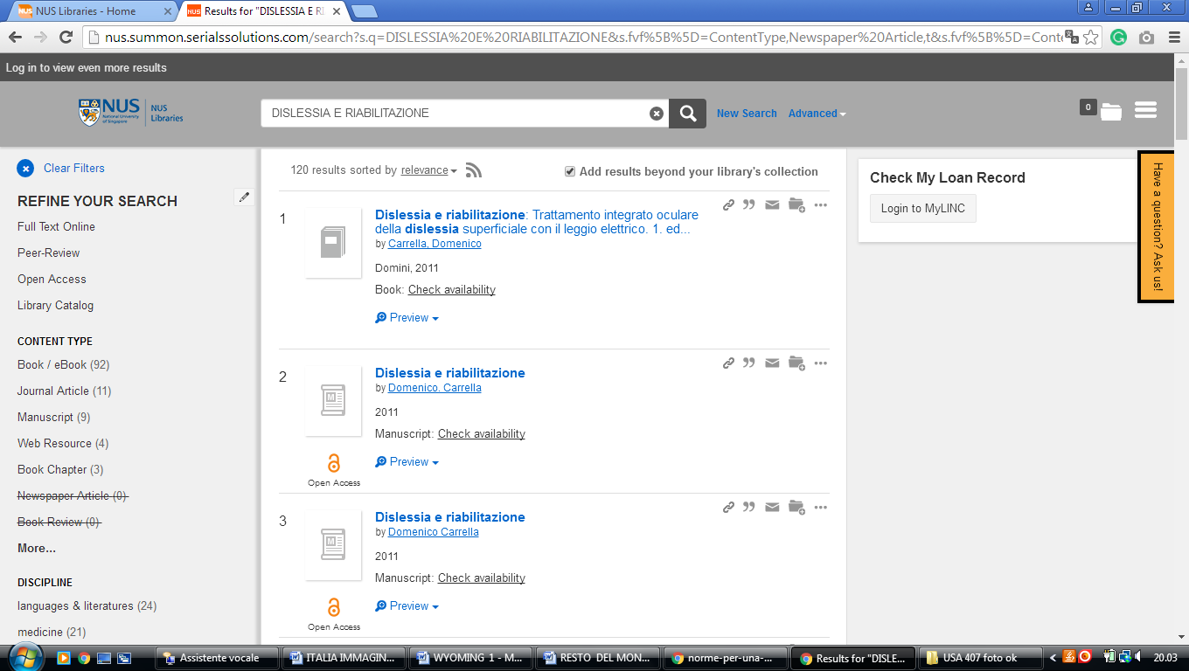

**3 LIBRARY** [**NATIONAL UNIVERSITY OF SINGAPORE**](http://libportal.nus.edu.sg/) **–** (Singapore)

<http://nus.summon.serialssolutions.com/search?s.q=DISLESSIA%20E%20RIABILITAZIONE&s.fvf%5B%5D=ContentType,Newspaper%20Article,t&s.fvf%5B%5D=ContentType,Book%20Review,t#!/search?ho=f&fvf=ContentType,Newspaper%20Article,t%7CContentType,Book%20Review,t&l=en&q=DISLESSIA%20E%20RIABILITAZIONE>

