**1** [**GLASGOW CALEDONIAN UNIVERSITY LIBRARY**](http://www.gcu.ac.uk/library/) - (Glasgow, Scotland)

<https://discover.gcu.ac.uk/primo-explore/search?institution=44GLCU&vid=44GLCU_VU1&tab=default_tab&search_scope=default_scope&mode=Basic&displayMode=full&highlight=true&dum=true&query=any,contains,dislessia%20e%20riabilitazione&displayField=all&sortby=rank&lang=en_US&pcAvailability=true>

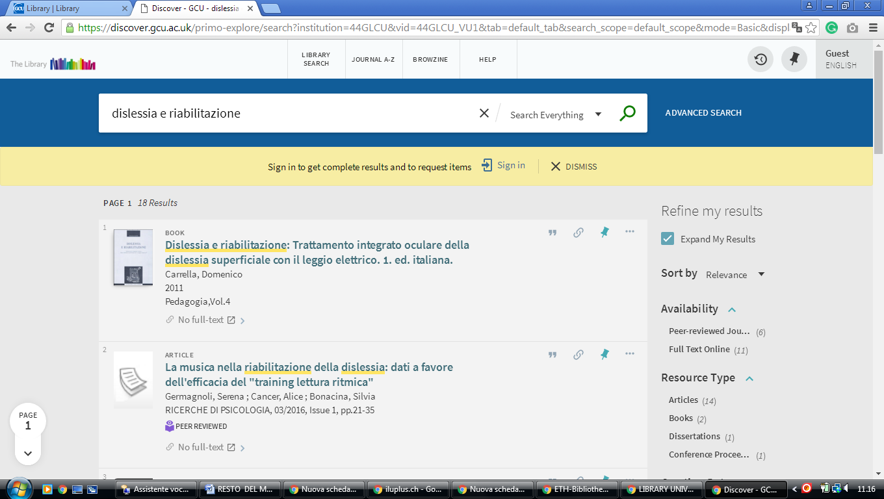

**2** [**NATIONAL LIBRARY OF SCOTLAND**](http://www.nls.uk/) – (Edinburgh, Scotland)

<https://nls.summon.serialssolutions.com/search?s.q=dislessia+e+riabilitazione#!/search?ho=f&l=it-IT&q=dislessia%20e%20riabilitazione>

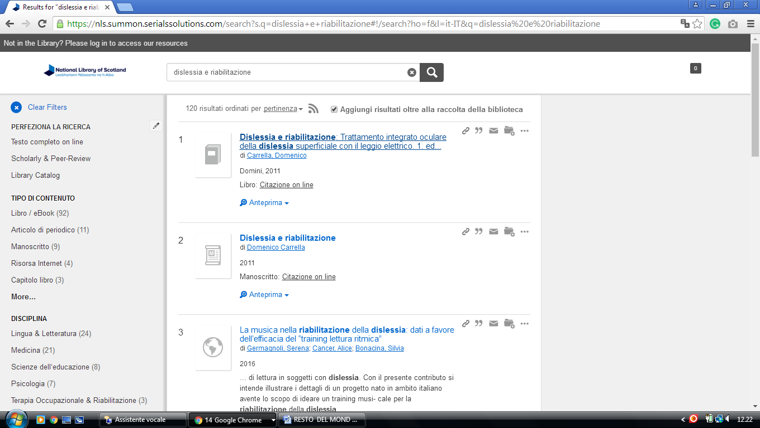

**3**  [**UNIVERSITY OF GLASGOW LIBRARY**](http://www.lib.gla.ac.uk/) – (Glasgow, Scotland)

<https://glasgow.summon.serialssolutions.com/?s.q=dislessia+e+riabilitazione&s.cmd=addFacetValueFilters%28ContentType%2CNewspaper+Article%2Ct%7CContentType%2CBook+Review%2Ct%29#!/search?ho=f&fvf=ContentType,Newspaper%20Article,t%7CContentType,Book%20Review,t&l=en-UK&q=dislessia%20e%20riabilitazione>

### 

**4 LIBRARY** [**UNIVERSITY OF EDINBURGH**](https://www.google.it/search?rlz=1C1CHIK_itIT460IT464&q=University+of+Edinburgh&spell=1&sa=X&ved=0ahUKEwj-yeWLgZrUAhVCORQKHRzMDogQvwUIIygA) **-** (South Bridge, Edinburgh, Scozia)

### <https://discovered.ed.ac.uk/primo-explore/search?institution=44UOE&vid=44UOE_VU2&search_scope=default_scope&query=any,contains,dislessia%20e%20riabilitazione&pcAvailabiltyMode=true&sortby=rank&pcAvailability=true>

