**SAMOA UNIVERSITY LIBRARY** [**Apia**](https://en.wikipedia.org/wiki/Apia,_Samoa)**,** [**SAMOA**](https://en.wikipedia.org/wiki/Samoa)

[SPREP Library | Pacific Environment](https://www.google.com/url?sa=t&rct=j&q=&esrc=s&source=web&cd=28&cad=rja&uact=8&ved=2ahUKEwip74eH-Y7pAhXGsaQKHXKCB7U4FBAWMAd6BAgIEAE&url=https%3A%2F%2Fwww.sprep.org%2Flibrary-information-resource-center%2Flibrary-home&usg=AOvVaw2g6NviKuE7MkXAwtldhdMf)

[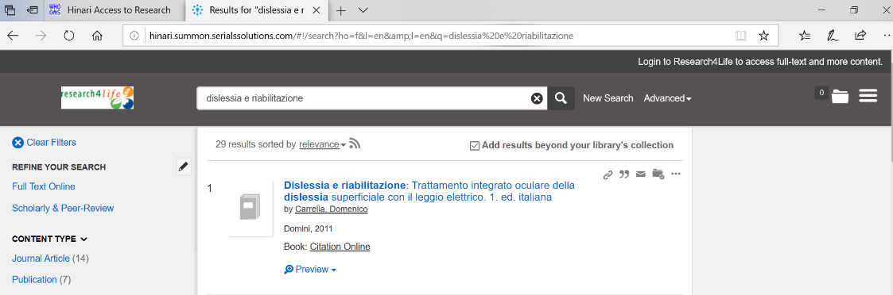](https://www.google.com/url?sa=t&rct=j&q=&esrc=s&source=web&cd=28&cad=rja&uact=8&ved=2ahUKEwip74eH-Y7pAhXGsaQKHXKCB7U4FBAWMAd6BAgIEAE&url=https%3A%2F%2Fwww.sprep.org%2Flibrary-information-resource-center%2Flibrary-home&usg=AOvVaw2g6NviKuE7MkXAwtldhdMf)