**1** [**GPNTB**](HTTP://GPNTB) – ([Russian National Public Library For](http://www.gpntb.ru/) Science And Technology

Moscow, Russia)

[http://gpntb.summon.serialssolutions.com/search?s.q=dislessia+e+riabilitazione#!/search?ho=f&l=en&q=dislessia%20e%20riabilitazione](http://gpntb.summon.serialssolutions.com/search?s.q=dislessia+e+riabilitazione%23!/search?ho=f&l=en&q=dislessia%20e%20riabilitazione)

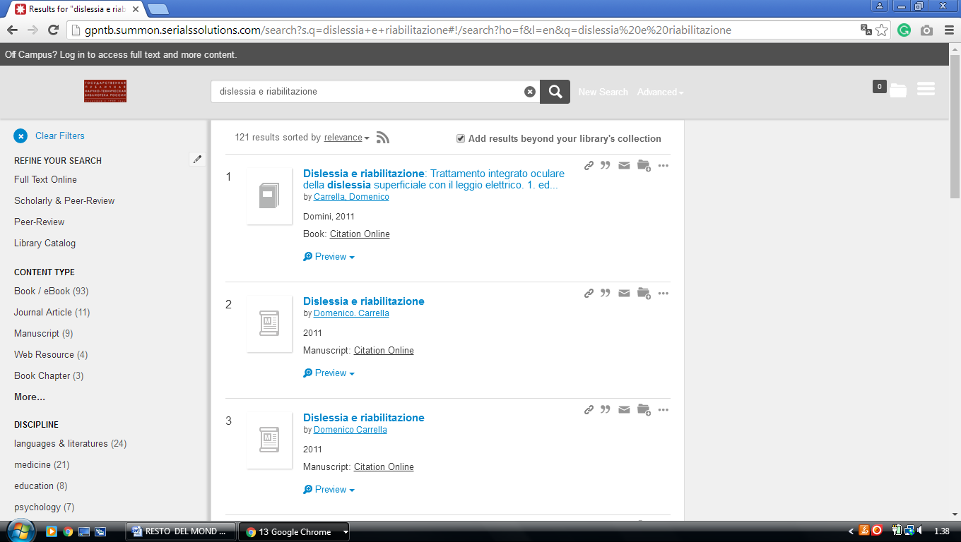

### 2 [NATIONAL LIBRARY OF RUSSIA - THE EUROPEAN LIBRARY](http://www.theeuropeanlibrary.org/tel4/contributor/P01230)

### (Russia)

### <http://www.theeuropeanlibrary.org/tel4/contributor/P01230>

### 