[**EDUCATION CITY**](https://en.wikipedia.org/wiki/Education_City)**, GEORGETOWN UNIVERSITY,** [**QATAR**](https://en.wikipedia.org/wiki/Qatar)

[Requesting Materials from the Georgetown University in Qatar ...](https://www.google.com/url?sa=t&rct=j&q=&esrc=s&source=web&cd=1&cad=rja&uact=8&ved=2ahUKEwjor7XYi8_oAhXqwqYKHTV0B1wQFjAAegQIBBAB&url=https%3A%2F%2Fwww.library.georgetown.edu%2Frequest-qatar&usg=AOvVaw0s2epLDJmx2lbD9pESNEou)

[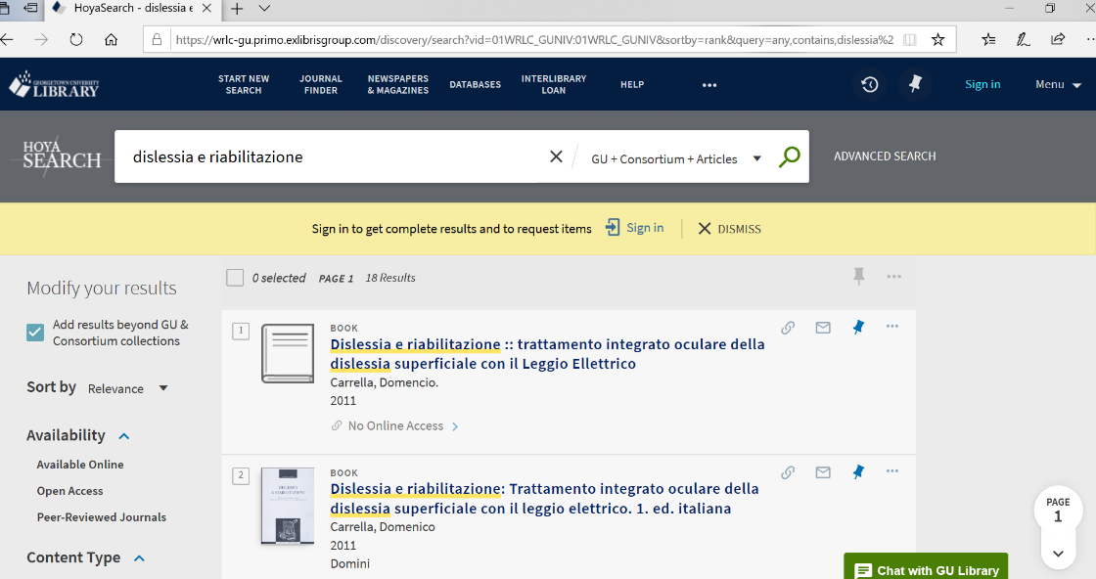](https://www.google.com/url?sa=t&rct=j&q=&esrc=s&source=web&cd=1&cad=rja&uact=8&ved=2ahUKEwjor7XYi8_oAhXqwqYKHTV0B1wQFjAAegQIBBAB&url=https%3A%2F%2Fwww.library.georgetown.edu%2Frequest-qatar&usg=AOvVaw0s2epLDJmx2lbD9pESNEou)

College of North Atlantic Qatar Library

**College of North Atlantic Qatar**  
[**Doha**](https://librarytechnology.org/libraries/search.pl?City=Doha&Country=Qatar), Qatar

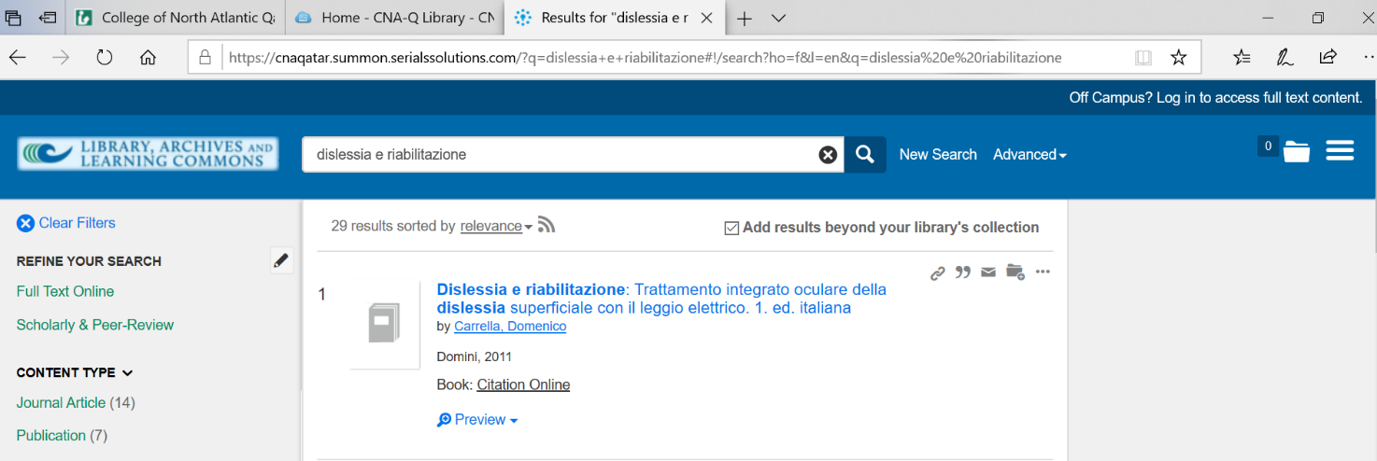https://cnaqatar.summon.serialssolutions.com/?q=dislessia+e+riabilitazione#!/search?ho=f&l=en&q=dislessia%20e%20riabilitazione