### 1 [UNIVERSITY OF NAMIBIA | LIBRARY](http://www.unam.edu.na/library) – (Windhoek, Namibia)

<http://unam.worldcat.org/title/dislessia-e-riabilitazione-trattamento-integrato-oculare-della-dislessia-superficiale-con-il-leggio-elettrico/oclc/878784487&referer=brief_results>

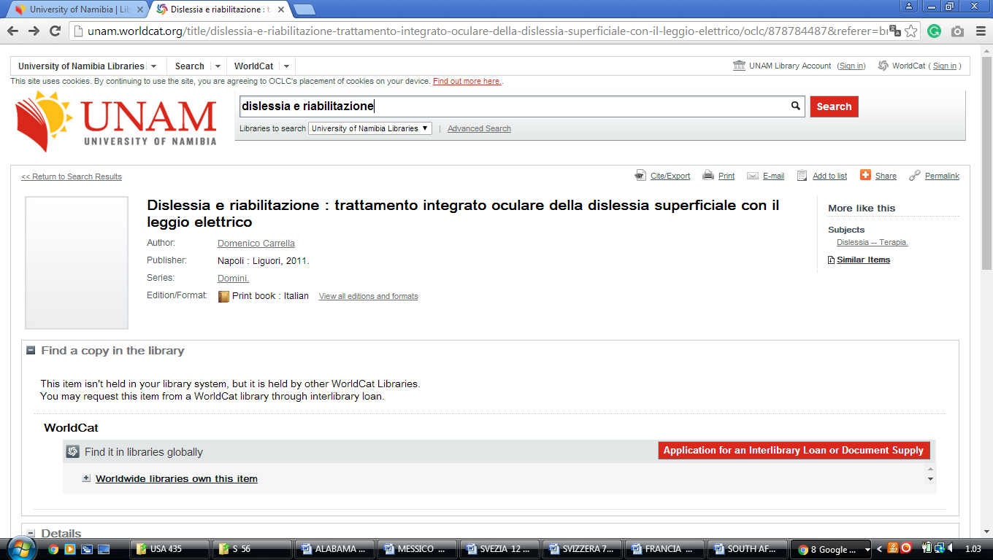

**International University of Management (IUM) library, Namibia**

IUM LIBRARY



