**BEIRA, UNIVERSIDADE CATOLICA DE MOCAMBIQUE**

[Universidade Católica de Moçambique](https://www.google.com/url?sa=t&rct=j&q=&esrc=s&source=web&cd=1&cad=rja&uact=8&ved=2ahUKEwizoYya3v_oAhVOlosKHVF9DHkQFjAAegQIAhAB&url=http%3A%2F%2Fwww.ucm.ac.mz%2F&usg=AOvVaw2NfO_81H4EhNQXhprt36Y0&cshid=1587685803871788)

[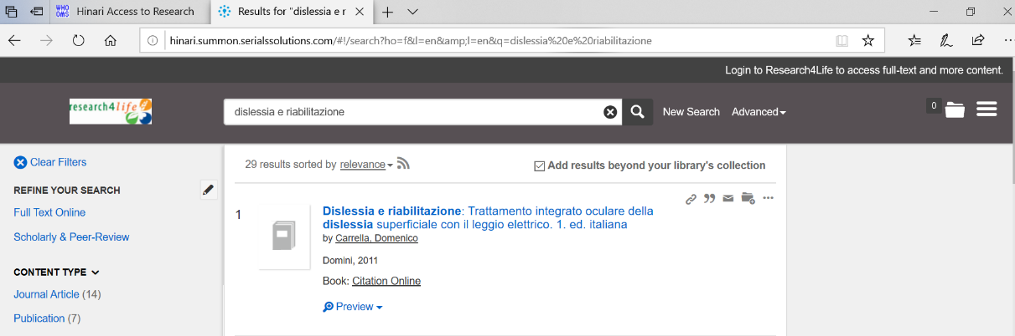](https://www.google.com/url?sa=t&rct=j&q=&esrc=s&source=web&cd=1&cad=rja&uact=8&ved=2ahUKEwizoYya3v_oAhVOlosKHVF9DHkQFjAAegQIAhAB&url=http%3A%2F%2Fwww.ucm.ac.mz%2F&usg=AOvVaw2NfO_81H4EhNQXhprt36Y0&cshid=1587685803871788)