**THE NATIONAL LIBRARY MAURITIUS**

[Contact Information: The National Library - WIPO](https://www.google.com/url?sa=t&rct=j&q=&esrc=s&source=web&cd=62&cad=rja&uact=8&ved=2ahUKEwi_jsDYgNLoAhXPXJoKHVeKCc84PBAWMAF6BAgBEAE&url=https%3A%2F%2Fwww.wipo.int%2Flibrary%2Fen%2Fcontact.jsp%3Fdir_id%3D2584&usg=AOvVaw1TGdY2ziE5OES_2fGONSCY)

[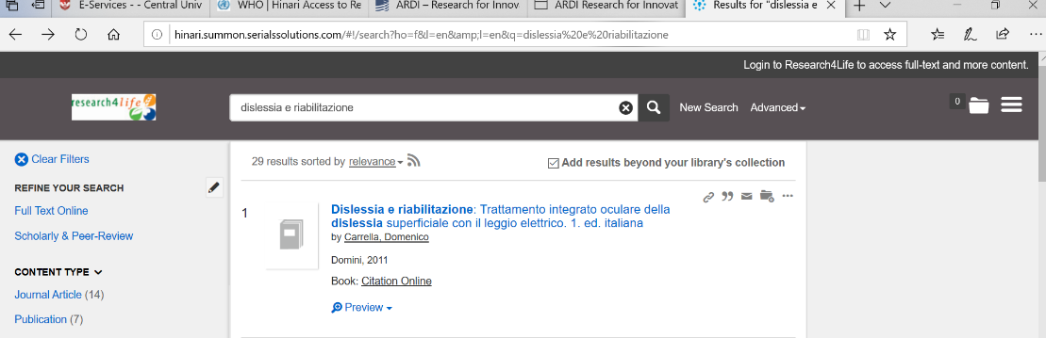](https://www.google.com/url?sa=t&rct=j&q=&esrc=s&source=web&cd=62&cad=rja&uact=8&ved=2ahUKEwi_jsDYgNLoAhXPXJoKHVeKCc84PBAWMAF6BAgBEAE&url=https%3A%2F%2Fwww.wipo.int%2Flibrary%2Fen%2Fcontact.jsp%3Fdir_id%3D2584&usg=AOvVaw1TGdY2ziE5OES_2fGONSCY)