[**CENTRE NATIONAL DE RECHERCHE SCIENTIFIQUE TECHNOLOGIQUE (CNRST)**](https://www.wipo.int/tisc/en/search/details.jsp?id=8037) **Bamako, MALI**

[TISC Directory: Mali - Bamako (Centre National de Recherche ...](https://www.google.com/url?sa=t&rct=j&q=&esrc=s&source=web&cd=3&cad=rja&uact=8&ved=2ahUKEwi73rCIg4zpAhUQThUIHYCOApoQFjACegQIAxAB&url=https%3A%2F%2Fwww.wipo.int%2Ftisc%2Fen%2Fsearch%2Fdetails.jsp%3Fid%3D8037&usg=AOvVaw0rKdZX-TloB6v4qAQo1zbJ)

[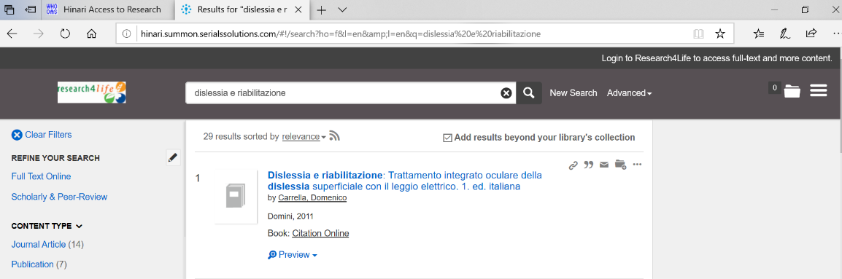](https://www.google.com/url?sa=t&rct=j&q=&esrc=s&source=web&cd=3&cad=rja&uact=8&ved=2ahUKEwi73rCIg4zpAhUQThUIHYCOApoQFjACegQIAxAB&url=https%3A%2F%2Fwww.wipo.int%2Ftisc%2Fen%2Fsearch%2Fdetails.jsp%3Fid%3D8037&usg=AOvVaw0rKdZX-TloB6v4qAQo1zbJ)