1 [**SARAWAK STATE LIBRARY**](http://www.pustaka-sarawak.com/) – (Kuching, Sarawak, Malaysia)

<http://pustaka.summon.serialssolutions.com/search/results?spellcheck=true&q=dislessia+e+riabilitazione#!/search?ho=f&l=en&q=dislessia%20e%20riabilitazione>

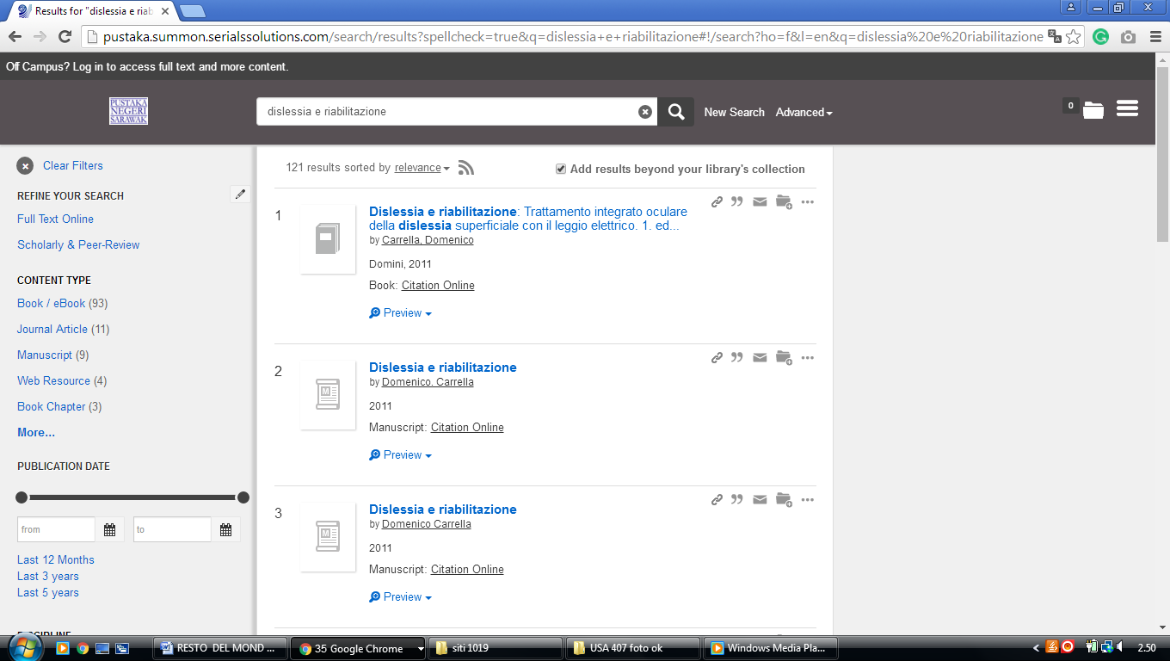

**2 LIBRARY UNIVERSITI MALAYSIA PAHANG –**  [(Pekan](https://en.wikipedia.org/wiki/Pekan_District), Pahang, Malaysia)

<https://ump.on.worldcat.org/search?databaseList=143%2C199%2C233%2C245%2C203%2C239%2C638%2C283%2C251%2C197%2C285&queryString=ti%3Adislessia+e+riabilitazione>

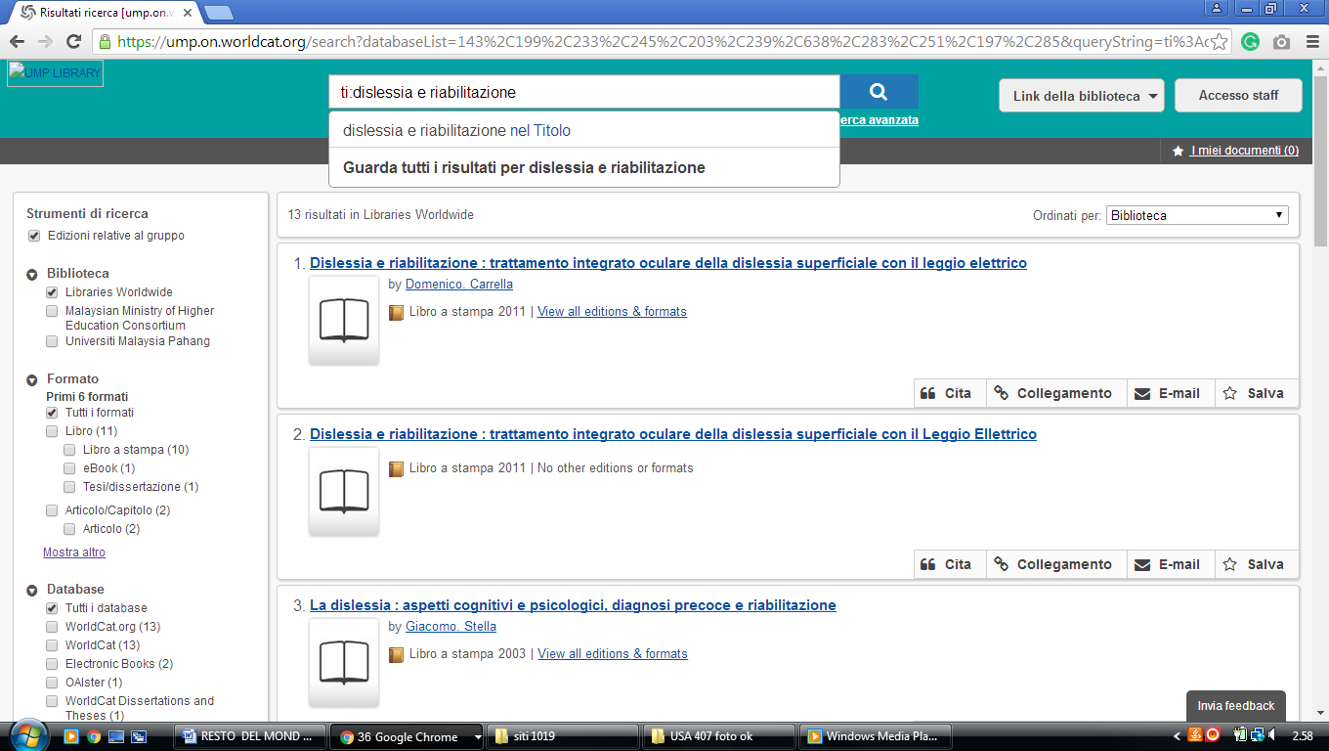

**1** [**NEWSPAPERS IN MELANESIA - PACIFIC ISLANDS NEWSPAPERS - RESEARCH ...**](https://guides.library.manoa.hawaii.edu/c.php?g=105813&p=683990)– (Melanesia)

<https://uhawaii-primo.hosted.exlibrisgroup.com/primo-explore/search?institution=OUZ&vid=OUZ&tab=default_tab&displayMode=full&bulkSize=10&highlight=true&dum=true&query=any,contains,dislessia%20e%20riabilitazione&displayField=all&pcAvailabiltyMode=true>

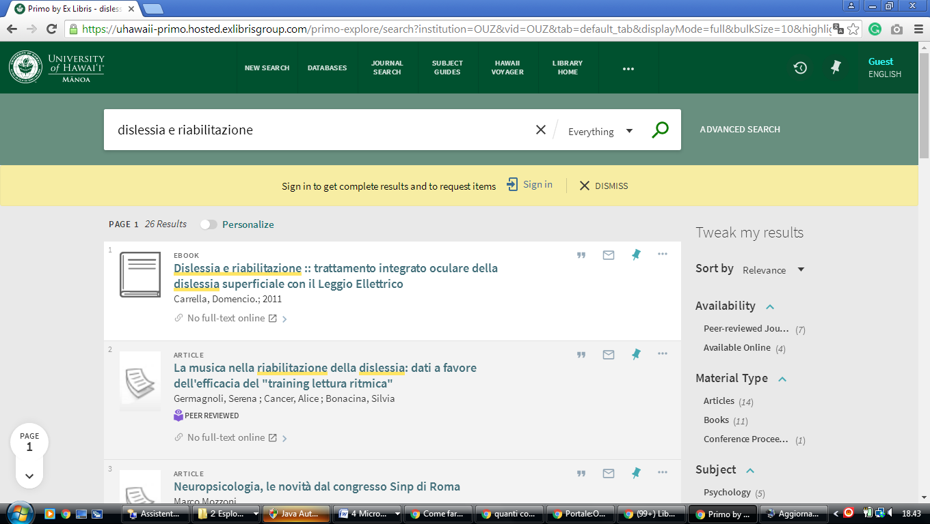

l