**CHANCELLOR COLLEGE Zomba UNIVERSITY OF MALAWI**

[Chancellor College: University of Malawi](https://www.google.com/url?sa=t&rct=j&q=&esrc=s&source=web&cd=11&cad=rja&uact=8&ved=2ahUKEwjFhPCO0__oAhWYycQBHd4WB7wQFjAKegQIAxAB&url=https%3A%2F%2Fwww.cc.ac.mw%2F&usg=AOvVaw0bTddiA-OAG2OK-hQ_OIzg)

[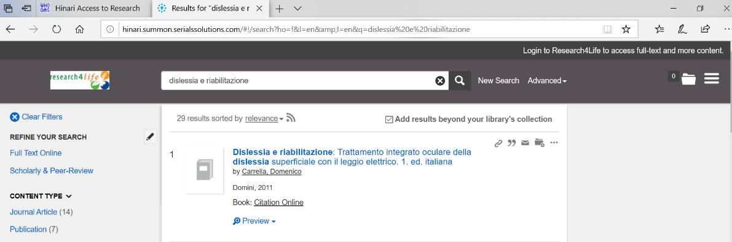](https://www.google.com/url?sa=t&rct=j&q=&esrc=s&source=web&cd=11&cad=rja&uact=8&ved=2ahUKEwjFhPCO0__oAhWYycQBHd4WB7wQFjAKegQIAxAB&url=https%3A%2F%2Fwww.cc.ac.mw%2F&usg=AOvVaw0bTddiA-OAG2OK-hQ_OIzg)