**1 BIBLIOTHÈQUE NATIONALE.DE LUXEMBOURB - (**Luxembourg)

<http://a-z.lu/primo-explore/search?query=any,contains,DISLESSIA%20E%20RIABILITAZIONE&tab=all_content&search_scope=All_content&vid=BIBNET&lang=fr_FR&offset=0&sortby=rank&pcAvailability=true>

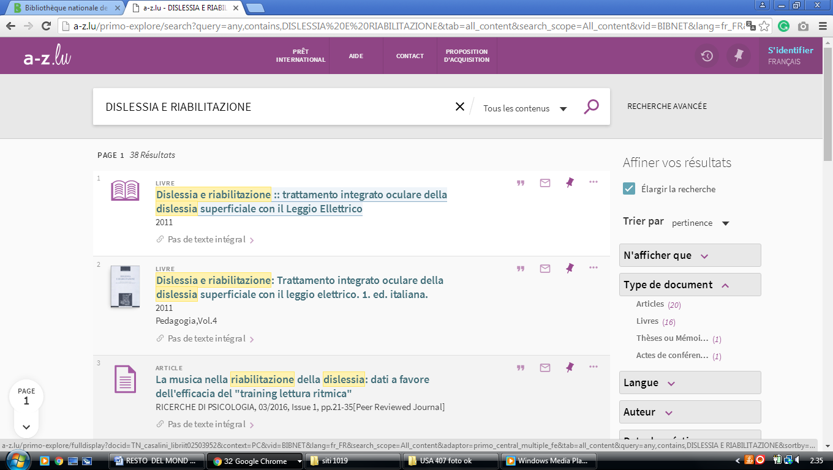

**2**  [**UNIVERSITY OF LUXEMBOURG LIBRARY**](http://wwwen.uni.lu/library) - (Luxembourg City, Luxembourg)

<http://a-z.lu/primo-explore/search?vid=BIBNET&institution=BIBNET&tab=libraries&mode=Basic&displayMode=full&bulkSize=true&highlight=true&dum=true&displayField=all&pcAvailabiltyMode=false&search_scope=CUNI&query=any,contains,dislessia%20e%20riabilitazione&sortby=rank&lang=fr_FR&pcAvailability=true>

