**A.M. DOGLIOTTI COLLEGE OF MEDICINE, Monrovia UNIVERSITY OF LIBERIA**

[Home - University of Liberia, A.M. Dogliotti College of ...](https://www.google.com/url?sa=t&rct=j&q=&esrc=s&source=web&cd=3&cad=rja&uact=8&ved=2ahUKEwiXsfiY0P_oAhWz8qYKHeB4BggQFjACegQIAxAB&url=https%3A%2F%2Flibraryguides.umassmed.edu%2Famdogliotticollegeofmedicine&usg=AOvVaw1oePR77HD5fL1uSm09BhO4)

[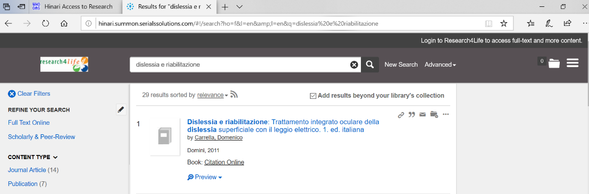](https://www.google.com/url?sa=t&rct=j&q=&esrc=s&source=web&cd=3&cad=rja&uact=8&ved=2ahUKEwiXsfiY0P_oAhWz8qYKHeB4BggQFjACegQIAxAB&url=https%3A%2F%2Flibraryguides.umassmed.edu%2Famdogliotticollegeofmedicine&usg=AOvVaw1oePR77HD5fL1uSm09BhO4)