**1 GULF UNIVERSITY FOR SCIENCE AND TECHNOLOGY LIBRARY** **– (Kuwait)**

<https://eds.b.ebscohost.com/eds/results?vid=0&sid=8862e044-f42c-49ba-bff7-c6207dd473b5%40sessionmgr104&bquery=dislessia+e+riabilitazione&bdata=JmNsaTA9RlQmY2x2MD1ZJnR5cGU9MCZzaXRlPWVkcy1saXZl>

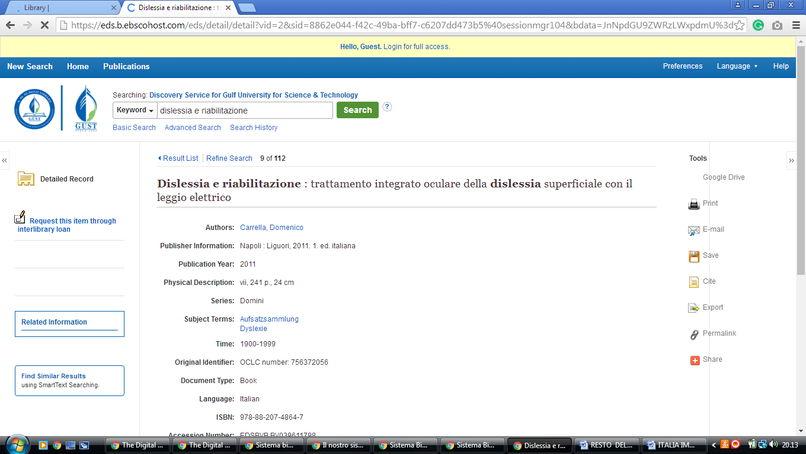

### 2 [AUK: LIBRARY > ABOUT US](http://www.auk.edu.kw/library/library_main.jsp) **- (Kuwait)**

<http://auk.summon.serialssolutions.com/?#!/search?ho=f&l=en&q=dislessia%20e%20riabilitazione>

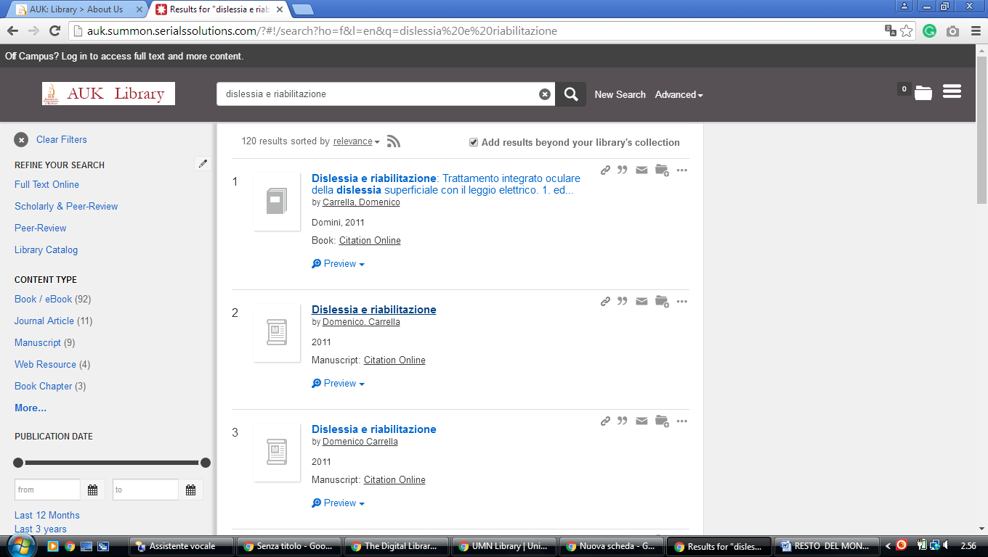

### 3. [KU Library - Kuwait University](http://kuweb.ku.edu.kw/kulib/index.htm)

http://kuniv.summon.serialssolutions.com/?q=%20%20%20dislessia%20e%20riabilitazione#!/search?ho=f&l=it-IT&q=%20%20%20dislessia%20e%20riabilitazione

