**1** [**BEN-GURION UNIVERSITY OF THE NEGEV**](http://www.bgu.ac.il/aranne/) **LIBRARY** – (Beer-Sheva, Israel)

<http://eds.b.ebscohost.com/eds/results?vid=0&sid=8e20815a-dbaa-4def-abdd-7685e4a07de0%40sessionmgr102&bquery=dislessia+e+riabilitazione&bdata=JmNsaTA9RlQxJmNsdjA9WSZ0eXBlPTAmc2l0ZT1lZHMtbGl2ZSZzY29wZT1zaXR>

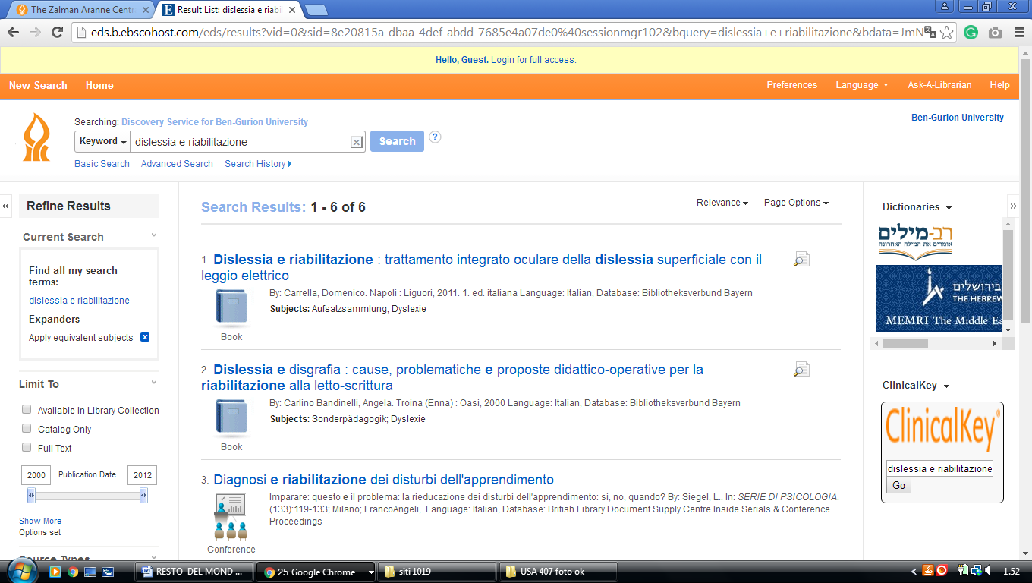

**2 LIBRARY** [**WEIZMANN INSTITUTE OF SCIENCE**](http://www.weizmann.ac.il/library/) **- (**Rehovot, Israel)

<https://weizmann-primo.hosted.exlibrisgroup.com/primo-explore/search?institution=972WIS&vid=972WIS_V1&onCampus=false&facet=rtype,include,books&facet=tlevel,include,online_resources&query=any,contains,dislessia%20e%20riabilitazione&sortby=rank&lang=en_US>

