**1** [**CAMBRIDGE UNIVERSITY LIBRARY**](http://www.lib.cam.ac.uk/) **-** (Cambridge, Inglilterra)

<https://idiscover.lib.cam.ac.uk/primo-explore/search?vid=44CAM_PROD&lang=en_US&search_scope=default_scope&tab=default_tab&sortby=rank&query=any,contains,dislessia%20e%20riabilitazione>

**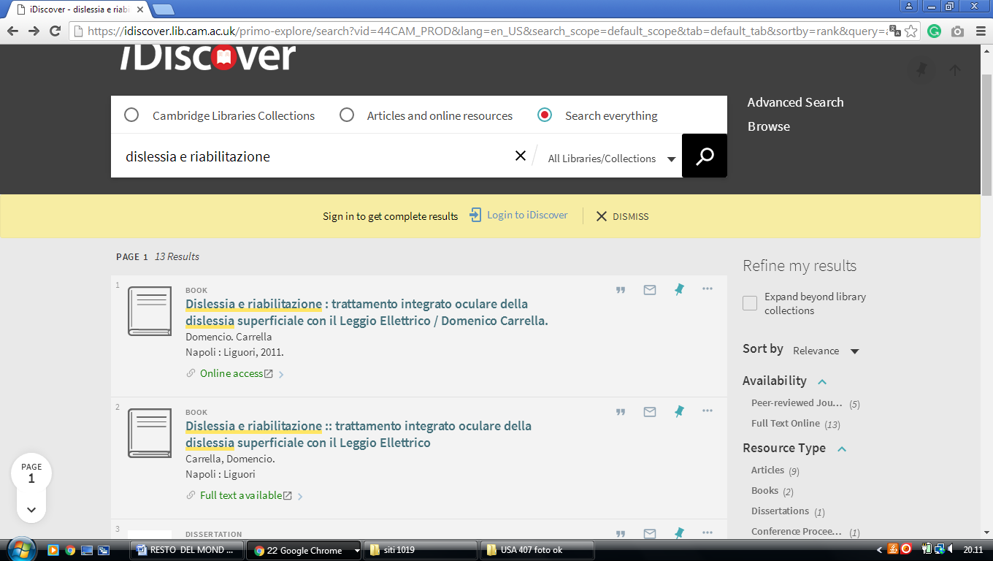**

### 2 [UNIVERSITY OF OXFORD BODLEIAN LIBRARIES - THE EUROPEAN](http://www.theeuropeanlibrary.org/tel4/contributor/P01374)

### [LIBRARY](http://www.theeuropeanlibrary.org/tel4/contributor/P01374) - (Oxford, England)

<http://www.theeuropeanlibrary.org/tel4/contributor/P01374>

<http://www.theeuropeanlibrary.org/tel4/search?query=dislessia%20e%20riabilitazione>

**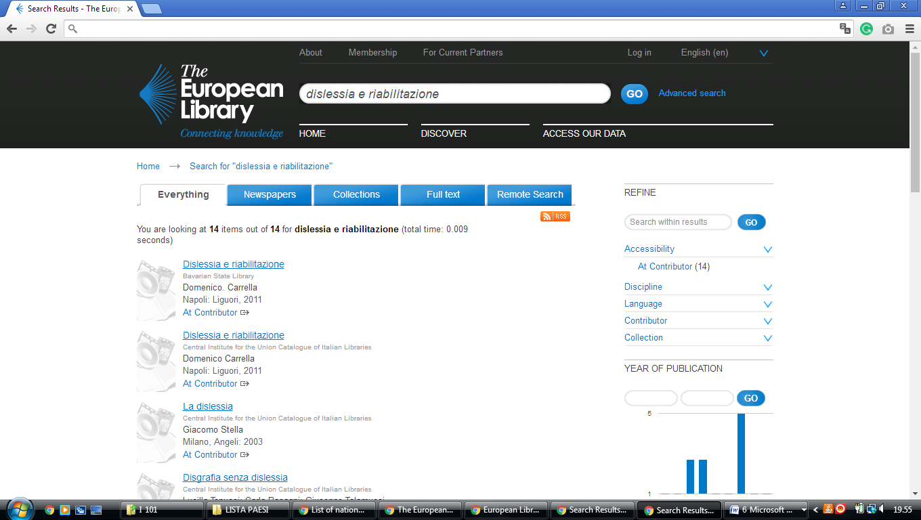**

**3 KING’S COLLEGE LONDON LIBRARY - (**London, England**)**

<https://librarysearch.kcl.ac.uk/primo_library/libweb/action/search.do;jsessionid=E017A2AE93F5CDC78B8819E747602A7E?ct=facet&pcAvailabiltyMode=true&pcAvailClicked=true&frbg=&&indx=1&fn=search&dscnt=0&scp.scps=scope%3A(44KCL_ALEPH_LIBGUIDES_DATABASES)%2Cscope%3A(44KCL_ALEPH_DS)%2Cscope%3A(44KCL_SFX_DS)%2Cscope%3A(44KCL_PURE_MODS)%2Cscope%3A(44KCL_ARCHIVES_DS)%2Cscope%3A(44KCL_PURE_DS)%2Cscope%3A(44KCL_ALEPH_RDM_DS)%2Cprimo_central_multiple_fe&mode=Basic&vid=kings_v1&ct=search&srt=rank&tab=default_tab&vl(freeText0)=%20dislessia%20e%20riabilitazione&dum=true&dstmp=1494862263580>

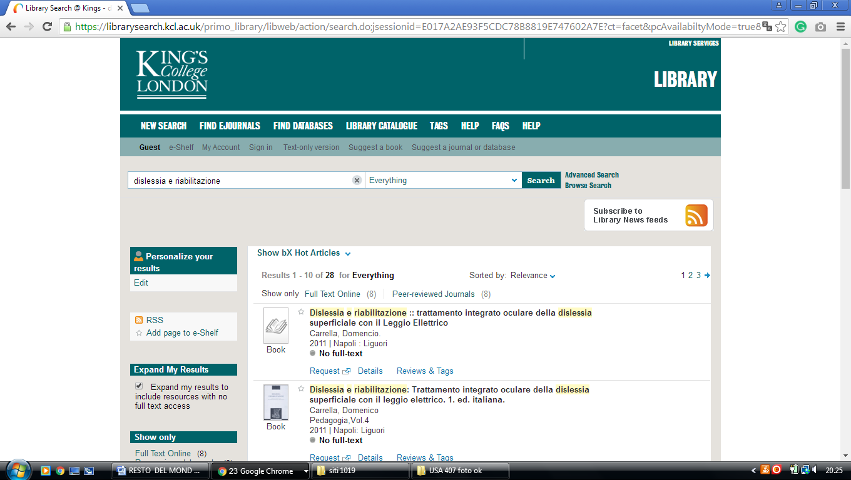

**4 LIBRARY, DE MONTFORT UNIVERSITY DMU - (**Leicester, England)

<https://dmu.summon.serialssolutions.com/?q=dislessia+e+riabilitazione#!/search?ho=f&l=it-IT&q=dislessia%20e%20riabilitazione>

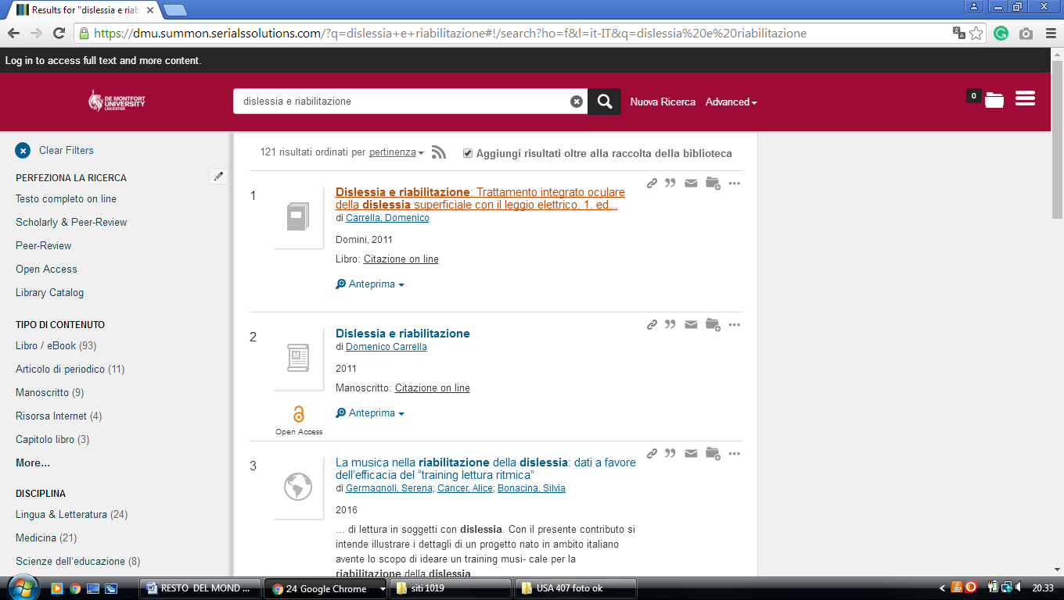

### 5 [UNIVERSITY OF LEEDS IT](https://www.google.it/url?sa=t&rct=j&q=&esrc=s&source=web&cd=8&cad=rja&uact=8&ved=0ahUKEwigxtXP7pXUAhXRZFAKHbbOC1QQFgg7MAc&url=https%3A%2F%2Fit.leeds.ac.uk%2F&usg=AFQjCNFuBb2ciUlJ9SRCW3QjIbwjtMFLWg) LIBRARY - (Leeds, England)

<https://leeds.summon.serialssolutions.com/?q=+DISLESSIA+E+RIABILITAZIONE++++++&fvf=ContentType%2CBook+Review%2Ct#!/search?ho=f&fvf=ContentType,Book%20Review,t&l=en&q=%20DISLESSIA%20E%20RIABILITAZIONE%20%20%20%20%20%20>

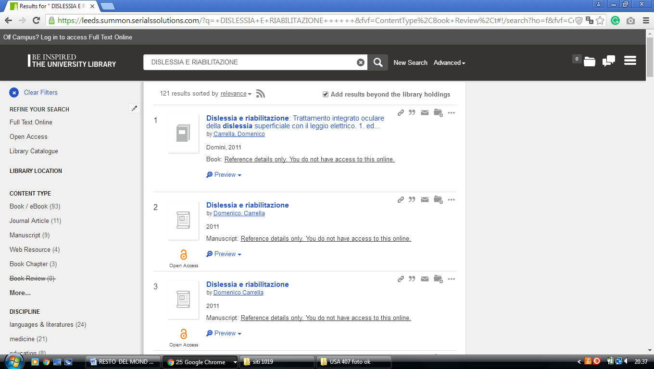

**6**  [**EDGE HILL UNIVERSITY**](http://www.edgehill.ac.uk/ls/) **LIBRARY – (**Ormskirk, England)

<https://edgehill.summon.serialssolutions.com/search?fvf=ContentType%2CNewspaper+Article%2Ct%7CContentType%2CBook+Review%2Ct&q=dislessia+e+riabilitazione&type=everything#!/search?ho=f&fvf=ContentType,Newspaper%20Article,t%7CContentType,Book%20Review,t&l=en&q=dislessia%20e%20riabilitazione&type=everything>

**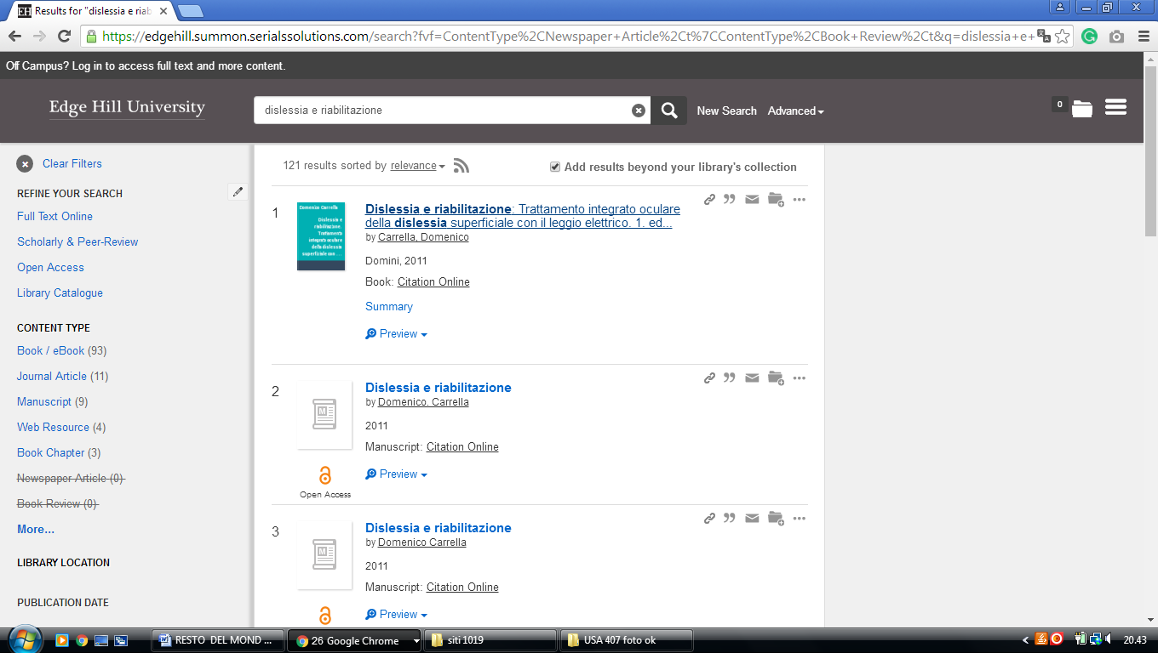**

**7 MANCHESTER METROPOLOITAN UNIVERSITY LIBRARY – (**Manchester, England)

<https://mmulibrary.summon.serialssolutions.com/search/?spellcheck=true&keep_r=true&s.q=dislessia+e+riabilitazione&s.cmd=#!/search?ho=f&l=en-UK&q=dislessia%20e%20riabilitazione>

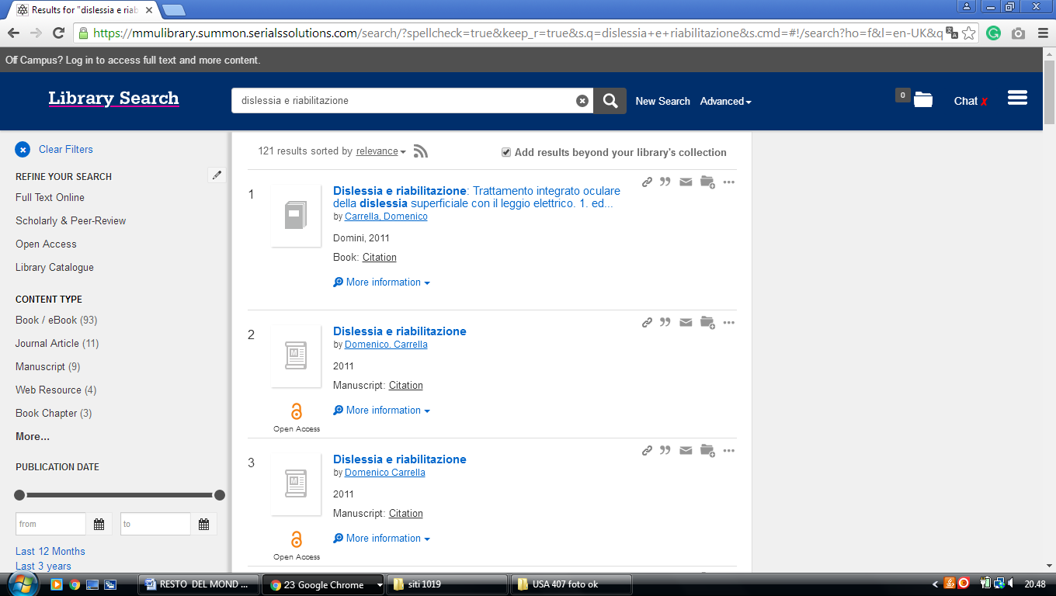-------------------------------------------------------------------------------------------------------------------------------

**8** [**TEESSIDE UNIVERSITY LIBRARY**](http://lis.tees.ac.uk/) **– (**Middlesbrough, England)

<http://tees.summon.serialssolutions.com/search?q=dislessia+e+riabilitazione&spellcheck=true&keep_r=true#!/search?ho=f&l=en-UK&q=dislessia%20e%20riabilitazione>

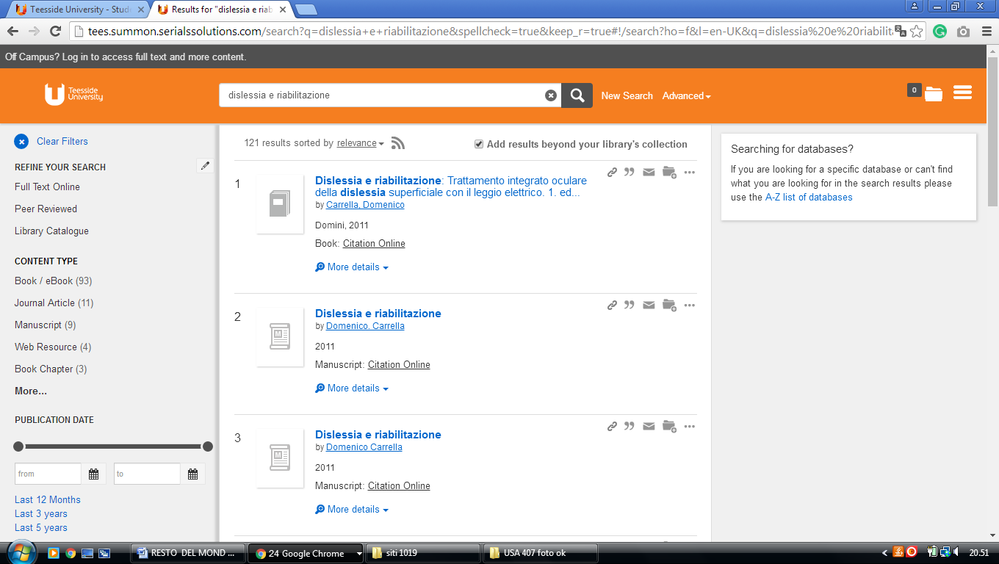

**9**  [**UNIVERSITY OF BATH LIBRARY**](http://www.bath.ac.uk/library/) - (Bath, England)

<http://bath-ac-primo.hosted.exlibrisgroup.com/primo_library/libweb/action/search.do?ct=facet&pcAvailabiltyMode=true&pcAvailClicked=true&vid=44BAT_VU1&fn=search&indx=1&dscnt=0&vl(freeText0)=dislessia%20e%20riabilitazione&dstmp=1518292456793>

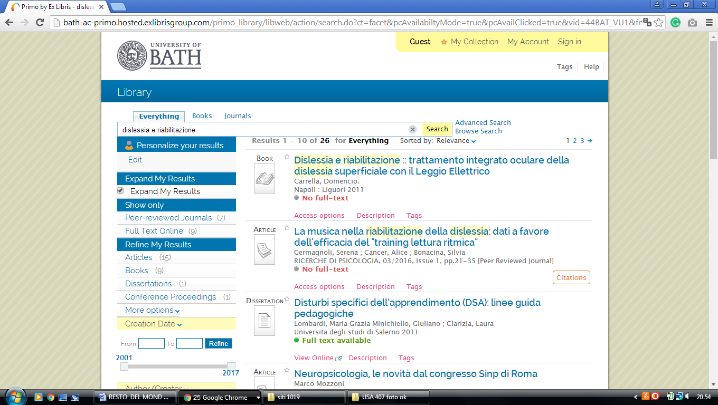

### 10 [LIBRARY CATALOGUE](https://capitadiscovery.co.uk/brighton-ac/home) UNIVERSITY OF BRIGHTON, ONE SEARCH

### (Brighton, England)

<https://brighton.summon.serialssolutions.com/?#!/search?ho=f&l=en-UK&q=DISLESSIA%20E%20RIABILITAZIONE>

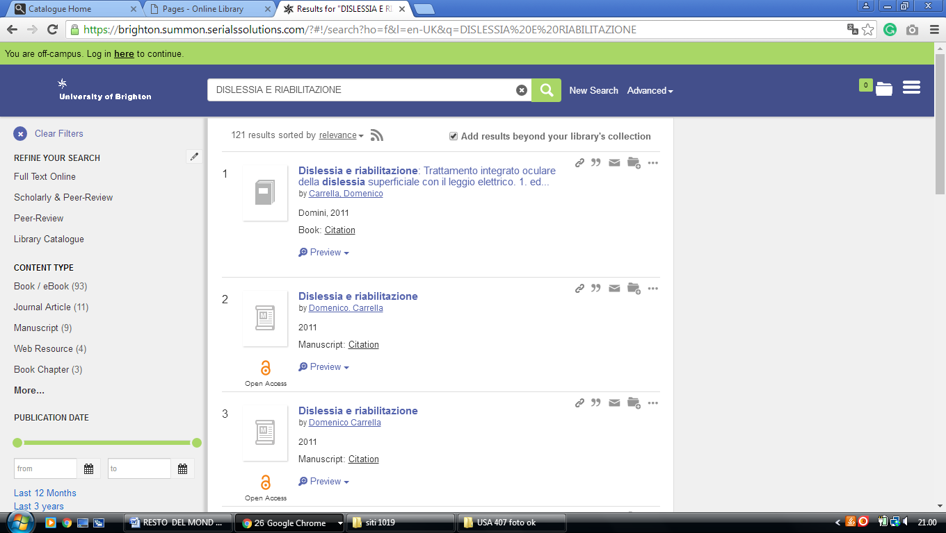

**11 HULL.SUMMON.SERIALSSOLUTIONS.COM - (**[University Of Hull](http://libguides.hull.ac.uk/lib)

Library, Hull, England)

<http://hull.summon.serialssolutions.com/search/results?s.fvf%5B%5D=ContentType%2CNewspaper+Article%2Ct&s.fvf%5B%5D=ContentType%2CBook+Review%2Ct&s.fvf%5B%5D=IsFullText%2Ctrue&s.q=dislessia+e+riabilitazione&spellcheck=true#!/search?ho=f&fvf=ContentType,Newspaper%20Article,t%7CContentType,Book%20Review,t&l=en&q=dislessia%20e%20riabilitazione>

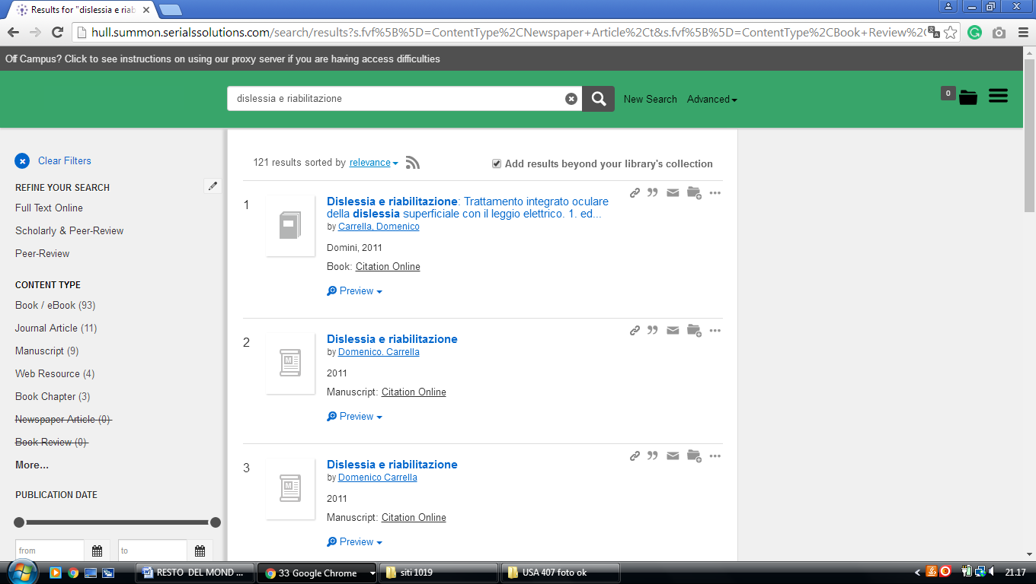

**12** [**UNIVERSITY OF LONDON - ROYAL HOLLOWAY**](http://www.rhul.ac.uk/library/home.aspx) **LIBRARY EGHAM -**(England)

<http://librarysearch.rhul.ac.uk/primo_library/libweb/action/search.do?ct=facet&pcAvailabiltyMode=true&pcAvailClicked=true&query=any%2Ccontains%2Cdislessia%20e%20riabilitazione&indx=1&fn=search&dscnt=0&search_scope=LSCOP_44ROY_ALL&scp.scps=scope%3A(44ROY)%2Cprimo_central_multiple_fe%2C44ROY_EbscoLocal&vid=44ROY_VU2&onCampus=false&ct=search&institution=44ROY&bulkSize=10&highlight=true&tab=tab1&d_query=dislessia%20e%20riabilitazione&displayField=title&dym=true&vl(656868514UI0)=any&vl(freeText0)=dislessia%20e%20riabilitazione&fromLogin=true&dstmp=1518294209472&fromDL>

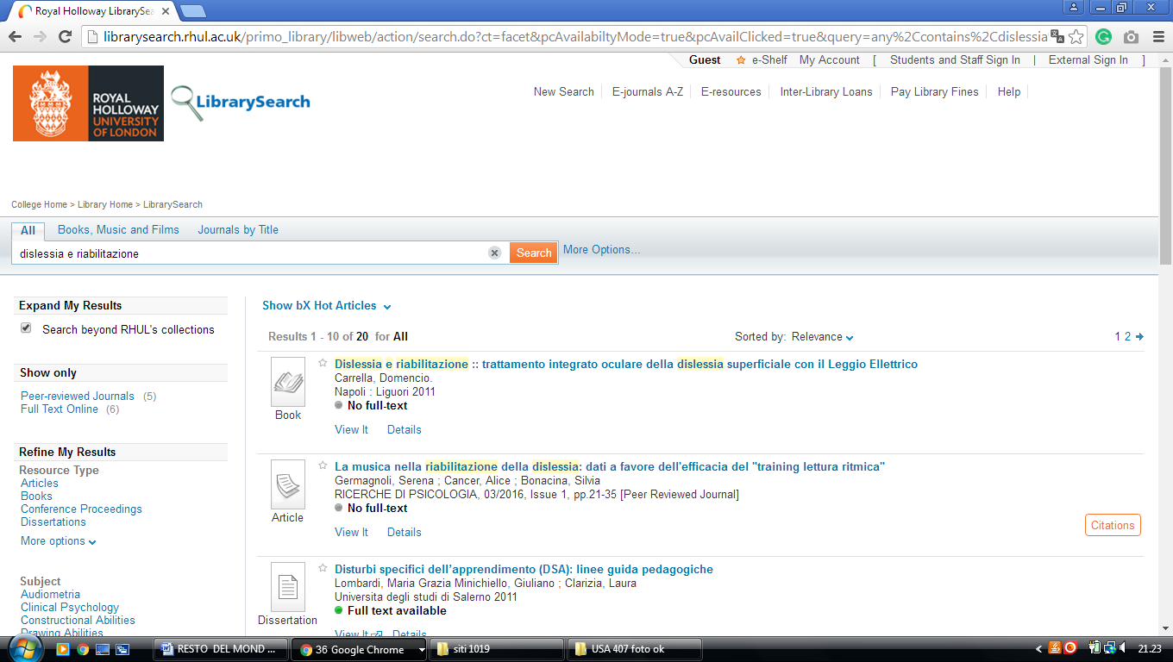

### 13 [LIBRARY – UNIVERSITY OF READING](https://www.reading.ac.uk/library/) - (England)

<http://reading.summon.serialssolutions.com/?keep_r=true&s.fvf%5B%5D=IsFullText%2Ctrue&s.q=dislessia+e+riabilitazione&utf8=%E2%9C%93#!/search?ho=f&l=en&q=dislessia%20e%20riabilitazione>

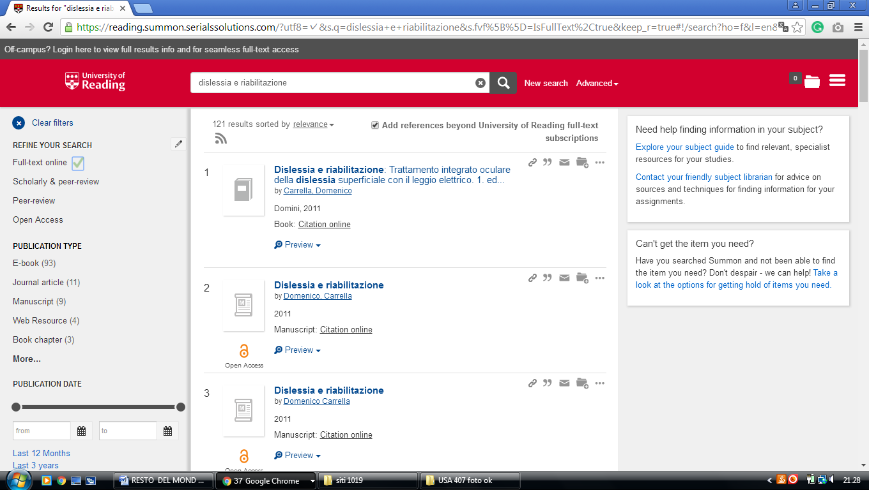

**14**  [**ANGLIA RUSKIN UNIVERSITY**](http://libweb.anglia.ac.uk/) **LIBRARY - (**Cambridge, England)

<https://primo.anglia.ac.uk/primo-explore/search?query=any,contains,dislessia%20e%20riabilitazione&tab=default_tab&search_scope=CSCOP_APU_DEEP&vid=ANG_VU1&offset=0&sortby=rank&pcAvailability=true>

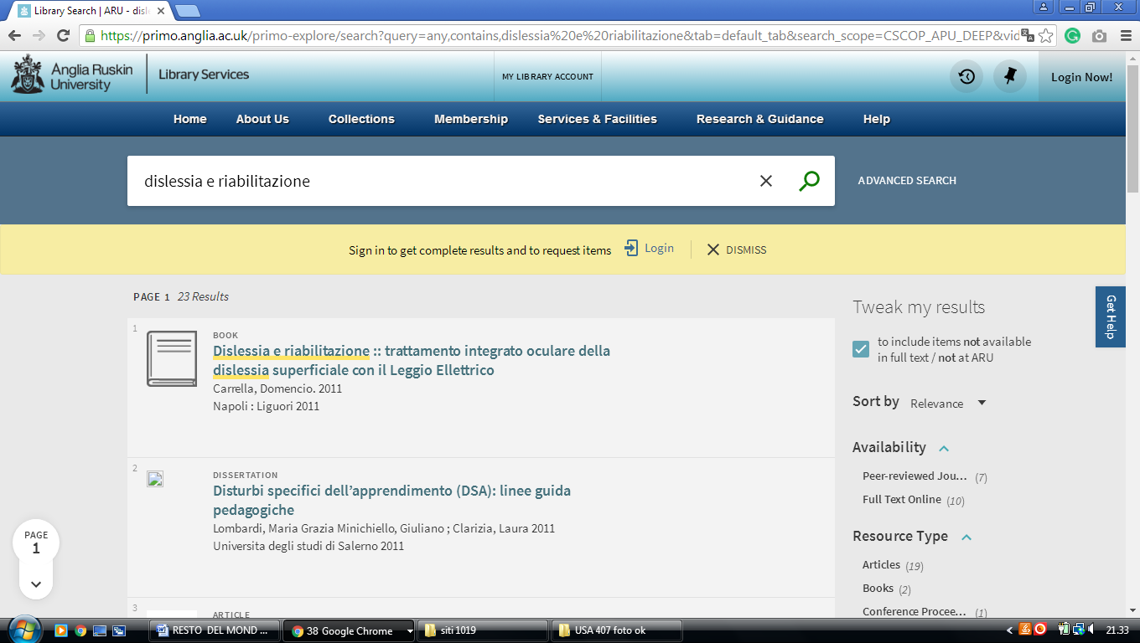

### 15 [Library | Brunel University London](https://www.brunel.ac.uk/life/library) – (England)

<http://brunel.summon.serialssolutions.com/search?spellcheck=true&s.q=dislessia+e+riabilitazione#!/search?ho=f&l=en-UK&q=dislessia%20e%20riabilitazione>

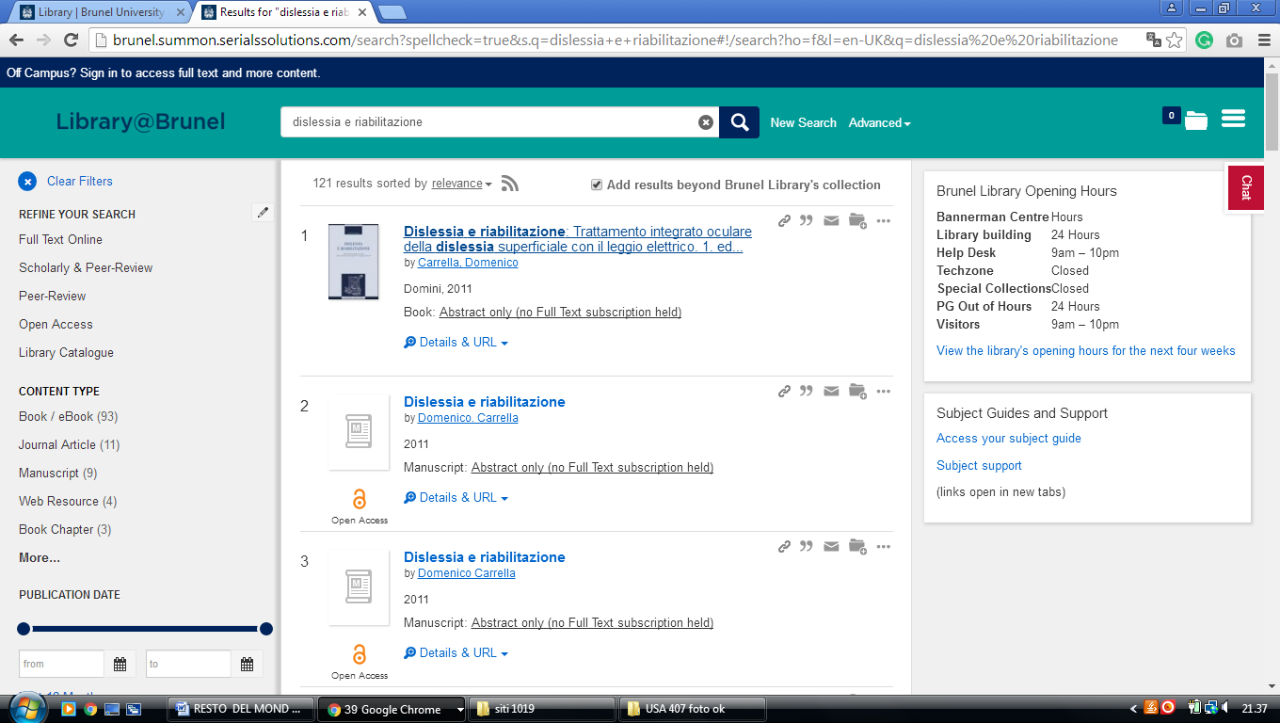

**16**  [**CITY UNIVERSITY LIBRARY**](http://www.city.ac.uk/library)– (London, England)

<https://city.summon.serialssolutions.com/?s.q=dislessia+e+riabilitazione&s.cmd=&s.cmd=addFacetValueFilters%28ContentType%2CBook+Review%3At%29&s.cmd=addFacetValueFilters%28ContentType%2CNewspaper+Article%3At%29#!/search?ho=f&fvf=ContentType,Book%20Review,t%7CContentType,Newspaper%20Article,t&l=en-UK&q=dislessia%20e%20riabilitazione>

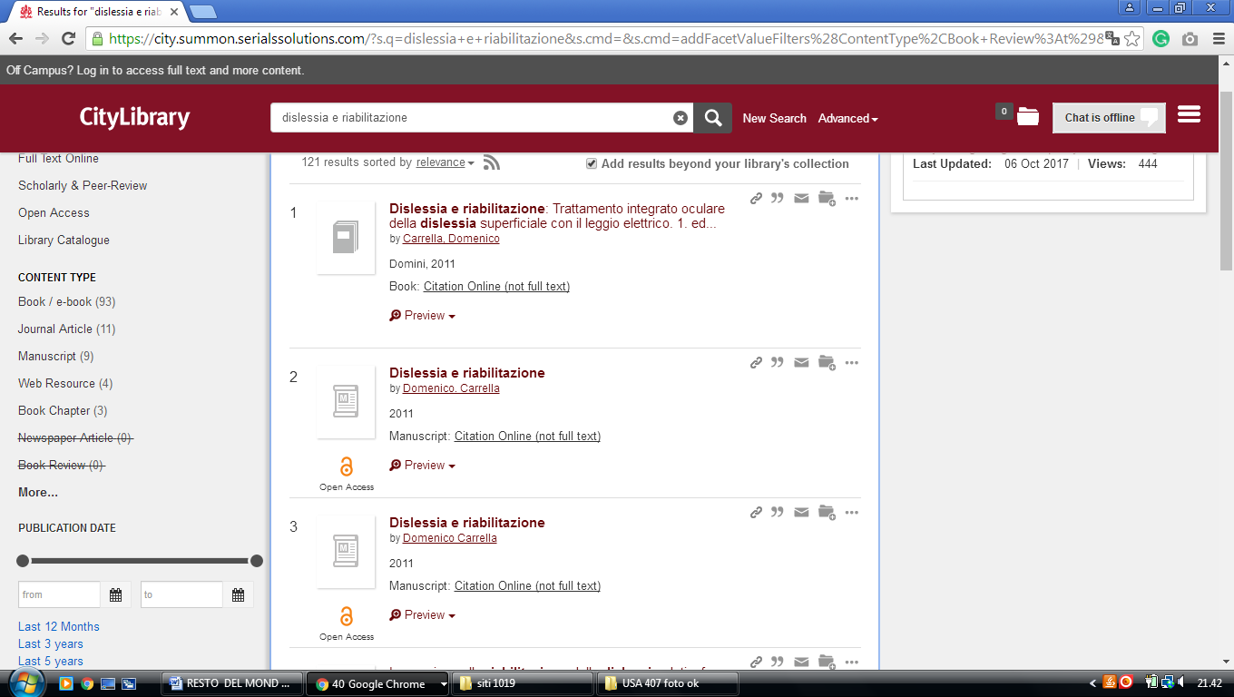

**17** [**DE MONTFORT UNIVERSITY LIBRARY**](http://www.library.dmu.ac.uk/) **-** (Leicester, England)

<https://dmu.summon.serialssolutions.com/?q=dislessia+e+riabilitazione#!/search?ho=f&l=it-IT&q=dislessia%20e%20riabilitazione>

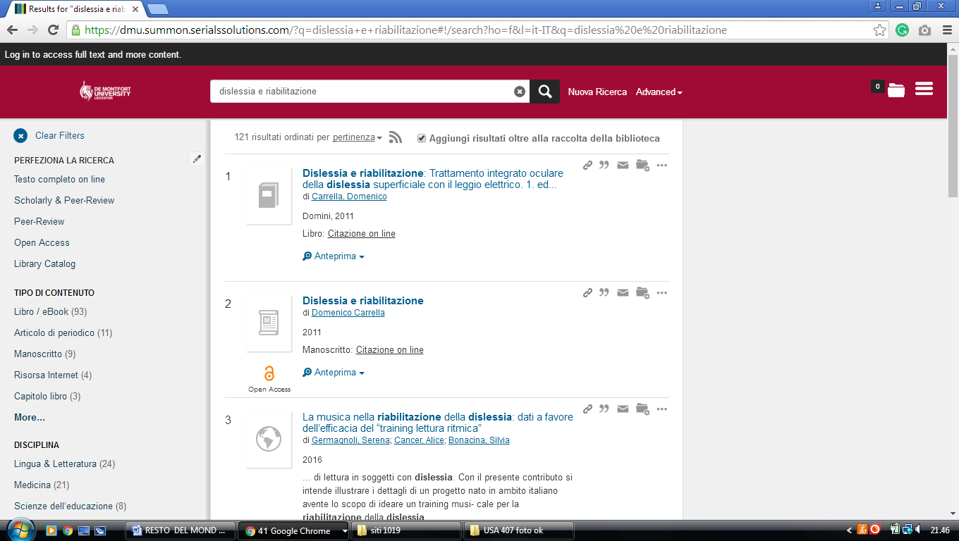

**18**  [**LIBRARY LIBRARY - QUEEN MARY UNIVERSITY OF LONDON**](http://www.library.qmul.ac.uk/) **–** (England)

<http://qmul.summon.serialssolutions.com/search?utf8=%E2%9C%93&s.q=DISLESSIA+E+RIABILITAZIONE#!/search?ho=f&l=en-UK&q=DISLESSIA%20E%20RIABILITAZIONE>

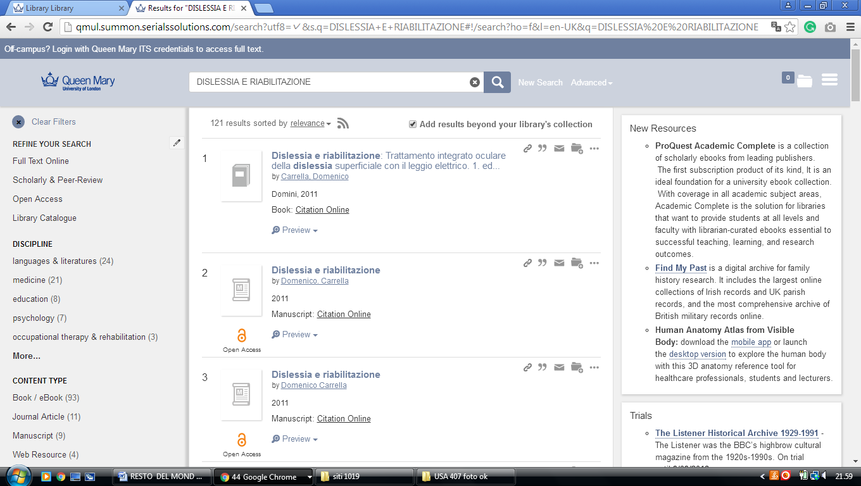

-------------------------------------------------------------------------------------------------------------------------------

**19**  [**MANCHESTER METROPOLITAN UNIVERSITY**](http://www.library.mmu.ac.uk/) **LIBRARY - (**Manchester,

England)

<https://mmulibrary.summon.serialssolutions.com/search/?spellcheck=true&keep_r=true&s.q=dislessia+e+riabilitazione&s.cmd=#!/search?ho=f&l=en-UK&q=dislessia%20e%20riabilitazione>

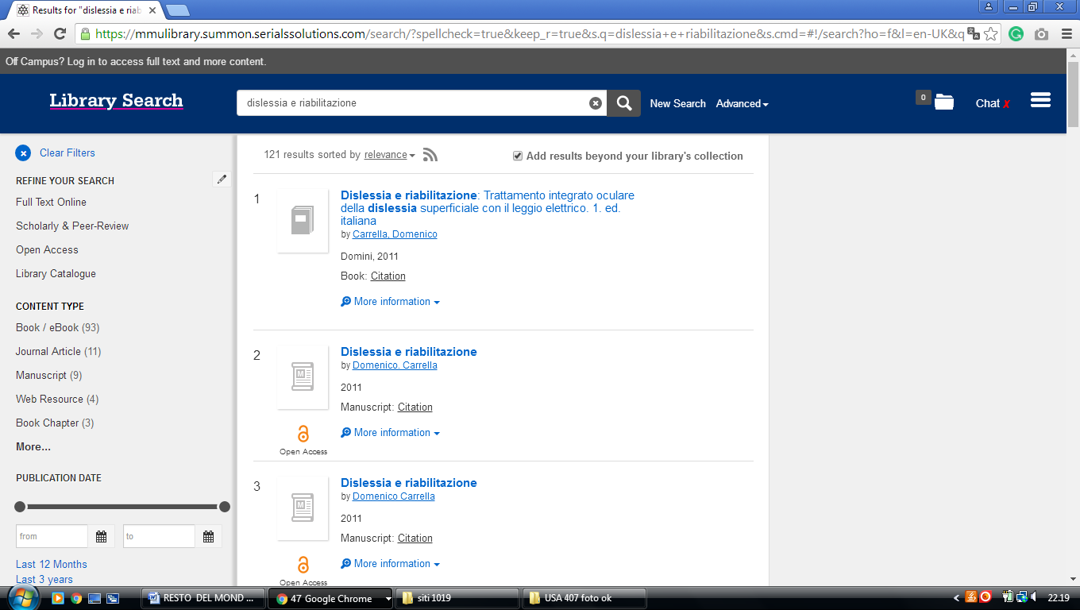

**20**  [**STAFFORDSHIRE UNIVERSITY**](http://www.staffs.ac.uk/uniservices/infoservices/library/) **LIBRARY** – (Stoke on Trent, England)

<https://staffs.summon.serialssolutions.com/search?s.q=dislessia+e+riabilitazione&spellcheck=true&keep_r=true&suggest=true&popup=true#!/search?ho=f&l=en-UK&q=dislessia%20e%20riabilitazione>

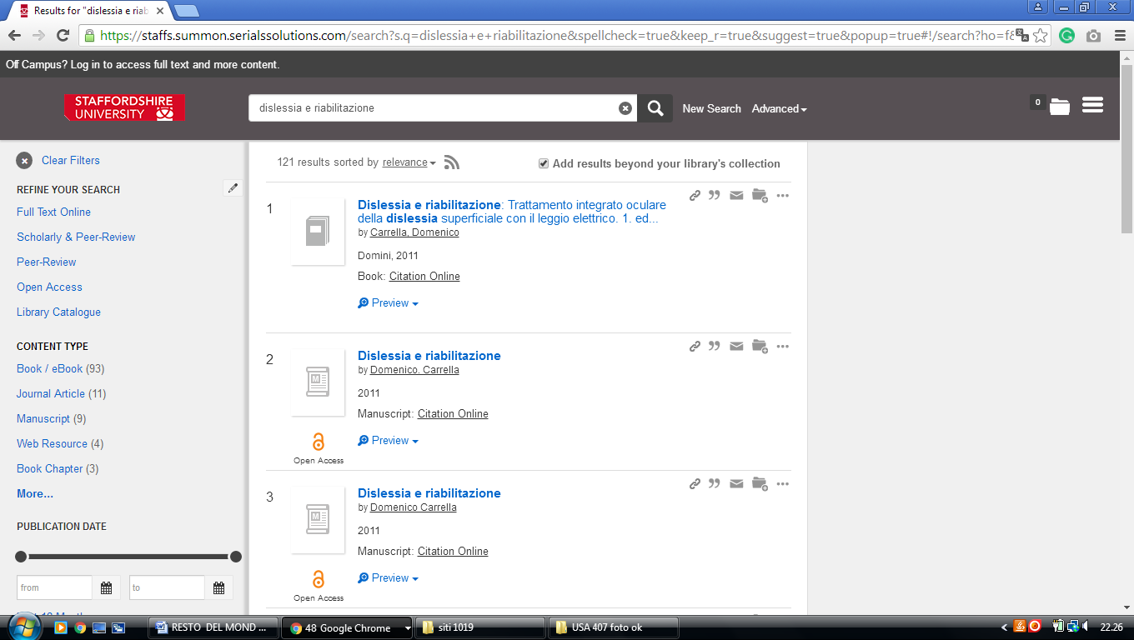

**21**  [**TEESSIDE UNIVERSITY LIBRARY**](http://lis.tees.ac.uk/) – (Middlesbrough, England)

<http://tees.summon.serialssolutions.com/search?q=dislessia+e+riabilitazione&spellcheck=true&keep_r=true#!/search?ho=f&l=en-UK&q=dislessia%20e%20riabilitazione>

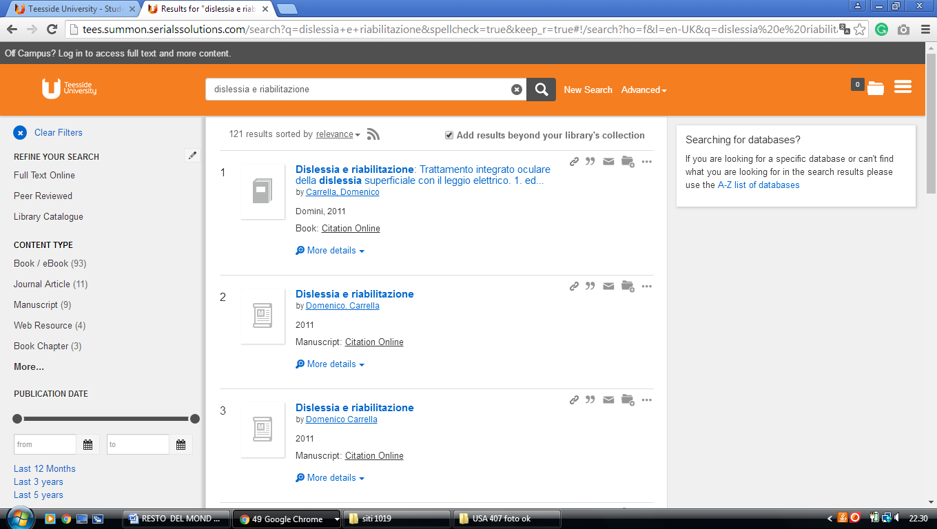

**22** [**UNIVERSITY OF BRADFORD LIBRARY**](http://www.brad.ac.uk/library/index.php) **-** (Bradford, England)

<https://bradford.summon.serialssolutions.com/search?q=dislessia%20e%20riabilitazione#!/search?ho=f&l=en-UK&q=dislessia%20e%20riabilitazione>

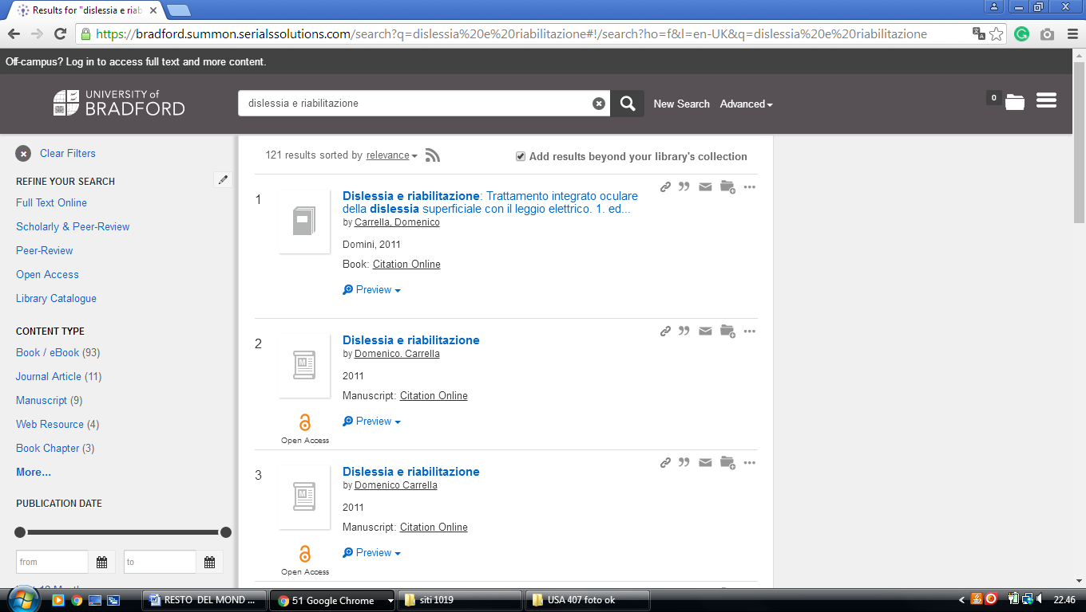

**23**  [**UNIVERSITY OF EAST ANGLIA LIBRARY**](http://www.uea.ac.uk/is/lib) – (Norwich, England)

<http://eds.a.ebscohost.com/eds/results?vid=0&sid=3883324c-26f4-49f6-ac10-33db62868029%40sessionmgr4006&bquery=(dislessia+e+riabilitazione)&bdata=JmNsaTA9RlQxJmNsdjA9WSZ0eXBlPTAmc2l0ZT1lZHMtbGl2ZSZzY29wZT1zaXRl>

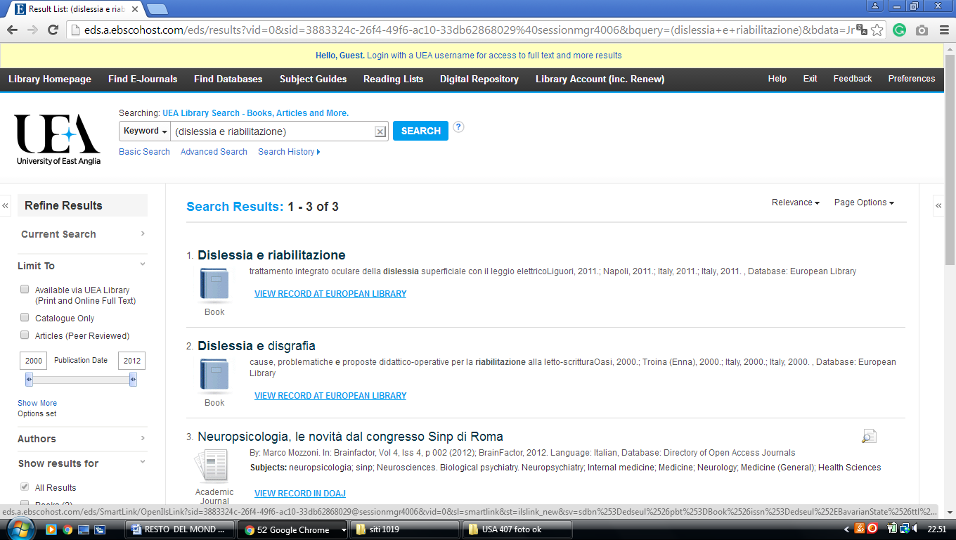

**24** [**HULL.SUMMON.SERIALSSOLUTIONS.COM**](http://hull.summon.serialssolutions.com) – (Library [University](http://libguides.hull.ac.uk/lib" \t "_blank" \o "University of Hull)

[of Hull](http://libguides.hull.ac.uk/lib" \t "_blank" \o "University of Hull), England)

<http://hull.summon.serialssolutions.com/search/results?s.fvf%5B%5D=ContentType%2CNewspaper+Article%2Ct&s.fvf%5B%5D=ContentType%2CBook+Review%2Ct&s.fvf%5B%5D=IsFullText%2Ctrue&s.q=dislessia+e+riabilitazione&spellcheck=true#!/search?ho=f&l=en&q=dislessia%20e%20riabilitazione>

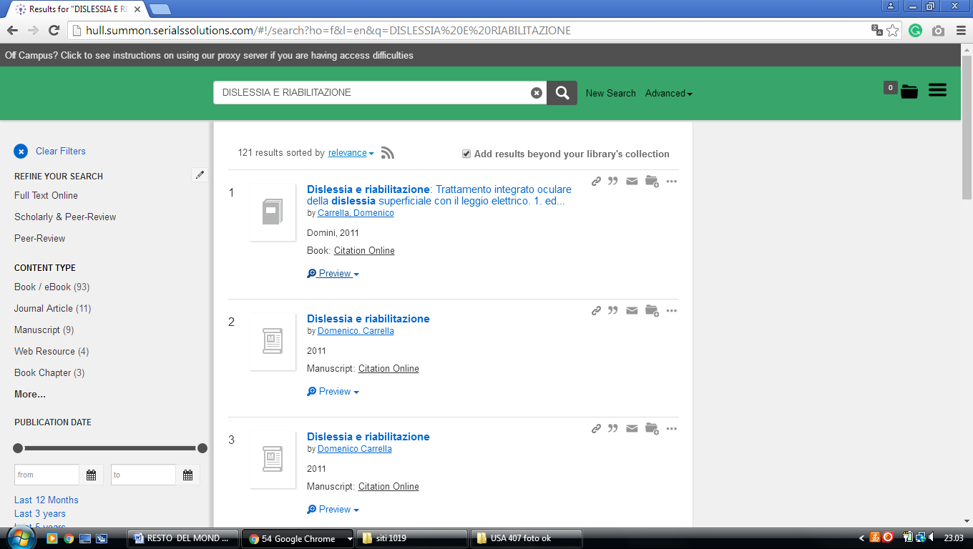

**25 LIBRARY** [**UNIVERSITY OF LONDON - ROYAL HOLLOWAY**](http://www.rhul.ac.uk/library/home.aspx) **-** (Egham,

England)

<http://librarysearch.rhul.ac.uk/primo_library/libweb/action/search.do?ct=facet&pcAvailabiltyMode=true&pcAvailClicked=true&query=any%2Ccontains%2Cdislessia%20e%20riabilitazione&indx=1&fn=search&dscnt=0&search_scope=LSCOP_44ROY_ALL&scp.scps=scope%3A(44ROY)%2Cprimo_central_multiple_fe%2C44ROY_EbscoLocal&vid=44ROY_VU2&onCampus=false&ct=search&institution=44ROY&bulkSize=10&highlight=true&tab=tab1&d_query=dislessia%20e%20riabilitazione&displayField=title&dym=true&vl(656868514UI0)=any&vl(freeText0)=dislessia%20e%20riabilitazione&fromLogin=true&dstmp=1518301041536&fromDL>

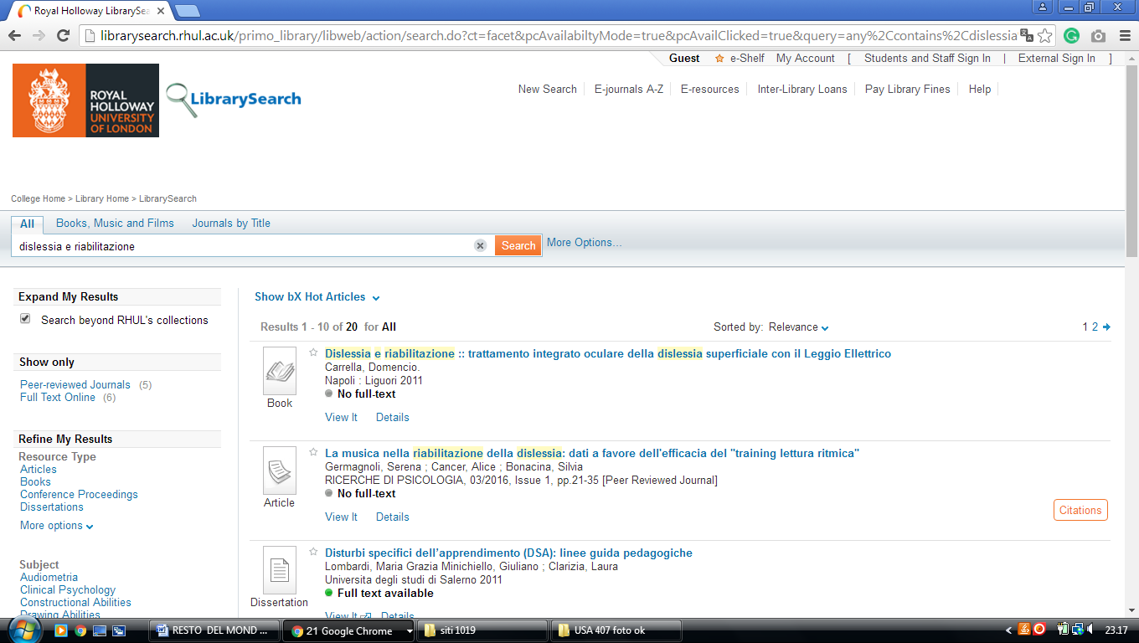

**26**  **LIBRARY** [**UNIVERSITY OF THE WEST OF ENGLAND**](http://www1.uwe.ac.uk/library/) – (Bristol, England)

<http://uwe.summon.serialssolutions.com/search?q=dislessia+e+riabilitazione#!/search?ho=f&l=en-UK&q=dislessia%20e%20riabilitazione>

**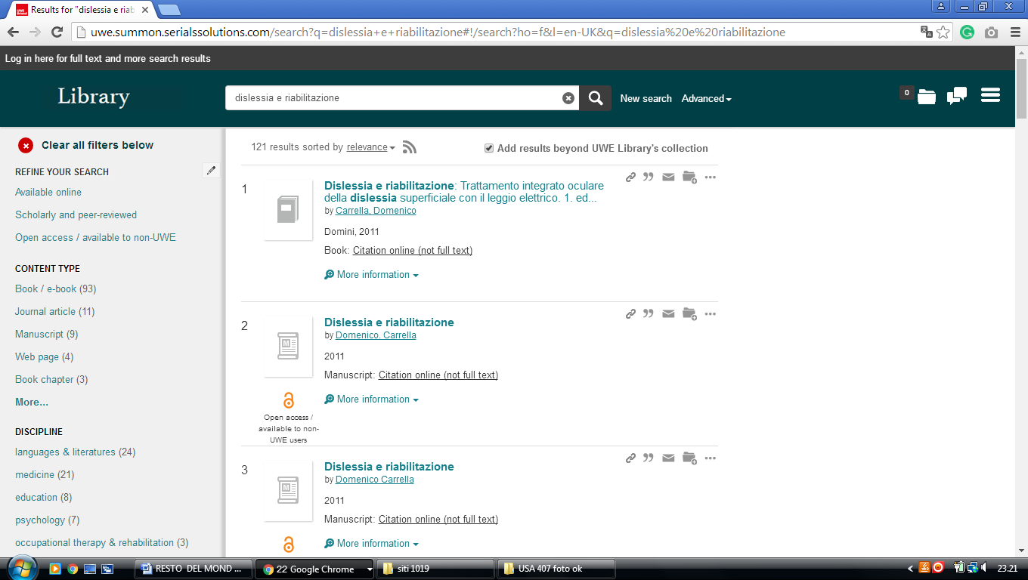**

**C:\Users\Domenico Carrella\Downloads\57beb15aa61f863529000406.pngUNIVERSITY OF WOLVERHAMPTON LIBRARY**

Wolverhampton, England

**27 LIBRARY** [**UNIVERSITY OF BRADFORD, UK**](http://www.brad.ac.uk/library/index.php) **- (**[Bradford](https://en.wikipedia.org/wiki/Bradford), [West Yorkshire](https://en.wikipedia.org/wiki/West_Yorkshire), England)

<https://bradford.summon.serialssolutions.com/search?q=dislessia%20e%20riabilitazione#!/search?ho=f&l=en-UK&q=dislessia%20e%20riabilitazione>

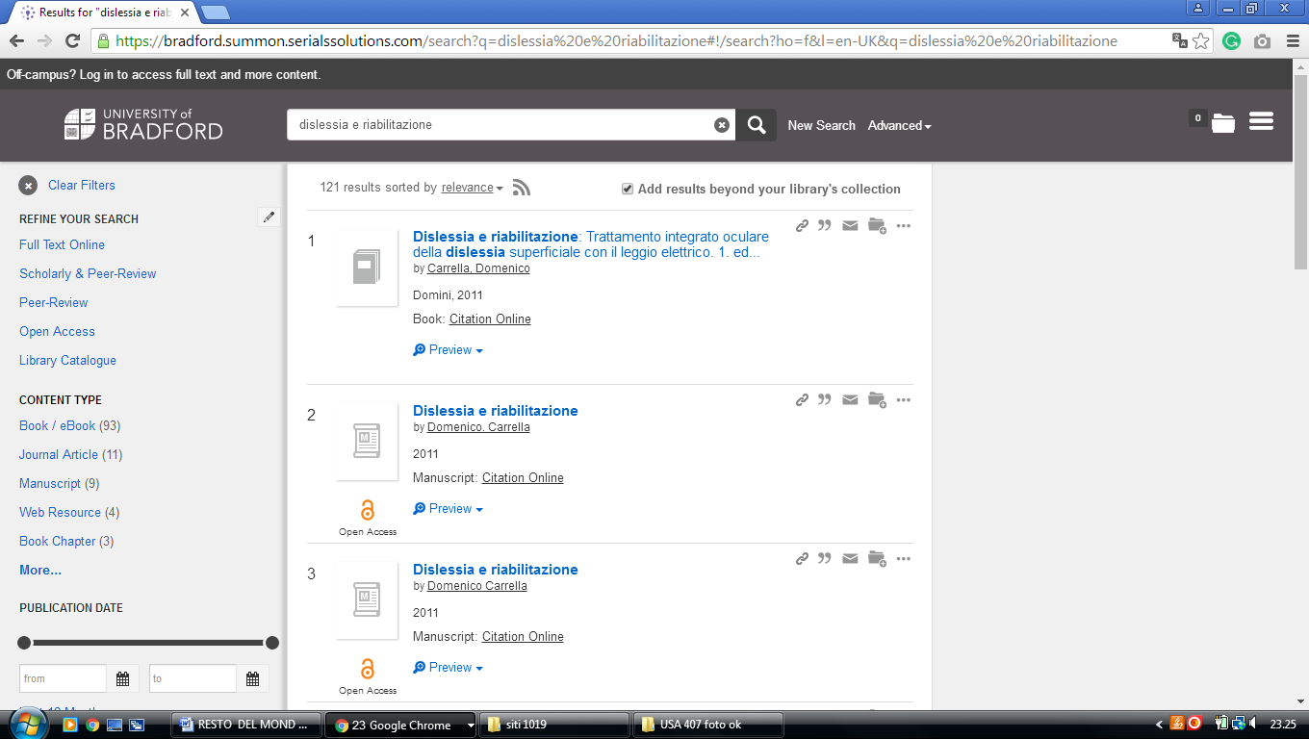

### 28 [LIBRARY | THE UNIVERSITY OF EDINBURGH](https://www.ed.ac.uk/information-services/library-museum-gallery) (England)

<https://discovered.ed.ac.uk/primo-explore/search?institution=44UOE&vid=44UOE_VU2&search_scope=default_scope&query=any,contains,dislessia%20e%20riabilitazione&pcAvailabiltyMode=true&sortby=rank&pcAvailability=true>

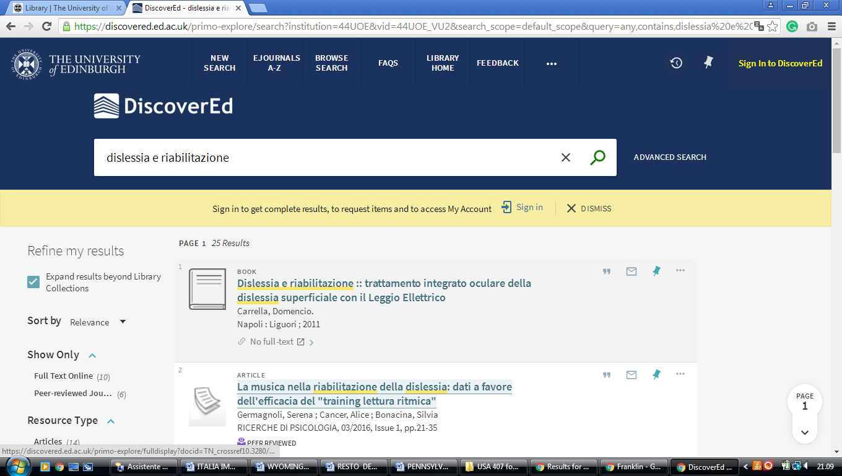

**29** [**WELCOME TO THE LIBRARY | UNIVERSITY OF BOLTON**](https://www.bolton.ac.uk/library/) **-**  (England)

<http://bolton.summon.serialssolutions.com/#!/search?ho=f&l=en-UK&q=dislessia%20e%20riabilitazione>

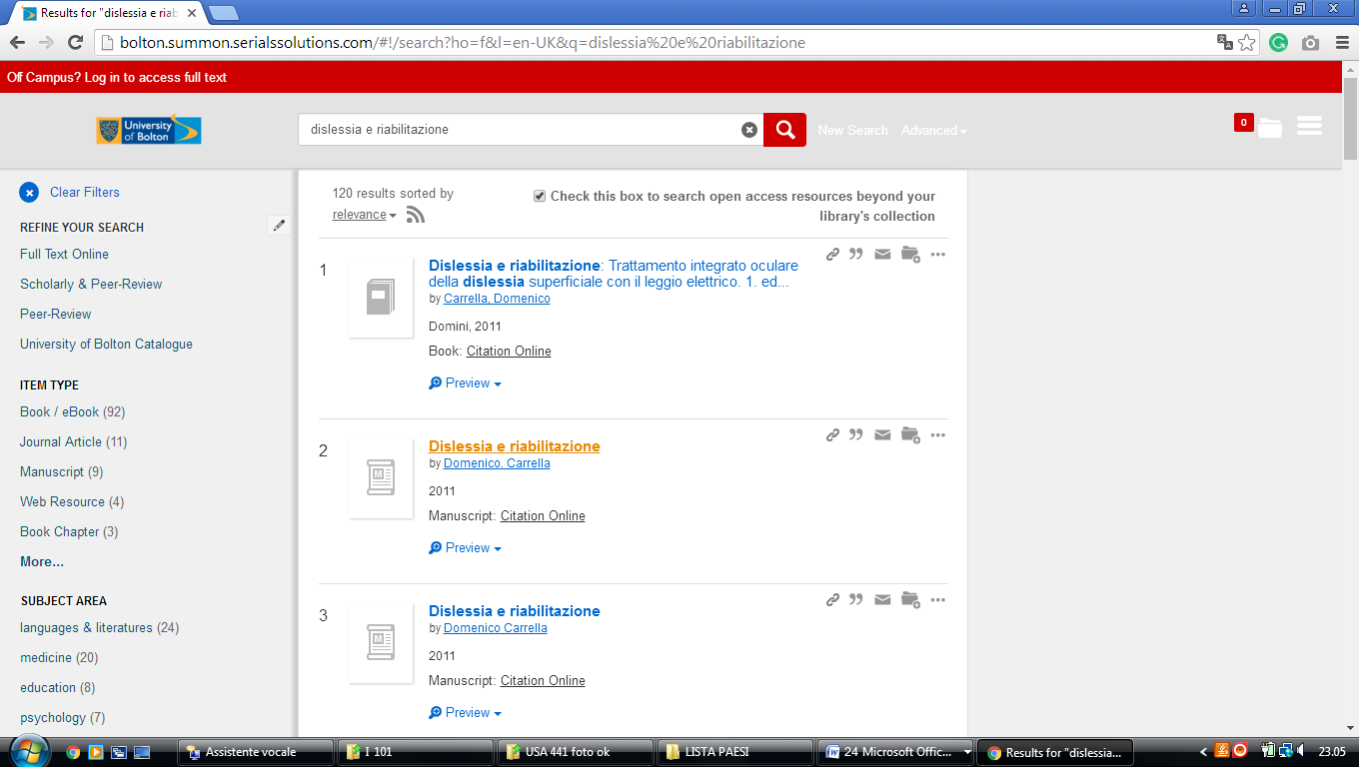

### 30 [UNIVERSITY COLLEGE LONDON - THE EUROPEAN LIBRARY](http://www.theeuropeanlibrary.org/tel4/contributor/P01376)- (England)

<http://www.theeuropeanlibrary.org/tel4/contributor/P01376>

<http://www.theeuropeanlibrary.org/tel4/search?query=dislessia%20e%20riabilitazione>

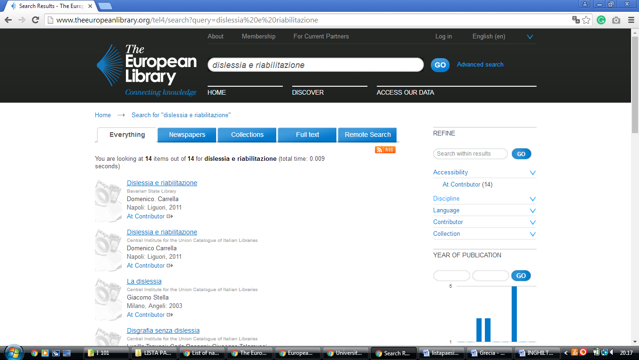

### 31 [LIBRARY HOMEPAGE - LIBRARY – UNIVERSITY OF READING](https://www.reading.ac.uk/library/) – (Reading England)

<https://reading.summon.serialssolutions.com/?utf8=%E2%9C%93&s.q=dislessia+e+riabilitazione&s.fvf%5B%5D=IsFullText%2Ctrue&keep_r=true#!/search?ho=f&l=en&q=dislessia%20e%20riabilitazione>

**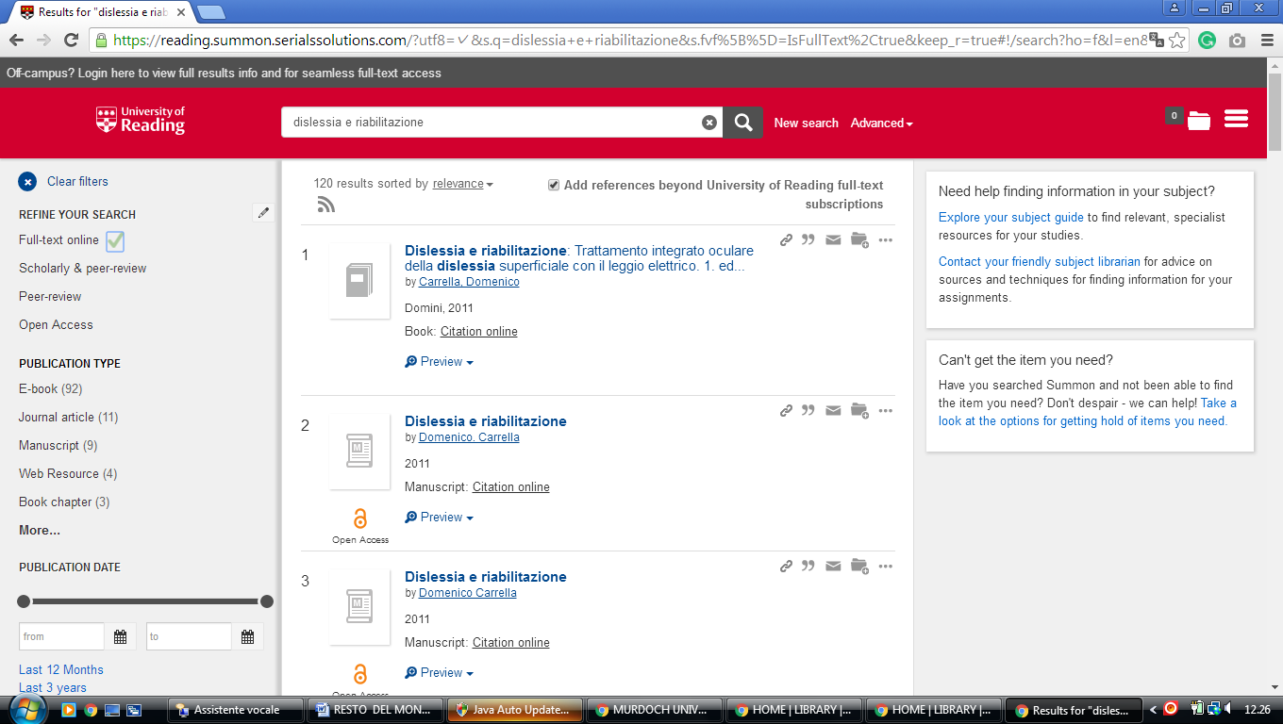**

### 32 UNIVERSITY OF BOLTON - RAS AL KHAIMAH ACADEMIC CENTRE – (England)

[https://bolton.summon.serialssolutions.com/#!/search?ho=f&l=en-UK&q=dislessia%20e%20riabilitazione](https://bolton.summon.serialssolutions.com/%23!/search?ho=f&l=en-UK&q=dislessia%20e%20riabilitazione)

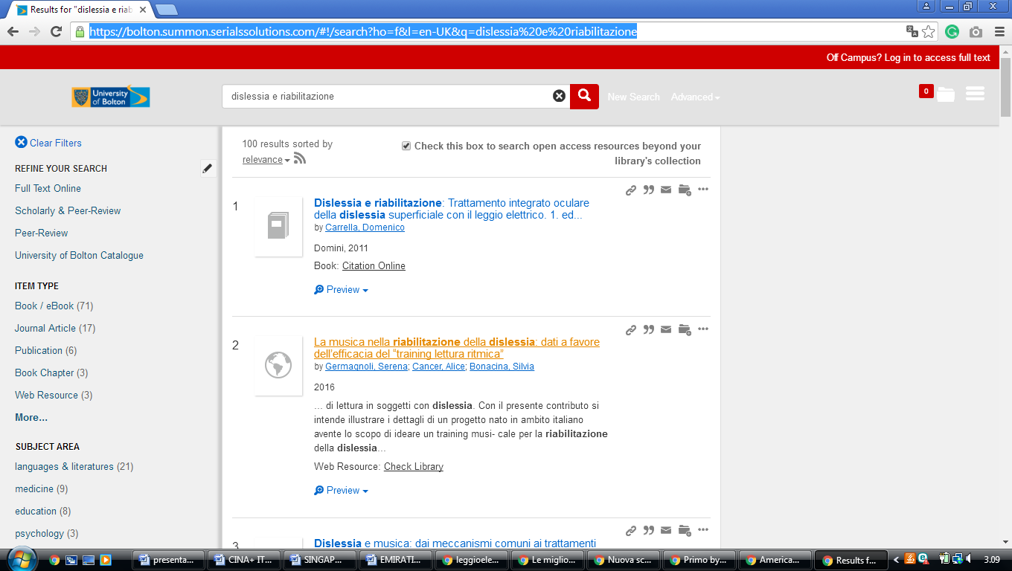

University of Hull Library

**University of Hull**

[https://hull.summon.serialssolutions.com/search/results?spellcheck=true&s.q=&button=#!/search?ho=f&l=en&q=dislessia%20e%20riabilitazione](https://hull.summon.serialssolutions.com/search/results?spellcheck=true&s.q=&button=%23!/search?ho=f&l=en&q=dislessia%20e%20riabilitazione)

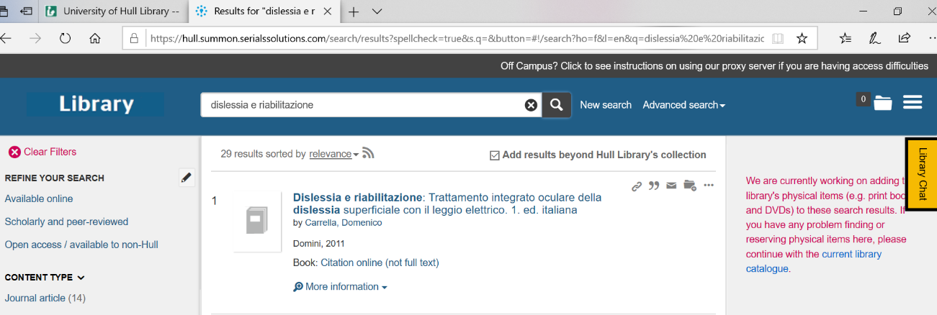

University Of Glasgow Library

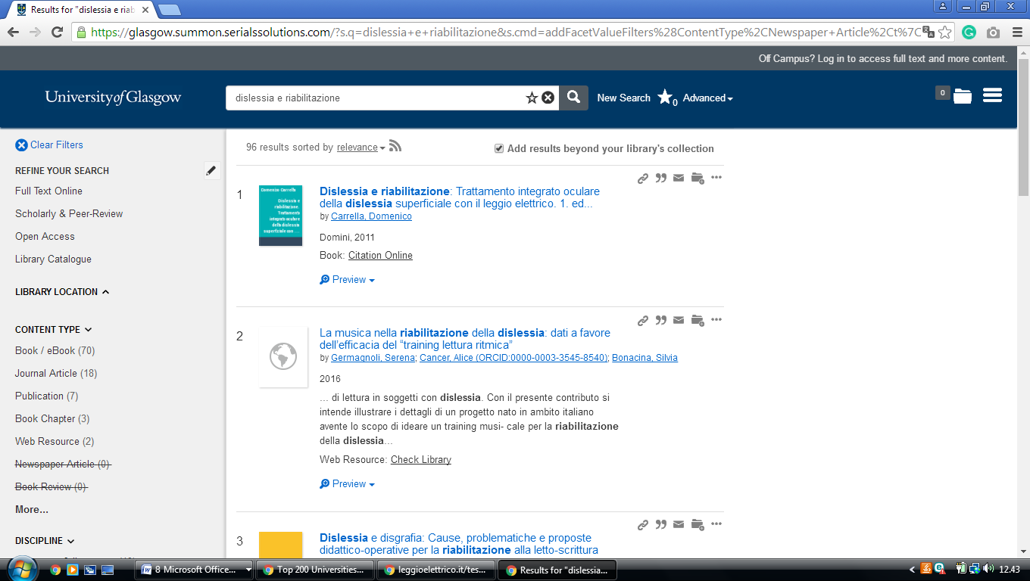https://glasgow.summon.serialssolutions.com/?s.q=dislessia+e+riabilitazione&s.cmd=addFacetValueFilters%28ContentType%2CNewspaper+Article%2Ct%7CContentType%2CBook+Review%2Ct%29#!/search?ho=f&fvf=ContentType,Newspaper%20Article,t%7CContentType,Book%20Review,t&l=en-UK&q=dislessia%20e%20riabilitazione

[Library Home - University of Wolverhampton](https://www.wlv.ac.uk/lib/)

https://librarysearch.wlv.ac.uk/discovery/search?query=any,contains,dislessia%20e%20riabilitazione&tab=ALL&search\_scope=MyInst\_and\_CI&vid=44UOWO\_INST:MAIN&offset=0&pcAvailability=true

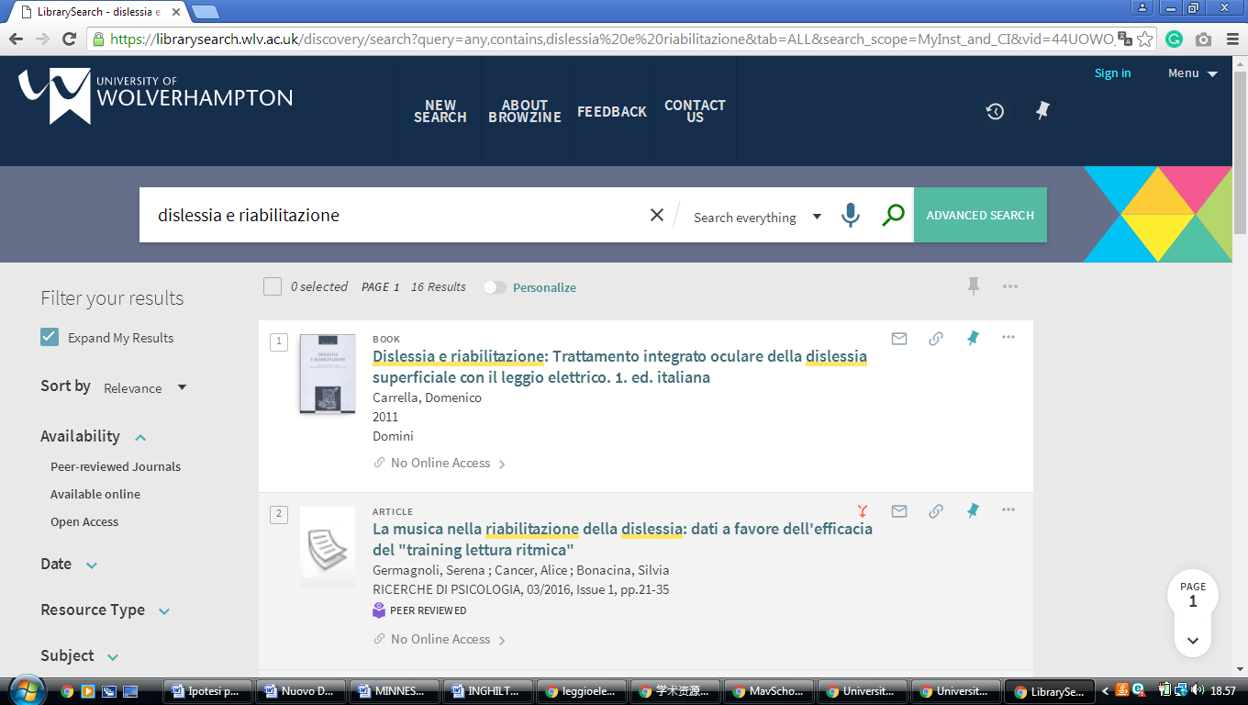

Wiggins Memorial Library

**Campbell University**

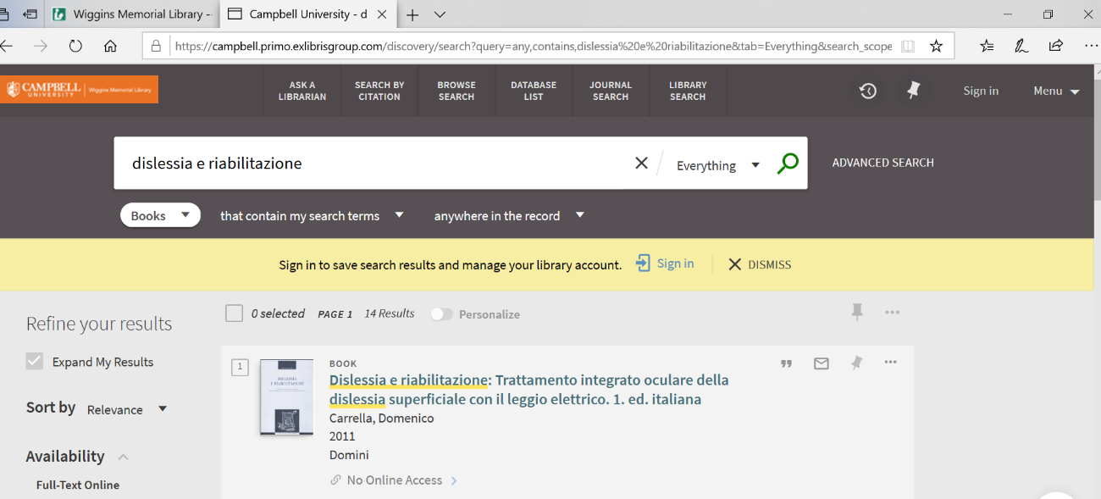https://campbell.primo.exlibrisgroup.com/discovery/search?query=any,contains,dislessia%20e%20riabilitazione&tab=Everything&search\_scope=MyInst\_and\_CI&vid=01CAMPBELL\_INST:01CAMPBELL&offset=0&pcAvailability=true