**61. BOGOR AGRICULTURAL UNIVERSITY** [**Bogor**](https://en.wikipedia.org/wiki/Bogor)[**INDONESIA**](https://en.wikipedia.org/wiki/Indonesia)

[Jurnal Manajemen & Agribisnis~Bogor Agricultural University ...](https://www.google.com/url?sa=t&rct=j&q=&esrc=s&source=web&cd=6&cad=rja&uact=8&ved=2ahUKEwjwkLyyi4fpAhWfwcQBHQSwB2QQFjAFegQIARAB&url=https%3A%2F%2Flibrary.seu.edu.bd%2Fjournal%2Fjurnal-manajemen-agribisnisbogor-agricultural-university&usg=AOvVaw04t1WgSp_4Mcp0HlD1v68-)

[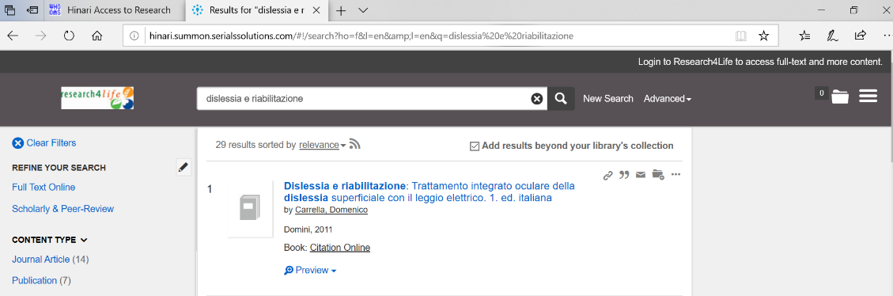](https://www.google.com/url?sa=t&rct=j&q=&esrc=s&source=web&cd=6&cad=rja&uact=8&ved=2ahUKEwjwkLyyi4fpAhWfwcQBHQSwB2QQFjAFegQIARAB&url=https%3A%2F%2Flibrary.seu.edu.bd%2Fjournal%2Fjurnal-manajemen-agribisnisbogor-agricultural-university&usg=AOvVaw04t1WgSp_4Mcp0HlD1v68-)